**Windows & Linux Images**

Using the Final-Fantasy-Adventure-Guide.pdf as the input file. I set both the image.prof and mobile_Image_Test.prof to have a trigger-dpi : 144, and target-dpi : 96.

The Image.pro recompress type is jpeg2000, and quality : high

The mobile_Image_Test.prof type is jpeg, and quality : high

The Final-Fantasy-Adventure-Guide_Mobile_out.pdf seems to reflect mobile_Image_Test.prof target-dpi, but the Final-Fantasy-Adventure-Guide_out.pdf doesn’t reflect the target-dpi set in the image.prof

Final-Fantasy-Adventure-Guide.pdf

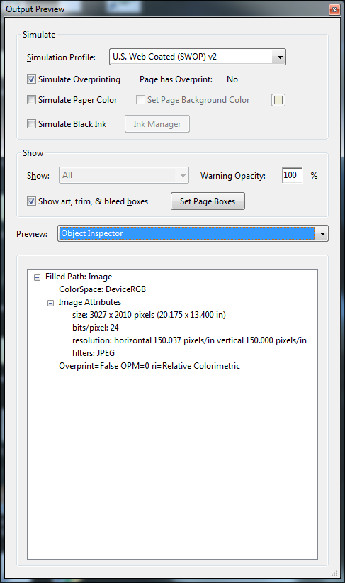

Final-Fantasy-Adventure-Guide_out.pdf using the Image.prof

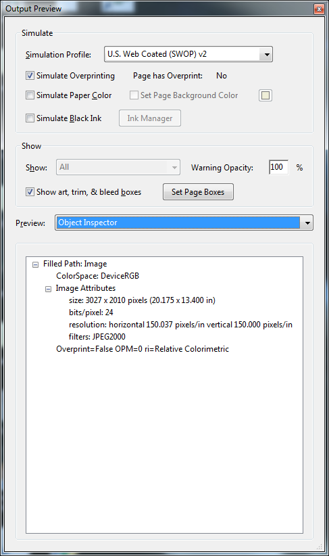

Final-Fantasy-Adventure-Guide_Mobile_out.pdf using mobile_Image_Test.prof

