**THUMBNAILS are being generated by Acrobat, and are not actually part of the document.**

Object

Physics_textbook.pdf contains bookmarks. The physics_textbook_out.pdf using the Objects.prof removes the bookmarks, but the physics_textbook_Mobile_out.pdf using the mobile_Objects_Test.prof does not remove the thumbnails.

Physics_textbook.pdf:

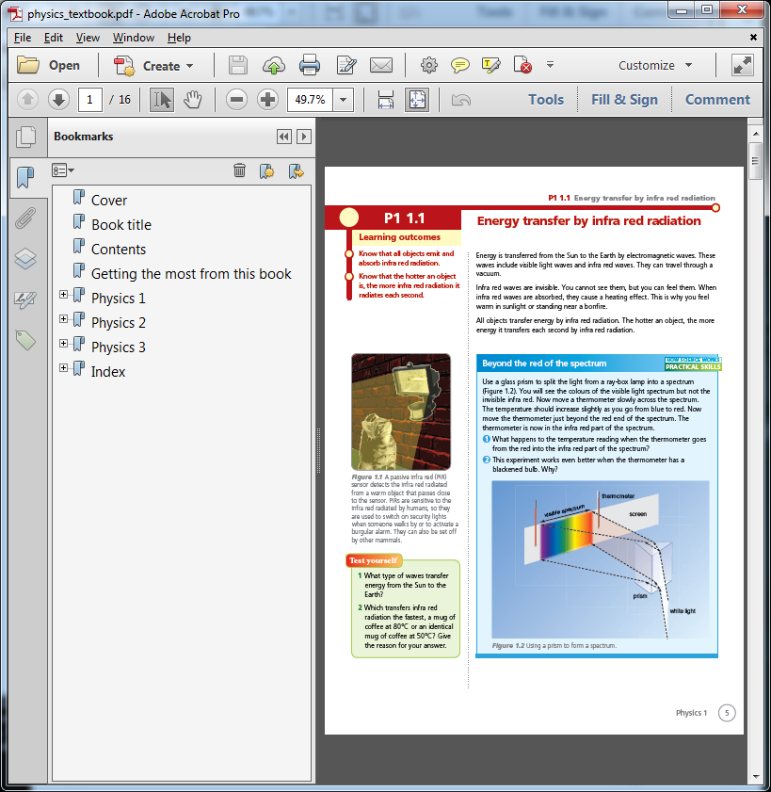

Physics_textbook_out.pdf

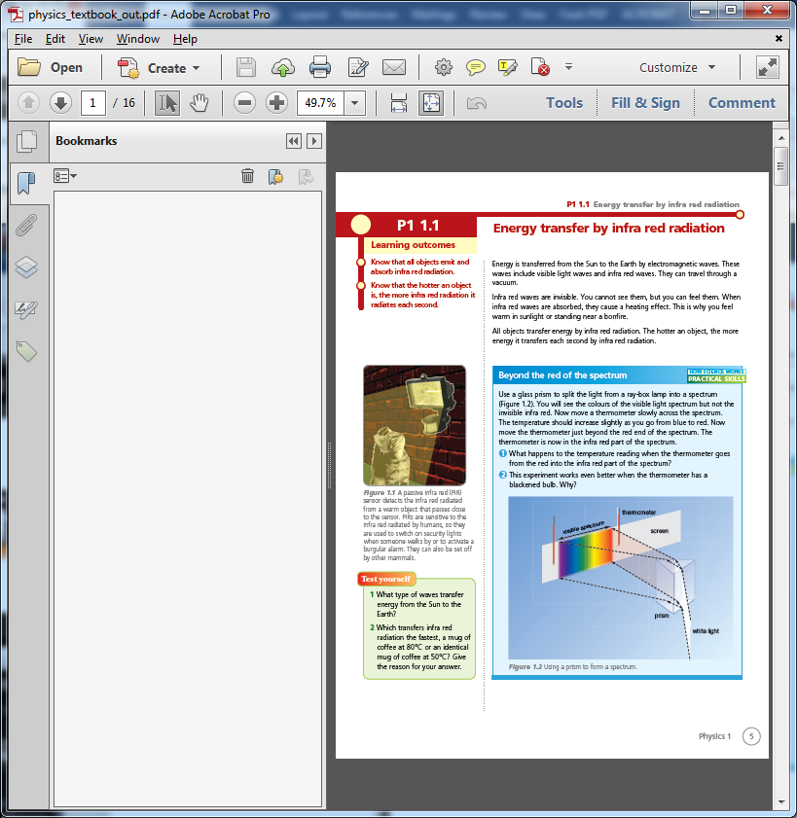

physics_textbook_Mobile_out.pdf

