**Windows & Linux: Userdata**

discard-external-crossreferences flag doesn’t appear to be working.

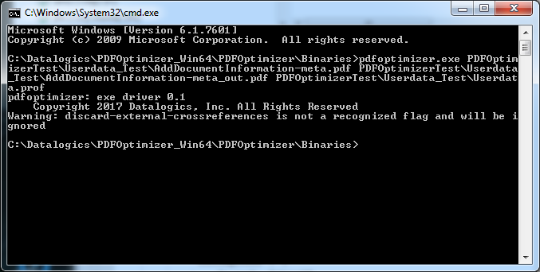

AddDocumentInformation-meta

Removes metadata from AddDocumentInformation-meta.pdf

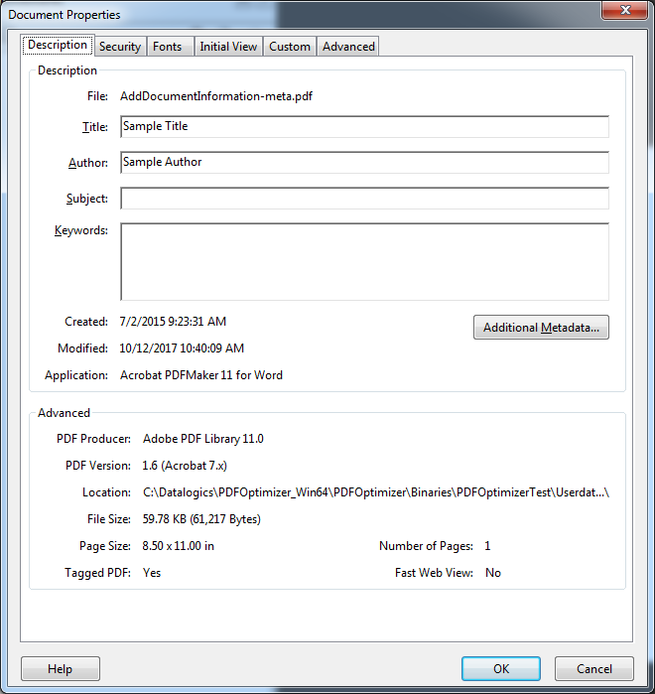

AddDocumentationInformation-meta_out.pdf

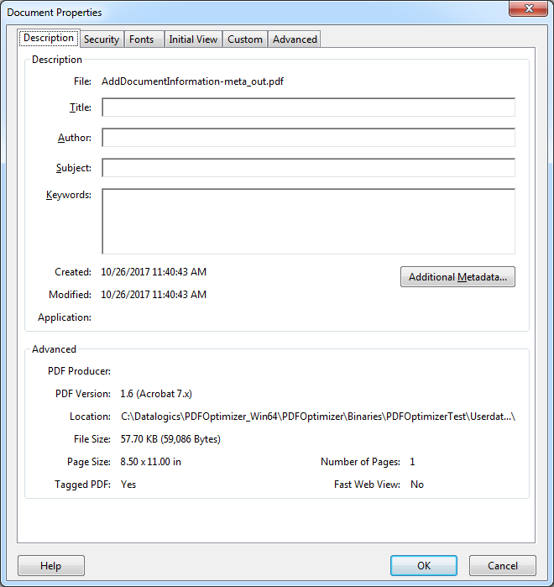

Attachments.pdf

The Attachments.pdf contains metadata and attachments that are removed in the Attachments_out.pdf

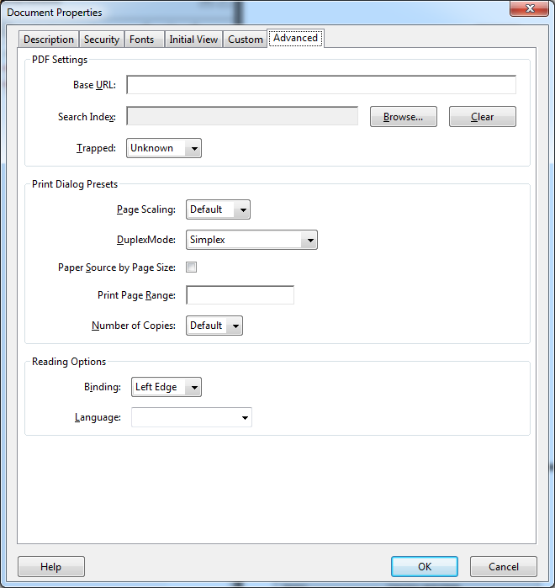

Attachments_out.pdf

