**Build Box2DOCL**

1. Open \Build\VS2010\Box2D.sln

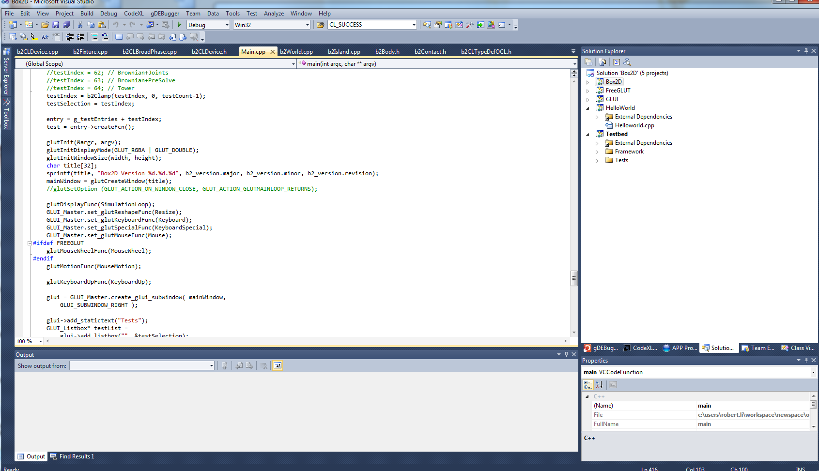

1. Right click Solution/Box2D->Property

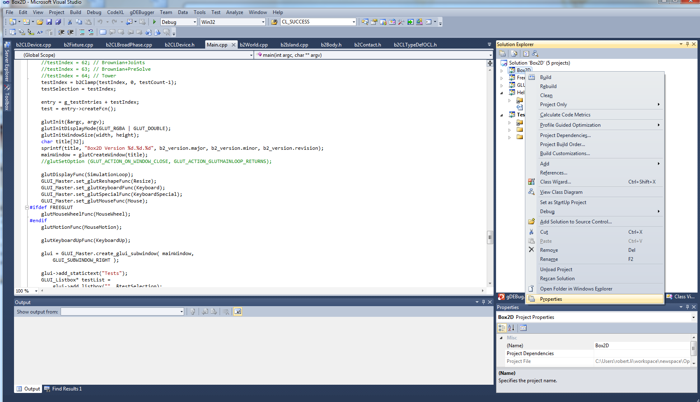

1. Goes to C++-> General->Additional Include Directories, add OpenCL header files’ directories.

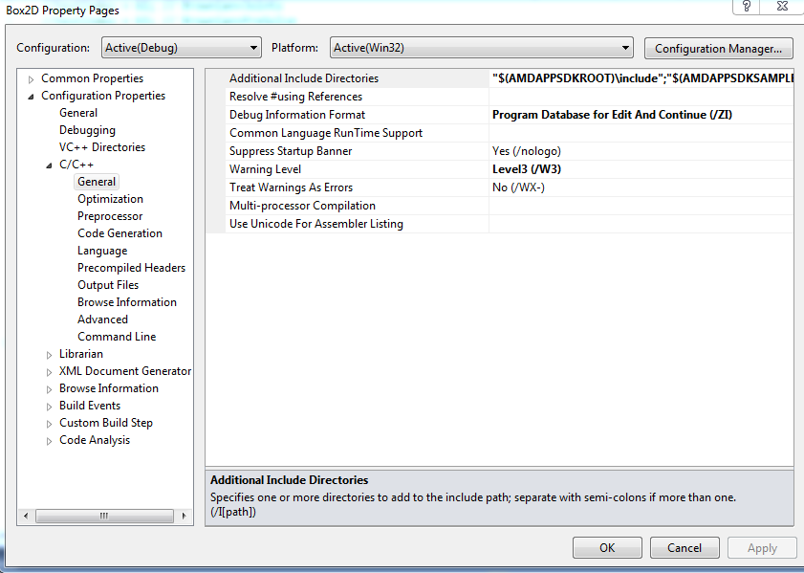

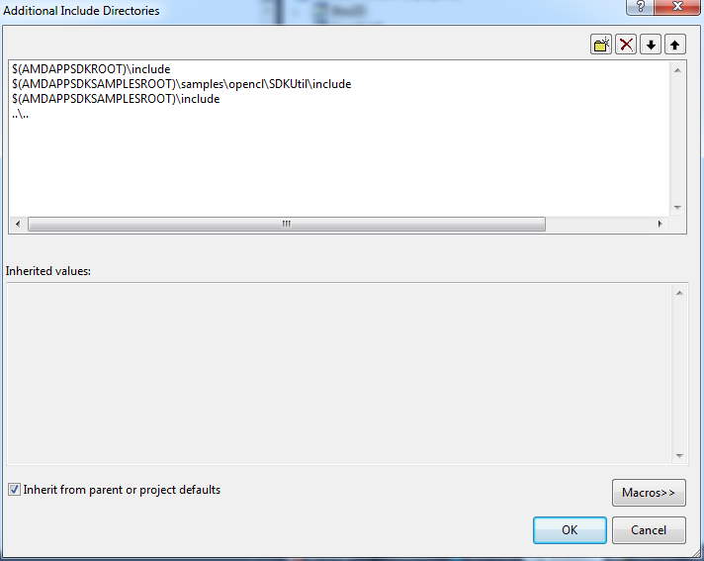

1. Go to Librarian->General. Add “OpenCL.lib” to “Additional Dependencies”. Add OpenCL Library directories to “Additional Library Directories”.

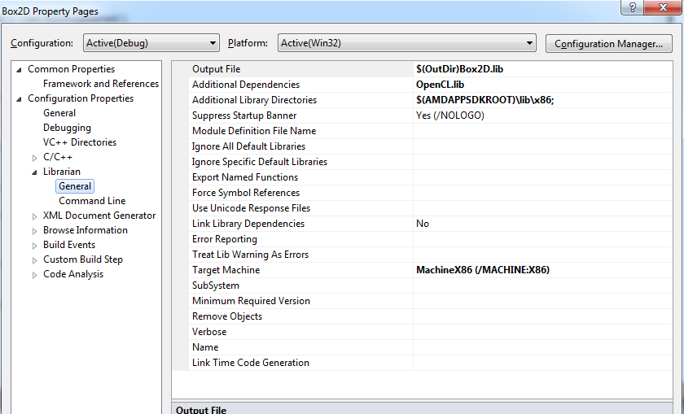

1. Build the Box2D project and generate the library.

**Run a demo using Box2DOCL**

**(Run Testbed or Helloworld)**

1. Our Testbed uses the original demo files from Box2D_v2.2.1. First Download the original Box2D (v2.2.1): <https://code.google.com/p/box2d/downloads/list>
2. Copy the folder glui and Testbed into our Box2DOCL folder.

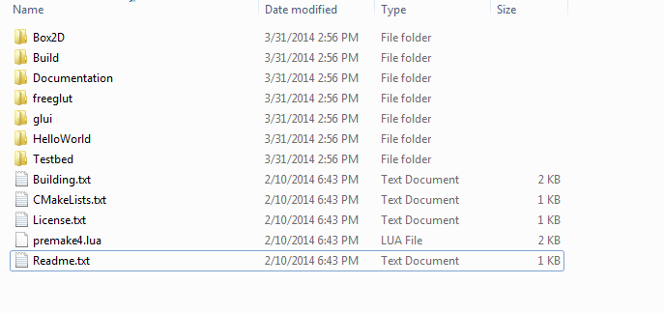

1. Open the visual studio Box2D.sln again.
2. Open the “Testbed (Helloworld) properties”.

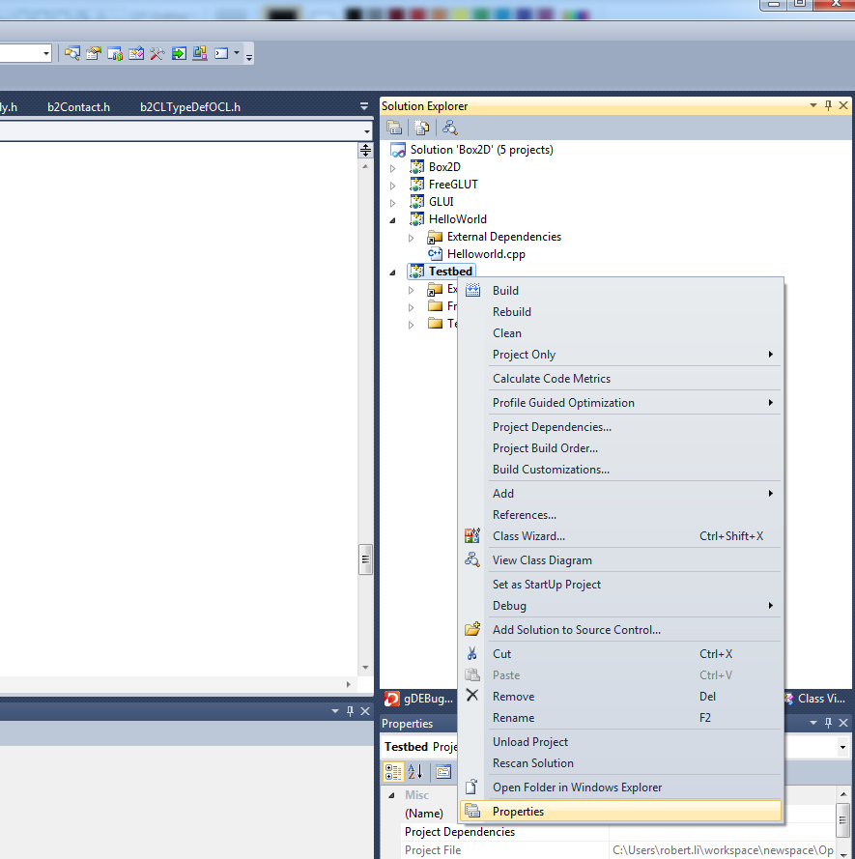

1. Go to C/C++->General, Add OpenCL directories into “Additional Include Directories”.

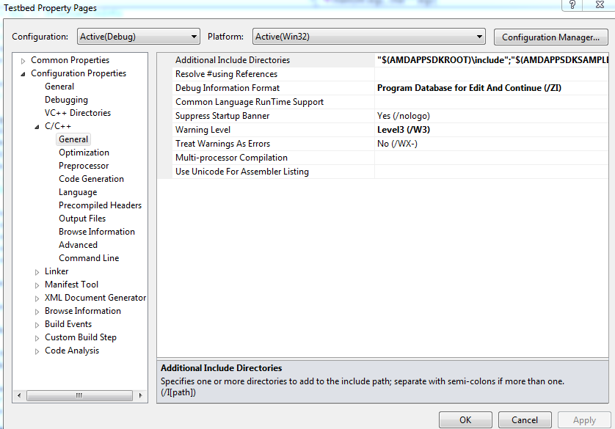

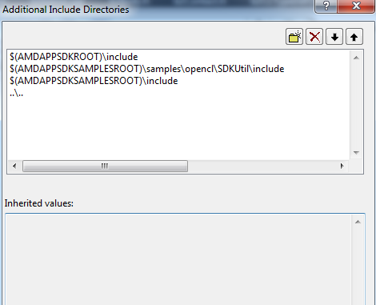

1. In Linker, add OpenCL library directories to “Additional Library Directories”

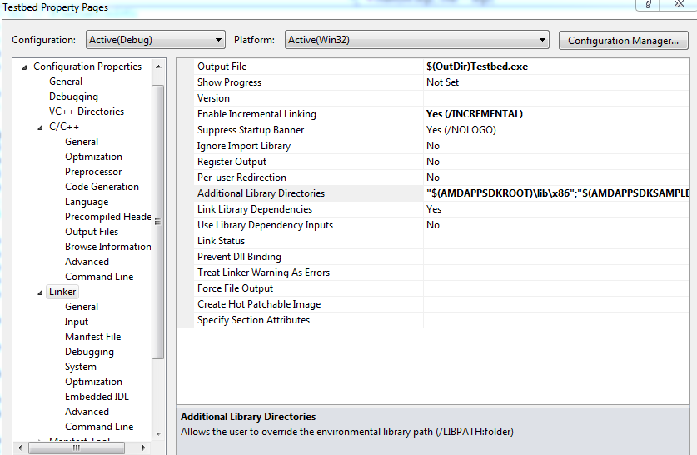

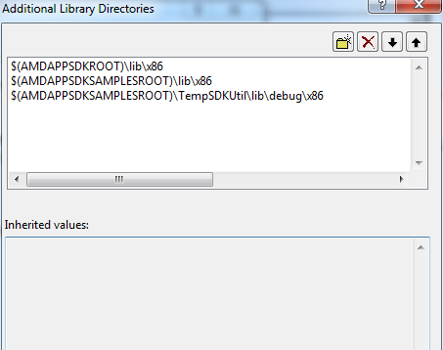

1. In Linker->input, add OpenCL libraries to “additional dependencies”

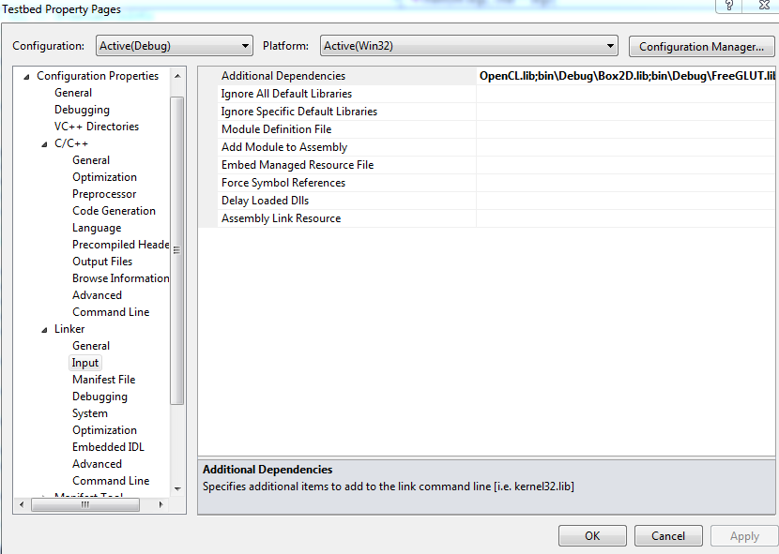

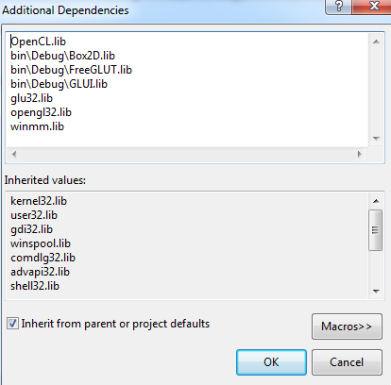

1. Build the Testbed (Helloworld) and run it directly.

**Using OpenCL CPU/GPU and Sequential CPU Mode**

In b2CLDevice.h first two lines:

Sequential CPU Model:

//#define BOX2D_OPENCL

//#define BOX2D_OPENCL_ON_CPU

OpenCL GPU mode:

#define BOX2D_OPENCL

//#define BOX2D_OPENCL_ON_CPU

OpenCL CPU mode:

#define BOX2D_OPENCL

#define BOX2D_OPENCL_ON_CPU

“Display the Computing Time” mode:

#define _DEBUG_TIME_STEP_TOTAL

#define _DEBUG_TIME_BROADPHASE

#define _DEBUG_TIME_NARROWPHASE

#define _DEBUG_TIME_SOLVER

**Xcode**

1. Open the file Build/xcode/password.sh, set the password as the system admin’s password.
2. Open Box2D.xcodeproj in Xcode. Change the active Scheme as Box2DOCL.
3. Run the scheme.
4. Copy glui/Testbed folders from Box2D as mentioned above.
5. Change the active scheme as Testbed and run the scheme.