Style Guidelines for Final Year Project ReportsTitle of the Project

Final Year Project Proposal

Session 20xx-20xx

A 4th Year Student

A project submitted in partial fulfilment of the

COMSATS University Degree

of

BSc. (Hons.)BS in Computer Science / Software Engineering (CUI)



Department of Computer Science

COMSATS University Islamabad, Lahore Campus

04 March 2022

**Project Registration**

|  |  |  |  |  |  |  |  |
| --- | --- | --- | --- | --- | --- | --- | --- |
| Project ID (for office use) | | |  | | | | |
| Type of project | | | [ ] Traditional [ ] Industrial [ ] Continuing | | | | |
| Nature of project | | | [ ] **D**evelopment [ ] **R**esearch [ ] **R**&**D** | | | | |
| Area of specialisation | | |  | | | | |
| **Project Group Members** | | | | | | | |
| Sr.# | Reg. # | Student Name | | CGPA | Email ID | Phone # | Signature |
| (i) | Group Leader |  | |  |  |  |  |
| (ii) |  |  | |  |  |  |  |
| (iii) |  |  | |  |  |  |  |
| **Declaration:** FYP group members have cleared all prerequisites courses For FYP-I as per their degree requirements.  For BS(Computer Science)  (CSC241 Object Oriented Programming, CSC291 Software Engineering Concepts, CSC371 Database Systems-I, HUM102 Report Writing Skills)  For BS(Software Engineering)  (CSC241 Object Oriented Programming, CSE291 Introduction to Software Engineering , CSC371 Database Systems-I , HUM102 Report Writing Skills) | | | | | | | |

# Plagiarism Free Certificate

This is to certify that, I am ________________________ S/D/o _______________________, group leader of FYP under registration no CIIT/_________________/LHR at Computer Science Department, COMSATS Institute of Information Technology, Lahore. I declare that my FYP proposal is checked by my supervisor and the similarity index is ________% that is less than 20%, an acceptable limit by HEC. Report is attached herewith as Appendix A.

Date: ____________ Name of Group Leader: ________________________ Signature: _____________

Name of Supervisor: _____________________ Co-Supervisor (if any):____________________

Designation: _____________________ Designation: _____________________

Signature: _____________________ Signature: _____________________

**Project Abstract (mandatory)**

Under this heading, briefly describe the project to convey the abstract idea of the project using 250 to 300 words. Distribute paragraphs text evenly between both margins to give the document a clean and crisp look, and this task can be performed by using justify paragraph option in MS word.

**Previous Project Objectives and Features ( mandatory in case of Continuing project)**

# Introduction (mandatory)

This section will expand the title quoted for the project by explaining the background to the work you propose and the objectives you expect to achieve. A project title often will do little more than identify a broad area within which you will work: the accompanying description must elaborate on this, giving details of specific goals to be achieved and precise characterizations of the methods used in the process. You should identify the main sub-tasks that make up your complete project and outline the algorithms or techniques to be adopted in completing them. A project description should give criteria that can be used at the end of the year to test whether you have achieved your goals and should back this up by explaining what form of evidence to this effect you expect to include in your dissertation.

# Success Criterion

Similarly, a proposal must specify what it means for the project to be a success. It is advisable to choose a reasonably modest but verifiable success criterion which you are as certain as possible can be met; this means that your dissertation can claim your project not only satisfies the success criterion but potentially exceeds it. Projects that do not satisfy the success criterion are, as in real life, liable to be seen as failures to some extent.

Success is the way to reach the defined objectives of your project if it is according to the project proposal and satisfies all the goals and objectives listed in the document. Success requires the acceptance of the project by the supervisor and satisfaction of the client if it is other than your primary supervisor.

# Related work (mandatory)

# The main reasons for using information from external sources are either to complement the contents of the work with relevant data or to provide a different opinion on the issue stated. In both cases, it means adding credibility to the project, making it look more trustworthy and complete. The author should create an analytical review of the previous scientific works on the topic or explore related development. The student has to provide the historical background and inform the reader about current achievements in research/development. Using only proven credible sources from journals, conferences, and books accepted in academic circles is vital. All the used sources have to be appropriately cited through the text. The bibliography is situated at the end of the paper. It should follow the provided format and display sources in alphabetical order. It is necessary to study the structure of such work to write a strong final year project proposal. Moreover, a clear scheme will make a formal proposal easier to read.

Use IEEE referencing style available in Microsoft word as shown in Fig. 3.

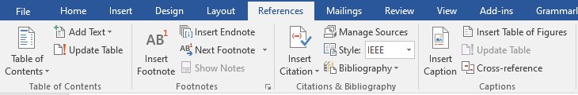

Figure 3. Word references tab.

# Project Rationale

Describe the purpose, motivation or relevance of the project. Describes why the problem is important. You must convey why you want to take this project and what you hoped to learn from your research/development.

## Aims and Objectives

The goal of the project and the main focused objectives of the project are discussed in this section.

## Scope of the Project

Scope defines what needs to be achieved and the work that must be done to deliver a project. It includes specific project goals, deliverables, features, functions, tasks, deadlines, and ultimately costs.

# Proposed Methodology and Architecture

This section provides insight into what methodology you will employ in the development of the envisioned system. It is the systematic, theoretical analysis of the methods applied to your study. It can comprise step-by-step procedures, flowcharts, block diagrams or algorithms of the proposed system.

# Individual Tasks (mandatory if group project)

Please mention individual tasks in the table indicating individual tasks and justify the one-year effort of two or three students. The expected individual task list with the tentative plan is given below.

|  |  |  |
| --- | --- | --- |
| **Team Member** | **Activity** | **Tentative Date** |
| <Name 1> | Activity 01 | <Date> |
|  | Activity 02 |  |
|  | Activity 03 |  |
|  | Activity 04 |  |
|  | **<Activity n>** |  |

# Gantt Chart (Mandatory)

As per individual tasks mentioned in the previous section, the Gantt chart shall graphically represent which tasks would be done in which duration, i.e., starting date, end date. What tasks shall be done in parallel, and what tasks shall be done in series? Duration of individual task. (View few samples from the internet before making your own to get ideas)

# Tools and Technologies

Please describe the tools and technologies that the FYP group is planning to use in the project.

# References (Mandatory)

You must provide references (IEEE style) when appropriate to justify your study.

# General Guidelines

Before starting write up, first, confirm that the correct template has the correct paper size. This FYP proposal template has been tailored for output on the A4 paper size. Specify paper width according to dimensions shown in Fig. 1.

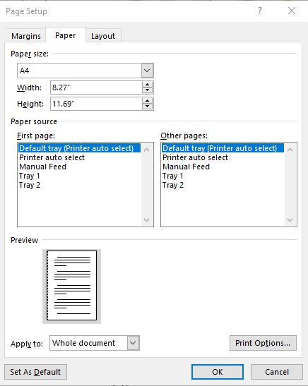

Figure 1. Paper size settings.

Ensure page margins are according to the margin values shown in Fig. 2.

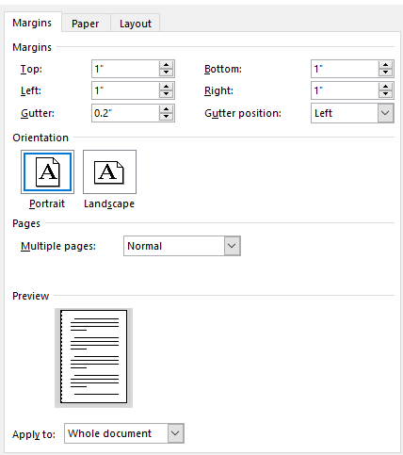

Figure 2. Template page margins.

# Template Heading (Heading-1)

Each section should start with heading font size 16, bold, and font face “Times New Roman”. First, outline the proposal in different sections and try to include relevant heading. If it is required to split the section into sub-headings, should use a font size of 13, bold, and font face “Times New Roman.

## Selecting a Sub Heading (Heading-2)

Describe FYP in detail problem background, problem complexity, and proposed solution.

### Selecting Sub Sub Heading (Heading-3)

Follow the numbering style for the sub-sub-section under the main section. In order to write the third level of subheading, use font size 12 and font face italic “Times New Roman.”

#### Body Text

All the body text should be in font size 12 and single line spacing. Moreover, ensure that the complete document must use only font-face “Times New Roman”.

# Figures and Tables

Use the following instructions to create tables and figures. All the figures and tables must be cross-referred in the text. For example, the figure is inserted in the introduction section in this document figure and can refer to the paper size, and margins see Fig. 1. In the same way, all tables should be cross-referred in the text.

## Figures and Tables

Figure captions should be below the figures; table heads should appear above the tables. Insert figures and tables after they are cited in the text. Use the abbreviation “Fig. 1”, even at the beginning of a sentence.

1. Table Type Styles

| Table Head | Table Column Head | | |
| --- | --- | --- | --- |
| Table column subhead | Subhead | Subhead |
| copy | More table copy |  |  |

1. Example of a figure caption. (*figure caption*)

Figure Labels: Use 11 point Times New Roman for Figure labels. Use words rather than symbols or abbreviations when writing Figure axis labels to avoid confusing the reader.

# Failure to Submit FYP proposal on time

Any student or group who fails to submit a project proposal on time breaches regulation and will not be registered in FYP-I.

Appendix A

*Include here the 1st page of Turnitin Report*

Every supervisor has his/her own Turnitin account. If not, then supervisors are requested to get the account from Library as soon as possible.