Snowball Monitoring / Protection / Parachute Risk Comparison
Normalized China-style structures, English first.

Executive Conclusion
Under normalized China-style terms, PPP-EKI is lower risk than PPP-DKI on raw loss probability (11.1500% vs 17.9167% for loss >5%) and NPP-DKI is materially worse on tail loss severity (ES95 0.4235 vs 0.2000). The monitoring value Δ_monitoring is 2.0698, while Δ_protection is 2.2161. PV is quoted ex-principal, consistent with current China index-note convention. The residual risk in EKI is more terminally concentrated: near the KI barrier at maturity, small terminal moves can flip the note between the rebate state and the downside state.

Structure Normalization and Methodology
Baseline assumptions: S0=100, strike=100, KI=70, KO=103, coupon=12.0000%, r=2.0000%, q=10.0000%, vol=22.0000%, tenor=12M, business-day count=244. Dividend yield q is calibrated to the current China equity-index convention and analyzed over the practical band [8.0000%, 15.0000%]. Daily-KI uses exact business-day discrete observations; EKI uses final-only KI. PV is quoted ex-principal and state probabilities come from common-random-number Monte Carlo on one shared observation grid.
Contract Terms Comparison
Structure | Monitoring | Tenor | KO Schedule | KO Barrier | Final KO | KI Barrier | Coupon / Rebate | PV Principal | Protection | Post-KI KO
PPP-EKI | European final-only KI | 12M | Monthly, months 3-12 | 103.0000 | 103.0000 | 70.0000 | 12.0000% | Excluded | PARTIAL (20.0000% floor) | Allowed
PPP-DKI | Daily business-day KI | 12M | Monthly, months 3-12 | 103.0000 | 103.0000 | 70.0000 | 12.0000% | Excluded | PARTIAL (20.0000% floor) | Allowed
NPP-DKI | Daily business-day KI | 12M | Monthly, months 3-12 | 103.0000 | 103.0000 | 70.0000 | 12.0000% | Excluded | NONE | Allowed
PPP-DKI-Parachute | Daily business-day KI | 12M | Monthly, months 3-12 | 103.0000 | 70.0000 | 70.0000 | 12.0000% | Excluded | PARTIAL (20.0000% floor) | Allowed
PPP-EKI-Parachute | European final-only KI | 12M | Monthly, months 3-12 | 103.0000 | 70.0000 | 70.0000 | 12.0000% | Excluded | PARTIAL (20.0000% floor) | Allowed

Matched-Structure Pricing Comparison
Structure | PV | StdErr | P(No KO) | P(KI) | P(KI & No KO) | P(loss>5%) | P(loss>10%) | P(loss>20%) | ES95 | ES99
PPP-EKI | 4.1739 | 0.0842 | 0.4441 | 0.1238 | 0.1115 | 0.1115 | 0.1115 | 0.0000 | 0.2000 | 0.2000
PPP-DKI | 2.1041 | 0.0968 | 0.4441 | 0.2009 | 0.1800 | 0.1792 | 0.1776 | 0.0000 | 0.2000 | 0.2000
NPP-DKI | -0.1120 | 0.1419 | 0.4441 | 0.2009 | 0.1800 | 0.1792 | 0.1776 | 0.1659 | 0.4235 | 0.4990
PPP-DKI-Parachute | 4.1899 | 0.0843 | 0.1115 | 0.2009 | 0.1115 | 0.1115 | 0.1115 | 0.0000 | 0.2000 | 0.2000
PPP-EKI-Parachute | 4.1899 | 0.0843 | 0.1115 | 0.1238 | 0.1115 | 0.1115 | 0.1115 | 0.0000 | 0.2000 | 0.2000
Measure | Value
Δ_monitoring | 2.0698
Δ_protection | 2.2161
Δ_parachute_DKI | 2.0858
Δ_parachute_EKI | 0.0160

Greeks Comparison
This section compares how delta, gamma, vega, and rhoq evolve as spot moves through the KI region, the rebound band, and the KO region. It now includes both spot sweeps and dividend-yield (q) sweeps, plus dedicated q panels at the KI and KO barrier neighborhoods. PPP-EKI should usually show less path-driven downside sensitivity than PPP-DKI after rebound states, while NPP-DKI should retain the same directional shape but with worse downside convexity.
Key Spot Greek Levels
Spot | Structure | Delta | Gamma | Vega | RhoQ
65.0000 | PPP-EKI | 0.6207 | -0.0095 | 0.2226 | -0.4077
65.0000 | PPP-DKI | 0.1239 | -0.0019 | 0.5827 | -0.0748
65.0000 | NPP-DKI | 1.0138 | -0.0156 | 0.9239 | -0.6476
70.0000 | PPP-EKI | 0.7112 | 4.2426 | 0.1030 | -0.5034
70.0000 | PPP-DKI | 0.5975 | 38.6380 | 0.6093 | -0.1653
70.0000 | NPP-DKI | 1.4268 | 38.9377 | 0.7934 | -0.7286
75.0000 | PPP-EKI | 0.7159 | -0.0095 | -0.0702 | -0.5470
75.0000 | PPP-DKI | 0.9783 | -0.0130 | 0.2744 | -0.3611
75.0000 | NPP-DKI | 1.7165 | -0.0229 | 0.3011 | -0.8943
85.0000 | PPP-EKI | 0.4824 | -0.0057 | -0.4741 | -0.4722
85.0000 | PPP-DKI | 0.8255 | -0.0097 | -0.4416 | -0.5237
85.0000 | NPP-DKI | 1.3299 | -0.0156 | -0.6429 | -0.9370
100.0000 | PPP-EKI | 0.0477 | -0.0005 | -0.4094 | -0.1690
100.0000 | PPP-DKI | 0.2382 | -0.0024 | -0.6170 | -0.2651
100.0000 | NPP-DKI | 0.4709 | -0.0047 | -0.8304 | -0.4546
103.0000 | PPP-EKI | -0.0108 | -3.0106 | -0.3070 | -0.1190
103.0000 | PPP-DKI | 0.1371 | -5.1543 | -0.7346 | -0.2003
103.0000 | NPP-DKI | 0.3220 | -7.7123 | -0.9571 | -0.3515
Key Dividend Yield Greek Levels
QShift | QLevel | Structure | Delta | Gamma | Vega | RhoQ
-0.0200 | 0.0800 | PPP-EKI | 0.0128 | -0.0001 | -0.3883 | -0.1404
-0.0200 | 0.0800 | PPP-DKI | 0.1947 | -0.0019 | -0.6128 | -0.2352
-0.0200 | 0.0800 | NPP-DKI | 0.4013 | -0.0040 | -0.8181 | -0.4037
0.0000 | 0.1000 | PPP-EKI | 0.0477 | -0.0005 | -0.4094 | -0.1690
0.0000 | 0.1000 | PPP-DKI | 0.2382 | -0.0024 | -0.6170 | -0.2651
0.0000 | 0.1000 | NPP-DKI | 0.4709 | -0.0047 | -0.8304 | -0.4546
0.0300 | 0.1300 | PPP-EKI | 0.1040 | -0.0010 | -0.4322 | -0.2140
0.0300 | 0.1300 | PPP-DKI | 0.3045 | -0.0030 | -0.6080 | -0.3096
0.0300 | 0.1300 | NPP-DKI | 0.5791 | -0.0058 | -0.8289 | -0.5328
0.0500 | 0.1500 | PPP-EKI | 0.1436 | -0.0014 | -0.4405 | -0.2449
0.0500 | 0.1500 | PPP-DKI | 0.3484 | -0.0035 | -0.5912 | -0.3383
0.0500 | 0.1500 | NPP-DKI | 0.6526 | -0.0065 | -0.8137 | -0.5852
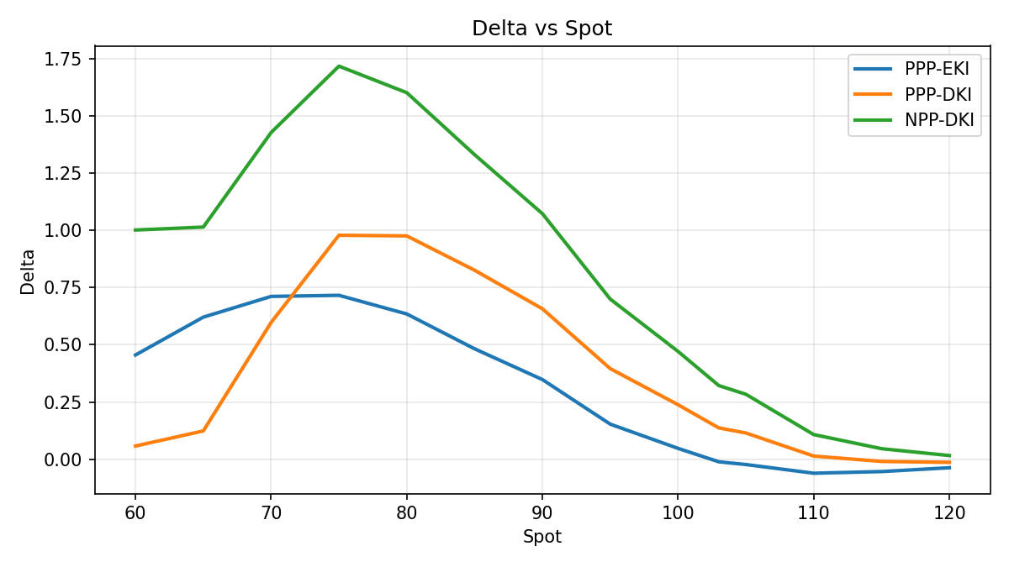
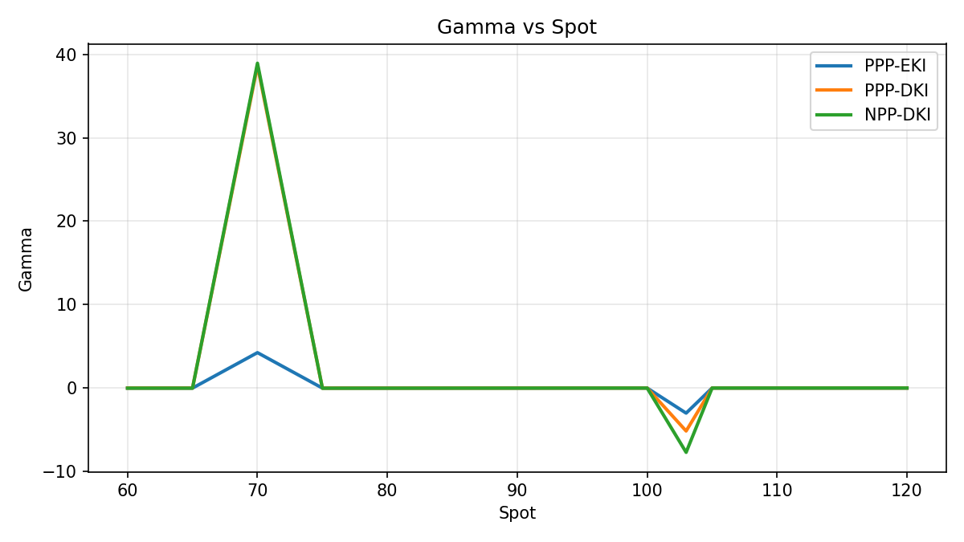
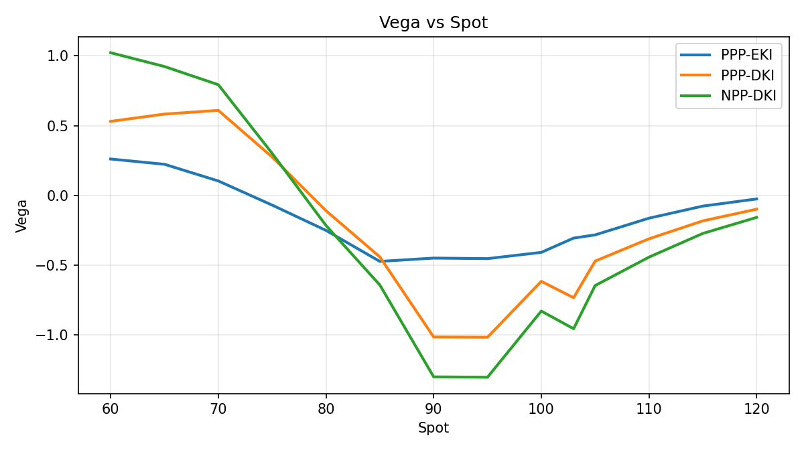
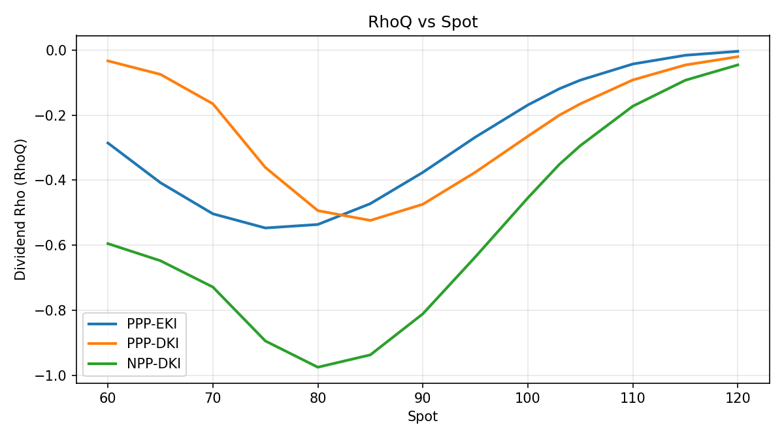
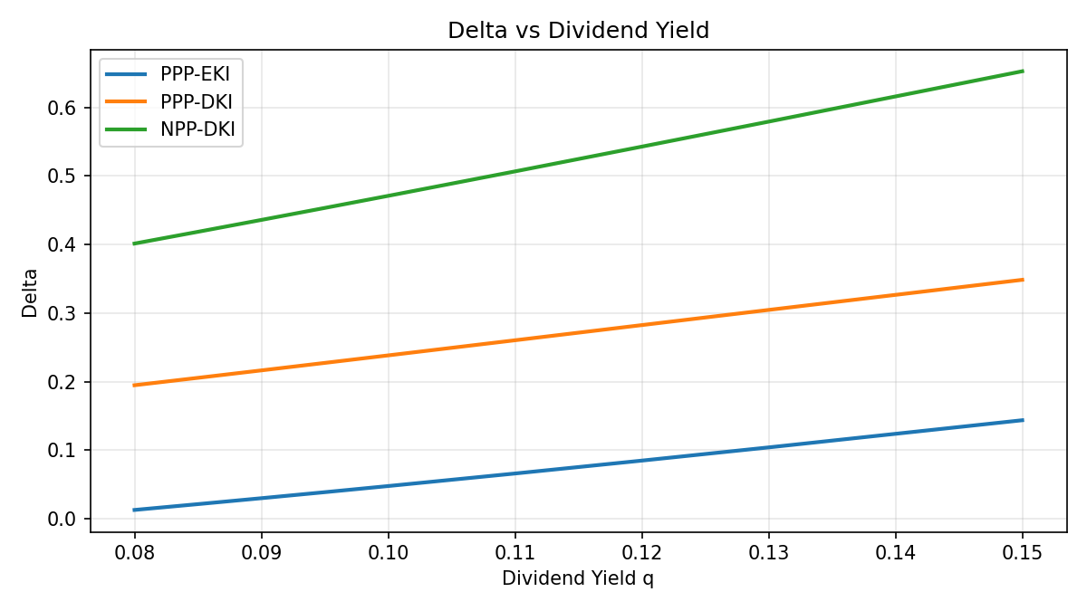
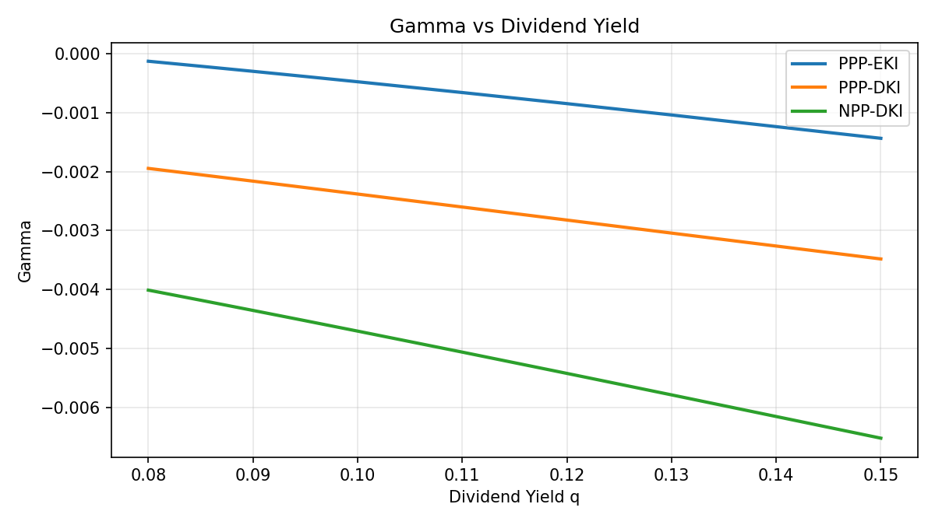
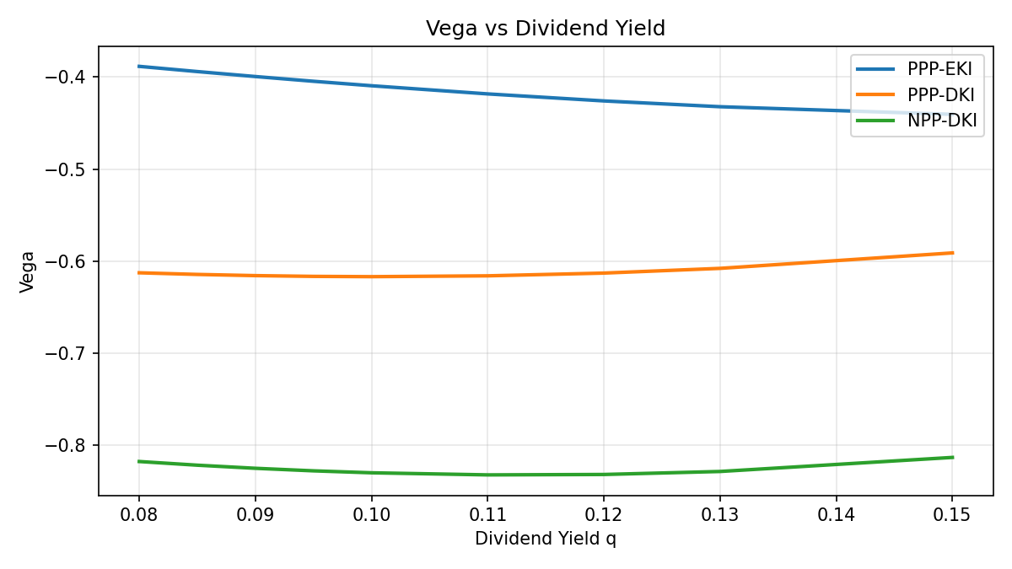
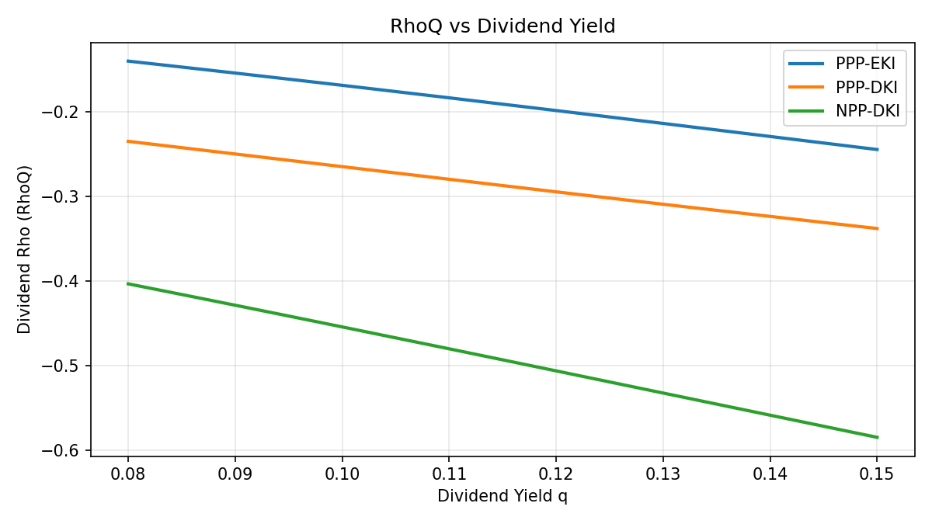
Near-KI and Near-KO q slices
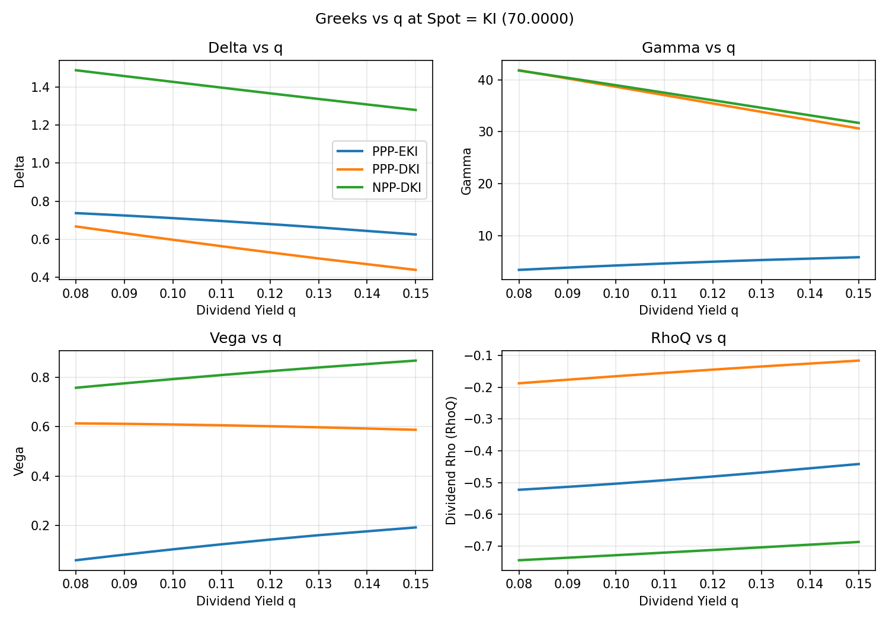
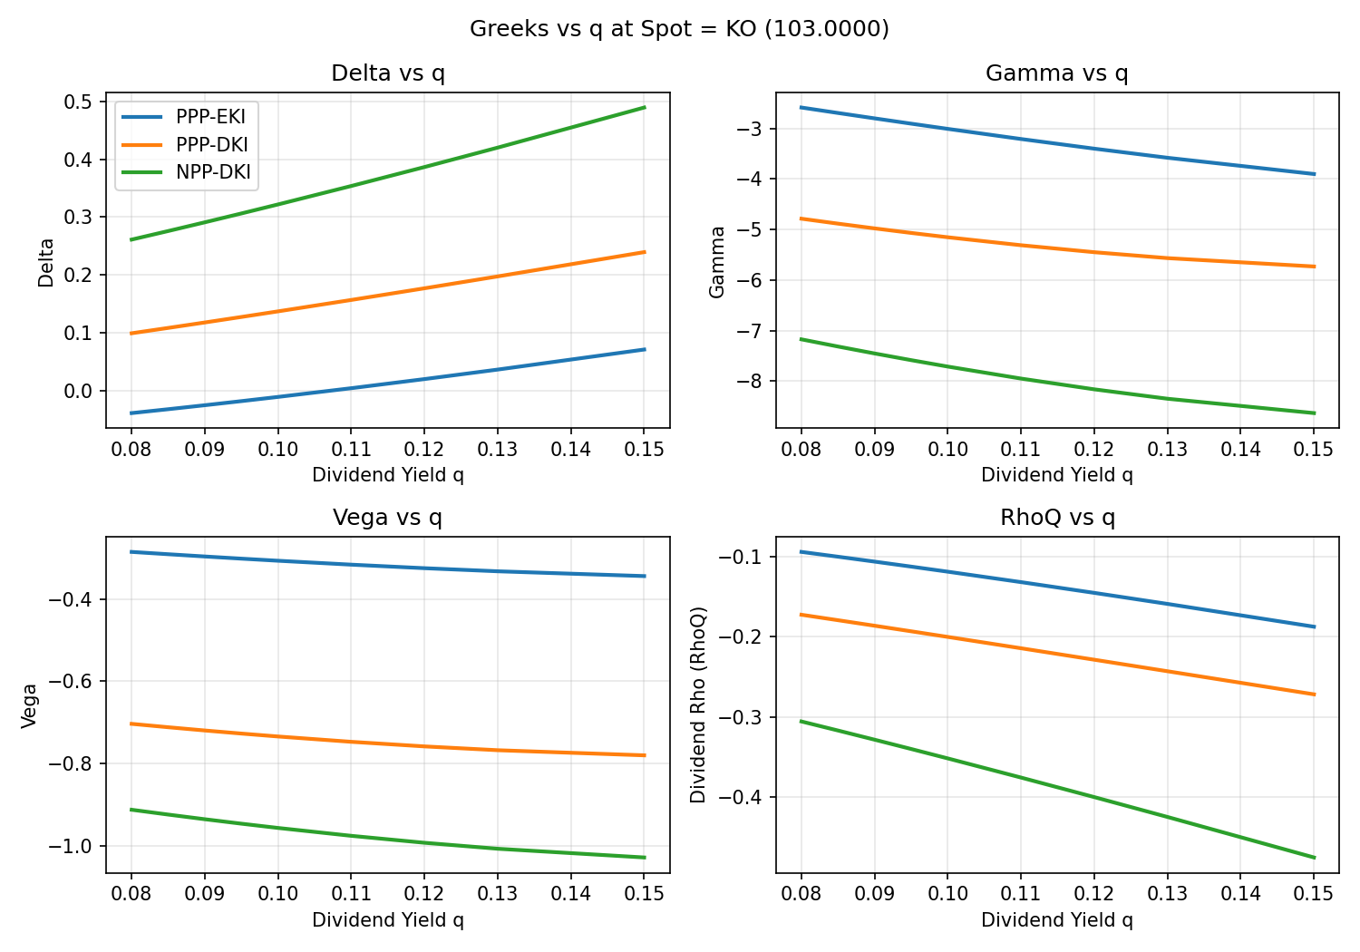

Path Template Evidence
Deterministic path tests show where monitoring rules matter most. The 100→65→85 case is the clean rebound band where PPP-EKI avoids the loss regime that still applies to PPP-DKI. The 100→65→74 case isolates parachute rescue value and shows why DKI benefits more than EKI.
Case | Structure | State | Payoff | Return | Terminal
Crash Then Full Rebound | PPP-DKI | KO | 11.0656 | 0.1107 | 110.0000
Crash Then Full Rebound | PPP-EKI | KO | 11.0656 | 0.1107 | 110.0000
Crash Then Full Rebound | NPP-DKI | KO | 11.0656 | 0.1107 | 110.0000
Crash Then Full Rebound | PPP-DKI-Parachute | KO | 11.0656 | 0.1107 | 110.0000
Crash Then Full Rebound | PPP-EKI-Parachute | KO | 11.0656 | 0.1107 | 110.0000
Crash Then Partial Rebound 85 | PPP-DKI | KI / No KO | -15.0000 | -0.1500 | 85.0000
Crash Then Partial Rebound 85 | PPP-EKI | No KI / No KO | 12.0000 | 0.1200 | 85.0000
Crash Then Partial Rebound 85 | NPP-DKI | KI / No KO | -15.0000 | -0.1500 | 85.0000
Crash Then Partial Rebound 85 | PPP-DKI-Parachute | KO | 12.0492 | 0.1205 | 85.0000
Crash Then Partial Rebound 85 | PPP-EKI-Parachute | KO | 12.0492 | 0.1205 | 85.0000
Parachute Rescue 74 | PPP-DKI | KI / No KO | -20.0000 | -0.2000 | 74.0000
Parachute Rescue 74 | PPP-EKI | No KI / No KO | 12.0000 | 0.1200 | 74.0000
Parachute Rescue 74 | NPP-DKI | KI / No KO | -26.0000 | -0.2600 | 74.0000
Parachute Rescue 74 | PPP-DKI-Parachute | KO | 12.0492 | 0.1205 | 74.0000
Parachute Rescue 74 | PPP-EKI-Parachute | KO | 12.0492 | 0.1205 | 74.0000
Slow Bleed Lower | PPP-DKI | KI / No KO | -20.0000 | -0.2000 | 68.0000
Slow Bleed Lower | PPP-EKI | KI / No KO | -20.0000 | -0.2000 | 68.0000
Slow Bleed Lower | NPP-DKI | KI / No KO | -32.0000 | -0.3200 | 68.0000
Slow Bleed Lower | PPP-DKI-Parachute | KI / No KO | -20.0000 | -0.2000 | 68.0000
Slow Bleed Lower | PPP-EKI-Parachute | KI / No KO | -20.0000 | -0.2000 | 68.0000
High-Vol Sideways Around KI | PPP-DKI | KI / No KO | -20.0000 | -0.2000 | 71.0000
High-Vol Sideways Around KI | PPP-EKI | No KI / No KO | 12.0000 | 0.1200 | 71.0000
High-Vol Sideways Around KI | NPP-DKI | KI / No KO | -29.0000 | -0.2900 | 71.0000
High-Vol Sideways Around KI | PPP-DKI-Parachute | KO | 12.0492 | 0.1205 | 71.0000
High-Vol Sideways Around KI | PPP-EKI-Parachute | KO | 12.0492 | 0.1205 | 71.0000
Late Selloff Final Window | PPP-DKI | KI / No KO | -20.0000 | -0.2000 | 69.0000
Late Selloff Final Window | PPP-EKI | KI / No KO | -20.0000 | -0.2000 | 69.0000
Late Selloff Final Window | NPP-DKI | KI / No KO | -31.0000 | -0.3100 | 69.0000
Late Selloff Final Window | PPP-DKI-Parachute | KI / No KO | -20.0000 | -0.2000 | 69.0000
Late Selloff Final Window | PPP-EKI-Parachute | KI / No KO | -20.0000 | -0.2000 | 69.0000

Event Probability and Cashflow Decomposition
PPP-EKI
ko_time | p_ko | p_survive | ed_ko_cf
0.2459 | 0.3040 | 0.6960 | 0.8926
0.3197 | 0.0725 | 0.6235 | 0.2763
0.4139 | 0.0530 | 0.5705 | 0.2611
0.4959 | 0.0324 | 0.5381 | 0.1910
0.5861 | 0.0267 | 0.5113 | 0.1859
0.6803 | 0.0189 | 0.4924 | 0.1523
0.7500 | 0.0147 | 0.4777 | 0.1308
0.8320 | 0.0140 | 0.4637 | 0.1375
0.9221 | 0.0116 | 0.4521 | 0.1258
1.0041 | 0.0080 | 0.4441 | 0.0945
PPP-DKI
ko_time | p_ko | p_survive | ed_ko_cf
0.2459 | 0.3040 | 0.6960 | 0.8926
0.3197 | 0.0725 | 0.6235 | 0.2763
0.4139 | 0.0530 | 0.5705 | 0.2611
0.4959 | 0.0324 | 0.5381 | 0.1910
0.5861 | 0.0267 | 0.5113 | 0.1859
0.6803 | 0.0189 | 0.4924 | 0.1523
0.7500 | 0.0147 | 0.4777 | 0.1308
0.8320 | 0.0140 | 0.4637 | 0.1375
0.9221 | 0.0116 | 0.4521 | 0.1258
1.0041 | 0.0080 | 0.4441 | 0.0945

Loss Tail and Expected Shortfall
Structure | Rebound Band | Rebound Band Loss | Parachute Rescue Band | Parachute Rescue Loss | Terminal Cliff Band | Terminal Cliff Loss
PPP-EKI | 0.0683 | 0.0000 | 0.0685 | 0.0000 | 0.0318 | 0.0152
PPP-DKI | 0.0683 | 0.0683 | 0.0685 | 0.0683 | 0.0318 | 0.0283
NPP-DKI | 0.0683 | 0.0683 | 0.0685 | 0.0683 | 0.0318 | 0.0283
PPP-DKI-Parachute | 0.0000 | 0.0000 | 0.0000 | 0.0000 | 0.0152 | 0.0152
PPP-EKI-Parachute | 0.0000 | 0.0000 | 0.0000 | 0.0000 | 0.0152 | 0.0152

Barrier / Terminal-Cliff Concentration
Initial KO barrier watch: level=103.00, pct distance=3.0000%, sigma distance=0.271. Within the terminal cliff band (±2.0000% around KI), PPP-EKI loss probability is 1.5250% versus 2.8250% for PPP-DKI.
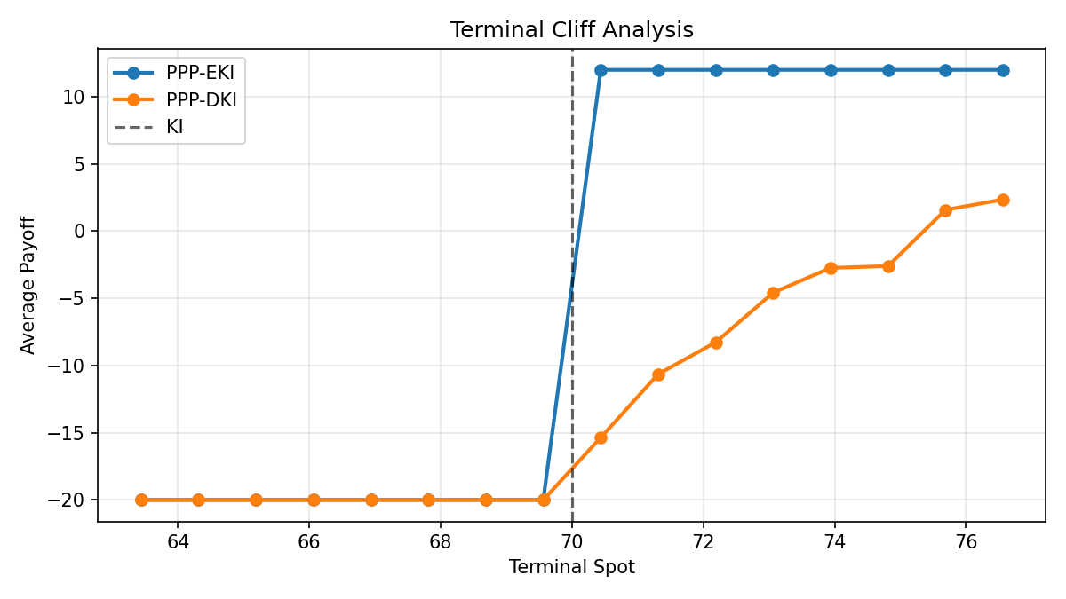

Parachute Feature Analysis
Δ_parachute_DKI = 2.0858 and Δ_parachute_EKI = 0.0160. The MC evidence and deterministic 100→65→74 path both support the same conclusion: parachute mostly rescues paths that had already knocked in under daily monitoring.

Stress Section
The stress layer uses fast repricing to show how the same structures redistribute risk under spot, vol, dividend, skew/smile, and combined trader ladders.
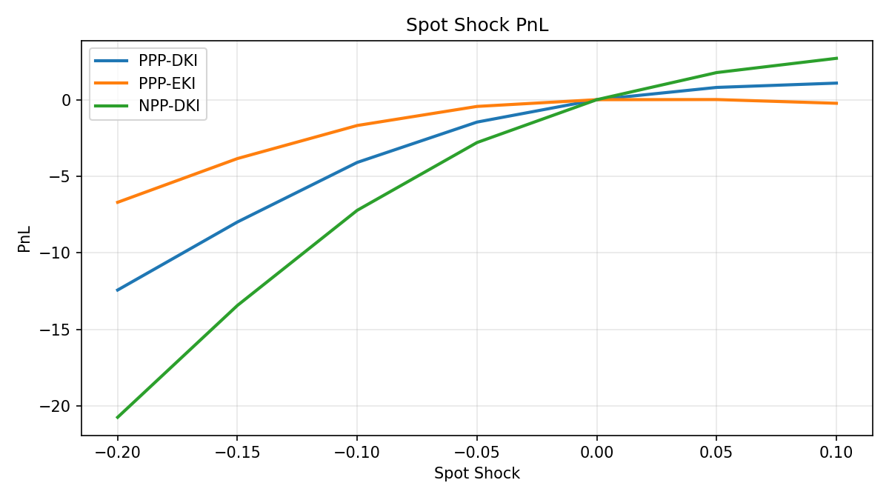
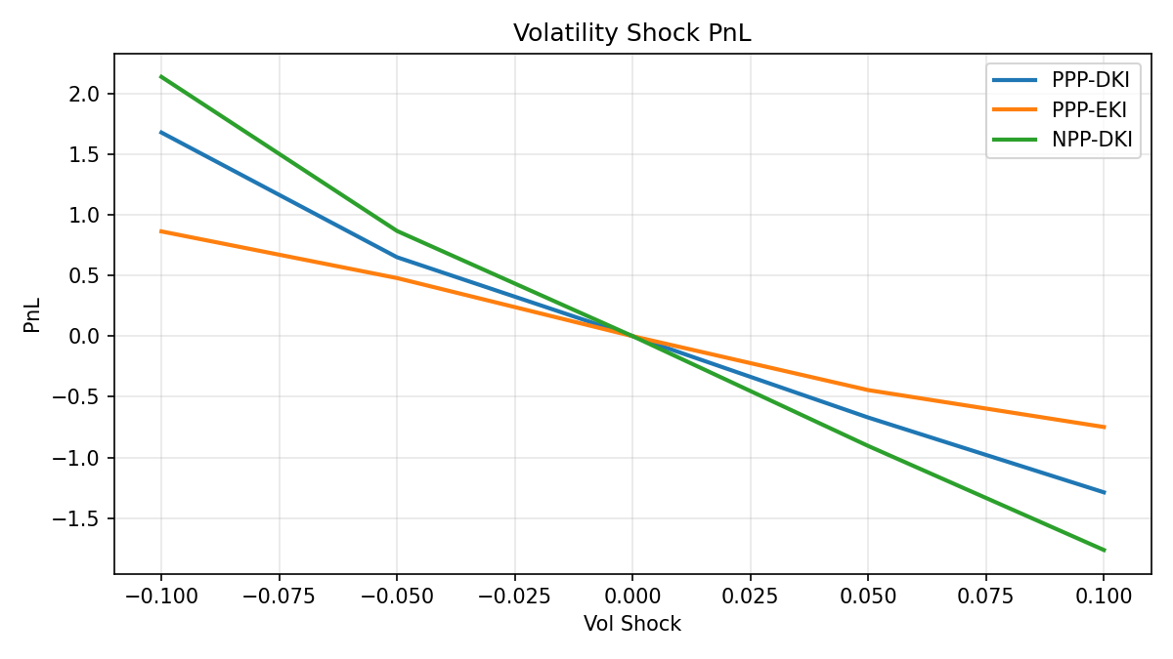
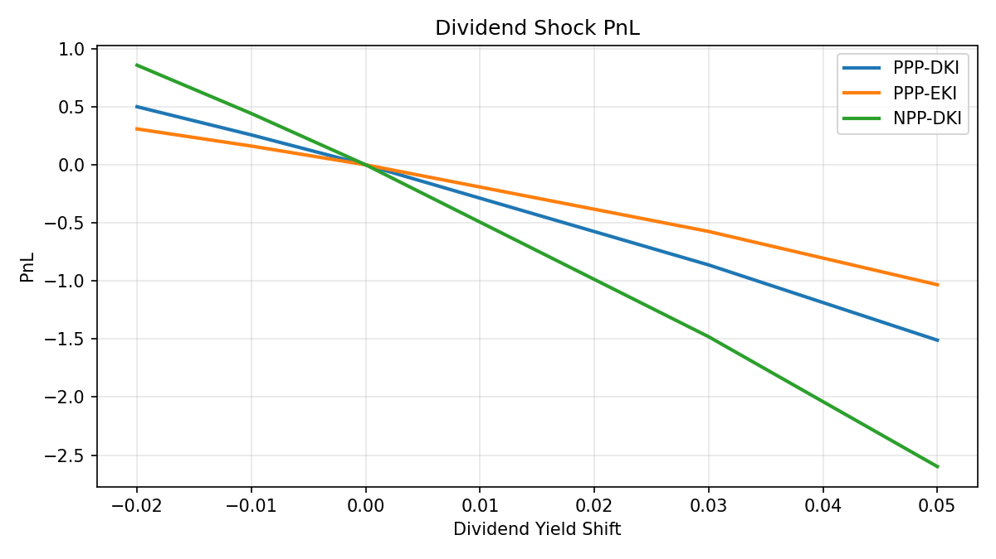
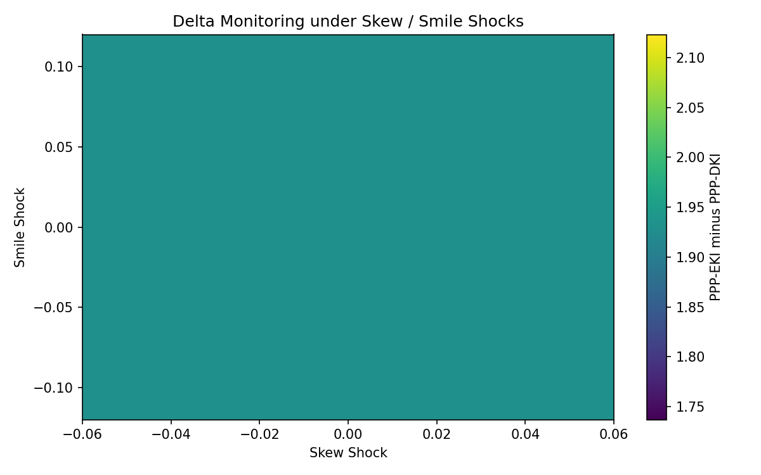
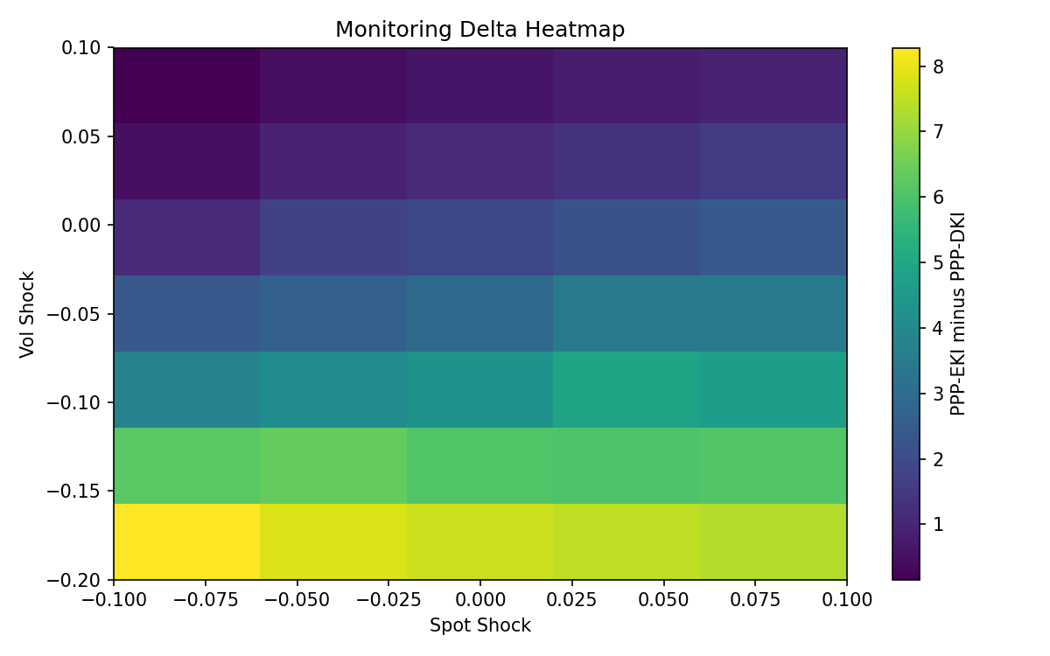
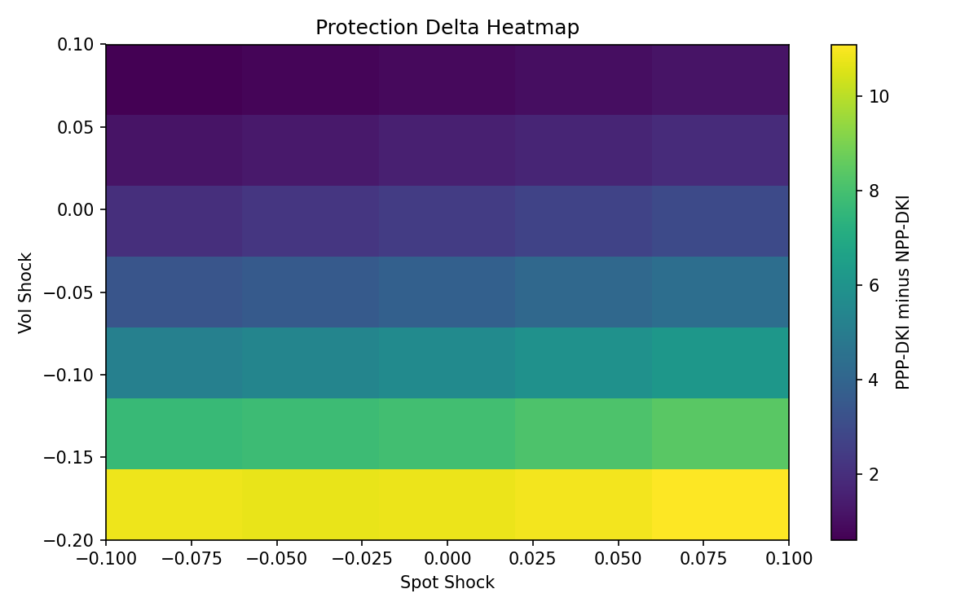

Limitations and Interpretation
This report is a normalized matched-structure study. It does not model issuer spread, secondary-market liquidity, or a dedicated local-vol / jump-diffusion snowball process. The purpose is to isolate the marginal contribution of monitoring, protection, and parachute design under exact discrete barrier rules.

Appendix: Terminology
Definitions for the key terms used throughout the report.
Term | English | Chinese | Definition
Snowball | Snowball | 雪球 | Autocallable structure with KO observations, KI condition, coupons, and a maturity payoff that depends on the path state.
KI | KI | 敲入 | Knock-in event. Once activated, the note moves into the downside payoff regime if it survives to maturity without KO.
EKI | EKI | 欧式敲入 | European knock-in. The KI barrier is checked only at the final fixing.
DKI | DKI | 日度敲入 | Daily knock-in. The KI barrier is checked on each business-day close.
KO | KO | 敲出 | Knock-out event. If triggered on an observation date, the note terminates early and pays the contractual KO payoff.
PPP | PPP | 部分保本 | Partial principal protection. Losses are floored by a contractual protection rate rather than fully exposed.
NPP | NPP | 非保本 | Non-principal protected. Downside is not floored by a protection level.
Parachute | Parachute | 降落伞 | Feature that lowers the final KO barrier to the KI barrier to rescue some KI paths that recover by maturity.
Rebound Band | Rebound Band | 反弹带 | State bucket defined by interim breach below KI, no KO, and terminal spot between KI and strike.
Parachute Rescue Band | Parachute Rescue Band | 降落伞救援带 | State bucket where the path breached KI, avoided standard KO, and finished between KI and the standard final KO barrier.
Terminal Cliff | Terminal Cliff | 终值悬崖 | Concentrated terminal-state risk when spot finishes close to the KI barrier near maturity.
PV | PV | 现值 | Present value of discounted expected cashflows under the report model.
ES95 / ES99 | ES95 / ES99 | ES95 / ES99 | Expected shortfall at the 95% / 99% confidence tail, measuring average tail loss severity.
Common Random Numbers | Common Random Numbers | 共同随机数 | Matched Monte Carlo draws reused across structures to make structural deltas less noisy.

雪球监控方式 / 保本 / 降落伞特征风险对比报告
归一化中资雪球结构，对应英文版镜像内容。

执行摘要
在归一化的中资雪球条款下，部分保本欧式敲入雪球在本金亏损概率上低于部分保本日度敲入雪球，其中亏损超过5%的概率分别为11.1500%与17.9167%；非保本日度敲入雪球的尾部损失显著更差，ES95分别为0.4235与0.2000。监控方式增量价值 Δ_monitoring 为2.0698，保本增量价值 Δ_protection 为2.2161。PV 采用当前中国指数雪球常见的不含本金口径。欧式敲入并非在所有维度都更安全，其剩余风险更集中于终值附近，尤其是在到期前临近敲入价时，终值的小幅波动即可触发状态切换。

结构归一与方法说明
基准假设为：S0=100，行权价=100，敲入价=70，敲出价=103，票息=12.0000%，r=2.0000%，q=10.0000%，波动率=22.0000%，期限=12个月，年交易日=244。股息率 q 采用当前中国股票指数常见口径，并在 [8.0000%, 15.0000%] 区间内分析。日度敲入采用精确离散交易日观察，欧式敲入仅在终值观察。PV 采用不含本金口径，状态概率基于统一观测网格与共同随机数的蒙特卡洛路径。
合约条款对比表
结构 | 敲入监控 | 期限 | 敲出安排 | 敲出价 | 最终敲出价 | 敲入价 | 票息 / 红利 | PV本金处理 | 保本方式 | 敲入后可敲出
PPP-EKI | 欧式终值敲入 | 12个月 | 月度观察，第3-12个月 | 103.0000 | 103.0000 | 70.0000 | 12.0000% | 不含本金 | 部分保本 | 允许
PPP-DKI | 交易日日度敲入 | 12个月 | 月度观察，第3-12个月 | 103.0000 | 103.0000 | 70.0000 | 12.0000% | 不含本金 | 部分保本 | 允许
NPP-DKI | 交易日日度敲入 | 12个月 | 月度观察，第3-12个月 | 103.0000 | 103.0000 | 70.0000 | 12.0000% | 不含本金 | 非保本 | 允许
PPP-DKI-Parachute | 交易日日度敲入 | 12个月 | 月度观察，第3-12个月 | 103.0000 | 70.0000 | 70.0000 | 12.0000% | 不含本金 | 部分保本 | 允许
PPP-EKI-Parachute | 欧式终值敲入 | 12个月 | 月度观察，第3-12个月 | 103.0000 | 70.0000 | 70.0000 | 12.0000% | 不含本金 | 部分保本 | 允许

匹配结构定价对比
Structure | PV | StdErr | P(No KO) | P(KI) | P(KI & No KO) | P(loss>5%) | P(loss>10%) | P(loss>20%) | ES95 | ES99
PPP-EKI | 4.1739 | 0.0842 | 0.4441 | 0.1238 | 0.1115 | 0.1115 | 0.1115 | 0.0000 | 0.2000 | 0.2000
PPP-DKI | 2.1041 | 0.0968 | 0.4441 | 0.2009 | 0.1800 | 0.1792 | 0.1776 | 0.0000 | 0.2000 | 0.2000
NPP-DKI | -0.1120 | 0.1419 | 0.4441 | 0.2009 | 0.1800 | 0.1792 | 0.1776 | 0.1659 | 0.4235 | 0.4990
PPP-DKI-Parachute | 4.1899 | 0.0843 | 0.1115 | 0.2009 | 0.1115 | 0.1115 | 0.1115 | 0.0000 | 0.2000 | 0.2000
PPP-EKI-Parachute | 4.1899 | 0.0843 | 0.1115 | 0.1238 | 0.1115 | 0.1115 | 0.1115 | 0.0000 | 0.2000 | 0.2000
Measure | Value
Δ_monitoring | 2.0698
Δ_protection | 2.2161
Δ_parachute_DKI | 2.0858
Δ_parachute_EKI | 0.0160

Greeks 对比
本节比较 delta、gamma、vega 与 rhoq 随现货穿越 KI 区间、反弹区间与 KO 区间时的变化，并新增了随股息率 q 变化的敏感度曲线，以及贴近 KI / KO 障碍位置的 q 切片图。一般而言，PPP-EKI 在反弹状态后的路径依赖型下行敏感度会弱于 PPP-DKI，而 NPP-DKI 的方向形态类似，但下行凸性风险更差。
关键点位 Greek 对比
Spot | Structure | Delta | Gamma | Vega | RhoQ
65.0000 | PPP-EKI | 0.6207 | -0.0095 | 0.2226 | -0.4077
65.0000 | PPP-DKI | 0.1239 | -0.0019 | 0.5827 | -0.0748
65.0000 | NPP-DKI | 1.0138 | -0.0156 | 0.9239 | -0.6476
70.0000 | PPP-EKI | 0.7112 | 4.2426 | 0.1030 | -0.5034
70.0000 | PPP-DKI | 0.5975 | 38.6380 | 0.6093 | -0.1653
70.0000 | NPP-DKI | 1.4268 | 38.9377 | 0.7934 | -0.7286
75.0000 | PPP-EKI | 0.7159 | -0.0095 | -0.0702 | -0.5470
75.0000 | PPP-DKI | 0.9783 | -0.0130 | 0.2744 | -0.3611
75.0000 | NPP-DKI | 1.7165 | -0.0229 | 0.3011 | -0.8943
85.0000 | PPP-EKI | 0.4824 | -0.0057 | -0.4741 | -0.4722
85.0000 | PPP-DKI | 0.8255 | -0.0097 | -0.4416 | -0.5237
85.0000 | NPP-DKI | 1.3299 | -0.0156 | -0.6429 | -0.9370
100.0000 | PPP-EKI | 0.0477 | -0.0005 | -0.4094 | -0.1690
100.0000 | PPP-DKI | 0.2382 | -0.0024 | -0.6170 | -0.2651
100.0000 | NPP-DKI | 0.4709 | -0.0047 | -0.8304 | -0.4546
103.0000 | PPP-EKI | -0.0108 | -3.0106 | -0.3070 | -0.1190
103.0000 | PPP-DKI | 0.1371 | -5.1543 | -0.7346 | -0.2003
103.0000 | NPP-DKI | 0.3220 | -7.7123 | -0.9571 | -0.3515
关键 q 水平 Greek 对比
QShift | QLevel | Structure | Delta | Gamma | Vega | RhoQ
-0.0200 | 0.0800 | PPP-EKI | 0.0128 | -0.0001 | -0.3883 | -0.1404
-0.0200 | 0.0800 | PPP-DKI | 0.1947 | -0.0019 | -0.6128 | -0.2352
-0.0200 | 0.0800 | NPP-DKI | 0.4013 | -0.0040 | -0.8181 | -0.4037
0.0000 | 0.1000 | PPP-EKI | 0.0477 | -0.0005 | -0.4094 | -0.1690
0.0000 | 0.1000 | PPP-DKI | 0.2382 | -0.0024 | -0.6170 | -0.2651
0.0000 | 0.1000 | NPP-DKI | 0.4709 | -0.0047 | -0.8304 | -0.4546
0.0300 | 0.1300 | PPP-EKI | 0.1040 | -0.0010 | -0.4322 | -0.2140
0.0300 | 0.1300 | PPP-DKI | 0.3045 | -0.0030 | -0.6080 | -0.3096
0.0300 | 0.1300 | NPP-DKI | 0.5791 | -0.0058 | -0.8289 | -0.5328
0.0500 | 0.1500 | PPP-EKI | 0.1436 | -0.0014 | -0.4405 | -0.2449
0.0500 | 0.1500 | PPP-DKI | 0.3484 | -0.0035 | -0.5912 | -0.3383
0.0500 | 0.1500 | NPP-DKI | 0.6526 | -0.0065 | -0.8137 | -0.5852








近 KI 与近 KO 的 q 切片



路径模板证据
确定性路径测试展示了监控规则最有差异的区间。100→65→85 对应典型反弹带，在该区间中 PPP-EKI 通常可以避免 PPP-DKI 仍会触发的亏损状态；100→65→74 则单独刻画了降落伞的救援价值，并显示其对 DKI 的提升明显大于对 EKI 的提升。
Case | Structure | State | Payoff | Return | Terminal
Crash Then Full Rebound | PPP-DKI | KO | 11.0656 | 0.1107 | 110.0000
Crash Then Full Rebound | PPP-EKI | KO | 11.0656 | 0.1107 | 110.0000
Crash Then Full Rebound | NPP-DKI | KO | 11.0656 | 0.1107 | 110.0000
Crash Then Full Rebound | PPP-DKI-Parachute | KO | 11.0656 | 0.1107 | 110.0000
Crash Then Full Rebound | PPP-EKI-Parachute | KO | 11.0656 | 0.1107 | 110.0000
Crash Then Partial Rebound 85 | PPP-DKI | KI / No KO | -15.0000 | -0.1500 | 85.0000
Crash Then Partial Rebound 85 | PPP-EKI | No KI / No KO | 12.0000 | 0.1200 | 85.0000
Crash Then Partial Rebound 85 | NPP-DKI | KI / No KO | -15.0000 | -0.1500 | 85.0000
Crash Then Partial Rebound 85 | PPP-DKI-Parachute | KO | 12.0492 | 0.1205 | 85.0000
Crash Then Partial Rebound 85 | PPP-EKI-Parachute | KO | 12.0492 | 0.1205 | 85.0000
Parachute Rescue 74 | PPP-DKI | KI / No KO | -20.0000 | -0.2000 | 74.0000
Parachute Rescue 74 | PPP-EKI | No KI / No KO | 12.0000 | 0.1200 | 74.0000
Parachute Rescue 74 | NPP-DKI | KI / No KO | -26.0000 | -0.2600 | 74.0000
Parachute Rescue 74 | PPP-DKI-Parachute | KO | 12.0492 | 0.1205 | 74.0000
Parachute Rescue 74 | PPP-EKI-Parachute | KO | 12.0492 | 0.1205 | 74.0000
Slow Bleed Lower | PPP-DKI | KI / No KO | -20.0000 | -0.2000 | 68.0000
Slow Bleed Lower | PPP-EKI | KI / No KO | -20.0000 | -0.2000 | 68.0000
Slow Bleed Lower | NPP-DKI | KI / No KO | -32.0000 | -0.3200 | 68.0000
Slow Bleed Lower | PPP-DKI-Parachute | KI / No KO | -20.0000 | -0.2000 | 68.0000
Slow Bleed Lower | PPP-EKI-Parachute | KI / No KO | -20.0000 | -0.2000 | 68.0000
High-Vol Sideways Around KI | PPP-DKI | KI / No KO | -20.0000 | -0.2000 | 71.0000
High-Vol Sideways Around KI | PPP-EKI | No KI / No KO | 12.0000 | 0.1200 | 71.0000
High-Vol Sideways Around KI | NPP-DKI | KI / No KO | -29.0000 | -0.2900 | 71.0000
High-Vol Sideways Around KI | PPP-DKI-Parachute | KO | 12.0492 | 0.1205 | 71.0000
High-Vol Sideways Around KI | PPP-EKI-Parachute | KO | 12.0492 | 0.1205 | 71.0000
Late Selloff Final Window | PPP-DKI | KI / No KO | -20.0000 | -0.2000 | 69.0000
Late Selloff Final Window | PPP-EKI | KI / No KO | -20.0000 | -0.2000 | 69.0000
Late Selloff Final Window | NPP-DKI | KI / No KO | -31.0000 | -0.3100 | 69.0000
Late Selloff Final Window | PPP-DKI-Parachute | KI / No KO | -20.0000 | -0.2000 | 69.0000
Late Selloff Final Window | PPP-EKI-Parachute | KI / No KO | -20.0000 | -0.2000 | 69.0000

事件概率与现金流分解
PPP-EKI 现金流分解
ko_time | p_ko | p_survive | ed_ko_cf
0.2459 | 0.3040 | 0.6960 | 0.8926
0.3197 | 0.0725 | 0.6235 | 0.2763
0.4139 | 0.0530 | 0.5705 | 0.2611
0.4959 | 0.0324 | 0.5381 | 0.1910
0.5861 | 0.0267 | 0.5113 | 0.1859
0.6803 | 0.0189 | 0.4924 | 0.1523
0.7500 | 0.0147 | 0.4777 | 0.1308
0.8320 | 0.0140 | 0.4637 | 0.1375
0.9221 | 0.0116 | 0.4521 | 0.1258
1.0041 | 0.0080 | 0.4441 | 0.0945
PPP-DKI 现金流分解
ko_time | p_ko | p_survive | ed_ko_cf
0.2459 | 0.3040 | 0.6960 | 0.8926
0.3197 | 0.0725 | 0.6235 | 0.2763
0.4139 | 0.0530 | 0.5705 | 0.2611
0.4959 | 0.0324 | 0.5381 | 0.1910
0.5861 | 0.0267 | 0.5113 | 0.1859
0.6803 | 0.0189 | 0.4924 | 0.1523
0.7500 | 0.0147 | 0.4777 | 0.1308
0.8320 | 0.0140 | 0.4637 | 0.1375
0.9221 | 0.0116 | 0.4521 | 0.1258
1.0041 | 0.0080 | 0.4441 | 0.0945

损失尾部与期望短缺
Structure | Rebound Band | Rebound Band Loss | Parachute Rescue Band | Parachute Rescue Loss | Terminal Cliff Band | Terminal Cliff Loss
PPP-EKI | 0.0683 | 0.0000 | 0.0685 | 0.0000 | 0.0318 | 0.0152
PPP-DKI | 0.0683 | 0.0683 | 0.0685 | 0.0683 | 0.0318 | 0.0283
NPP-DKI | 0.0683 | 0.0683 | 0.0685 | 0.0683 | 0.0318 | 0.0283
PPP-DKI-Parachute | 0.0000 | 0.0000 | 0.0000 | 0.0000 | 0.0152 | 0.0152
PPP-EKI-Parachute | 0.0000 | 0.0000 | 0.0000 | 0.0000 | 0.0152 | 0.0152

障碍附近 / 到期悬崖风险集中
初始敲出障碍监控：障碍水平=103.00，百分比距离=3.0000%，标准差距离=0.271。在终值位于 KI 附近 ±2.0000% 的悬崖区间内，PPP-EKI 的亏损概率为1.5250%，PPP-DKI 为2.8250%。


降落伞特征分析
Δ_parachute_DKI = 2.0858，Δ_parachute_EKI = 0.0160。蒙特卡洛结果与 100→65→74 的确定性路径结论一致：降落伞的主要价值在于挽救那些在日度监控下已提前敲入、但终值又回到 KI 以上的路径。

压力测试部分
压力测试层通过快速重定价展示相同结构在现货、波动率、股息、偏斜/微笑以及组合交易员阶梯情景下如何重新分配风险。







局限性与解读边界
本报告是归一化的匹配结构研究，不包含发行人信用利差、二级市场流动性，也未单独实现局部波动率或跳扩散雪球模型。其目标是基于精确离散障碍规则，分离监控方式、保本设置与降落伞设计的边际贡献。

附录：术语说明
以下列示报告中反复出现的核心术语及其定义。
术语 | 英文 | 中文 | 定义
雪球 | Snowball | 雪球 | 带有敲出观察、敲入条件、票息以及按路径状态决定到期收益的自动赎回结构。
敲入 | KI | 敲入 | 敲入事件。一旦触发，若产品未提前敲出并持有到期，则进入下跌损失收益状态。
欧式敲入 | EKI | 欧式敲入 | 欧式敲入。仅在最终观察日检查敲入障碍。
日度敲入 | DKI | 日度敲入 | 日度敲入。每个交易日收盘检查敲入障碍。
敲出 | KO | 敲出 | 敲出事件。在观察日触发后，产品提前终止并支付约定的敲出收益。
部分保本 | PPP | 部分保本 | 部分保本。损失受到保本比例下限约束，而不是完全暴露。
非保本 | NPP | 非保本 | 非保本。下行损失没有保本下限约束。
降落伞 | Parachute | 降落伞 | 一种将最终敲出价降至敲入价的条款，用于挽救部分到期前反弹的敲入路径。
反弹带 | Rebound Band | 反弹带 | 一种状态区间：路径中途跌破 KI、未敲出、且终值位于 KI 与行权价之间。
降落伞救援带 | Parachute Rescue Band | 降落伞救援带 | 一种状态区间：路径曾跌破 KI、未达到标准敲出、且终值位于 KI 与标准最终敲出价之间。
终值悬崖 | Terminal Cliff | 终值悬崖 | 到期前终值贴近 KI 时形成的集中终值状态风险。
现值 | PV | 现值 | 在本报告模型下，贴现后的期望现金流现值。
ES95 / ES99 | ES95 / ES99 | ES95 / ES99 | 95% / 99% 置信尾部的期望短缺，用于衡量平均尾部损失严重度。
共同随机数 | Common Random Numbers | 共同随机数 | 在不同结构之间复用相同蒙特卡洛随机路径，以减少结构差值的噪声。

