PPP/NPP Snowball Backtest Case Study
Delta-neutral hedge comparison for PPP-DKI, NPP-DKI, and PPP-EKI Parachute Snowballs on 000852.SH hedged with IM futures.

Terms
Term | Value
underlying | 000852.SH
hedging_instrument | IM.CFE
initial_spot | 6733.969
issue_date | 2023-05-04
maturity_date | 2026-04-29
tenor_years_realized | 2.989041095890411
pv_convention | principal_excluded_zero_upfront
payoff_include_principal | False
initial_product_price | 0.0
notional | 10000000
ko_ratio | 1.03
ki_ratio | 0.75
ko_barrier_level | 6935.98807
ki_barrier_level | 5050.47675
observation_schedule_date_basis | KO target dates are mapped to the first available path date on or after each monthly observation time; DKI dates use every trading date after issue date
ko_observation.PPP-DKI | 36 monthly discrete observations; 2023-06-05 to 2026-04-29
ko_observation.NPP-DKI | 36 monthly discrete observations; 2023-06-05 to 2026-04-29
ko_observation.PPP-EKI-Parachute | 36 monthly discrete observations; 2023-06-05 to 2026-04-29; final KO barrier equals KI barrier (75.00%)
ki_observation.PPP-DKI | 724 trading-day discrete observations; 2023-05-05 to 2026-04-29
ki_observation.NPP-DKI | 724 trading-day discrete observations; 2023-05-05 to 2026-04-29
ki_observation.PPP-EKI-Parachute | final-only discrete KI observation on 2026-04-29
final_observation_precedence | KO has precedence at a final KO/KI tie; spot >= KI exits by KO, spot < KI settles through KI/maturity payoff
post_ki_ko_allowed | True; later KO remains allowed after KI unless a product explicitly disables it
ppp_protection_rate | 0.25
rate | 0.02
dividend_yield | 0.08
volatility | 0.25
futures_multiplier | 200
ko_observation_dates.PPP-DKI.01 | 2023-06-05, 2023-07-04, 2023-08-03, 2023-09-04, 2023-10-09, 2023-11-02, 2023-12-04, 2024-01-02, 2024-02-01, 2024-03-04, 2024-04-01, 2024-05-06, 2024-06-03, 2024-07-01, 2024-08-01, 2024-09-02, 2024-09-30, 2024-10-31
ko_observation_dates.PPP-DKI.02 | 2024-12-02, 2024-12-30, 2025-02-05, 2025-03-03, 2025-03-31, 2025-04-30, 2025-06-03, 2025-06-30, 2025-07-30, 2025-09-01, 2025-09-29, 2025-10-29, 2025-11-28, 2025-12-29, 2026-01-28, 2026-02-27, 2026-03-30, 2026-04-29
ko_observation_dates.NPP-DKI.01 | 2023-06-05, 2023-07-04, 2023-08-03, 2023-09-04, 2023-10-09, 2023-11-02, 2023-12-04, 2024-01-02, 2024-02-01, 2024-03-04, 2024-04-01, 2024-05-06, 2024-06-03, 2024-07-01, 2024-08-01, 2024-09-02, 2024-09-30, 2024-10-31
ko_observation_dates.NPP-DKI.02 | 2024-12-02, 2024-12-30, 2025-02-05, 2025-03-03, 2025-03-31, 2025-04-30, 2025-06-03, 2025-06-30, 2025-07-30, 2025-09-01, 2025-09-29, 2025-10-29, 2025-11-28, 2025-12-29, 2026-01-28, 2026-02-27, 2026-03-30, 2026-04-29
ko_observation_dates.PPP-EKI-Parachute.01 | 2023-06-05, 2023-07-04, 2023-08-03, 2023-09-04, 2023-10-09, 2023-11-02, 2023-12-04, 2024-01-02, 2024-02-01, 2024-03-04, 2024-04-01, 2024-05-06, 2024-06-03, 2024-07-01, 2024-08-01, 2024-09-02, 2024-09-30, 2024-10-31
ko_observation_dates.PPP-EKI-Parachute.02 | 2024-12-02, 2024-12-30, 2025-02-05, 2025-03-03, 2025-03-31, 2025-04-30, 2025-06-03, 2025-06-30, 2025-07-30, 2025-09-01, 2025-09-29, 2025-10-29, 2025-11-28, 2025-12-29, 2026-01-28, 2026-02-27, 2026-03-30, 2026-04-29
ki_observation_dates.PPP-DKI.01 | 2023-05-05, 2023-05-08, 2023-05-09, 2023-05-10, 2023-05-11, 2023-05-12, 2023-05-15, 2023-05-16, 2023-05-17, 2023-05-18, 2023-05-19, 2023-05-22, 2023-05-23, 2023-05-24, 2023-05-25, 2023-05-26, 2023-05-29, 2023-05-30
ki_observation_dates.PPP-DKI.02 | 2023-05-31, 2023-06-01, 2023-06-02, 2023-06-05, 2023-06-06, 2023-06-07, 2023-06-08, 2023-06-09, 2023-06-12, 2023-06-13, 2023-06-14, 2023-06-15, 2023-06-16, 2023-06-19, 2023-06-20, 2023-06-21, 2023-06-26, 2023-06-27
ki_observation_dates.PPP-DKI.03 | 2023-06-28, 2023-06-29, 2023-06-30, 2023-07-03, 2023-07-04, 2023-07-05, 2023-07-06, 2023-07-07, 2023-07-10, 2023-07-11, 2023-07-12, 2023-07-13, 2023-07-14, 2023-07-17, 2023-07-18, 2023-07-19, 2023-07-20, 2023-07-21
ki_observation_dates.PPP-DKI.04 | 2023-07-24, 2023-07-25, 2023-07-26, 2023-07-27, 2023-07-28, 2023-07-31, 2023-08-01, 2023-08-02, 2023-08-03, 2023-08-04, 2023-08-07, 2023-08-08, 2023-08-09, 2023-08-10, 2023-08-11, 2023-08-14, 2023-08-15, 2023-08-16
ki_observation_dates.PPP-DKI.05 | 2023-08-17, 2023-08-18, 2023-08-21, 2023-08-22, 2023-08-23, 2023-08-24, 2023-08-25, 2023-08-28, 2023-08-29, 2023-08-30, 2023-08-31, 2023-09-01, 2023-09-04, 2023-09-05, 2023-09-06, 2023-09-07, 2023-09-08, 2023-09-11
ki_observation_dates.PPP-DKI.06 | 2023-09-12, 2023-09-13, 2023-09-14, 2023-09-15, 2023-09-18, 2023-09-19, 2023-09-20, 2023-09-21, 2023-09-22, 2023-09-25, 2023-09-26, 2023-09-27, 2023-09-28, 2023-10-09, 2023-10-10, 2023-10-11, 2023-10-12, 2023-10-13
ki_observation_dates.PPP-DKI.07 | 2023-10-16, 2023-10-17, 2023-10-18, 2023-10-19, 2023-10-20, 2023-10-23, 2023-10-24, 2023-10-25, 2023-10-26, 2023-10-27, 2023-10-30, 2023-10-31, 2023-11-01, 2023-11-02, 2023-11-03, 2023-11-06, 2023-11-07, 2023-11-08
ki_observation_dates.PPP-DKI.08 | 2023-11-09, 2023-11-10, 2023-11-13, 2023-11-14, 2023-11-15, 2023-11-16, 2023-11-17, 2023-11-20, 2023-11-21, 2023-11-22, 2023-11-23, 2023-11-24, 2023-11-27, 2023-11-28, 2023-11-29, 2023-11-30, 2023-12-01, 2023-12-04
ki_observation_dates.PPP-DKI.09 | 2023-12-05, 2023-12-06, 2023-12-07, 2023-12-08, 2023-12-11, 2023-12-12, 2023-12-13, 2023-12-14, 2023-12-15, 2023-12-18, 2023-12-19, 2023-12-20, 2023-12-21, 2023-12-22, 2023-12-25, 2023-12-26, 2023-12-27, 2023-12-28
ki_observation_dates.PPP-DKI.10 | 2023-12-29, 2024-01-02, 2024-01-03, 2024-01-04, 2024-01-05, 2024-01-08, 2024-01-09, 2024-01-10, 2024-01-11, 2024-01-12, 2024-01-15, 2024-01-16, 2024-01-17, 2024-01-18, 2024-01-19, 2024-01-22, 2024-01-23, 2024-01-24
ki_observation_dates.PPP-DKI.11 | 2024-01-25, 2024-01-26, 2024-01-29, 2024-01-30, 2024-01-31, 2024-02-01, 2024-02-02, 2024-02-05, 2024-02-06, 2024-02-07, 2024-02-08, 2024-02-19, 2024-02-20, 2024-02-21, 2024-02-22, 2024-02-23, 2024-02-26, 2024-02-27
ki_observation_dates.PPP-DKI.12 | 2024-02-28, 2024-02-29, 2024-03-01, 2024-03-04, 2024-03-05, 2024-03-06, 2024-03-07, 2024-03-08, 2024-03-11, 2024-03-12, 2024-03-13, 2024-03-14, 2024-03-15, 2024-03-18, 2024-03-19, 2024-03-20, 2024-03-21, 2024-03-22
ki_observation_dates.PPP-DKI.13 | 2024-03-25, 2024-03-26, 2024-03-27, 2024-03-28, 2024-03-29, 2024-04-01, 2024-04-02, 2024-04-03, 2024-04-08, 2024-04-09, 2024-04-10, 2024-04-11, 2024-04-12, 2024-04-15, 2024-04-16, 2024-04-17, 2024-04-18, 2024-04-19
ki_observation_dates.PPP-DKI.14 | 2024-04-22, 2024-04-23, 2024-04-24, 2024-04-25, 2024-04-26, 2024-04-29, 2024-04-30, 2024-05-06, 2024-05-07, 2024-05-08, 2024-05-09, 2024-05-10, 2024-05-13, 2024-05-14, 2024-05-15, 2024-05-16, 2024-05-17, 2024-05-20
ki_observation_dates.PPP-DKI.15 | 2024-05-21, 2024-05-22, 2024-05-23, 2024-05-24, 2024-05-27, 2024-05-28, 2024-05-29, 2024-05-30, 2024-05-31, 2024-06-03, 2024-06-04, 2024-06-05, 2024-06-06, 2024-06-07, 2024-06-11, 2024-06-12, 2024-06-13, 2024-06-14
ki_observation_dates.PPP-DKI.16 | 2024-06-17, 2024-06-18, 2024-06-19, 2024-06-20, 2024-06-21, 2024-06-24, 2024-06-25, 2024-06-26, 2024-06-27, 2024-06-28, 2024-07-01, 2024-07-02, 2024-07-03, 2024-07-04, 2024-07-05, 2024-07-08, 2024-07-09, 2024-07-10
ki_observation_dates.PPP-DKI.17 | 2024-07-11, 2024-07-12, 2024-07-15, 2024-07-16, 2024-07-17, 2024-07-18, 2024-07-19, 2024-07-22, 2024-07-23, 2024-07-24, 2024-07-25, 2024-07-26, 2024-07-29, 2024-07-30, 2024-07-31, 2024-08-01, 2024-08-02, 2024-08-05
ki_observation_dates.PPP-DKI.18 | 2024-08-06, 2024-08-07, 2024-08-08, 2024-08-09, 2024-08-12, 2024-08-13, 2024-08-14, 2024-08-15, 2024-08-16, 2024-08-19, 2024-08-20, 2024-08-21, 2024-08-22, 2024-08-23, 2024-08-26, 2024-08-27, 2024-08-28, 2024-08-29
ki_observation_dates.PPP-DKI.19 | 2024-08-30, 2024-09-02, 2024-09-03, 2024-09-04, 2024-09-05, 2024-09-06, 2024-09-09, 2024-09-10, 2024-09-11, 2024-09-12, 2024-09-13, 2024-09-18, 2024-09-19, 2024-09-20, 2024-09-23, 2024-09-24, 2024-09-25, 2024-09-26
ki_observation_dates.PPP-DKI.20 | 2024-09-27, 2024-09-30, 2024-10-08, 2024-10-09, 2024-10-10, 2024-10-11, 2024-10-14, 2024-10-15, 2024-10-16, 2024-10-17, 2024-10-18, 2024-10-21, 2024-10-22, 2024-10-23, 2024-10-24, 2024-10-25, 2024-10-28, 2024-10-29
ki_observation_dates.PPP-DKI.21 | 2024-10-30, 2024-10-31, 2024-11-01, 2024-11-04, 2024-11-05, 2024-11-06, 2024-11-07, 2024-11-08, 2024-11-11, 2024-11-12, 2024-11-13, 2024-11-14, 2024-11-15, 2024-11-18, 2024-11-19, 2024-11-20, 2024-11-21, 2024-11-22
ki_observation_dates.PPP-DKI.22 | 2024-11-25, 2024-11-26, 2024-11-27, 2024-11-28, 2024-11-29, 2024-12-02, 2024-12-03, 2024-12-04, 2024-12-05, 2024-12-06, 2024-12-09, 2024-12-10, 2024-12-11, 2024-12-12, 2024-12-13, 2024-12-16, 2024-12-17, 2024-12-18
ki_observation_dates.PPP-DKI.23 | 2024-12-19, 2024-12-20, 2024-12-23, 2024-12-24, 2024-12-25, 2024-12-26, 2024-12-27, 2024-12-30, 2024-12-31, 2025-01-02, 2025-01-03, 2025-01-06, 2025-01-07, 2025-01-08, 2025-01-09, 2025-01-10, 2025-01-13, 2025-01-14
ki_observation_dates.PPP-DKI.24 | 2025-01-15, 2025-01-16, 2025-01-17, 2025-01-20, 2025-01-21, 2025-01-22, 2025-01-23, 2025-01-24, 2025-01-27, 2025-02-05, 2025-02-06, 2025-02-07, 2025-02-10, 2025-02-11, 2025-02-12, 2025-02-13, 2025-02-14, 2025-02-17
ki_observation_dates.PPP-DKI.25 | 2025-02-18, 2025-02-19, 2025-02-20, 2025-02-21, 2025-02-24, 2025-02-25, 2025-02-26, 2025-02-27, 2025-02-28, 2025-03-03, 2025-03-04, 2025-03-05, 2025-03-06, 2025-03-07, 2025-03-10, 2025-03-11, 2025-03-12, 2025-03-13
ki_observation_dates.PPP-DKI.26 | 2025-03-14, 2025-03-17, 2025-03-18, 2025-03-19, 2025-03-20, 2025-03-21, 2025-03-24, 2025-03-25, 2025-03-26, 2025-03-27, 2025-03-28, 2025-03-31, 2025-04-01, 2025-04-02, 2025-04-03, 2025-04-07, 2025-04-08, 2025-04-09
ki_observation_dates.PPP-DKI.27 | 2025-04-10, 2025-04-11, 2025-04-14, 2025-04-15, 2025-04-16, 2025-04-17, 2025-04-18, 2025-04-21, 2025-04-22, 2025-04-23, 2025-04-24, 2025-04-25, 2025-04-28, 2025-04-29, 2025-04-30, 2025-05-06, 2025-05-07, 2025-05-08
ki_observation_dates.PPP-DKI.28 | 2025-05-09, 2025-05-12, 2025-05-13, 2025-05-14, 2025-05-15, 2025-05-16, 2025-05-19, 2025-05-20, 2025-05-21, 2025-05-22, 2025-05-23, 2025-05-26, 2025-05-27, 2025-05-28, 2025-05-29, 2025-05-30, 2025-06-03, 2025-06-04
ki_observation_dates.PPP-DKI.29 | 2025-06-05, 2025-06-06, 2025-06-09, 2025-06-10, 2025-06-11, 2025-06-12, 2025-06-13, 2025-06-16, 2025-06-17, 2025-06-18, 2025-06-19, 2025-06-20, 2025-06-23, 2025-06-24, 2025-06-25, 2025-06-26, 2025-06-27, 2025-06-30
ki_observation_dates.PPP-DKI.30 | 2025-07-01, 2025-07-02, 2025-07-03, 2025-07-04, 2025-07-07, 2025-07-08, 2025-07-09, 2025-07-10, 2025-07-11, 2025-07-14, 2025-07-15, 2025-07-16, 2025-07-17, 2025-07-18, 2025-07-21, 2025-07-22, 2025-07-23, 2025-07-24
ki_observation_dates.PPP-DKI.31 | 2025-07-25, 2025-07-28, 2025-07-29, 2025-07-30, 2025-07-31, 2025-08-01, 2025-08-04, 2025-08-05, 2025-08-06, 2025-08-07, 2025-08-08, 2025-08-11, 2025-08-12, 2025-08-13, 2025-08-14, 2025-08-15, 2025-08-18, 2025-08-19
ki_observation_dates.PPP-DKI.32 | 2025-08-20, 2025-08-21, 2025-08-22, 2025-08-25, 2025-08-26, 2025-08-27, 2025-08-28, 2025-08-29, 2025-09-01, 2025-09-02, 2025-09-03, 2025-09-04, 2025-09-05, 2025-09-08, 2025-09-09, 2025-09-10, 2025-09-11, 2025-09-12
ki_observation_dates.PPP-DKI.33 | 2025-09-15, 2025-09-16, 2025-09-17, 2025-09-18, 2025-09-19, 2025-09-22, 2025-09-23, 2025-09-24, 2025-09-25, 2025-09-26, 2025-09-29, 2025-09-30, 2025-10-09, 2025-10-10, 2025-10-13, 2025-10-14, 2025-10-15, 2025-10-16
ki_observation_dates.PPP-DKI.34 | 2025-10-17, 2025-10-20, 2025-10-21, 2025-10-22, 2025-10-23, 2025-10-24, 2025-10-27, 2025-10-28, 2025-10-29, 2025-10-30, 2025-10-31, 2025-11-03, 2025-11-04, 2025-11-05, 2025-11-06, 2025-11-07, 2025-11-10, 2025-11-11
ki_observation_dates.PPP-DKI.35 | 2025-11-12, 2025-11-13, 2025-11-14, 2025-11-17, 2025-11-18, 2025-11-19, 2025-11-20, 2025-11-21, 2025-11-24, 2025-11-25, 2025-11-26, 2025-11-27, 2025-11-28, 2025-12-01, 2025-12-02, 2025-12-03, 2025-12-04, 2025-12-05
ki_observation_dates.PPP-DKI.36 | 2025-12-08, 2025-12-09, 2025-12-10, 2025-12-11, 2025-12-12, 2025-12-15, 2025-12-16, 2025-12-17, 2025-12-18, 2025-12-19, 2025-12-22, 2025-12-23, 2025-12-24, 2025-12-25, 2025-12-26, 2025-12-29, 2025-12-30, 2025-12-31
ki_observation_dates.PPP-DKI.37 | 2026-01-05, 2026-01-06, 2026-01-07, 2026-01-08, 2026-01-09, 2026-01-12, 2026-01-13, 2026-01-14, 2026-01-15, 2026-01-16, 2026-01-19, 2026-01-20, 2026-01-21, 2026-01-22, 2026-01-23, 2026-01-26, 2026-01-27, 2026-01-28
ki_observation_dates.PPP-DKI.38 | 2026-01-29, 2026-01-30, 2026-02-02, 2026-02-03, 2026-02-04, 2026-02-05, 2026-02-06, 2026-02-09, 2026-02-10, 2026-02-11, 2026-02-12, 2026-02-13, 2026-02-24, 2026-02-25, 2026-02-26, 2026-02-27, 2026-03-02, 2026-03-03
ki_observation_dates.PPP-DKI.39 | 2026-03-04, 2026-03-05, 2026-03-06, 2026-03-09, 2026-03-10, 2026-03-11, 2026-03-12, 2026-03-13, 2026-03-16, 2026-03-17, 2026-03-18, 2026-03-19, 2026-03-20, 2026-03-23, 2026-03-24, 2026-03-25, 2026-03-26, 2026-03-27
ki_observation_dates.PPP-DKI.40 | 2026-03-30, 2026-03-31, 2026-04-01, 2026-04-02, 2026-04-03, 2026-04-07, 2026-04-08, 2026-04-09, 2026-04-10, 2026-04-13, 2026-04-14, 2026-04-15, 2026-04-16, 2026-04-17, 2026-04-20, 2026-04-21, 2026-04-22, 2026-04-23
ki_observation_dates.PPP-DKI.41 | 2026-04-24, 2026-04-27, 2026-04-28, 2026-04-29
ki_observation_dates.NPP-DKI.01 | 2023-05-05, 2023-05-08, 2023-05-09, 2023-05-10, 2023-05-11, 2023-05-12, 2023-05-15, 2023-05-16, 2023-05-17, 2023-05-18, 2023-05-19, 2023-05-22, 2023-05-23, 2023-05-24, 2023-05-25, 2023-05-26, 2023-05-29, 2023-05-30
ki_observation_dates.NPP-DKI.02 | 2023-05-31, 2023-06-01, 2023-06-02, 2023-06-05, 2023-06-06, 2023-06-07, 2023-06-08, 2023-06-09, 2023-06-12, 2023-06-13, 2023-06-14, 2023-06-15, 2023-06-16, 2023-06-19, 2023-06-20, 2023-06-21, 2023-06-26, 2023-06-27
ki_observation_dates.NPP-DKI.03 | 2023-06-28, 2023-06-29, 2023-06-30, 2023-07-03, 2023-07-04, 2023-07-05, 2023-07-06, 2023-07-07, 2023-07-10, 2023-07-11, 2023-07-12, 2023-07-13, 2023-07-14, 2023-07-17, 2023-07-18, 2023-07-19, 2023-07-20, 2023-07-21
ki_observation_dates.NPP-DKI.04 | 2023-07-24, 2023-07-25, 2023-07-26, 2023-07-27, 2023-07-28, 2023-07-31, 2023-08-01, 2023-08-02, 2023-08-03, 2023-08-04, 2023-08-07, 2023-08-08, 2023-08-09, 2023-08-10, 2023-08-11, 2023-08-14, 2023-08-15, 2023-08-16
ki_observation_dates.NPP-DKI.05 | 2023-08-17, 2023-08-18, 2023-08-21, 2023-08-22, 2023-08-23, 2023-08-24, 2023-08-25, 2023-08-28, 2023-08-29, 2023-08-30, 2023-08-31, 2023-09-01, 2023-09-04, 2023-09-05, 2023-09-06, 2023-09-07, 2023-09-08, 2023-09-11
ki_observation_dates.NPP-DKI.06 | 2023-09-12, 2023-09-13, 2023-09-14, 2023-09-15, 2023-09-18, 2023-09-19, 2023-09-20, 2023-09-21, 2023-09-22, 2023-09-25, 2023-09-26, 2023-09-27, 2023-09-28, 2023-10-09, 2023-10-10, 2023-10-11, 2023-10-12, 2023-10-13
ki_observation_dates.NPP-DKI.07 | 2023-10-16, 2023-10-17, 2023-10-18, 2023-10-19, 2023-10-20, 2023-10-23, 2023-10-24, 2023-10-25, 2023-10-26, 2023-10-27, 2023-10-30, 2023-10-31, 2023-11-01, 2023-11-02, 2023-11-03, 2023-11-06, 2023-11-07, 2023-11-08
ki_observation_dates.NPP-DKI.08 | 2023-11-09, 2023-11-10, 2023-11-13, 2023-11-14, 2023-11-15, 2023-11-16, 2023-11-17, 2023-11-20, 2023-11-21, 2023-11-22, 2023-11-23, 2023-11-24, 2023-11-27, 2023-11-28, 2023-11-29, 2023-11-30, 2023-12-01, 2023-12-04
ki_observation_dates.NPP-DKI.09 | 2023-12-05, 2023-12-06, 2023-12-07, 2023-12-08, 2023-12-11, 2023-12-12, 2023-12-13, 2023-12-14, 2023-12-15, 2023-12-18, 2023-12-19, 2023-12-20, 2023-12-21, 2023-12-22, 2023-12-25, 2023-12-26, 2023-12-27, 2023-12-28
ki_observation_dates.NPP-DKI.10 | 2023-12-29, 2024-01-02, 2024-01-03, 2024-01-04, 2024-01-05, 2024-01-08, 2024-01-09, 2024-01-10, 2024-01-11, 2024-01-12, 2024-01-15, 2024-01-16, 2024-01-17, 2024-01-18, 2024-01-19, 2024-01-22, 2024-01-23, 2024-01-24
ki_observation_dates.NPP-DKI.11 | 2024-01-25, 2024-01-26, 2024-01-29, 2024-01-30, 2024-01-31, 2024-02-01, 2024-02-02, 2024-02-05, 2024-02-06, 2024-02-07, 2024-02-08, 2024-02-19, 2024-02-20, 2024-02-21, 2024-02-22, 2024-02-23, 2024-02-26, 2024-02-27
ki_observation_dates.NPP-DKI.12 | 2024-02-28, 2024-02-29, 2024-03-01, 2024-03-04, 2024-03-05, 2024-03-06, 2024-03-07, 2024-03-08, 2024-03-11, 2024-03-12, 2024-03-13, 2024-03-14, 2024-03-15, 2024-03-18, 2024-03-19, 2024-03-20, 2024-03-21, 2024-03-22
ki_observation_dates.NPP-DKI.13 | 2024-03-25, 2024-03-26, 2024-03-27, 2024-03-28, 2024-03-29, 2024-04-01, 2024-04-02, 2024-04-03, 2024-04-08, 2024-04-09, 2024-04-10, 2024-04-11, 2024-04-12, 2024-04-15, 2024-04-16, 2024-04-17, 2024-04-18, 2024-04-19
ki_observation_dates.NPP-DKI.14 | 2024-04-22, 2024-04-23, 2024-04-24, 2024-04-25, 2024-04-26, 2024-04-29, 2024-04-30, 2024-05-06, 2024-05-07, 2024-05-08, 2024-05-09, 2024-05-10, 2024-05-13, 2024-05-14, 2024-05-15, 2024-05-16, 2024-05-17, 2024-05-20
ki_observation_dates.NPP-DKI.15 | 2024-05-21, 2024-05-22, 2024-05-23, 2024-05-24, 2024-05-27, 2024-05-28, 2024-05-29, 2024-05-30, 2024-05-31, 2024-06-03, 2024-06-04, 2024-06-05, 2024-06-06, 2024-06-07, 2024-06-11, 2024-06-12, 2024-06-13, 2024-06-14
ki_observation_dates.NPP-DKI.16 | 2024-06-17, 2024-06-18, 2024-06-19, 2024-06-20, 2024-06-21, 2024-06-24, 2024-06-25, 2024-06-26, 2024-06-27, 2024-06-28, 2024-07-01, 2024-07-02, 2024-07-03, 2024-07-04, 2024-07-05, 2024-07-08, 2024-07-09, 2024-07-10
ki_observation_dates.NPP-DKI.17 | 2024-07-11, 2024-07-12, 2024-07-15, 2024-07-16, 2024-07-17, 2024-07-18, 2024-07-19, 2024-07-22, 2024-07-23, 2024-07-24, 2024-07-25, 2024-07-26, 2024-07-29, 2024-07-30, 2024-07-31, 2024-08-01, 2024-08-02, 2024-08-05
ki_observation_dates.NPP-DKI.18 | 2024-08-06, 2024-08-07, 2024-08-08, 2024-08-09, 2024-08-12, 2024-08-13, 2024-08-14, 2024-08-15, 2024-08-16, 2024-08-19, 2024-08-20, 2024-08-21, 2024-08-22, 2024-08-23, 2024-08-26, 2024-08-27, 2024-08-28, 2024-08-29
ki_observation_dates.NPP-DKI.19 | 2024-08-30, 2024-09-02, 2024-09-03, 2024-09-04, 2024-09-05, 2024-09-06, 2024-09-09, 2024-09-10, 2024-09-11, 2024-09-12, 2024-09-13, 2024-09-18, 2024-09-19, 2024-09-20, 2024-09-23, 2024-09-24, 2024-09-25, 2024-09-26
ki_observation_dates.NPP-DKI.20 | 2024-09-27, 2024-09-30, 2024-10-08, 2024-10-09, 2024-10-10, 2024-10-11, 2024-10-14, 2024-10-15, 2024-10-16, 2024-10-17, 2024-10-18, 2024-10-21, 2024-10-22, 2024-10-23, 2024-10-24, 2024-10-25, 2024-10-28, 2024-10-29
ki_observation_dates.NPP-DKI.21 | 2024-10-30, 2024-10-31, 2024-11-01, 2024-11-04, 2024-11-05, 2024-11-06, 2024-11-07, 2024-11-08, 2024-11-11, 2024-11-12, 2024-11-13, 2024-11-14, 2024-11-15, 2024-11-18, 2024-11-19, 2024-11-20, 2024-11-21, 2024-11-22
ki_observation_dates.NPP-DKI.22 | 2024-11-25, 2024-11-26, 2024-11-27, 2024-11-28, 2024-11-29, 2024-12-02, 2024-12-03, 2024-12-04, 2024-12-05, 2024-12-06, 2024-12-09, 2024-12-10, 2024-12-11, 2024-12-12, 2024-12-13, 2024-12-16, 2024-12-17, 2024-12-18
ki_observation_dates.NPP-DKI.23 | 2024-12-19, 2024-12-20, 2024-12-23, 2024-12-24, 2024-12-25, 2024-12-26, 2024-12-27, 2024-12-30, 2024-12-31, 2025-01-02, 2025-01-03, 2025-01-06, 2025-01-07, 2025-01-08, 2025-01-09, 2025-01-10, 2025-01-13, 2025-01-14
ki_observation_dates.NPP-DKI.24 | 2025-01-15, 2025-01-16, 2025-01-17, 2025-01-20, 2025-01-21, 2025-01-22, 2025-01-23, 2025-01-24, 2025-01-27, 2025-02-05, 2025-02-06, 2025-02-07, 2025-02-10, 2025-02-11, 2025-02-12, 2025-02-13, 2025-02-14, 2025-02-17
ki_observation_dates.NPP-DKI.25 | 2025-02-18, 2025-02-19, 2025-02-20, 2025-02-21, 2025-02-24, 2025-02-25, 2025-02-26, 2025-02-27, 2025-02-28, 2025-03-03, 2025-03-04, 2025-03-05, 2025-03-06, 2025-03-07, 2025-03-10, 2025-03-11, 2025-03-12, 2025-03-13
ki_observation_dates.NPP-DKI.26 | 2025-03-14, 2025-03-17, 2025-03-18, 2025-03-19, 2025-03-20, 2025-03-21, 2025-03-24, 2025-03-25, 2025-03-26, 2025-03-27, 2025-03-28, 2025-03-31, 2025-04-01, 2025-04-02, 2025-04-03, 2025-04-07, 2025-04-08, 2025-04-09
ki_observation_dates.NPP-DKI.27 | 2025-04-10, 2025-04-11, 2025-04-14, 2025-04-15, 2025-04-16, 2025-04-17, 2025-04-18, 2025-04-21, 2025-04-22, 2025-04-23, 2025-04-24, 2025-04-25, 2025-04-28, 2025-04-29, 2025-04-30, 2025-05-06, 2025-05-07, 2025-05-08
ki_observation_dates.NPP-DKI.28 | 2025-05-09, 2025-05-12, 2025-05-13, 2025-05-14, 2025-05-15, 2025-05-16, 2025-05-19, 2025-05-20, 2025-05-21, 2025-05-22, 2025-05-23, 2025-05-26, 2025-05-27, 2025-05-28, 2025-05-29, 2025-05-30, 2025-06-03, 2025-06-04
ki_observation_dates.NPP-DKI.29 | 2025-06-05, 2025-06-06, 2025-06-09, 2025-06-10, 2025-06-11, 2025-06-12, 2025-06-13, 2025-06-16, 2025-06-17, 2025-06-18, 2025-06-19, 2025-06-20, 2025-06-23, 2025-06-24, 2025-06-25, 2025-06-26, 2025-06-27, 2025-06-30
ki_observation_dates.NPP-DKI.30 | 2025-07-01, 2025-07-02, 2025-07-03, 2025-07-04, 2025-07-07, 2025-07-08, 2025-07-09, 2025-07-10, 2025-07-11, 2025-07-14, 2025-07-15, 2025-07-16, 2025-07-17, 2025-07-18, 2025-07-21, 2025-07-22, 2025-07-23, 2025-07-24
ki_observation_dates.NPP-DKI.31 | 2025-07-25, 2025-07-28, 2025-07-29, 2025-07-30, 2025-07-31, 2025-08-01, 2025-08-04, 2025-08-05, 2025-08-06, 2025-08-07, 2025-08-08, 2025-08-11, 2025-08-12, 2025-08-13, 2025-08-14, 2025-08-15, 2025-08-18, 2025-08-19
ki_observation_dates.NPP-DKI.32 | 2025-08-20, 2025-08-21, 2025-08-22, 2025-08-25, 2025-08-26, 2025-08-27, 2025-08-28, 2025-08-29, 2025-09-01, 2025-09-02, 2025-09-03, 2025-09-04, 2025-09-05, 2025-09-08, 2025-09-09, 2025-09-10, 2025-09-11, 2025-09-12
ki_observation_dates.NPP-DKI.33 | 2025-09-15, 2025-09-16, 2025-09-17, 2025-09-18, 2025-09-19, 2025-09-22, 2025-09-23, 2025-09-24, 2025-09-25, 2025-09-26, 2025-09-29, 2025-09-30, 2025-10-09, 2025-10-10, 2025-10-13, 2025-10-14, 2025-10-15, 2025-10-16
ki_observation_dates.NPP-DKI.34 | 2025-10-17, 2025-10-20, 2025-10-21, 2025-10-22, 2025-10-23, 2025-10-24, 2025-10-27, 2025-10-28, 2025-10-29, 2025-10-30, 2025-10-31, 2025-11-03, 2025-11-04, 2025-11-05, 2025-11-06, 2025-11-07, 2025-11-10, 2025-11-11
ki_observation_dates.NPP-DKI.35 | 2025-11-12, 2025-11-13, 2025-11-14, 2025-11-17, 2025-11-18, 2025-11-19, 2025-11-20, 2025-11-21, 2025-11-24, 2025-11-25, 2025-11-26, 2025-11-27, 2025-11-28, 2025-12-01, 2025-12-02, 2025-12-03, 2025-12-04, 2025-12-05
ki_observation_dates.NPP-DKI.36 | 2025-12-08, 2025-12-09, 2025-12-10, 2025-12-11, 2025-12-12, 2025-12-15, 2025-12-16, 2025-12-17, 2025-12-18, 2025-12-19, 2025-12-22, 2025-12-23, 2025-12-24, 2025-12-25, 2025-12-26, 2025-12-29, 2025-12-30, 2025-12-31
ki_observation_dates.NPP-DKI.37 | 2026-01-05, 2026-01-06, 2026-01-07, 2026-01-08, 2026-01-09, 2026-01-12, 2026-01-13, 2026-01-14, 2026-01-15, 2026-01-16, 2026-01-19, 2026-01-20, 2026-01-21, 2026-01-22, 2026-01-23, 2026-01-26, 2026-01-27, 2026-01-28
ki_observation_dates.NPP-DKI.38 | 2026-01-29, 2026-01-30, 2026-02-02, 2026-02-03, 2026-02-04, 2026-02-05, 2026-02-06, 2026-02-09, 2026-02-10, 2026-02-11, 2026-02-12, 2026-02-13, 2026-02-24, 2026-02-25, 2026-02-26, 2026-02-27, 2026-03-02, 2026-03-03
ki_observation_dates.NPP-DKI.39 | 2026-03-04, 2026-03-05, 2026-03-06, 2026-03-09, 2026-03-10, 2026-03-11, 2026-03-12, 2026-03-13, 2026-03-16, 2026-03-17, 2026-03-18, 2026-03-19, 2026-03-20, 2026-03-23, 2026-03-24, 2026-03-25, 2026-03-26, 2026-03-27
ki_observation_dates.NPP-DKI.40 | 2026-03-30, 2026-03-31, 2026-04-01, 2026-04-02, 2026-04-03, 2026-04-07, 2026-04-08, 2026-04-09, 2026-04-10, 2026-04-13, 2026-04-14, 2026-04-15, 2026-04-16, 2026-04-17, 2026-04-20, 2026-04-21, 2026-04-22, 2026-04-23
ki_observation_dates.NPP-DKI.41 | 2026-04-24, 2026-04-27, 2026-04-28, 2026-04-29
ki_observation_dates.PPP-EKI-Parachute.01 | 2026-04-29
fair_coupon.PPP-DKI | 0.1853579434825359
fair_coupon.NPP-DKI | 0.3426743691121528
fair_coupon.PPP-EKI-Parachute | 0.1173616467784668
reported_delta_bump_size | 0.01
reported_gamma_bump_size | 0.01

Scenario Metrics
scenario | product | final_total_pnl | min_total_pnl | num_trades | lifecycle_actions
high_oscillation | NPP-DKI | -40,714.45 | -40,825.97 | 6 | KO
high_oscillation | PPP-DKI | 3,985.65 | 0.00 | 5 | KO
high_oscillation | PPP-EKI-Parachute | -23,329.75 | -23,404.22 | 2 | KO
historical | NPP-DKI | 1,719,232.89 | -706,278.30 | 242 | KI,KO
historical | PPP-DKI | 314,940.47 | -815,139.82 | 199 | KI,KO
historical | PPP-EKI-Parachute | 168,325.00 | -1,008,317.43 | 150 | KO
low_oscillation | NPP-DKI | -449,474.68 | -449,474.68 | 14 | KO
low_oscillation | PPP-DKI | -245,672.75 | -245,672.75 | 12 | KO
low_oscillation | PPP-EKI-Parachute | -169,496.84 | -169,496.84 | 11 | KO
rapid_down | NPP-DKI | 654,018.02 | -338,313.33 | 123 | KI,MATURITY
rapid_down | PPP-DKI | 1,003,697.60 | -138,485.89 | 101 | KI,MATURITY
rapid_down | PPP-EKI-Parachute | 1,630,013.24 | -187,850.52 | 142 | KI,MATURITY
rapid_up | NPP-DKI | -162,771.53 | -166,224.47 | 6 | KO
rapid_up | PPP-DKI | -86,334.56 | -86,418.95 | 5 | KO
rapid_up | PPP-EKI-Parachute | -54,091.09 | -55,770.76 | 4 | KO

Charts
Price Paths
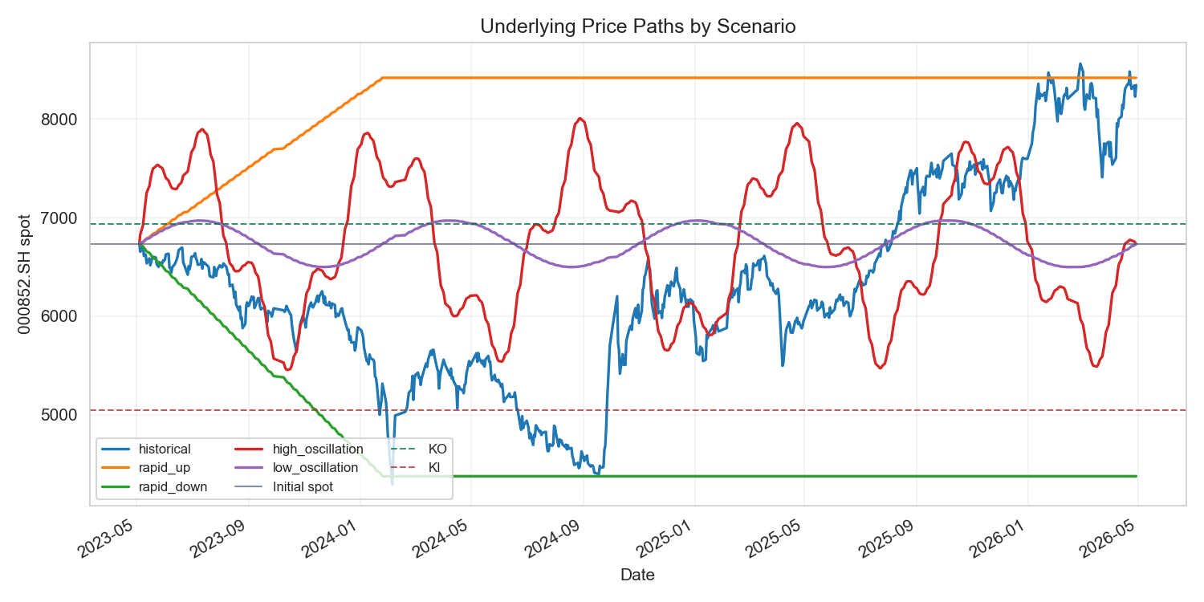
Pnl
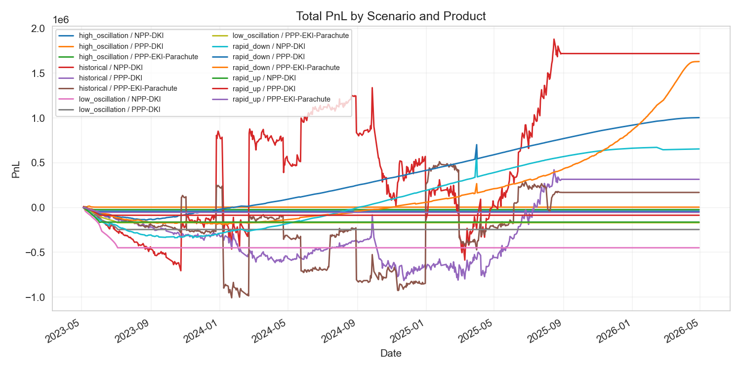
Delta
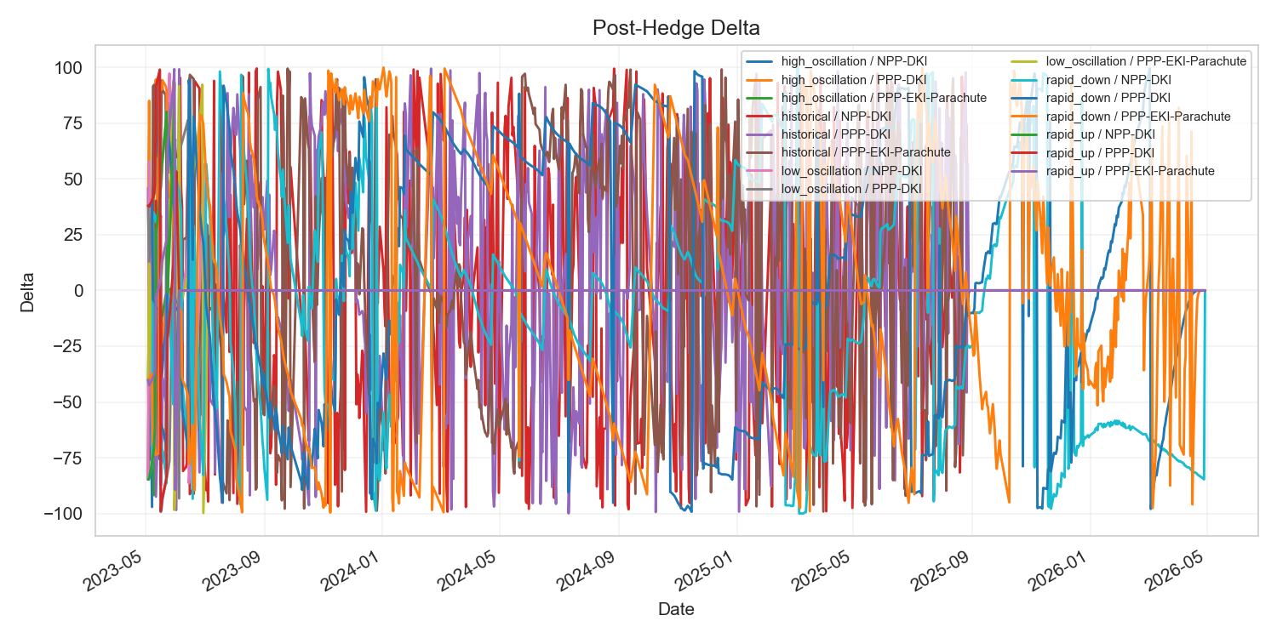
Gamma
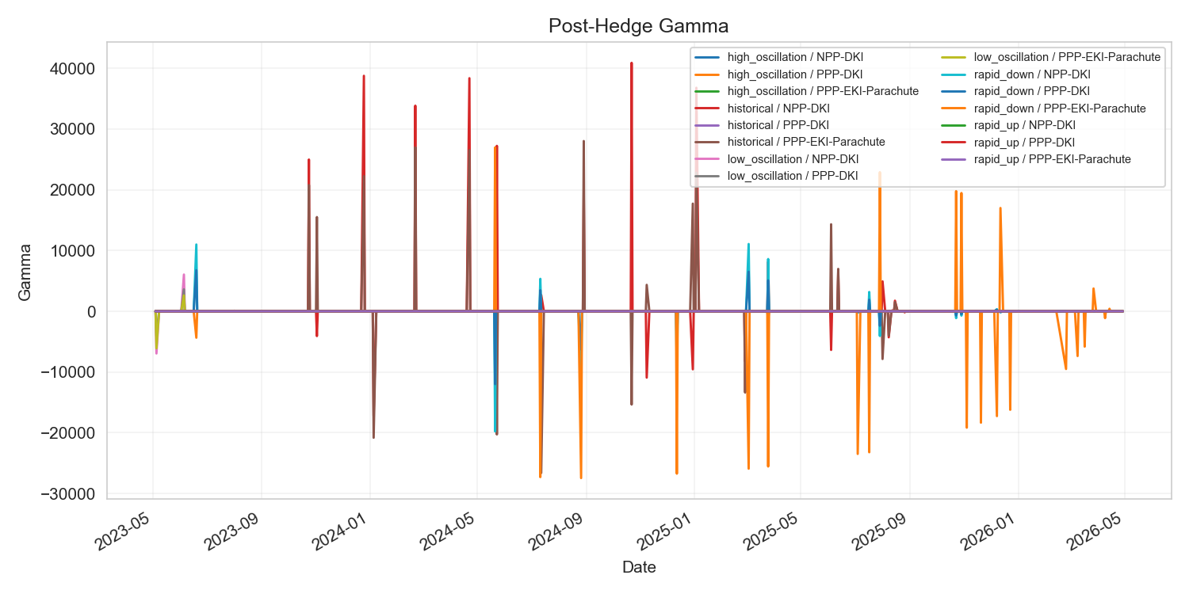
Hedge
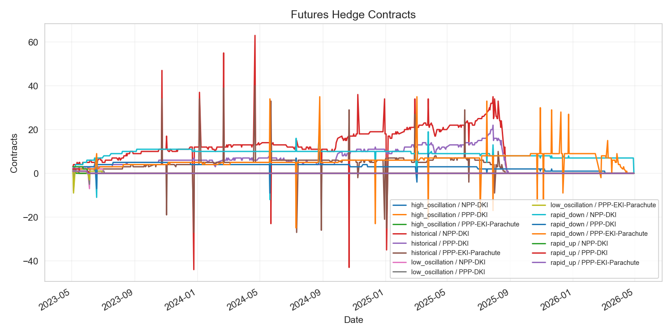
Scenario Pnl
