Computer Networks

**19K-1512 Zaid Bin Shahab  
19K-0331 Muhammad Ali Tanveer  
19K-0229 Saud A Abbasi**

Section 6B

# Setup, All the Important Things:

Add HWIC-2T Port to each router: 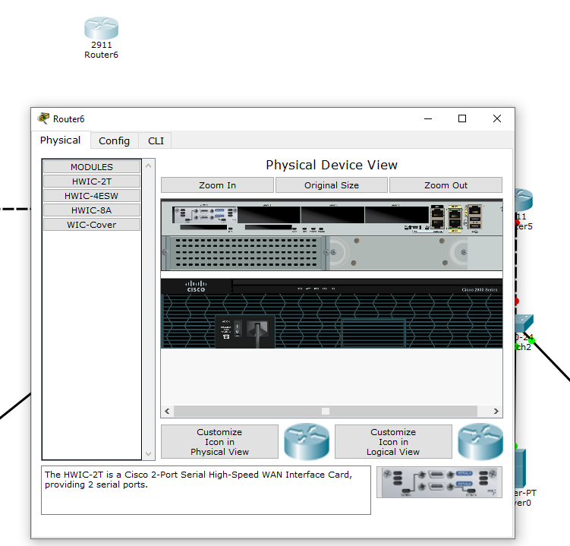

Office#1 Setup:

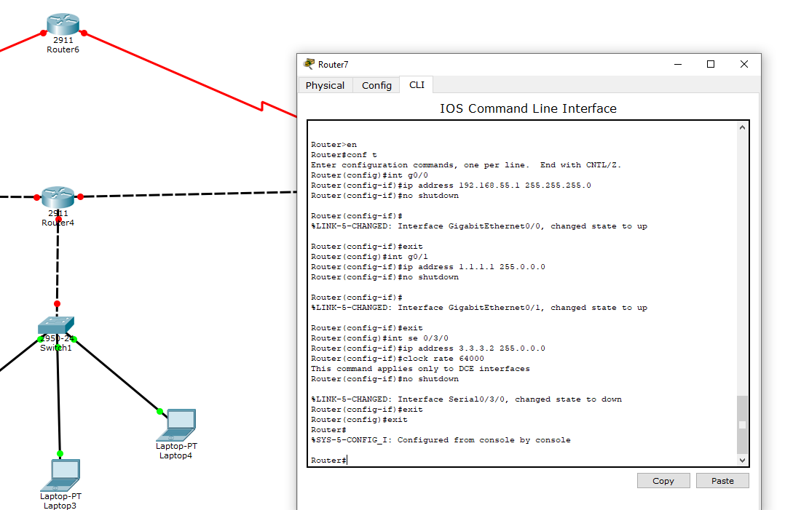

Office#2 Setup:

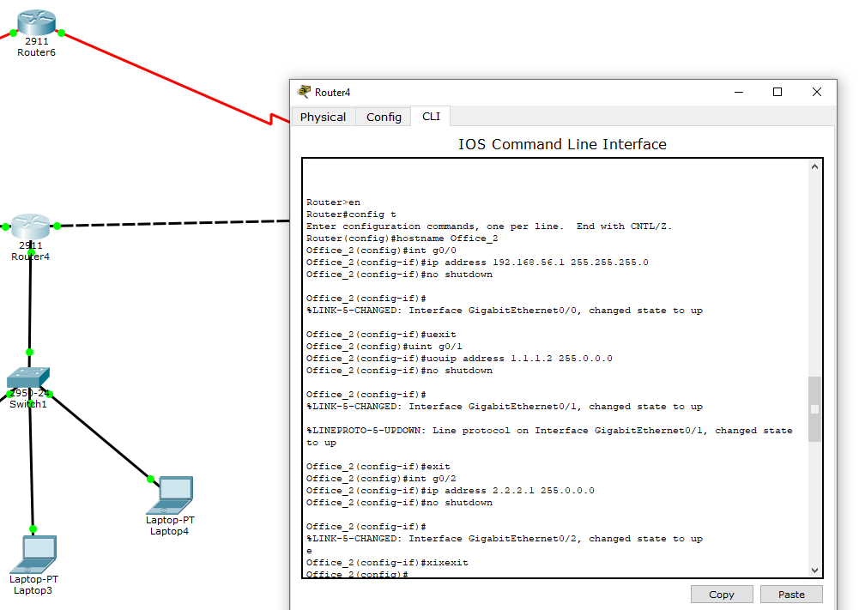

Office#3 Setup:

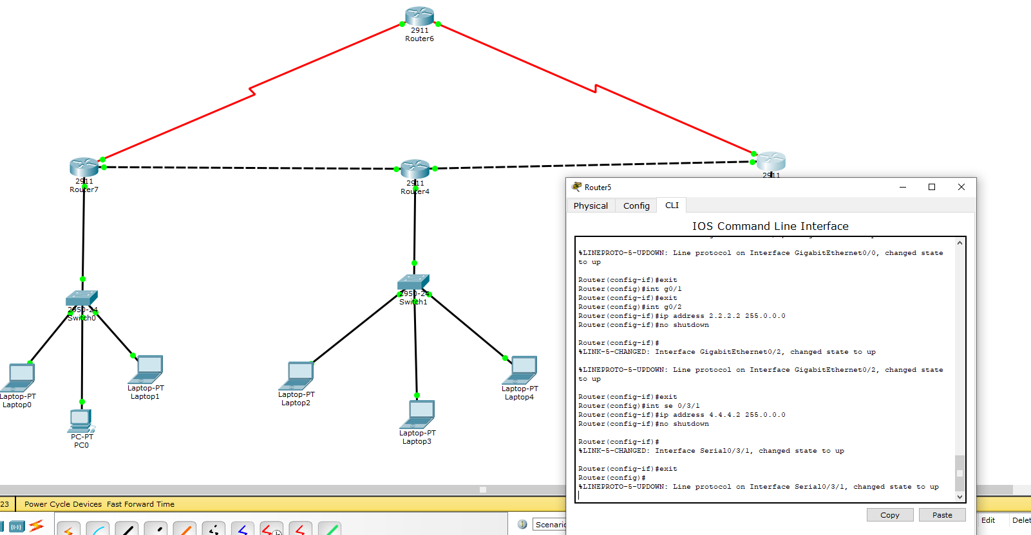

Head Office Serial Link Setup (+Clock Rate):

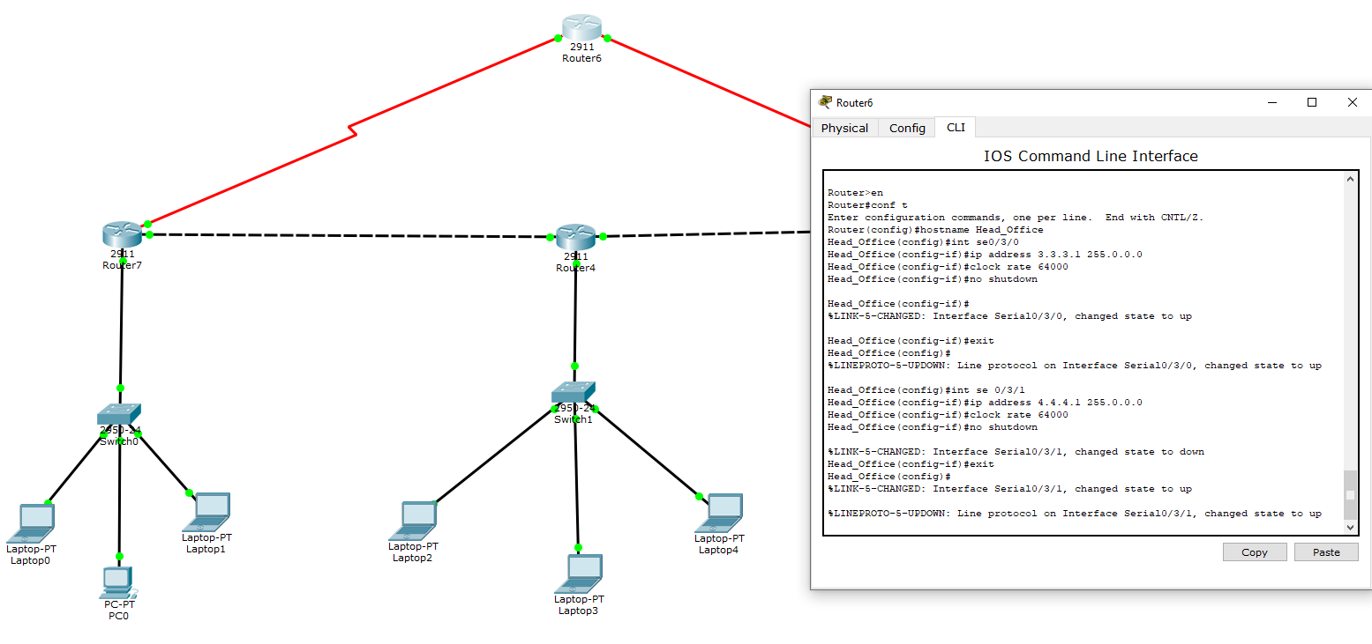

RIP Configuration on Office# 1 Router and Redistribution to OSPF:

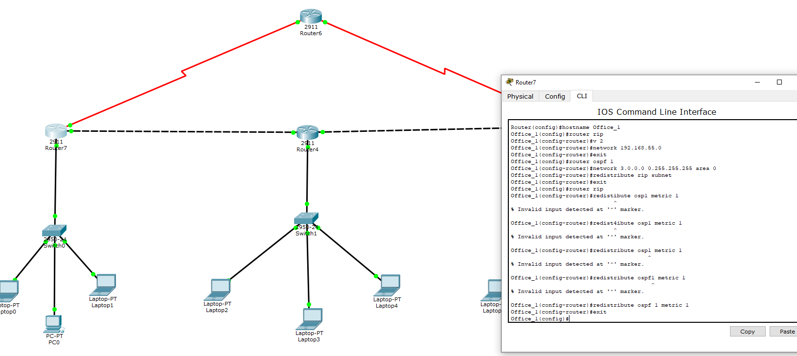

Metric Redistribution for EIGRP and RIP for Office# 2 Router :

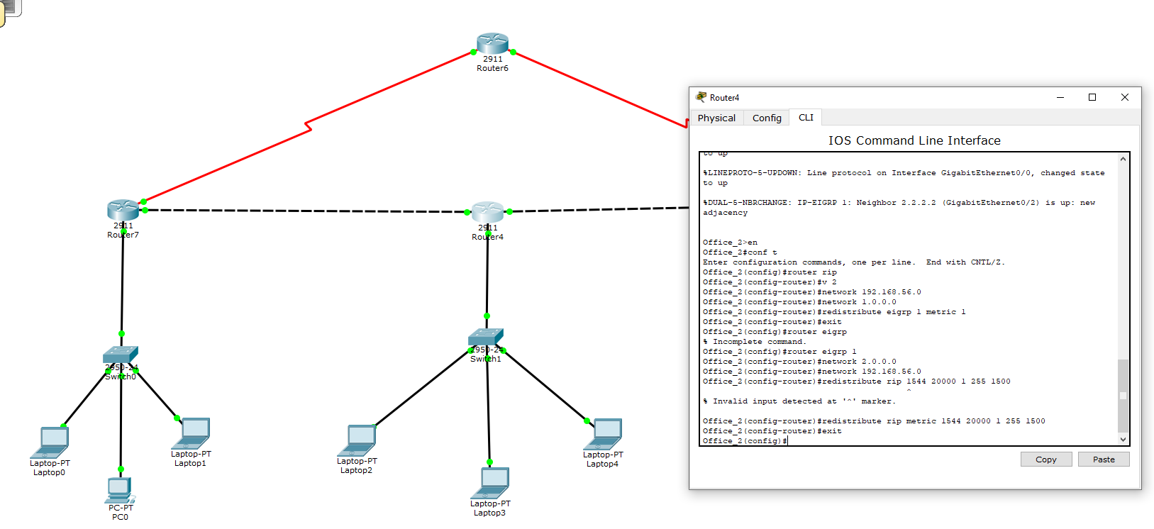

Office# 3 router OSPF and EIGRIP subnet redistribution:

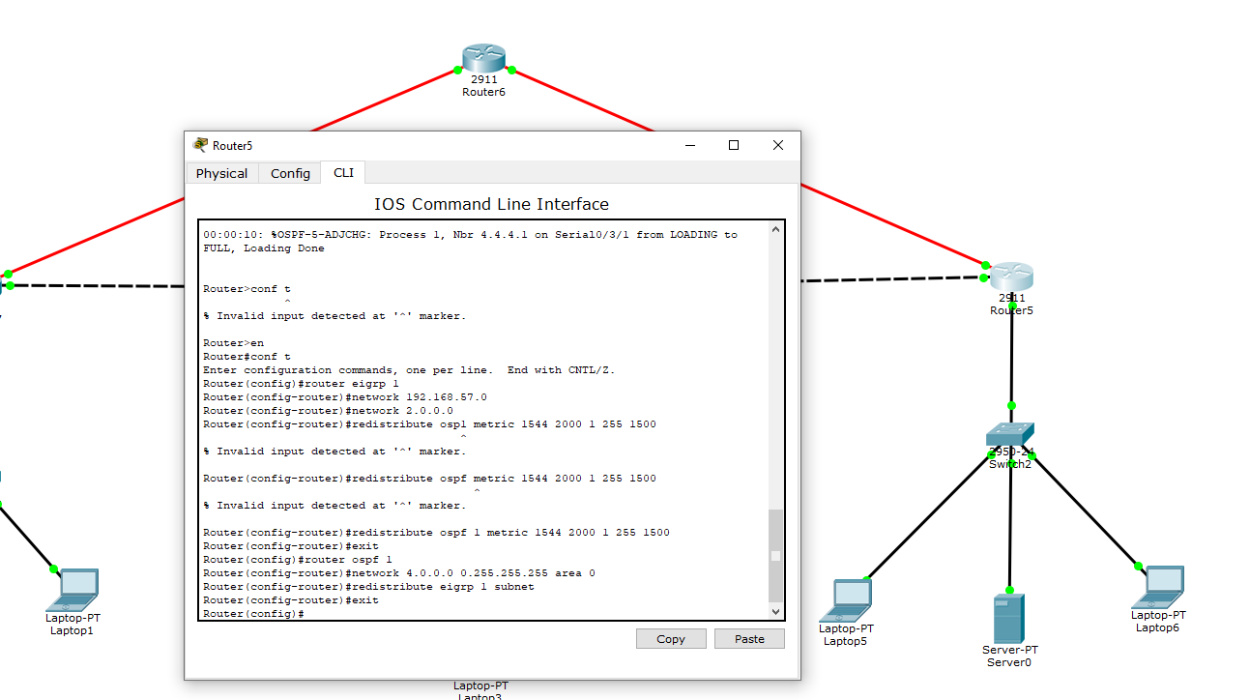

Head Office OSPF Area 0 Configuration:

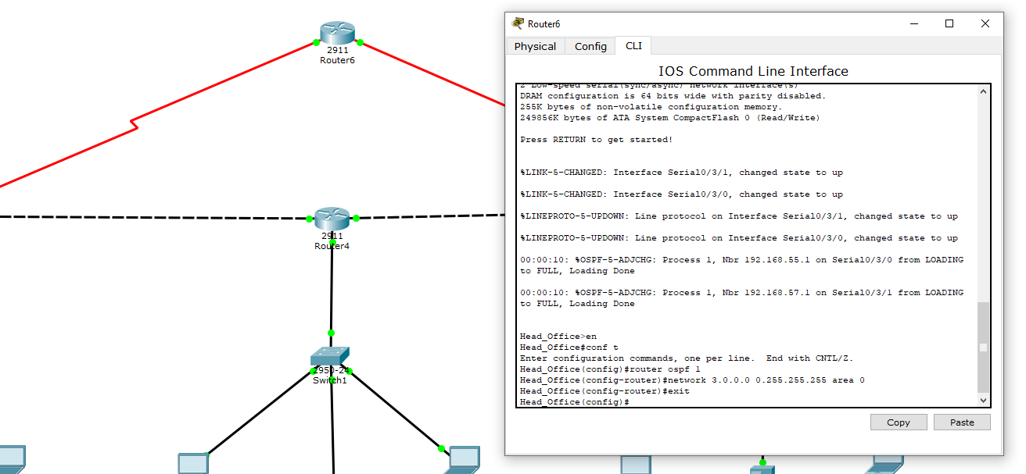

# Debugging EIGRP, OSPF, and RIP Configurations:

## -show ip protocols:

Office#3 (eigrp and ospf active):

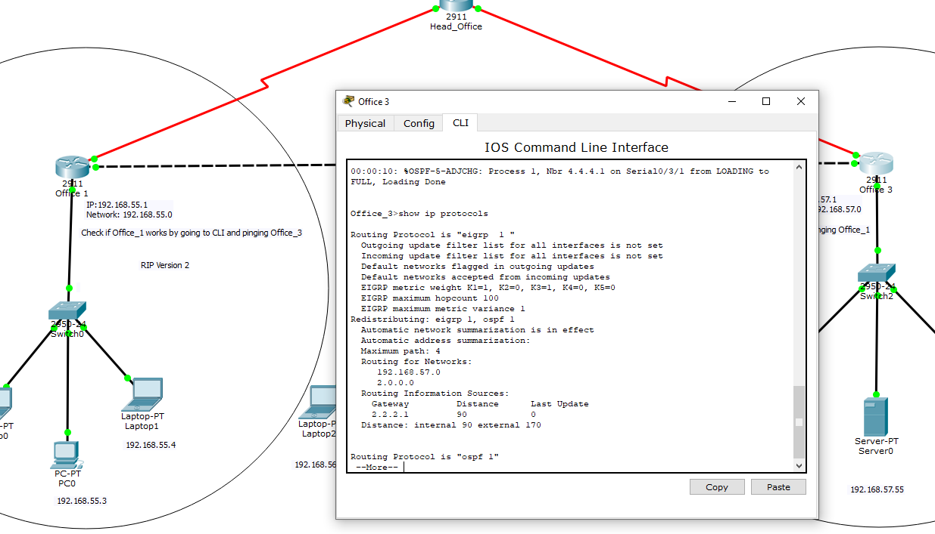

Office#1 (rip and ospf active):

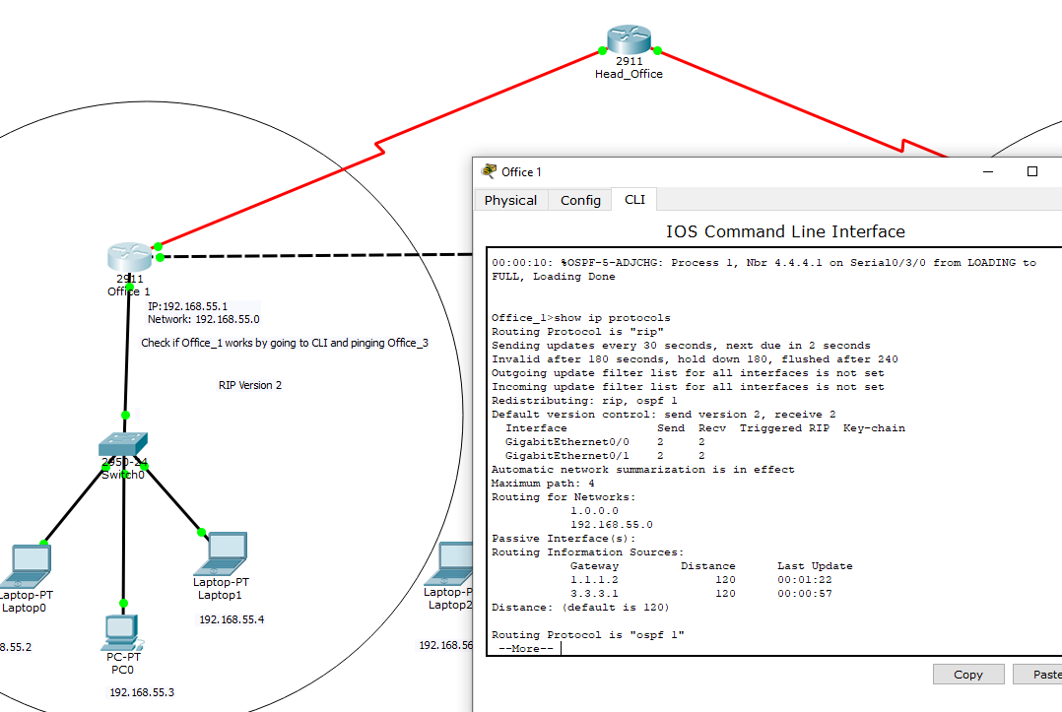

## -show ip route:

Office#3:

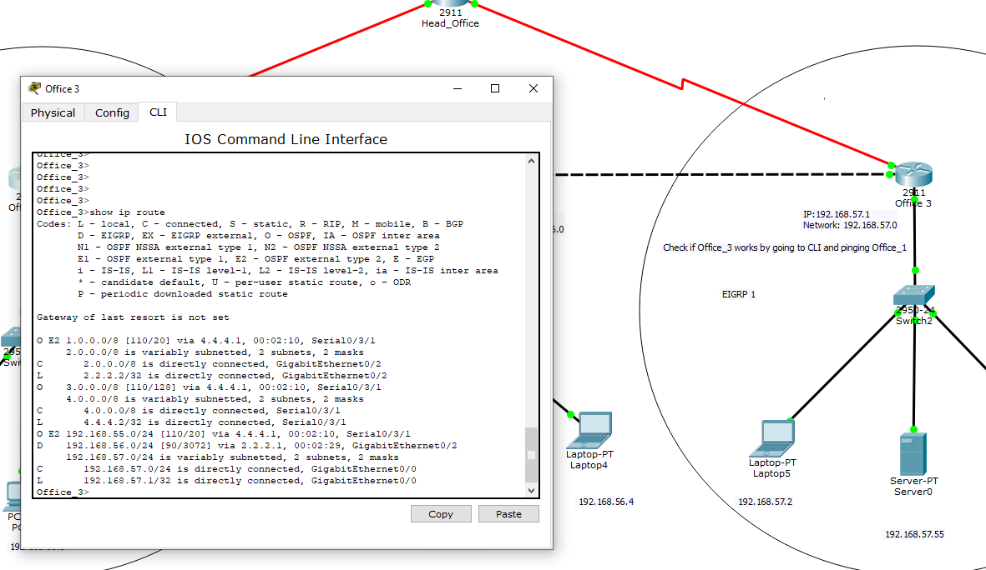

Office#1:

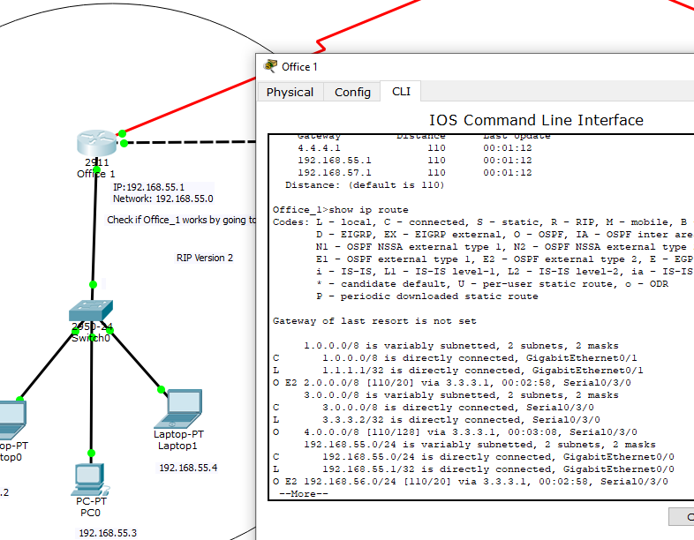

## -debug ip rip:

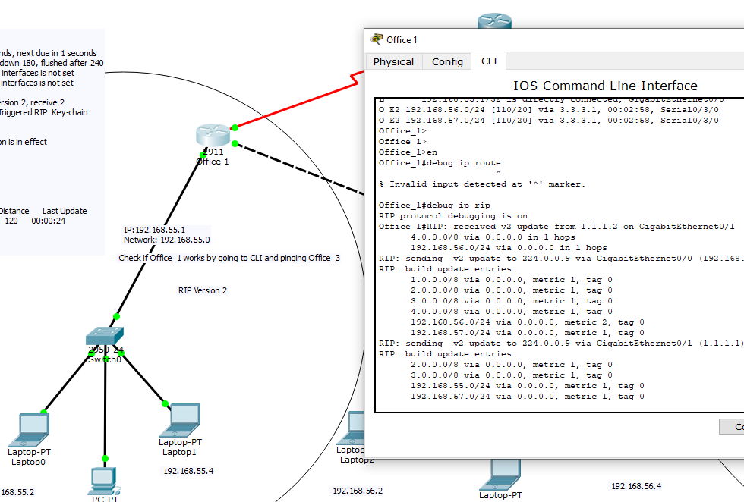

## -undebug all

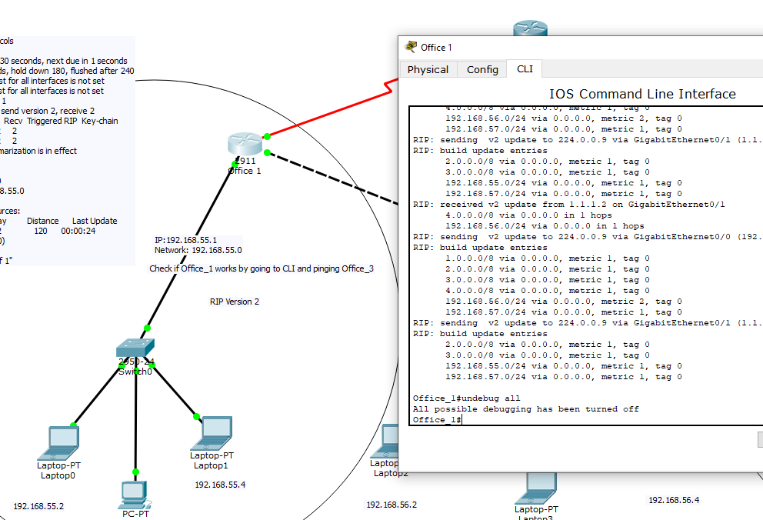

## -show ip eigrp traffic:

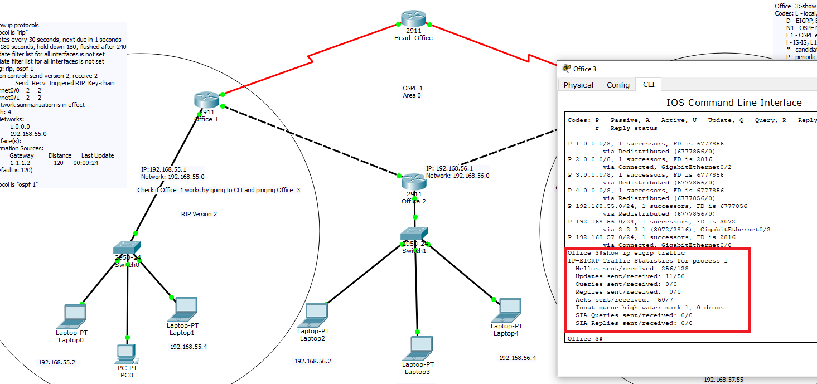

## -debug eigrp packets

