

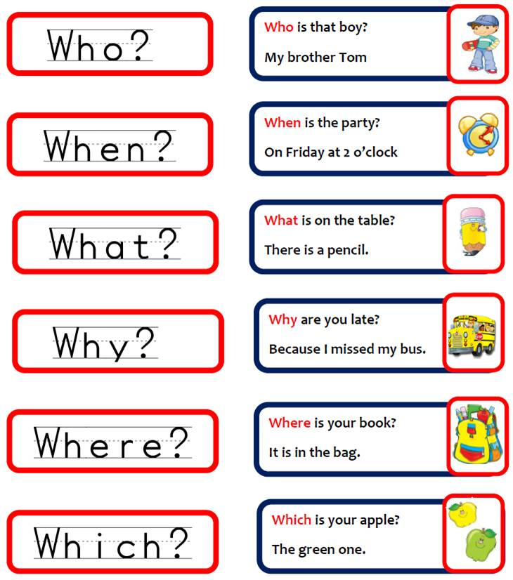

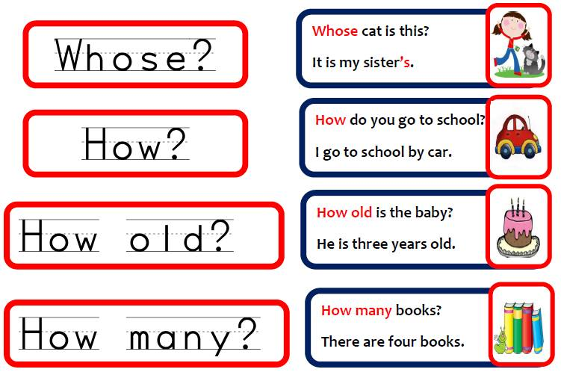

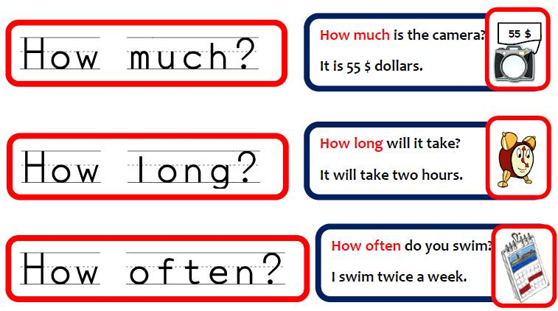

**Match the questions to the answers.**

|  |  |
| --- | --- |
| 1. **Where** is your house? | a. because I'm sick. |
| 2. **How** are you? | b. spaghetti. |
| 3. **When** is the school party? | c. on Herzl Street. |
| 4. **Why** are you home today? | d. I'm great,thank you. |
| 5. **Who** is your best friend? | e.  Anna |
| 6. **What** is your favorite food? | f. on July 15th |

• **Tick http://www.englishexercises.org/makeagame/images/rightcheckbox.gifthe correct Wh-word  .**

|  |  |
| --- | --- |
| 1. **Who / Why / Where**   are the kids? | They are outside now. |
| 2.**How / Who / Why**   is the baby in bed ? | Because he is very tired. |
| 3.**What / When / How** **old**   is the test? | on Friday |
| 4. **How much / When / How**   are the oranges? | two dollars a kilo |
| 5. **How much / How old / When**  is your sister? | She is 17 years old today. |
| 6.**What / Where / Who**  color is the dress? | It is green. |
| 7.**How / How many / Why**  do you go to work every morning? | I go to work by car. |
| 8.**Where / What / When**   are my shoes? | They are under the chair. |
| 9. **Why / What / When**   are you home every day? | at about 17:00 p.m. |
| 10.**How / Where / What**   is on the shelf? | the radio |

• **Complete the sentences with the correct Wh-word .**

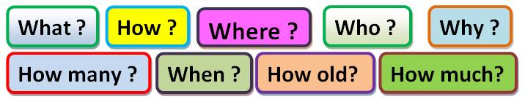

    1.   are you excited?                 **because I have birthday today**.

2. are you today ?                 **I’m fine ,thank you.**

3. is  your coat ?                   **in the bedroom**

  4. is she at the moment?       **at home**

5. is your birthday ?              **in September**

   6.is Mr. Bean ?                     **55 years old**

7. is that woman?                  **She is our sport teacher.**

8. are they  working?            **in the book shop**

9. apples do you have ?         **three apples**

10. are the children?             **in the swimming pool**

11. is Rita doing ?                    **She is watching TV now.**

12. does your car cost ?         **2.000 $ dollars**

13. time is it ?                         **It’s nine o’clock.**

14. are the kids sad?                 **because they don’t go to the cinema.**

15. is the party?                     **at 5 o’clock**

16. friends do you have?        **I have two good friends.**

17. do they go to school?       **by bus**

18. do you eat lunch?              **in the afternoon**

19. is on the desk?                  **a new notebook**

   20.  is in the kitchen?           **my little brother**