ASIMOV-HAWKS
TECHNICAL DEPLOYMENT PLAN

Web Application Deployment and Infrastructure Plan

EXECUTIVE SUMMARY
This document proposes a production-ready deployment architecture for the ASIMOV-HAWKS Web Application. The design addresses the current coupling of application code and large geospatial assets while establishing a practical path from initial production deployment to future horizontal scaling.
The current public directory contains approximately 6,000,000 files totaling about 200 GB. Packaging these files with the Next.js application increases build time, complicates deployment, and makes asset updates dependent on application releases.
The recommended workshop architecture separates application services from geospatial asset delivery by using Docker, NGINX, MinIO or another approved asset origin, Cloudflare, and Supabase. Complete CI/CD automation remains incremental, and Kubernetes is deferred until operating scale and monitoring evidence justify its complexity.

WORKSHOP 2026 PUBLIC-INTERNET DEPLOYMENT SCOPE
The September 28-30, 2026 release is a limited public-internet production deployment for invited users attending the October workshop. It is not a LAN-only deployment.
Minimum workshop scope includes Dockerized Next.js, NGINX, Cloudflare DNS and HTTPS with proxying, caching and basic protection, Supabase authentication and relational data, and MinIO or another approved protected asset origin with stable public URLs.
Only invited clients and their required surveys, maps, tiles, point clouds, detected-object outputs, metadata, and other approved outputs are migrated before the workshop. The full historical dataset and all other client data remain deferred.
Reliability, organization-based access control, backup and rollback, and testing through external internet connections are release gates. Restricted assets require an approved protected-delivery and cache design.

1. CURRENT STATE AND DEPLOYMENT CHALLENGES

1.1 Application Stack
• Frontend: Next.js 15
• Backend services: Supabase
• Mapping framework: MapLibre GL
• 3D visualization: Three.js / React Three Fiber
• Geospatial assets: PNG raster tile pyramids and PCD point-cloud files

1.2 Current Asset Delivery Model
Raster tiles and point-cloud assets are stored inside the Next.js public directory and therefore participate in the same build, packaging, and deployment lifecycle as the application code.
Area | Current condition | Operational impact
Application build | Millions of static files are scanned and packaged | Long build times and high memory consumption
Deployment | Code and datasets move together | Slow releases and difficult rollback
Asset updates | A data change can require application redeployment | Unnecessary coupling and release risk
Storage | Large numbers of small files across local disks | Backup, migration, and indexing overhead
Scaling | App servers also serve heavy geospatial traffic | Inefficient resource use under concurrency

2. DESIGN OBJECTIVES AND PRINCIPLES

2.1 Objectives
• Reduce application build and deployment size
• Deliver tiles and point clouds efficiently to concurrent users
• Support multiple storage disks without exposing physical paths to the application
• Provide a cloud-portable asset interface
• Enable monitoring, repeatable releases, backup, and recovery
• Scale incrementally without adopting unnecessary infrastructure early

2.2 Architectural Principles

Separation of concerns
Application logic and geospatial asset delivery operate as independent services.

Stateless application layer
Next.js containers do not store large persistent datasets.

Stable asset URLs
Client-facing URLs remain consistent even if storage technology changes.

Horizontal scalability
Additional application instances can be added without copying asset datasets.

Operational simplicity
The first production phase uses mature components that the team can maintain.

3. PROPOSED PRODUCTION ARCHITECTURE
The proposed topology places Cloudflare at the public edge, NGINX at the origin entry point, Next.js in a Docker container, Supabase for backend services, and MinIO as the dedicated geospatial asset store.
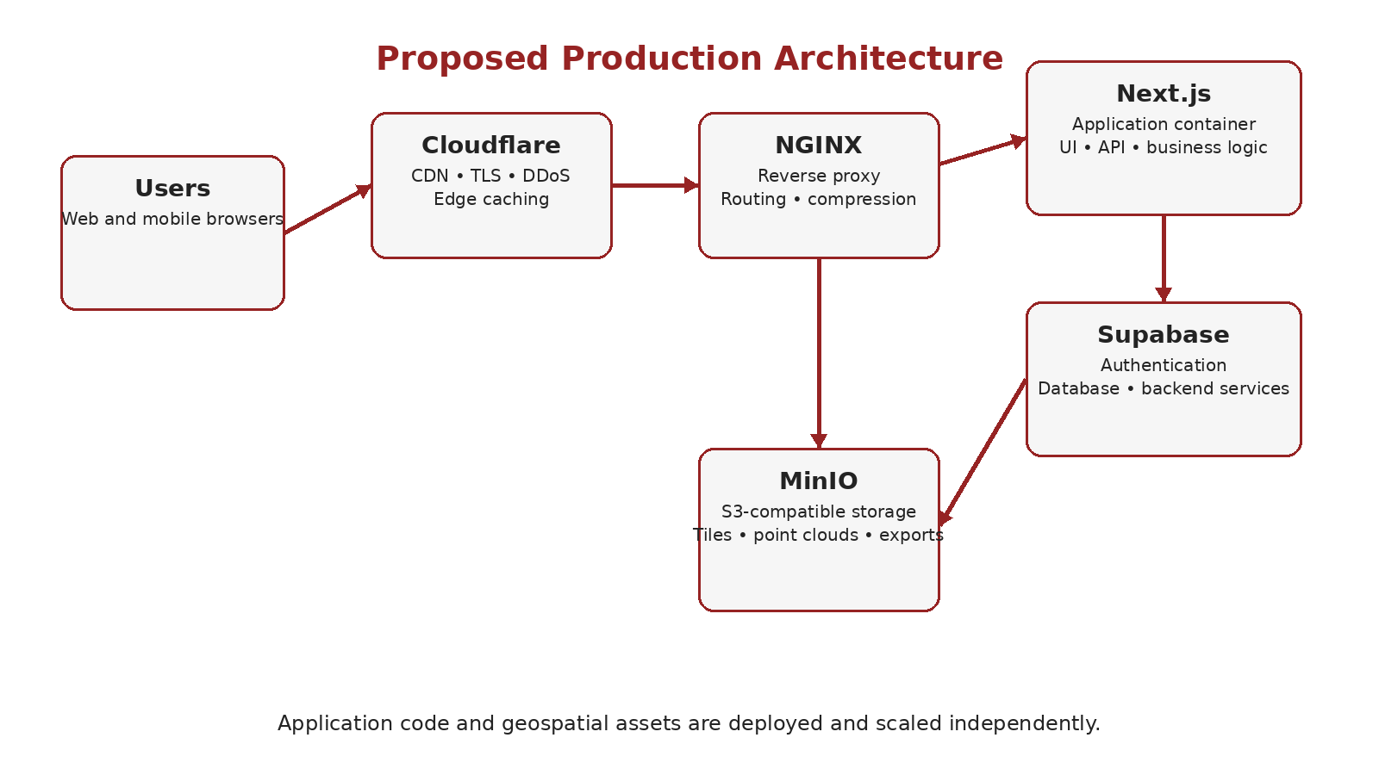
Figure 1. Proposed ASIMOV-HAWKS production architecture.

3.1 Request Flow
1. A browser requests the application or a geospatial asset through the public domain.
2. Cloudflare terminates edge traffic, applies protection controls, and serves cached content when available.
3. Uncached requests reach NGINX, which routes application paths to Next.js and asset paths to the storage origin.
4. Next.js accesses Supabase for authentication, metadata, and application data; it does not read asset files from its container filesystem.
5. MinIO returns tiles, point clouds, and exports through controlled URLs that can be cached by Cloudflare.

4. INFRASTRUCTURE COMPONENTS

4.1 Next.js Application Layer
The application container is responsible for user interface rendering, authentication workflows, API endpoints, business logic, and Supabase integration. Removing geospatial datasets from the image produces smaller, faster, and more repeatable releases.

4.2 NGINX Reverse Proxy
NGINX provides origin routing, TLS termination where applicable, compression, request buffering, access logging, and high-performance forwarding. It also gives the system a stable URL structure while allowing storage backends to change independently.
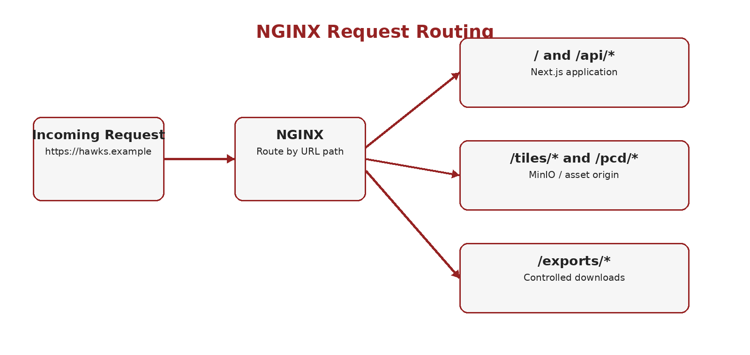
Figure 2. Path-based routing through NGINX.

4.3 MinIO Object Storage
MinIO is recommended as the initial self-hosted storage manager because it exposes an S3-compatible API while allowing the organization to use existing HDD capacity. Buckets abstract the physical disks and support policies, versioning, lifecycle rules, and future migration to managed object storage.
• hawks-assets/tiles/{survey_id}/{z}/{x}/{y}.png
• hawks-assets/pointclouds/{survey_id}/...
• hawks-assets/exports/{survey_id}/...
• hawks-assets/manifests/{survey_id}.json

4.4 Cloudflare CDN
Cloudflare may cache only asset responses whose access model and cache key are approved. Restricted survey assets must not become public cache entries. Cache headers, authorization behavior, and invalidation rules must be tested to prevent cross-organization leakage.

4.5 Supabase
Supabase remains responsible for authentication, relational metadata, role-based access, and application data. The database should store asset identifiers and canonical URLs rather than local filesystem paths.

5. GEOSPATIAL ASSET STRATEGY

5.1 Raster Tiles
The existing PNG z/x/y tile structure can be migrated first with minimal frontend change. NGINX and MinIO can serve the same URL pattern while the Next.js public directory is gradually emptied.
For future large-area datasets, PMTiles should be evaluated because it consolidates many small tile files into a single archive and uses HTTP range requests. This can substantially reduce filesystem overhead, but conversion should be introduced only after compatibility and performance testing.

5.2 Point-Cloud Data
Current PCD files of approximately 200 MB or less can be stored directly in MinIO. The application should stream or download them through stable asset URLs. Larger future datasets may justify formats and viewers optimized for progressive point-cloud delivery.

5.3 Asset Versioning and Cache Control
• Use immutable versioned paths or object keys for published datasets
• Store dataset status and active version in Supabase
• Validate file count, size, and checksums before publication
• Apply long cache lifetimes to immutable assets
• Invalidate or switch the active version only after validation succeeds

6. STORAGE AND DISK MANAGEMENT
MinIO can pool or distribute data across available HDDs, but storage design must account for disk failure, rebuild time, and performance. Production data should not rely on a single unprotected disk.
Concern | Recommended control
Capacity | Track usable space, reserved headroom, and dataset growth
Performance | Use SSD for operating system, metadata, logs, and hot cache where possible
Resilience | Use redundancy supported by the selected MinIO topology and maintain separate backups
Integrity | Record checksums and run scheduled verification
Backup | Maintain at least one independent copy outside the active storage pool
Recovery | Document object restore, database restore, and cache rebuild procedures

The interns’ Digital Asset Management system may complement this design for cataloging, approval, metadata, and user-facing asset administration. It should not replace the object-storage layer unless it has demonstrated S3-compatible storage, concurrency handling, integrity checks, lifecycle management, and backup support.

7. SCALABILITY ROADMAP
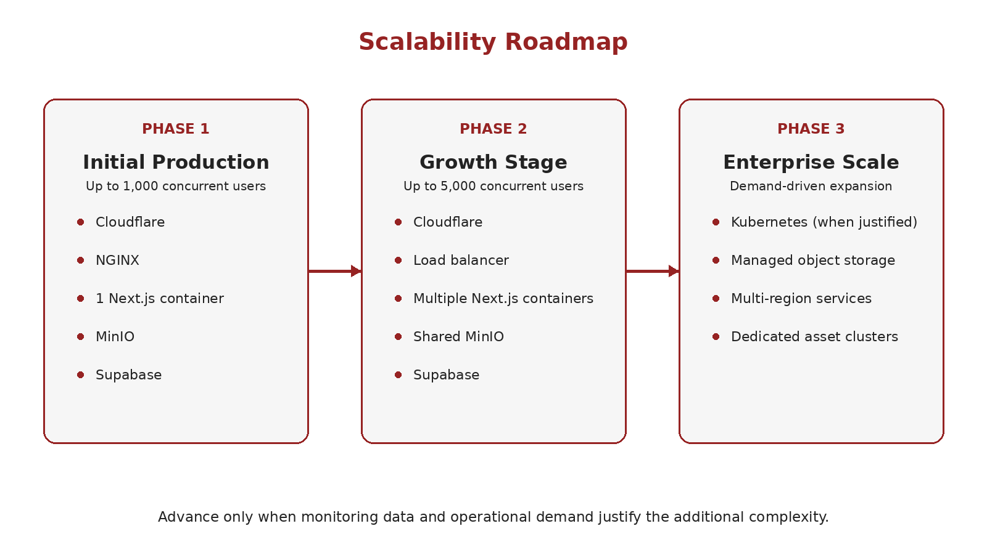
Figure 3. Incremental scalability roadmap.

7.1 Phase 1 - Initial Production
• Target: invited October 2026 workshop users over the public internet; concurrency remains subject to measured load testing
• One Next.js container behind NGINX
• MinIO object storage on dedicated storage hardware
• Cloudflare CDN for cacheable assets
• Supabase for authentication and application data

7.2 Phase 2 - Growth Stage
• Multiple stateless Next.js containers
• Load balancing through NGINX or a dedicated load balancer
• Shared MinIO storage and shared CDN cache
• Database and connection-pool review
• Automated capacity and latency alerts

7.3 Phase 3 - Enterprise Scale
Kubernetes, managed object storage, multi-region deployment, and dedicated asset-delivery clusters are future options rather than initial requirements. Kubernetes is valuable when the organization needs automated scheduling, service discovery, self-healing, rolling deployment, and management of many containers; it also adds substantial operational complexity.

8. SECURITY, RELIABILITY, AND ACCESS CONTROL
• Expose only Cloudflare and the required NGINX endpoints publicly
• Keep MinIO administration interfaces and Supabase service credentials private
• Use least-privilege S3 policies and signed URLs for restricted assets
• Apply rate limiting, request-size limits, and security headers at NGINX
• Store secrets outside the source repository
• Patch operating systems, containers, NGINX, and MinIO regularly
• Test backup restoration, not only backup creation

9. MONITORING AND OBSERVABILITY

9.1 Metrics
Prometheus and Grafana are recommended for infrastructure and service metrics. The minimum dashboard should cover CPU, memory, disk latency, storage capacity, network throughput, request rate, error rate, response latency, cache hit ratio, object-storage response time, and container health.

9.2 Logging
Centralized logs should include Cloudflare events where available, NGINX access and error logs, Next.js application logs, deployment logs, and MinIO audit or access logs. Loki with Grafana is suitable for centralized search and correlation.

9.3 Initial Service Objectives
Indicator | Initial target for validation
Application availability | Define after baseline testing and operational agreement
Cached tile latency | Measure p50, p95, and p99 from target user locations
Origin error rate | Alert on sustained 5xx responses
Storage capacity | Alert before critical free-space threshold
Deployment health | Automated smoke test and rollback decision

10. CI/CD AND RELEASE MANAGEMENT
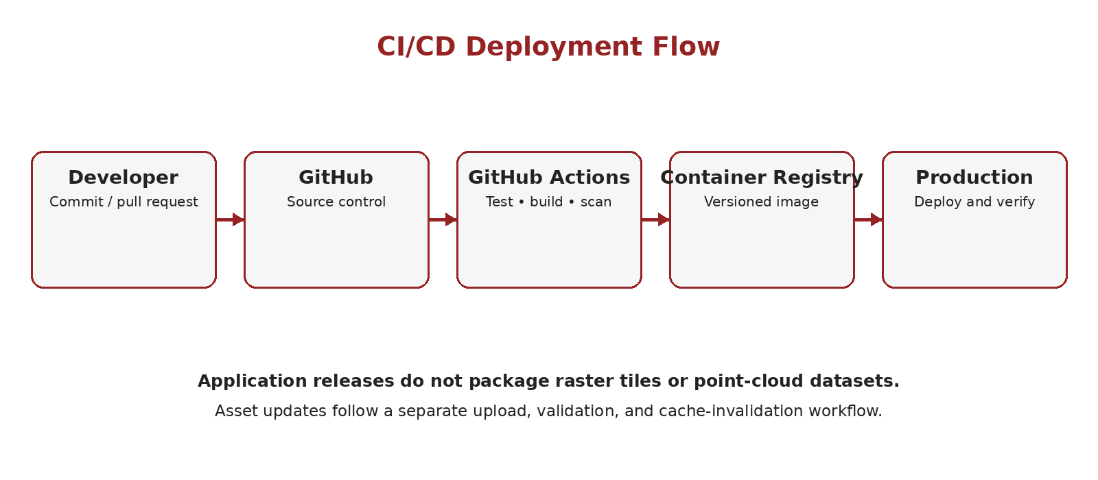
Figure 4. Application CI/CD flow, separate from asset publication.

10.1 Application Pipeline
• Install dependencies and run linting, tests, and security checks
• Build the Next.js production image
• Tag and push the Docker image to a registry
• Deploy the versioned image
• Run health checks and smoke tests
• Roll back automatically or manually when acceptance checks fail

10.2 Asset Publication Pipeline
• Upload to a staging prefix or bucket
• Validate structure, checksums, file counts, and metadata
• Publish an immutable version
• Update the active dataset record in Supabase
• Warm or invalidate caches as required
• Retain rollback access to the previous version

11. IMPLEMENTATION PLAN
Stage | Scope | Primary output
1. Baseline and backup | Inventory assets, measure traffic, confirm backups | Verified inventory and rollback point
2. Containerize application | Build Next.js Docker image without public datasets | Small repeatable application image
3. Deploy MinIO | Configure storage, buckets, policies, monitoring | Dedicated asset origin
4. Configure NGINX | Route application and asset paths | Stable production URL structure
5. Enable Cloudflare | DNS, TLS, cache rules, protection | Edge caching and protected origin
6. Migrate selected workshop assets | Copy, validate, and publish manifest-listed datasets | Selected workshop assets served from approved origin
7. Operationalize delivery | Documented release, health checks, rollback, then incremental automation | Reliable workshop release procedure
8. Load and recovery test | Concurrency, failover, restore, and rollback tests | Production readiness evidence

11.1 Migration Approach
Migration should be incremental and allowlisted by an approved workshop manifest. Existing URLs and source assets remain active while only invited clients and their required surveys, maps, tiles, point clouds, detections, outputs, and metadata move. After checksum, authorization, stable-URL, and external-internet validation, routing can switch dataset by dataset. Full historical and non-invited client data remain deferred.

12. RISKS AND MITIGATIONS
Risk | Mitigation
Storage disk failure | Redundancy, independent backups, monitoring, and tested restore procedures
Incorrect cache content | Immutable asset versions and controlled cache invalidation
Migration data loss | Checksums, file-count validation, and source retention until acceptance
Origin overload | Cloudflare caching, load testing, and capacity alerts
Operational complexity | Phase deployment and document ownership and runbooks
Vendor or platform change | Use standard HTTP, Docker, and S3-compatible interfaces

13. FINAL RECOMMENDATION
Proceed with a limited public-internet workshop deployment using Next.js, Supabase, Docker, NGINX, Cloudflare, and MinIO or another approved protected asset origin. Migrate only approved invited-client datasets before the workshop. Prioritize reliable access, organization authorization, stable URLs, backups, and rollback over full historical migration or complete automation.
Do not introduce Kubernetes during the initial production phase. Reassess it after Phase 2 when the system has multiple services and containers, measurable scaling pressure, and staff capacity to operate a cluster reliably.
Before production cutover, complete load testing, backup restoration, protected-cache validation, security review, manifest reconciliation, external-internet testing, and documented application and asset rollback. Confirm capacity with measured performance rather than architecture estimates.

