Game Design Document

Fill up the following document

1. Write the title of your project.

Birthday hunt

1. What is the goal of the game?

The goal is to complete all tasks and win

1. Write a brief story of your game.

A boy will go to a birthday party, he will find no one there… he will see a button which when pressed, states a question start the game? He will then begin the hunt and complete the tasks assigned to him,but he has to remember the bonus points and the detoriative points.If he completes the game within the given amount of time,he will win.

1. Which are the playing characters of this game?

* Playing characters are the ones who respond to the user based on the input from the user.
* Cars, monkeys, dinos, wizards, etc., are the playing characters in the game.

|  |  |  |
| --- | --- | --- |
| Number | Character Name | What can this character do? |
| 1 | Tokyo | This character has to play the game from the very beginning till the end, the whole game is based upon him |
| 2 |  |  |
| 3 |  |  |
| 4 |  |  |
| 5 |  |  |
| 6 |  |  |
| 7 |  |  |
| 8 |  |  |

1. Which are the Non-Playing Characters of this game?

* Non-Playing characters are the ones that don't have an action or behavior when the user interacts with the game.
* Hurdles, stones, bananas, coins, etc., are non-playing characters in the game.

|  |  |  |
| --- | --- | --- |
| Number | Character Name | What can this character do? |
| 1 | bird | This will come during a stage and the user has to shoot the birds. |
| 2 | Hot air ballon | The user does not have to hit this. |
| 3 | flappy | This will be a bonus game and the user can earn extra points thru this.. |
| 4 | chocolates | User has to collect these |
| 5 | Yellow gummies | Will look similar to the chocolates but are not supposed to be usedd |
| 6 | Rest will be unvieled soon |  |
| 7 |  |  |
| 8 |  |  |

Draw your imagination of this game. What does this game look like?

* Draw the game either on your computer or on paper.
* Add images of the game scenes to show each of the playing and non-playing characters at least once.

3-4

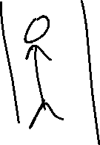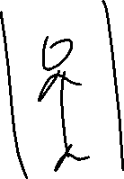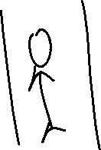

Levels

How do you plan to make your game engaging?

I plan to make the game engaging by making it interacting and by not just sticking to one idea. The user gets to try different games and has to also make some choices which will determine the users end result.