
BRINDAVAN ANGLO VEDIC INTERNATIONAL SENIOR SECONDARY SCHOOL
Affiliated to CBSE, New Delhi
Name: SCIENCE WORK SHEET DATE:
STD: V
- Identify the name of the species and their migration:

Pictures | Name of the species | Place of migration
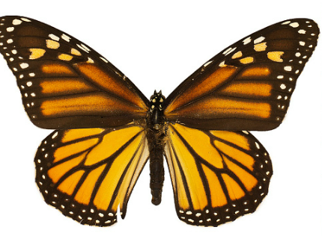
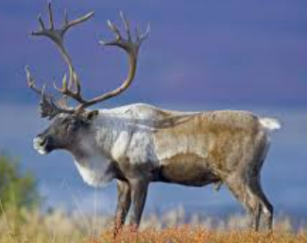
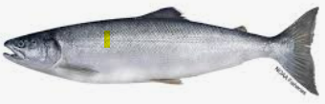
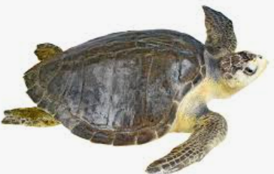
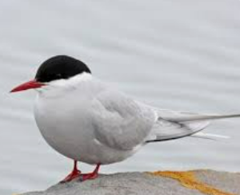

- Plant & Animal Adaptations Crossword Puzzle
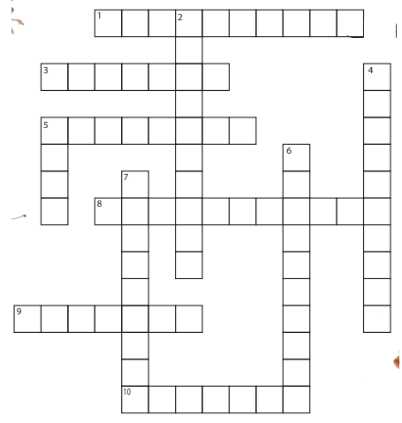

ACROSS
1. Type of adaptation is based on how an organism acts.
3. Environment or natural home that an organism lives.
5. Prey is attacked by its __________.
8. Natural world or surroundings in which an organism lives - similar to habitat.
9. Type of behaviour that happens from experience or watching others.
10. An animal or plant must adapt to its environment in order to _____________.
DOWN
2. Change in behaviour or structure in order to survive.
4. Type of adaptation based on body parts or coverings.
5. A predator goes after its ______.
6. Type of adaptation in which an organism blends into its environment.
7. A behaviour that comes naturally. An organism is born with it.

- Make a flow diagram to show the stages of agriculture:

- Identify and name the methods of reproduction shown in the following pictures:
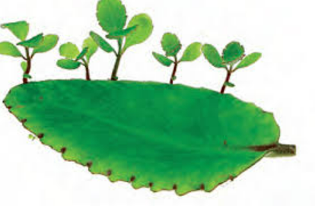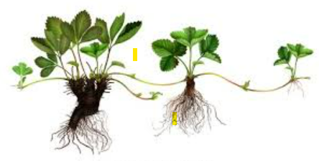
- _____________________ b. __________________________
- Label the parts of seed:
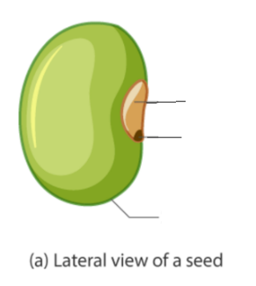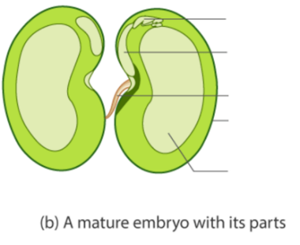

- Complete the table below.
