Reptiles—cold-blooded animals, made distinct by the scales or plates on their bodies—are a diverse group of animals that includes tortoises and turtles, tuataras, lizards, snakes, crocodiles, and alligators. They inhabit a range of habitats on every continent, except Antarctica. They have a host of amazing adaptations and abilities—there are lizards that sprint on water, tortoises that can live for a few hundred years, and chameleons that can move their eyes in different directions at once.
Adaptations
Marine
Marine environments present their own set of challenges, and reptiles such as sea turtles have developed remarkable adaptations to navigate these vast waters. Leatherback turtles, for example, possess a unique adaptation in their blubber layer, which helps them regulate body temperature and venture into colder waters. They also have powerful front flippers that make them excellent swimmers, capable of traveling thousands of miles across oceans. Saltwater crocodiles, on the other hand, have salt glands that allow them to excrete excess salt from their bodies, enabling them to thrive in both freshwater and marine environments.
Freshwater
Reptiles in freshwater habitats, such as rivers and lakes, have developed adaptations to live and hunt in these environments. The alligator snapping turtle, with its camouflaged appearance and a worm-like appendage on its tongue, lures fish close enough to snap them up with its powerful jaws. Freshwater turtles often have streamlined shells that aid in swimming, and some species, like the painted turtle, can absorb oxygen through their skin while submerged, allowing them to stay underwater for extended periods.
Desert
Surviving in the desert is like living on a different planet, and many reptiles have evolved amazing tricks to thrive in these harsh environments. Take the thorny devil, for example. This lizard looks like a tiny dragon and can collect water through grooves in its skin, channeling moisture directly to its mouth. Then there’s the desert iguana, which can tolerate scorching temperatures that would cook other animals. These reptiles have specialized kidneys to conserve water and behaviors like burrowing to escape the heat. These adaptations allow them to live in a place where water is scarce, and the sun is relentless.
Deserts are home to some of the most unique reptiles on the planet. The thorny devil, with its spiky appearance and water-collecting abilities, is a marvel of adaptation. The desert iguana, which can withstand temperatures up to 42°C (107.6°F), thrives where few others can. And let’s not forget the sidewinder rattlesnake, which moves in a unique sideways motion to avoid burning its belly on the hot sand. Each of these reptiles has evolved special traits that allow them to live in one of the most challenging environments on Earth. They are true desert survivors, showing us the power of nature’s ingenuity.
Mountains
High-altitude environments can be harsh, with fluctuating temperatures and thin air. Reptiles like the Himalayan pit viper have evolved to live in these conditions. This viper has heat-sensing pits that allow it to detect warm-blooded prey even in the cold. Additionally, reptiles in mountainous areas often have darker skin to absorb more heat and are capable of brumation, a hibernation-like state that helps them survive the cold winter months.
Islands
Island habitats can be isolated and resource-scarce, leading to unique evolutionary paths for reptiles. The Galápagos tortoise is a prime example, having evolved different shell shapes depending on the specific island environment. Marine iguanas of the Galápagos have developed the ability to forage underwater, grazing on algae and holding their breath for up to 30 minutes. These adaptations enable them to exploit niches that are unavailable to other animals.
Forests
In dense forest environments, reptiles like chameleons and tree-dwelling snakes exhibit remarkable adaptations for camouflage and arboreal living. Chameleons can change their skin color to blend into their surroundings and have prehensile tails for gripping branches. Meanwhile, the green tree python has a slender body and vibrant green coloration that help it remain hidden among the foliage as it hunts.
These examples illustrate the incredible versatility and adaptability of reptiles, enabling them to inhabit a wide range of environments and thrive in conditions that many other animals would find inhospitable.
Ecosystem Role
Desert reptiles play crucial roles in their ecosystems. As predators, they help control populations of insects, rodents, and other small animals, preventing overpopulation and maintaining a balance in the food web. Their burrows provide shelter for other animals, and their presence can indicate the health of the desert ecosystem. By understanding and protecting these reptiles, we can preserve the intricate balance of life in the desert. These resilient creatures remind us of the incredible diversity and adaptability of life on Earth.
HABITS & HABITAT
Burrowing Behaviors
Burrow into the lives of reptiles and discover their architectural genius! Many reptiles, like tortoises and certain lizards, are expert diggers. They create intricate tunnels and burrows to escape the heat, hide from predators, and create safe places to lay their eggs. These burrows can be quite complex, with multiple chambers and entrances.
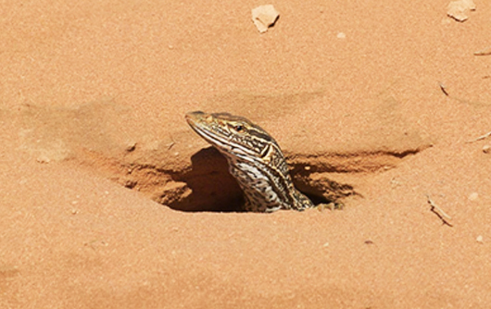
By digging these shelters, reptiles play a vital role in their ecosystems. Their burrows provide homes for other animals and help aerate the soil, promoting plant growth. These reptilian architects show us how even the smallest creatures can have a big impact on their environment.
Nest Building
Reptiles are also skilled nest builders. Female crocodiles and alligators construct large nests out of mud and vegetation to lay their eggs. These nests are carefully guarded to protect the eggs from predators.
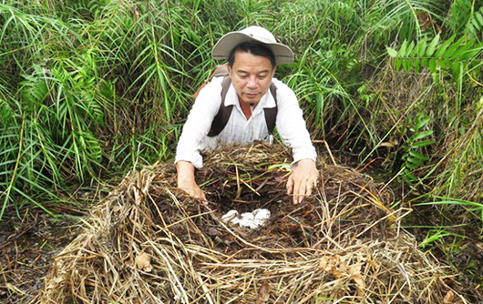
Some reptiles, like sea turtles, travel long distances to return to the beaches where they were born to lay their eggs. They dig deep holes in the sand, lay their eggs, and cover them up, leaving the sun to incubate the eggs. These nesting behaviors are crucial for the survival of their young and demonstrate the incredible care reptiles take in ensuring the next generation thrives.
Communal Living
Not all reptiles are solitary creatures. Some, like certain species of lizards, engage in communal living. These reptiles live in groups, sharing burrows and working together to find food and protect against predators. This social behavior helps them survive in challenging environments. For example, the desert horned lizard lives in colonies, where members look out for each other and share resources. This cooperative living showcases the complex social structures that can exist in the reptile world and highlights the benefits of working together for survival.
Ecosystem Engineers
Reptiles are true ecosystem engineers. Their burrowing and nesting activities create habitats for other animals and help maintain the health of the ecosystem. By digging burrows, they aerate the soil, which promotes plant growth and increases soil fertility. Their nests provide shelter for other species, and their predatory behaviors help control populations of other animals, maintaining a balance in the food web. Protecting these reptilian architects is essential for preserving the intricate balance of their ecosystems and ensuring the continued health of their habitats.

REPRODUCTION
Temperature-Dependent Sex Determination
some reptiles decide if their babies will be boys or girls based on the temperature! For creatures like sea turtles, the temperature of the sand where their eggs are buried determines the sex of the hatchlings. Warmer sand means more females and cooler sand means more males. This amazing trait is called temperature-dependent sex determination (TSD). It’s a clever way to balance populations. But there’s a hitch—climate change. Rising temperatures could mean more female turtles, leading to imbalances. Scientists are racing against time to find solutions and protect these incredible species from the impacts of climate change.
Viviparity and Oviparity in Reptiles (Image panels)
Reptiles are known for their incredible diversity in reproductive strategies, making them fascinating creatures in the animal kingdom. Imagine a world where some reptiles lay eggs, while others give birth to live young—it's a wild reproductive ride!
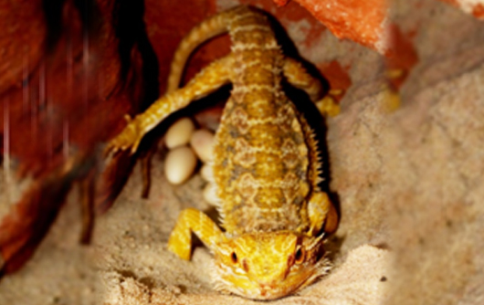
Let's delve deeper into this reptilian reproductive rollercoaster. Picture a scene where a lizard is pondering its options: "Should I lay eggs in this warm, sandy spot or give birth to live little lizards?" It turns out, certain lizards are like the Swiss Army knives of reproduction—they can do both! This ability allows them to adapt to their ever-changing environments like true evolutionary superheroes.
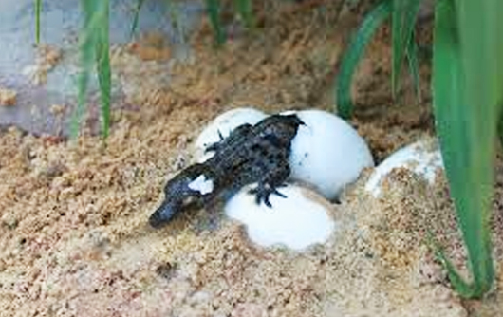
In hot and sunny climates, laying eggs (oviparity) is like setting up a natural incubator. The warm sand acts like a cozy blanket, nurturing the eggs until they hatch into adorable hatchlings ready to take on the world. Meanwhile, in cooler and shadier areas, giving birth to live young (viviparity or ovoviviparity) becomes the winning strategy. It's like having a portable nursery where the little ones can stay safe and snug until they are strong enough to explore their surroundings.
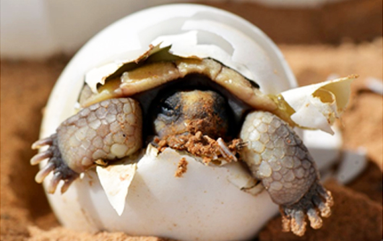
This flexibility isn't just about convenience—it's a survival superpower! It enables reptiles to thrive in a wide range of habitats, from scorching deserts to lush rainforests. Imagine a lizard in a bowtie, adjusting its reproductive strategy like a savvy businessperson deciding between a tropical vacation and a cozy winter retreat.
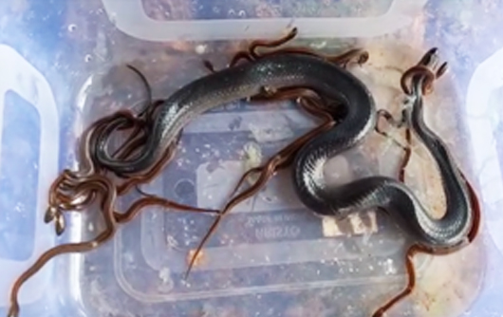
So next time you see a lizard basking in the sun or slinking through the shadows, remember their incredible adaptability in the game of life. From eggs to live births, these reptilian wonders keep the world guessing and their species flourishing!
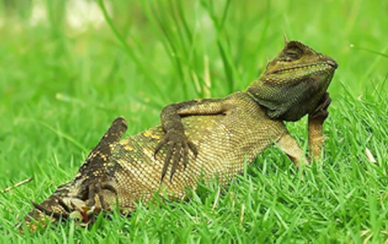
Parthenogenesis: Reproduction Without a Mate
Imagine a world where you could have babies without needing a partner! Some reptiles can do just that through a process called parthenogenesis. This extraordinary ability allows reptiles like Komodo dragons and certain snakes to reproduce without mating. During parthenogenesis, the female’s egg develops into a baby on its own. This adaptation is incredibly useful for species living in isolated areas where finding a mate is difficult. It ensures the species can continue even when population numbers are low. While parthenogenesis is rare, it showcases the incredible versatility and resilience of reptiles.
Impact of Climate Change on Reproductive Strategies
Climate change is turning up the heat on reptiles, affecting how they reproduce. Rising temperatures and shifting weather patterns are altering their habitats and making it harder for them to find the right conditions for nesting. For species with temperature-dependent sex determination, warmer climates can skew sex ratios, making it difficult for populations to sustain themselves. Changing environments can also disrupt nesting sites and reduce the availability of resources needed for successful reproduction. Scientists are working hard to understand these impacts and develop conservation strategies to help reptiles adapt to a changing world.
THREATS
Reptiles face numerous threats that jeopardize their survival and biodiversity. Among the most pressing are illegal wildlife trade, habitat loss, and pollution. These threats, driven largely by human activities, have severe impacts on reptile populations worldwide, leading to declines and, in some cases, extinction.
Illegal Wildlife Trade
Illegal wildlife trade poses a significant threat to reptile species, driven by demand for exotic pets, traditional medicine, and fashion. This black market trade leads to overexploitation, with species such as turtles and snakes being captured in large numbers, often resulting in severe population declines and disrupted ecosystems.
Habitat Loss
Habitat loss, primarily due to deforestation, urbanization, and agricultural expansion, is a critical threat to reptiles. As their natural habitats are destroyed or fragmented, reptiles struggle to find food, shelter, and breeding sites. This loss of habitat leads to reduced population sizes and increased vulnerability to predators and environmental changes.
Pollution
Pollution, including pesticides, plastics, and chemical runoff, adversely affects reptile health and habitats. Contaminants can poison reptiles directly or disrupt their food sources and ecosystems. For example, marine turtles often mistake plastic debris for food, leading to ingestion that can be fatal. Pollution also degrades habitats, making them unsuitable for reptile survival.
Climate Change
Climate change is making life even tougher for desert reptiles. Rising temperatures and changing rainfall patterns are altering their habitats and affecting their ability to find food and water. Some species are being forced to move to cooler areas, while others are struggling to survive in increasingly hostile environments. Scientists are studying these impacts to develop strategies to help desert reptiles adapt. Conservation efforts, such as creating protected areas and preserving critical habitats, are essential for ensuring the survival of these remarkable creatures in a changing world.

SNAKES
Snakes are elongated, legless reptiles found in a wide range of habitats across the globe. They are known for their unique mode of locomotion and diverse adaptations that enable them to thrive in various environments. Snakes play crucial roles in ecosystems as predators and prey, contributing to the balance of natural systems.
Reproduction
Snakes exhibit diverse reproductive strategies, including oviparity (laying eggs), viviparity (giving birth to live young), and ovoviviparity (where eggs develop inside the mother and young are born live). Many species lay eggs in protected environments, while others retain eggs within their bodies until hatching. Reproductive behaviors and cycles vary widely, influenced by factors such as climate, habitat, and species-specific traits.
Habits & habitat
Snakes inhabit a variety of environments, from deserts and forests to wetlands and oceans. They are highly adaptable and can be found on every continent except Antarctica. Snake habits include hunting, basking for thermoregulation, and seeking shelter in burrows or vegetation. Their diet typically consists of small mammals, birds, amphibians, and other reptiles.
Ecology
Ecologically, snakes are important predators that help control populations of rodents and other small animals. They occupy various niches within ecosystems, from ground-dwelling to arboreal lifestyles. Snakes also serve as prey for larger animals, thus contributing to the food web. Their presence indicates a healthy, balanced ecosystem.
Adaptation
Infrared Detection
Pit vipers are like secret agents with night vision goggles! These snakes have evolved special organs that allow them to detect infrared radiation, enabling them to see the heat emitted by warm objects, such as prey animals. These heat-sensing pits, located on their faces, give them an incredible advantage when hunting, especially at night. Imagine stepping into the shoes of a snake with night vision and experiencing their remarkable ability to see in the dark!
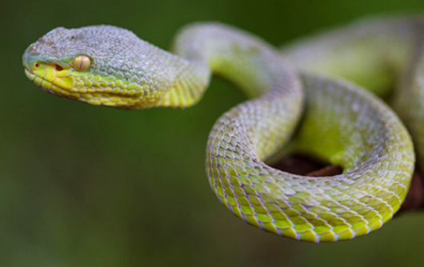
Even in complete darkness, they can "see" the warmth of a mouse or bird and strike with pinpoint accuracy. It’s like having heat-vision superpowers! This adaptation makes these snakes some of the most efficient nocturnal hunters around.
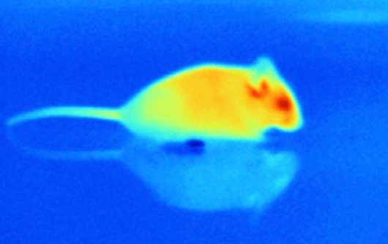
The heat-sensing pits allow snakes to create a thermal image of their surroundings. They can detect even the slightest temperature differences, helping them locate warm-blooded prey hiding in the dark. Once a snake locks onto its target, it strikes with incredible speed and precision, delivering a venomous bite. This ability to hunt in total darkness gives these snakes a significant advantage, allowing them to find food while avoiding competition and predators. It’s a perfect example of nature’s ingenuity and the wonders of evolution.
Other Sensory Adaptations
Snakes are sensory wizards with more than just infrared detection. They also have an excellent sense of smell, thanks to their forked tongues and Jacobson’s organ, which analyzes scent particles. By flicking their tongues, snakes can “taste” the air, tracking prey and navigating their environment. Additionally, snakes can detect vibrations through the ground, helping them sense approaching danger or moving prey. These combined sensory adaptations make snakes highly effective hunters and survivors. They’ve evolved to thrive in diverse environments, showcasing the incredible variety of life strategies in the reptile world.
Expandable Jaws and Feeding Mechanisms
Imagine being able to eat a meal twice the size of your head! Some snakes can do just that, thanks to their incredible adaptations. Snakes like pythons and puff adders have highly flexible jaws that can unhinge, allowing them to swallow prey whole. Their lower jawbones are connected by stretchy ligaments, and their skin can expand to accommodate large meals. This means a snake can feast on animals much larger than itself. Once the prey is swallowed, the snake’s powerful digestive system goes to work, breaking down the food over days or even weeks. This ability to consume large prey helps snakes survive in environments where food can be scarce.
Digestive System Adaptations
A snake’s digestive system is a marvel of nature. After a big meal, their metabolism ramps up dramatically, producing a flood of digestive enzymes and stomach acids to break down the food.
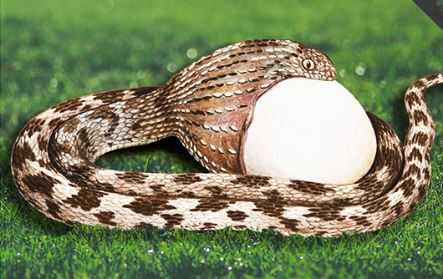
This process allows them to extract as many nutrients as possible, storing energy for long periods. Some snakes can go months without eating after a large meal. Their bodies are incredibly efficient, and they even recycle their digestive system tissues when not in use to save energy. These adaptations ensure that snakes make the most out of every meal, a key survival strategy in the wild.
Impact on Ecosystems
Snakes play a crucial role in maintaining the balance of their ecosystems. As predators, they help control populations of small mammals, birds, and other prey species, preventing overpopulation and the depletion of resources. This, in turn, supports biodiversity and the health of the ecosystem. Snakes also serve as prey for larger animals, contributing to the complex food web. Their unique sensory adaptations make them effective hunters, ensuring they fulfill their ecological roles. Protecting snake populations is essential for preserving the intricate balance of nature and supporting the diversity of life on our planet.
Prey and Predator Dynamics
Snakes are both predators and prey, playing vital roles in their ecosystems. As predators, they help control populations of small mammals, birds, and other reptiles, maintaining a balance in the food web. This control prevents overgrazing and the spread of diseases among prey populations. As prey, snakes provide food for larger animals like birds of prey, mammals, and even other reptiles. This dynamic creates a complex and interconnected ecosystem where every species has a role. By studying these relationships, we can better understand the importance of each species in maintaining ecological balance.
Ecosystem Role
Snakes are essential for healthy ecosystems. Their ability to control prey populations helps prevent overpopulation and resource depletion. This, in turn, supports biodiversity and the health of the environment. Snakes also contribute to the food web as prey for larger animals. Additionally, their presence can indicate the health of an ecosystem, as they are sensitive to changes in their habitat. Protecting snake populations is crucial for preserving the intricate balance of nature. By appreciating the role of snakes, we can better understand and protect the ecosystems they inhabit.

CROCODILES
Adaptations
Hunting Strategies
Think crocodiles are lone hunters? Think again! These crafty creatures often team up to catch their prey. Crocodiles communicate using sounds and body language to coordinate their hunting strategies. One crocodile might scare fish toward waiting teammates, while others lie in ambush, ready to snap their powerful jaws shut. This teamwork makes them some of the most sophisticated predators in the animal kingdom. Watching a group of crocodiles hunt together is like seeing a perfectly synchronized performance, showcasing their intelligence and adaptability.
Crocodiles are nature’s ultimate hunters, with bodies built for the kill. Their jaws can exert a force of over 3,000 pounds per square inch, enough to crush bones easily. Their eyes and nostrils sit on top of their heads, allowing them to see and breathe while mostly submerged. This makes them perfect ambush predators. They can stay still for hours, blending in with their surroundings, before striking with lightning speed. Their thick, scaly skin acts like armor, and their powerful tails help them swim swiftly. These adaptations make crocodiles fearsome hunters and top predators in their habitats.
Habits & habitat
Crocodiles are incredibly versatile and can be found in a variety of habitats, from rivers and lakes to swamps and estuaries. They can live in both freshwater and saltwater environments. During the day, they bask in the sun to regulate their body temperature. At night, they become more active, hunting and patrolling their territory. Crocodiles are also known for their nesting habits. Females build nests out of vegetation and mud, where they lay their eggs. They guard these nests fiercely, protecting their young from predators. These behaviors highlight the crocodile’s adaptability and resilience.
Reproduction
Crocodiles have a unique approach to reproduction. Females build nests using vegetation and mud to create a warm, humid environment for their eggs. After laying their eggs, they cover them and remain nearby to guard against predators. Temperature within the nest determines the sex of the hatchlings: warmer temperatures typically produce males, while cooler temperatures produce females. This temperature-dependent sex determination is crucial for maintaining balanced crocodile populations.
Ecology
Ecologically, crocodiles play a significant role in their environments as apex predators. They help control populations of fish, amphibians, and other prey species, maintaining the balance within their ecosystems. Crocodiles also contribute to nutrient cycling; when they feed, they break down carcasses, which releases nutrients back into the ecosystem. Their presence in both freshwater and saltwater habitats indicates healthy, functioning ecosystems, as they require clean, undisturbed environments to thrive.
Role in ecosystems
Crocodiles play a vital role in their ecosystems. As apex predators, they help control populations of fish, birds, and mammals, ensuring that no single species dominates the environment. This balance supports biodiversity and the stability of the ecosystem. Additionally, crocodile nests contribute to nutrient cycling, enriching the soil and supporting plant growth. By preying on weak and sick animals, crocodiles also help keep prey populations healthy. Protecting crocodiles is essential for preserving the intricate web of life in their habitats, showcasing the interconnectedness of all living things.

LIZARDS
Lizards are a diverse group of reptiles found on every continent except Antarctica. They exhibit a wide range of sizes, shapes, and behaviors, adapted to various environments from deserts to rainforests. Known for their agility and sometimes vibrant colors, lizards play crucial roles in their ecosystems.
Reproduction
Lizards employ various reproductive strategies, including oviparity (laying eggs) and viviparity (giving birth to live young). Many species lay eggs in concealed or protected locations, such as under rocks or in burrows, to safeguard them from predators. Some lizards exhibit parental care, with behaviors like guarding their eggs. In some species, environmental factors like temperature can influence the sex of the offspring, a phenomenon known as temperature-dependent sex determination.
Habits & habitat
Lizards inhabit a wide range of environments, including deserts, forests, grasslands, and urban areas. They display varied habits, from basking in the sun to regulate body temperature to burrowing or climbing trees and walls. Some lizards are diurnal, active during the day, while others are nocturnal. Their diets are diverse, consisting of insects, plants, small mammals, and other reptiles, making them adaptable to different ecological niches.
Ecology
Ecologically, lizards are pivotal as both predators and prey. They help control insect populations, which can benefit agricultural and human health. Lizards are also a crucial food source for birds, mammals, and larger reptiles, forming an essential part of the food web. Additionally, some lizards contribute to seed dispersal and pollination, aiding in plant reproduction and biodiversity. Their ecological roles underscore their importance in maintaining the balance of ecosystems.
Adaptation
Lizards have evolved various adaptations to survive in their respective environments. Many possess excellent camouflage, allowing them to blend into their surroundings to evade predators. Species like chameleons can change color to communicate or regulate their temperature. Lizards have developed specialized structures, such as sticky toe pads for climbing (seen in geckos) and frilled necks for defense displays. Additionally, some can regenerate lost tails, providing an escape mechanism from predators.
Role in ecosystems
Lizards play a critical role in maintaining ecological balance. As insectivores, they help control populations of pests, contributing to the health of plant communities. As prey, they support the diets of numerous predators, ensuring energy flow within the ecosystem. Their activities, such as burrowing, aerate the soil, enhancing nutrient cycling and promoting plant growth. By fulfilling these roles, lizards help sustain biodiversity and ecosystem resilience, making them indispensable components of their habitats.

TURTLES & TORTOISES
Turtles and tortoises are fascinating reptiles known for their distinctive shells, which provide protection and aid in their survival. While turtles are generally adapted to aquatic or semi-aquatic environments, tortoises are land-dwellers. These creatures have existed for millions of years, showcasing a wide range of adaptations that enable them to thrive in diverse habitats.
Reproduction
Turtles and tortoises have varied reproductive strategies, typically involving laying eggs on land. Females dig nests in sand or soil to deposit their eggs, covering them to protect from predators. Temperature plays a crucial role in determining the sex of the hatchlings, with warmer temperatures usually producing females and cooler temperatures producing males. After laying eggs, most species leave them to develop on their own, though some, like the female tortoises, may guard their nests for a short period.
Habits & habitat
Turtles and tortoises inhabit a variety of environments, from oceans and rivers to deserts and forests. Turtles are often found in water or near water bodies, using their webbed feet or flippers for swimming. Tortoises, in contrast, are land-based, with sturdy, column-like legs adapted for walking on rough terrain. Both groups exhibit basking behavior to regulate body temperature and can often be seen sunning themselves on rocks or logs. Turtles tend to be more mobile, while tortoises may establish small territories that they rarely leave.
Ecology
Turtles and tortoises play crucial roles in their environments. Turtles contribute to aquatic ecosystems by controlling the population of small aquatic organisms and maintaining healthy seagrass beds. Tortoises, as herbivores, help in seed dispersal and maintaining vegetation balance in terrestrial ecosystems. Both are prey for various predators and thus integral to the food web. Their presence indicates a healthy ecosystem, as they are sensitive to environmental changes and pollution.
Adaptation
Turtles and tortoises have evolved numerous adaptations to survive in their respective habitats. Turtles possess streamlined shells and flippers for efficient swimming, while tortoises have dome-shaped shells and sturdy legs for terrestrial mobility. Their shells provide excellent protection from predators, and many species can retract their heads and limbs inside the shell when threatened. Additionally, some species have developed specialized beaks to help them feed on a variety of plant and animal matter.
Role in ecosystems
Turtles and tortoises are vital to ecosystem health. As grazers, tortoises help control plant growth and facilitate seed dispersal, promoting plant diversity. Aquatic turtles maintain the balance of marine and freshwater ecosystems by feeding on algae, dead fish, and other organic matter, preventing overgrowth and supporting nutrient cycling. Their activities enhance habitat quality for other species and contribute to the overall biodiversity and stability of their environments.

What’s the Difference Between a Turtle and a Tortoise?
What is a tortoise anyway? Is it just a fancy way to say “turtle”? Well, actually, there’s a meaningful difference between tortoises and other turtles. All tortoises are in fact turtles—that is, they belong to the order Testudines or Chelonia, reptiles having bodies encased in a bony shell—but not all turtles are tortoises. If tortoises are turtles, why not just call all turtlelike creatures “turtle”? Because if the animal you’re referring to is a tortoise, some wise guy is going to correct you every time.
The most important thing to remember about tortoises is that they are exclusively land creatures. They live in a variety of habitats, from deserts to wet tropical forests. (Unlike most sea turtles, which take to land only when they are laying eggs, tortoises don’t have much to do with water other than drinking it and occasionally bathing in it.) However, not all land turtles are tortoises; thus, box turtles and wood turtles have been called tortoises, though they are not considered tortoises today. But that’s a matter for another day.
One way to further distinguish tortoises from other turtles is to look for certain anatomical features. The testudinids (their family is Testudinidae) are easily recognized because all share a unique hind-limb anatomy made up of elephantine (or columnar) hind limbs and hind feet. Their forelimbs are not flipperlike, and their hind feet are not webbed. Each digit in their forefeet and hind feet contains two or fewer phalanges. Finally, if you can’t see their legs, try feeding them meat. Tortoises are generally vegetarians, while other turtles are omnivorous.

TUATARA
Tuataras are unique reptiles endemic to New Zealand, often referred to as living fossils due to their ancient lineage dating back to the Mesozoic era. Despite resembling lizards, they belong to a distinct order, Sphenodontia, and are the only surviving members of this group. Tuataras are notable for their longevity and slow growth.
Reproduction
Tuataras have a slow and unique reproductive process. They reach sexual maturity around 10–20 years of age and reproduce infrequently. Females lay eggs every 2-5 years, with a clutch size of 5–15 eggs. The eggs are buried in the soil and incubate for 12-15 months, one of the longest incubation periods of any reptile. Temperature influences the sex of the offspring, with warmer temperatures typically producing males.
Habits & habitat
Tuataras are primarily nocturnal and inhabit burrows, which they may dig themselves or share with seabirds. They are found on offshore islands of New Zealand, living in forests, grasslands, and coastal areas. During the day, they stay in their burrows to avoid predators and regulate their body temperature. At night, they emerge to hunt insects, spiders, and small vertebrates, including young seabirds.
Ecology
Ecologically, tuataras play a critical role in their habitats. As predators, they help control the populations of invertebrates and small vertebrates, maintaining ecological balance. They also serve as prey for larger animals, although they have few natural predators on the protected islands where they now primarily reside. Their burrowing behavior influences soil structure and nutrient cycling, benefiting plant growth and other organisms.
Adaptation
Tuataras have several adaptations that have enabled their survival over millions of years. They possess a well-developed parietal eye, a light-sensitive organ on top of their head that helps regulate their circadian rhythms and detect light changes. Their slow metabolism allows them to endure long periods without food. Additionally, tuataras have robust jaws and sharp teeth, which they use to efficiently capture and consume prey.
Role in ecosystems
Tuataras are essential to the ecosystems they inhabit. Their predatory role helps maintain the balance of invertebrate and small vertebrate populations. As burrowers, they influence soil composition and aeration, promoting healthy plant communities. By contributing to the biodiversity and ecological stability of their habitats, tuataras play a vital part in the functioning and resilience of New Zealand's island ecosystems. Their presence is also of significant conservation and scientific interest, providing insights into ancient reptilian life and evolutionary processes.

Fun Facts
1. Snakes have no eyelids. They use a clear scale called a spectacle to cover and protect their
eyes.
2. Chameleons' tongues can be as long as their bodies. This helps them catch insects from a
distance.
3. Geckos can climb walls. They have tiny hair-like structures on their feet that create adhesive
forces, allowing them to stick to surfaces.
4. Sea turtles can live up to 100 years. They have long lifespans similar to humans.
5. Komodo dragons can smell carrion from up to 2.5 miles away. Their sense of smell is
incredibly acute.
6. Crocodiles have been around for 200 million years. They are ancient survivors from the
time of dinosaurs.
7. Anoles can change color like chameleons. This ability helps them communicate and regulate
their body temperature.
8. Gharials have the longest snouts of any crocodilian. Their snouts are perfect for catching
fish.
9. The green basilisk lizard can run on water. It’s also known as the "Jesus Christ lizard" for this
ability.
10. Some turtles can breathe through their butts. This process, called cloacal respiration, helps
them stay underwater longer.
11. Snakes can dislocate their jaws. This allows them to swallow prey much larger than their
heads.
12. Reptiles have been to space. Tortoises were sent to the Moon by the Soviet Union in 1968.
13. Certain geckos can drop their tails as a defense mechanism. The tail continues to wriggle,
distracting predators.
14. Female Komodo dragons can reproduce without males. This process is called
parthenogenesis.
15. Iguanas have a third eye on their head. Known as a parietal eye, it can detect light and
movement.
16. Leatherback sea turtles can dive deeper than any other turtle. They can reach depths of
over 4,000 feet (1,219 meters).
17. Some snakes give birth to live young. While most lay eggs, species like boas and vipers give
birth to live offspring.
18. Crocodiles can't stick out their tongues. Their tongues are attached to the roof of their
mouths.
19. Geckos can regenerate lost tails. This helps them escape from predators and survive
injuries.
20. The tuatara has a unique "third eye." This pineal eye is visible only in hatchlings and is
thought to help regulate circadian rhythms.
21. Certain tortoises can survive without food and water for over a year. Their slow
metabolism allows them to go long periods without sustenance.
22. Bearded dragons can change the color of their beard. They do this to show aggression,
attract mates, or regulate temperature.
23. Some reptiles use their tails as weapons. Iguanas, for example, can deliver powerful tail
whips to defend themselves.
24. The Matamata turtle has a leaf-like appearance. This camouflage helps it blend into the
aquatic environments of South America.
25. Crocodiles and alligators use tools. They balance sticks on their snouts to lure birds
searching for nesting material.
26. The black mamba is one of the fastest snakes. It can slither at speeds of up to 12.5 miles per
hour (20 km/h).
27. Gila monsters store fat in their tails. This helps them survive during periods when food is
scarce.
28. Some lizards can squirt blood from their eyes. The horned lizard does this to deter
predators.
29. The smallest reptile is the nano-chameleon. It measures just over half an inch (13.5 mm)
from nose to tail.
30. Turtles have an incredible sense of direction. They can navigate back to their home beaches
after traveling thousands of miles.

Reptiles, as commonly defined, are a group of tetrapods with usually an ectothermic metabolism and amniotic development. Living reptiles comprise four orders: Testudines, Crocodilia, Squamata, and Rhynchocephalia. As of May 2023, about 12,000 living species of reptiles are listed in the Reptile Database.
ஊர்வன என்பவை முதுகெலும்பி வகையைச் சேர்ந்த விலங்குகள் ஆகும். இவை குளிர் இரத்தம் கொண்டவை. இவை முட்டையிட்டுக் குஞ்சு பொரிப்பவை. தங்கள் வயிற்றைப் பயன்படுத்தி தரையில் ஊர்ந்து செல்பவை. பெரும்பாலானவை கால்களைக் கொண்டுள்ளன. ஆனால் பாம்புகள் கால்கள் அற்றவை.
List Of Reptiles Names For Kids
Reptile is the name for a large group of animals.
Reptiles are vertebrates, which means they have backbones. They are also cold-blooded, have scaly skin, and lay eggs.
When we say that reptiles are cold-blooded, that does not mean that they are cold! It just means that they cannot keep their bodies the right temperature without help. To warm up, reptiles move somewhere warmer – often a nice, sunny rock. To cool down, reptiles move somewhere cooler, perhaps into the water, or a nice shady burrow. Because of this, reptiles mainly live places where it does not get too cold. This is probably why reptiles live on every
continent - except for Antarctica! Their skin is one good way to tell if the animal you are looking at is a reptile or an amphibian. Reptiles' scaly skin is dry and watertight. It may be rough or smooth, dull or shiny, but never slimy! If you see an animal that looks like a snake or lizard but it has wet or slimy skin, you're probably looking at an amphibian instead of a reptile. Almost all reptiles lay eggs, although some give birth to live young. Unlike bird's eggs, which have hard shells, reptile eggs are soft and leathery. Unlike amphibians, reptiles lay their eggs on land. Even reptiles that spend most of their time in the water, like alligators and sea turtles, lay their eggs on dry land.
Reptiles are fascinating creatures, and come in many different shapes and sizes. Some people even keep reptiles as pets! Some reptiles make good pets...and some would make very bad pets.

