
BRINDAVAN ANGLO VEDIC INTERNATIONAL
SENIOR SECONDARY SCHOOL
(Affiliated to CBSE, New Delhi)
Class: V Subject: Science Date: -
Student Name: Unit test-II Marks: 30
--------------------------------------------------------------------------------------------------

I. Choose the correct answer 1 X 10 = 10
MCQ
II. Label the following: 1 X 5 = 5
- 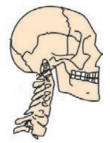 2.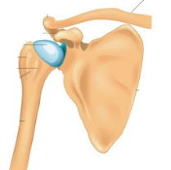 3. 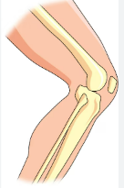 4. 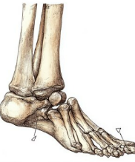 5. 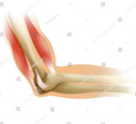
___________ _____________ ___________ _____________ _________________
III. Answer the following: (Any 5) 5 x 2 = 10
1. Differentiate between the hinge and pivot joint
2. Which part of the skull helps us to eat and talk? How?
3. The heart has strong muscles. Give reason.
4. Differentiate between proteins and carbohydrates.
5. Babies are vaccinated soon after their birth. Give reason.
6. List the factors that determine the amount of nutrients needed by a person.
7.Classify the following as communicable and non-communicable disease:
Cholera, beri beri, measles, scurvy, malaria, anaemia, typhoid, goitre,
Polio, night blindness.

IV. Answer the following in detail:(Any 1) 1 X 5 = 5
- Write the difference between voluntary and involuntary muscles?
- What is hygiene? How can we maintain hygiene to stay healthy?

