
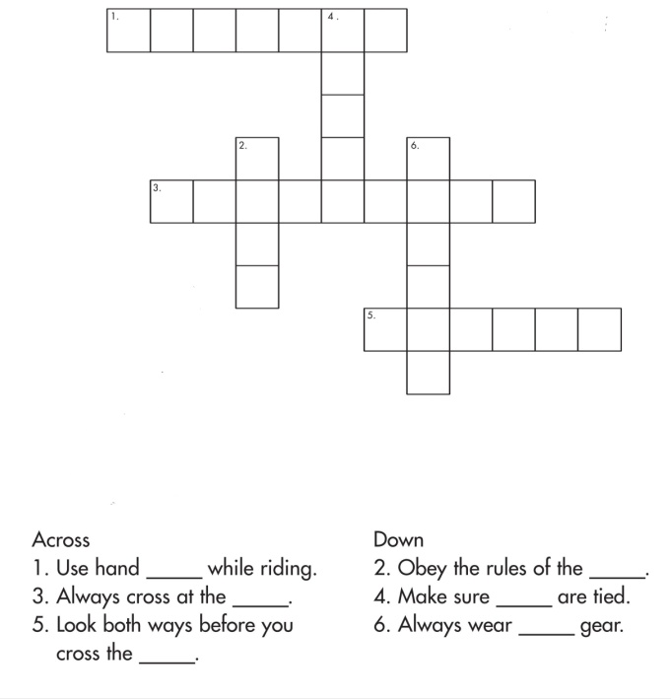
BRINDAVAN ANGLO VEDIC INTERNATIONAL
SENIOR SECONDARY SCHOOL
Affiliated to CBSE, New Delhi
NAME: SCIENCE DATE:
STD: IV WORK SHEET
- Classify the following animals according to the environment they live as terrestrial, aquatic, arboreal and amphibian animals:

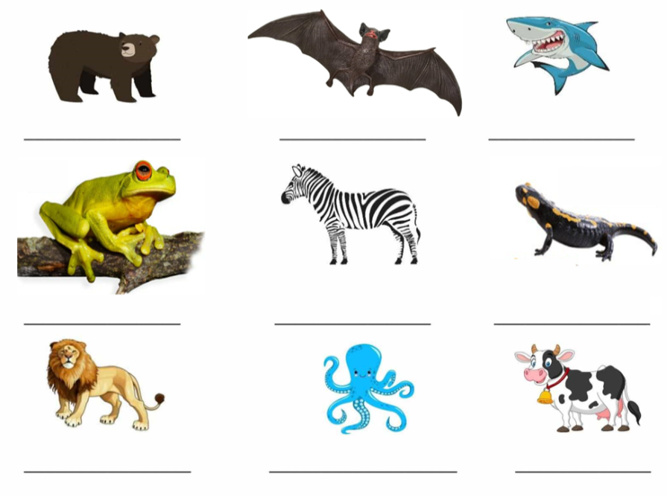
- Write the special features of the below animals based on environment:
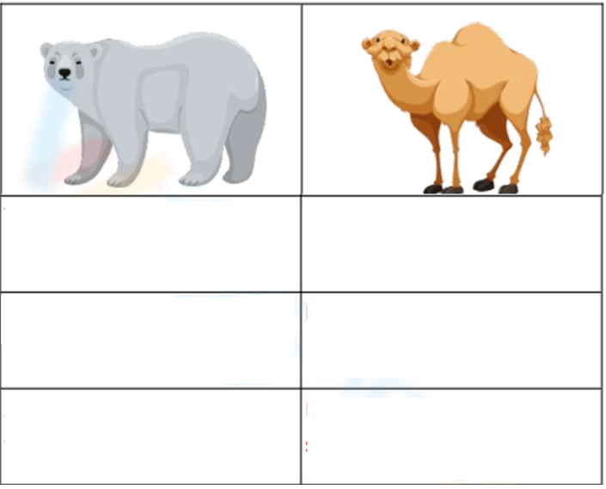

- Label the parts of birds:



- Choose one animal found in India that is endangered. Write a story keeping an animal as the mail character. In your story, tell why that animal is endangered and how it can be saved.

V. Compare the different types of soil according to their physical characteristics:
Soil | Structure | Ability to hold water
- Gravel
- Sand
- Clay
- Loam
- Silt

- How do you the following animals protect themselves?

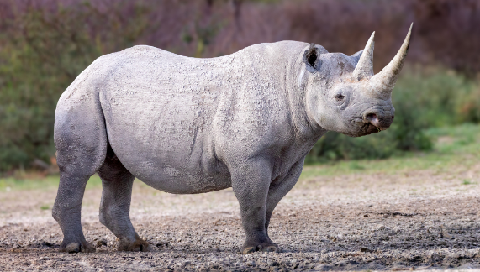
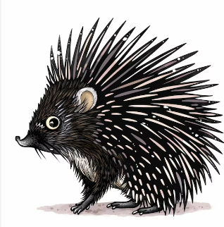

_____________________________ ___________________________________
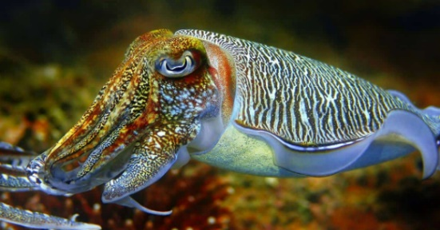
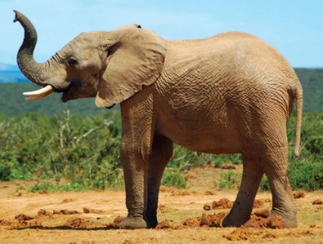

______________________________ ______________________________
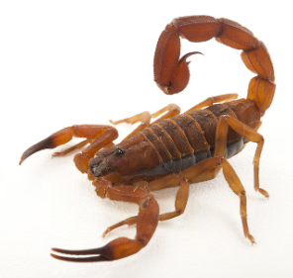
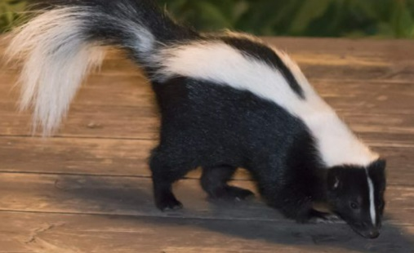

______________________________ _______________________________
- Label the layers of soil:

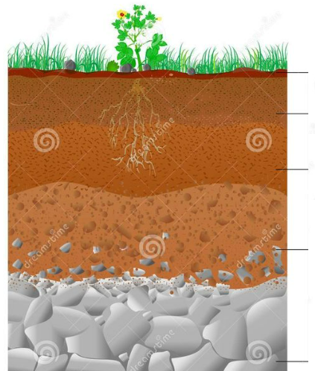

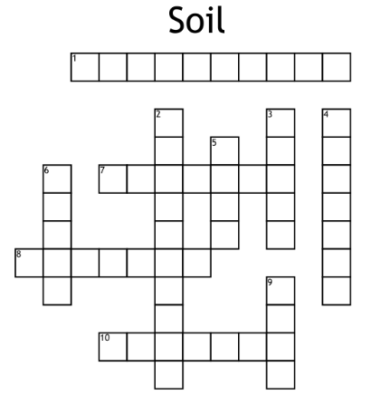
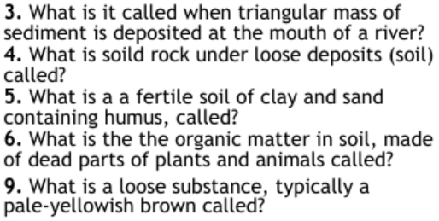
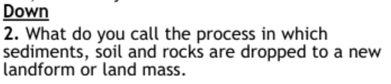
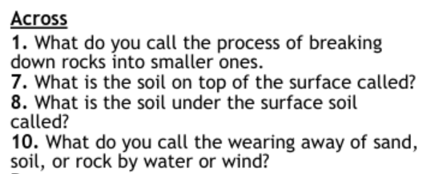
VIII. Solve the puzzle:

IX. Why do you think the polar bear is looking sad?
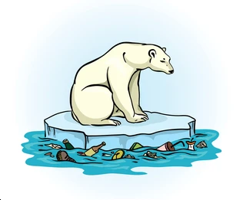

X. Name the various types of soil conservation methods:
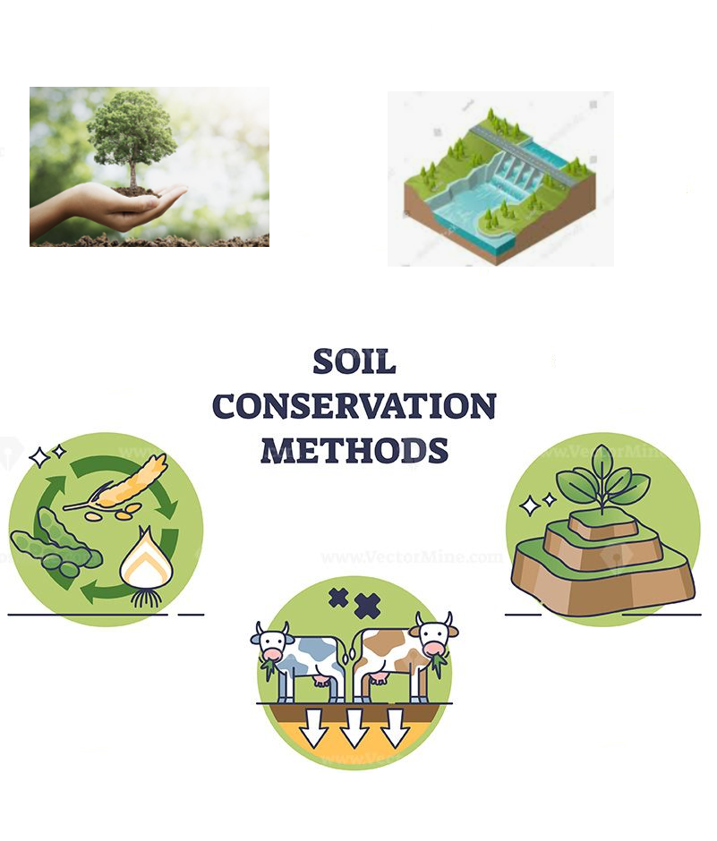

XI. Identify the various types of soil and write one properties of each:

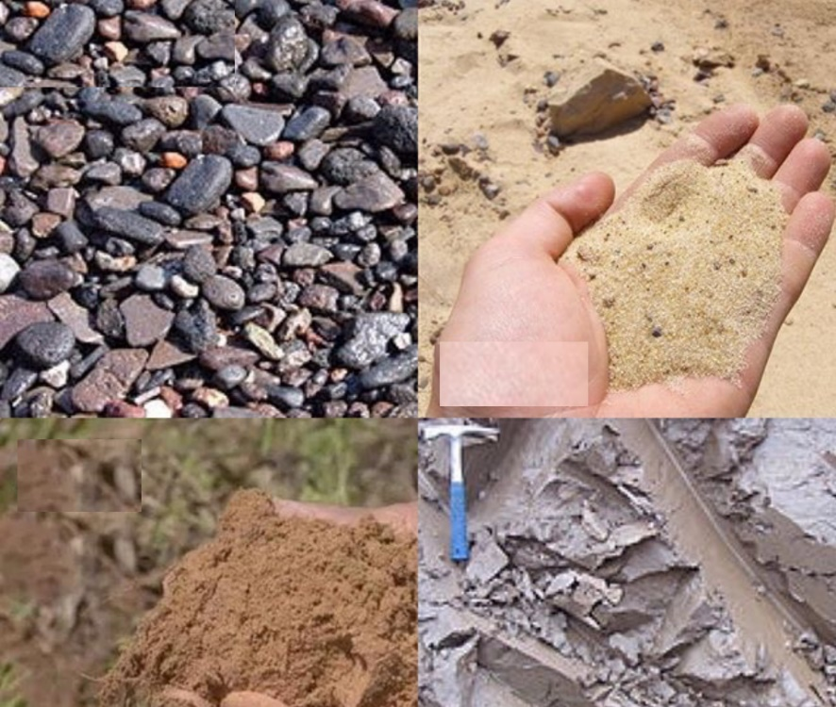s

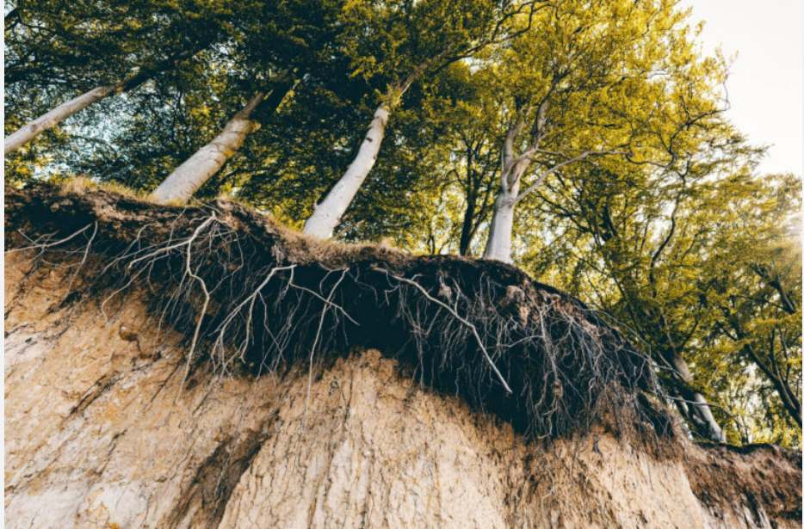
XII. Look at the given picture and describe about them:

