
BRINDAVAN ANGLO VEDIC INTERNATIONAL SENIOR SECONDARY SCHOOL
Affiliated to CBSE, New Delhi

GRADE: IV Model Question
- The larva of the animal shown in the figure given below is called:

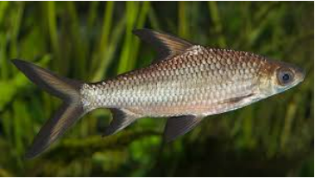
- Caterpillar b) maggot c) fry d) nymph e) none of these

- Water hyacinth is a
- Fixed plant b) underwater plant c) floating plant d) desert plant e) none of these

3. Column A Column B
(i) Scavenger (a) white tiger
(ii) Aerial animal (b) dodo
(iii) Endangered animal (c) hyena
(iv) Extinct animal (d) bat
a) (i-d), (ii-a),(iii-b),(iv-c) (b) (i-b),(ii-a),(iii-d),(iv-c)
c) (i-c),(ii-d),(iii-a),(iv-b) (d) (i-b), (ii-c),(iii-a),(iv-d)
e) None of these
4. Which of the following animals give birth to their young ones?

a)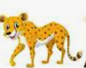 b) 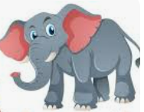 c)  d) all of these
e) none of these

5. ________ is a thick layer of fat present inside some animals living in extreme cold conditions
a) Cellulose b) blubber c) cell membrane d) shell e) none of these

6. The vitamin which plays an important role in maintaining healthy teeth and gums is
a) Vitamin K b) Vitamin E c) Vitamin C d) vitamin B e) None of these
7. A rod is 7 metre long, find its length in cm
a) 70 cm b) 75cm c) 0.007cm d) 700 cm e) none of these
8. Which of the following is not correct?
a) Planets do not have their own light
b) Planets do not rotate on their own axis
c) planets revolve around the sun
d) There are eight planets in the solar system
e) none of these
9. Find the next letter of the following series:
D,F,H,J?
- K b)L c) M d)N e) none of these
10. One morning Rani started to walk towards the sun. After covering some distance, she turned to right then again to the right. Now in which direction is she facing?
A) East B) West C) South D) North
11. Stomata present on the leaf is responsible for:
a) Taking up carbon dioxide from the surrounding air b) Giving out oxygen in the air
c) Both A and B d) Either A or B e) None of these
12. Which of the following animals do not perform camouflage?
a) grasshopper b) Elephant c) octopus d) chameleon e) none of these
13. Match the following:

Column A Column B
(i) Clay (a) Dead plants and animals
(ii) Humus (b) Does not hold much water
(iii) Loam soil (c) Best soil for growing plants
(iv) sand (d) Sticky and soft soil
a) (i-d), (ii-c),(iii-a),(iv-b) (b) (i-c),(ii-a),(iii-d),(iv-b)
c) (i-b),(ii-a),(iii-d),(iv-c) (d) (i-d), (ii-a),(iii-c),(iv-b) e) None of these

14. Which type of energy is present in flowing water?

- Electrical energy b) Kinetic energy c) gravitational energy
d) solar energy e) none of these

15. Which one of the following is an arboreal animal?
a) 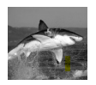b)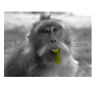c)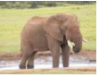 d)

16. Which among the following statements is incorrect?
a) Different parts of our body perform different functions
b) All sense organs send message to our brain
c) Blood carries food and oxygen to all body parts
d) When we inhale, our heart is filled with air
e) None of these
17. Chewing of food helps in :
a) photosynthesis b) reproduction c) respiration d) digestion
e) none of these
18. Match the following:

Column A Column B
(i) Pulses (a) Metre
(ii) A piece of cloth (b) Dozen
(iii) Juice (c) Kilogram
(iv) Bananas (d) Litre
a) (i-d), (ii-c),(iii-b),(iv-a) (b) (i-c),(ii-a),(iii-d),(iv-b)
c) (i-b),(ii-a),(iii-d),(iv-c) (d) (i-c), (ii-d),(iii-b),(iv-a) e) None of these

19. It makes soil fertile and is rich in humus.

- Fertilizer b) rock c) manure d) clay e) none of these

20. Which one of the following gives birth to young ones?
- Amphibians B) Reptiles C) Mammals D) Fishes E) None of these

21. Which one of the following is a biodegradable substance?
A) Wooden pencil B) Dried leaves C) Dead animals D) All the above E) None of these

22. Column A Column B
1. Length [A] Litre
2. Volume [B] Second
3. Time [C] Metre
4. Mass [D] Kilogram
A) 1 - C, 2 - A, 3 - B, 4 – D (B) 1 - A, 2 - B, 3 - D, 4 – C (C) 1 - B, 2 - D, 3 - A, 4 - C

D) 1 - A, 2 - D, 3 - C, 4 – B
23. Melting down of candle into liquid wax is an example of conversion of:
A) Liquid into gas B) Gas into liquid C) Solid into liquid D) Liquid into solid E) None of these

24. Which one of the following is the natural : satellite of the earth?
A) Rohini B) Aryabhatta C) Moon D) Sun E) None of these

- The small openings in the lower surface of the leaves are called:
A) Chlorophyll B) Stomata C) Pores D) Leaf E) None of these

26.Through which one of the following parts a leaf is attached to the stem?
A) Seed B) Root C) Flower D) Stalk E) None of these

27. Column A Column B
1. Soil pollution (a) loudspeaker
2. Air pollution (b) sewage
3. Water pollution (c) smoke
4. Noise pollution (d) Plastic

- 1-d,2-c,3-b,4-a (b) 1-c,2-d,3-b,4-a (c) 1-b,2-c,3-d,4-a (d) 1-a,2-c,3-b,4-d
28. Which constellation among the following is also known as the “Great Bear”
a) LEO (b) Orion (c) Scorpius (d) Ursa Major (e) none of these
29. Which of these changes are not permanent?
(A) Rusting of iron B) Burning of paper C) Growth of seedling into a plant
(D) Change of water into ice

30. Look at the diagram given below and choose the incorrect option.
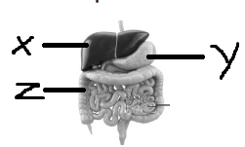
- X – windpipe, Y- pancreas, Z – stomach
- X – oesophagus, Y- liver, Z – pancreas
- X – liver, Y- stomach, Z – small intestine
- X – food pipe, Y- pancreas, Z – stomach
- None of these
31. which of the following does not have backbone?
a) cow (b) elephant (c) butterfly (d) tiger (e) none of these
32. All the stars that we see in the sky are not equally bright.
Choose the correct reason for this.
(A) Distance of the star from us (B) Earth is a small planet (C) Amount of light that the star emits
(D) Both (A) and (C)
33. Consider the following statements:
Micky: Work is always done by a force.
Goofy: A moving body can be stopped by applying force.
Donald: We do not need energy to write answers of this
question paper.
Who is telling the wrong fact?
- Goofy B) Micky (C) Donald (D) All of these
34. Which type of pollution is shown in the given figure
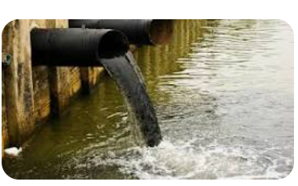
- Water pollution b) soil pollution c) air pollution d) all the above e)none of these
35. ___________ soil is mostly used for making pots.
A) sandy b) clayey (c) loamy (d) humus

36.The energy obtained from splitting of an atom is:
(a) muscular energy (b) solar energy (c) wind energy (d) atomic energy (e) none of these

37. What does the given sign is indicating?

- arrow (b) danger (c) recycle (d) atomic energy (e) none of these

38. Which planet is known as morning or evening star
(a) Earth (b) Mercury (c) Venus (d) Uranus (e) none of these

39. Mr Deepak Mohan walks 5 km towards the south and then turns to the right. After walking 3km he turns to the left and walks 5 km. What direction is he facing right now?
A) West (B) South (C) North-East (D) South-West (E) none of these

40. One morning after sunrise, Nandita and Ravi were sitting in a lawn with their backs towards each other. Nandita’s shadow fell exactly towards her left-hand side. Which direction was Ravi facing?
(A) East (B) West (C) North (D) South
41. Select the odd one out:
a) O (b) W (c) G (d) Y (e) none of these
42. Chlorophyll are __________ colour pigment.
(A) brown (B) yellow (C) green (D) yellow
43. If the given number table follows a certain rule row- wise or column – wise , the missing number will be:

13 | 12 | 18
5 | 8 | 3
61 | 92 | ?

- 52 b) 54 c) 50 d) 60 e) none of these

44. Identify the given simple machine:


- Screw b) Wedge c) lever d) pulley e) none of these
45. The habit of some animals to sit on their eggs to keep them warm is called ______
a) metamorphosis (b) incubation (c) moulting (d) hibernation (e) none of these
46. Premolar teeth is also called as _______________ .
a) biting teeth (b) tearing teeth (c) cracking teeth (d) grinding teeth (e) none of these
47. The water trapped in the soil is called ____________
a) manure (b) loam (c) moisture (d) humus (e) none of these
48. Which type of force is shown in the given figure
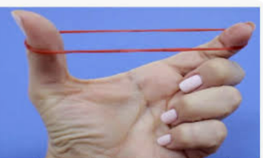

a) Muscular (b) elastic (c) gravitational (d) mechanical (e) none of these
48. If ‘sun’ is called ‘blue’, ‘blue’ is called ‘moon’, ‘moon’ is called ‘violet’, ‘violet’ is called ‘dark’,
Then the colour of clear sky is:
a) violet (b) Sun (c) moon (d) dark (e) none of these
49. Which of the following is a source of air pollution?
a) smoke (b) factory c) oxygen (d) both a and b (e) none of these
50. Environmental day is celebrated on ________
a) 5 August (b) 5 December c) 5 June (d) 5 July (e) none of these

