
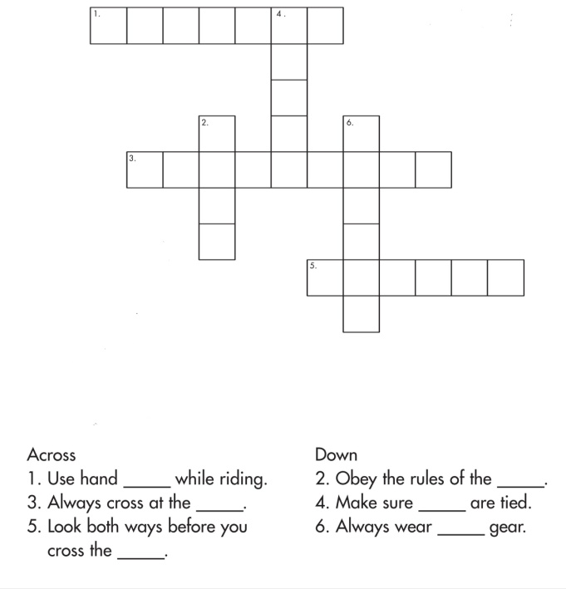
BRINDAVAN ANGLO VEDIC INTERNATIONAL
SENIOR SECONDARY SCHOOL
Affiliated to CBSE, New Delhi
NAME: SCIENCE DATE :
STD: V WORK SHEET -1
- Classify the following animals according to the environment they live as terrestrial, aquatic, arboreal and amphibian animals:

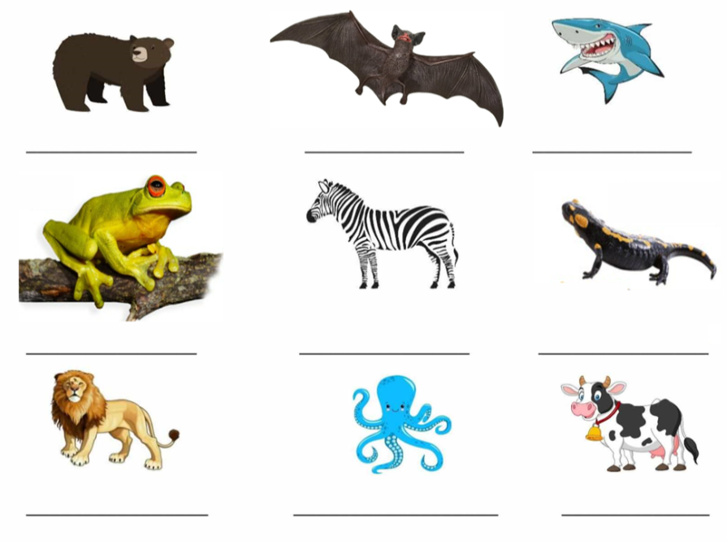
- Write the special features of the below animals based on environment:
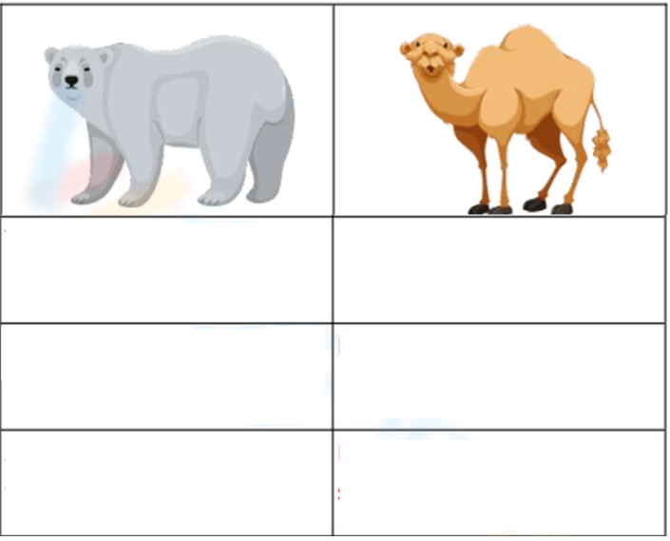

- Label the parts of birds:

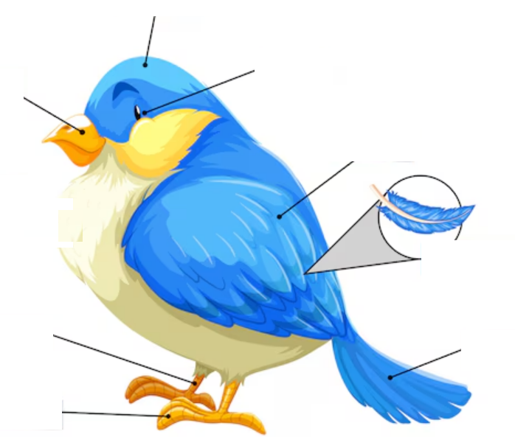

- Choose one animal found in India that is endangered. Write a story keeping an animal as the mail character. In your story, tell why that animal is endangered and how it can be saved.

- How do you the following animals protect themselves?

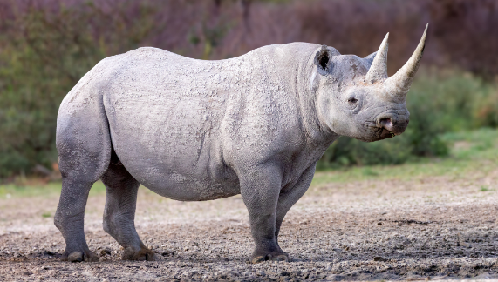
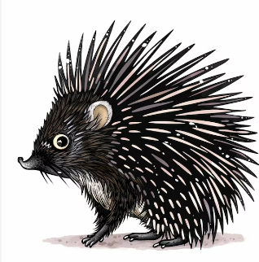

_____________________________ ___________________________________
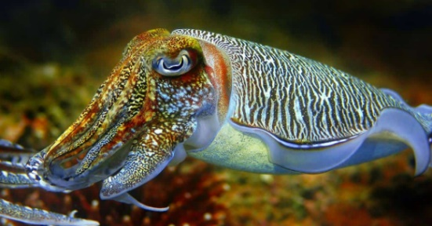
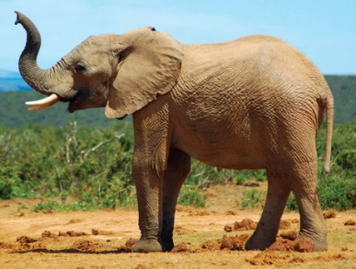

______________________________ ______________________________
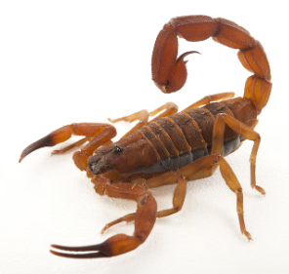
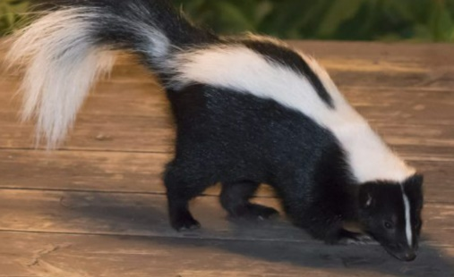

______________________________ _______________________________
- Label the layers of soil:

