
BRINDAVAN ANGLO VEDIC INTERNATIONAL SENIOR SECONDARY SCHOOL
Affiliated to CBSE, New Delhi
Name: SCIENCE WORK SHEET DATE:
STD: V

I. Identify the pictures and write their names:
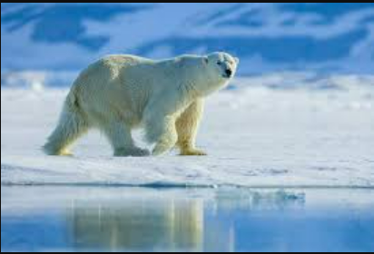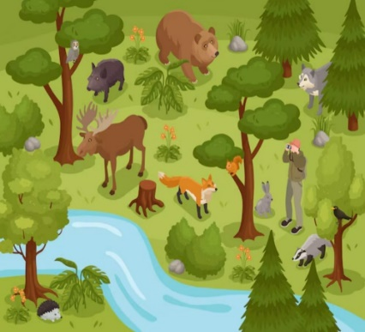
a.________________________________ b._____________________________

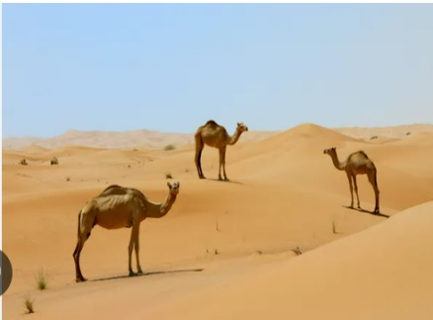
c.__________________________________ d.______________________________

II. Unscramble the following words:
- 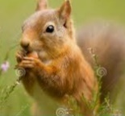 N G W N A I G - _________________

- 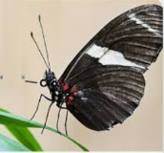 B O P S O R I C S - _________________

-  C A N S A Y T R U - _________________

- 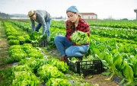 S H V A T E R - _________________

- 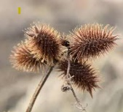 K C L B C U R O E - _________________
III. Identify the kind of Movement for the following:
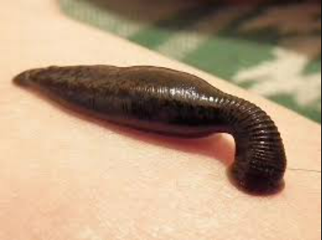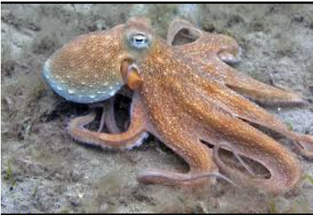
a._______________________________ b.____________________________

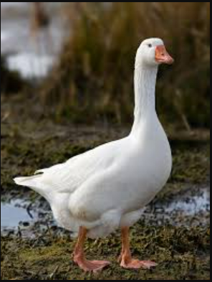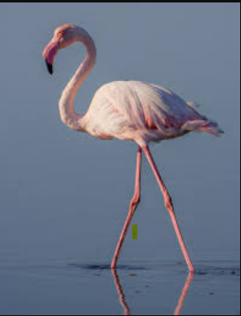
c._______________________________ d. ______________________________
IV. Who am I?
- I am a bird that uses my long beak to sip nectar from flowers.

- I am a reptile with powerful jaws and sharp teeth used for tearing apart my prey, often found in rivers and swamps.

- I am a scavenger with strong jaws and sharp teeth that allow me to tear through tough hides and bones

- I am a bird that hunts small mammals and fish with my sharp talons and beak.
- I am an animal that uses my long tongue to catch ants and termites. My diet consists mainly of insects.

V. Make a flow diagram to show the stages of agriculture:

VI. Identify and name the methods of reproduction shown in the following pictures:
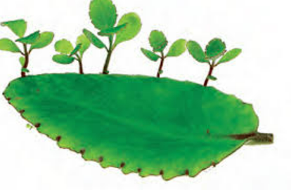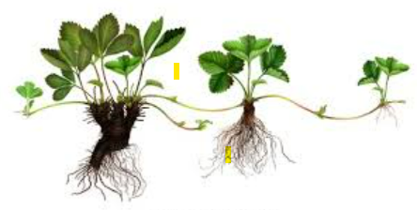
- _____________________ b. __________________________

VII. Label the parts of seed:
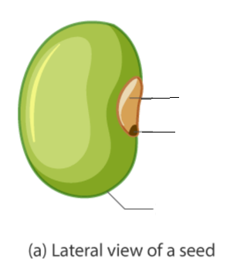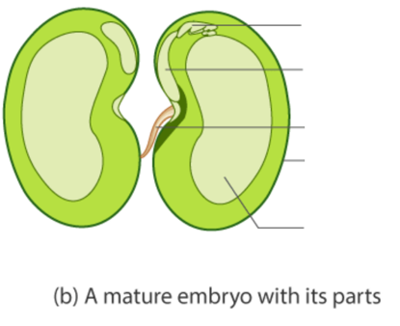

VIII. Complete the table below.

