
BRINDAVAN ANGLO VEDIC INTERNATIONAL SENIOR SECONDARY SCHOOL
Affiliated to CBSE, New Delhi
Name: SCIENCE WORK SHEET DATE:
STD: V
- Identify the name of the species and their migration:

Pictures | Name of the species | Place of migration
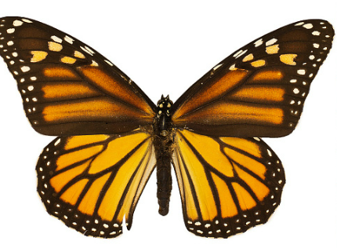
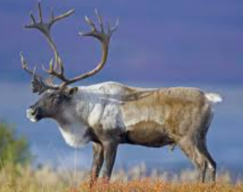
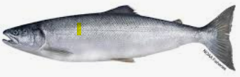
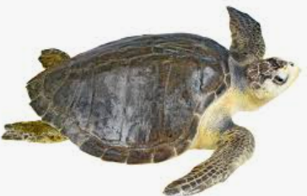
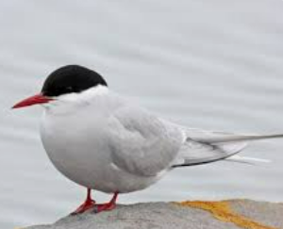

- Plant & Animal Adaptations Crossword Puzzle
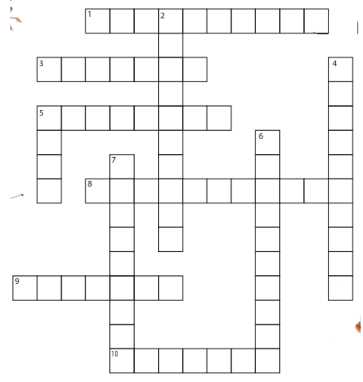

ACROSS
1. Type of adaptation is based on how an organism acts.
3. Environment or natural home that an organism lives.
5. Prey is attacked by its __________.
8. Natural world or surroundings in which an organism lives - similar to habitat.
9. Type of behaviour that happens from experience or watching others.
10. An animal or plant must adapt to its environment in order to _____________.
DOWN
2. Change in behaviour or structure in order to survive.
4. Type of adaptation based on body parts or coverings.
5. A predator goes after its ______.
6. Type of adaptation in which an organism blends into its environment.
7. A behaviour that comes naturally. An organism is born with it.

- Make a flow diagram to show the stages of agriculture:

- Identify and name the methods of reproduction shown in the following pictures:
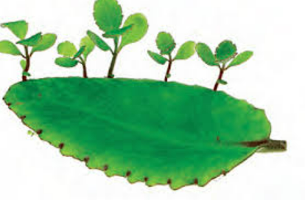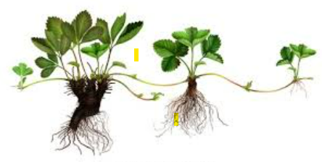
- _____________________ b. __________________________
- Label the parts of seed:
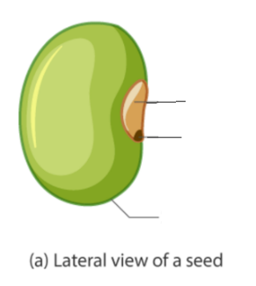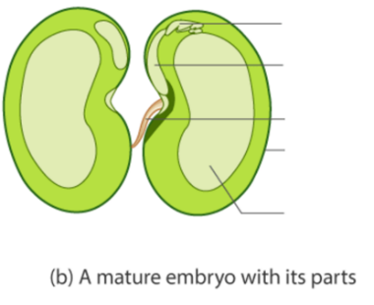

- Complete the table below.
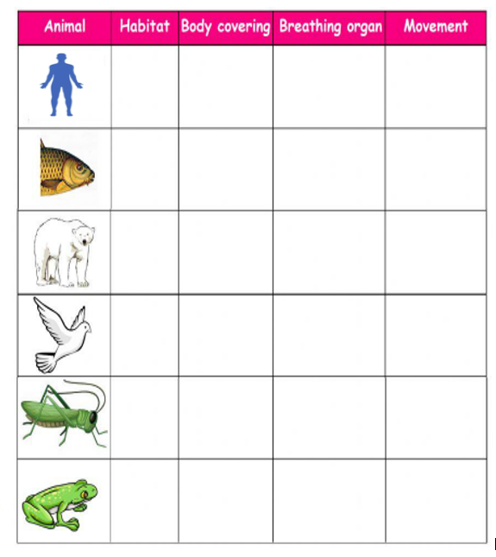

I. Identify the pictures and write their habitat:
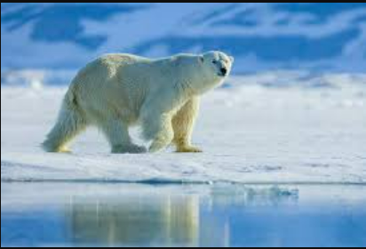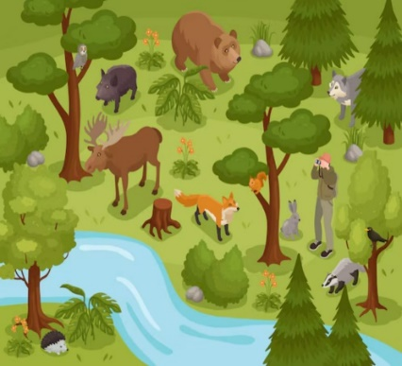
a.________________________________ b._____________________________

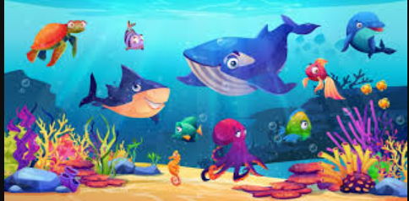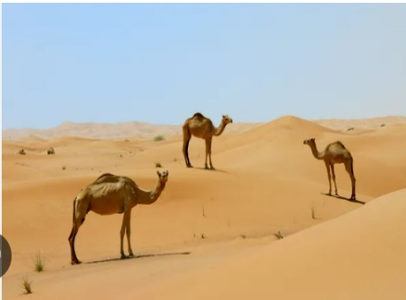
c.__________________________________ d.______________________________

III. Identify the kind of Movement for the following:
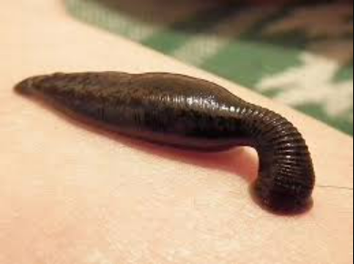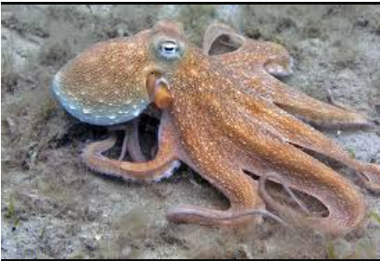
a._______________________________ b.____________________________

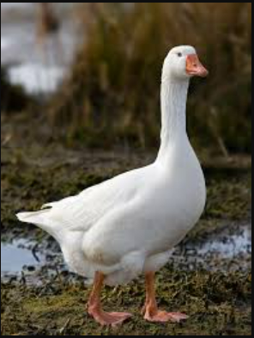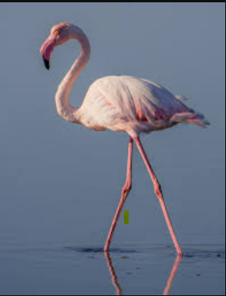
c._______________________________ d. ______________________________
IV. Who am I?
- I am a bird that uses my long beak to sip nectar from flowers.

- I am a reptile with powerful jaws and sharp teeth used for tearing apart my prey, often found in rivers and swamps.

- I am a scavenger with strong jaws and sharp teeth that allow me to tear through tough hides and bones

- I am a bird that hunts small mammals and fish with my sharp talons and beak.
- I am an animal that uses my long tongue to catch ants and termites. My diet consists mainly of insects.
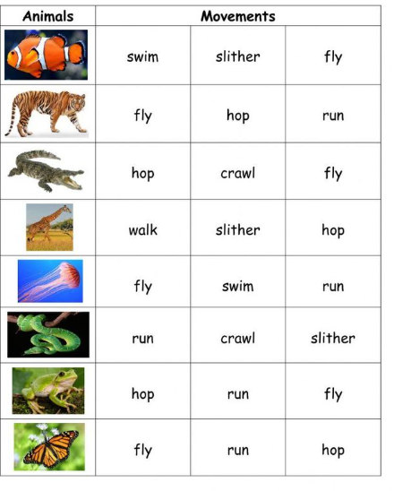S
