
BRINDAVAN ANGLO VEDIC INTERNATIONAL SENIOR SECONDARY SCHOOL
Affiliated to CBSE, New Delhi
Name: SCIENCE WORK SHEET DATE:
STD: V

- Label the parts of seed and write function for each:

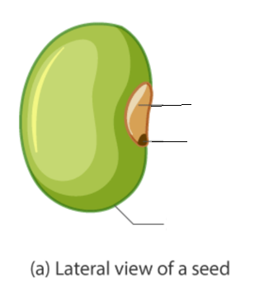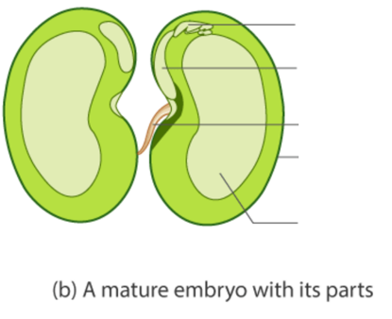
_________________________________________________________________________________________
_________________________________________________________________________________________
_________________________________________________________________________________________
_________________________________________________________________________________________
_________________________________________________________________________________________

- Write few examples for the following:

Monocot seeds | Dicot seeds
__________________________________________  __________________________________________  __________________________________________  __________________________________________ | __________________________________________  __________________________________________  __________________________________________  __________________________________________

- Explain the process of germination with help of a diagram:

- In each group Identify and mention few rabi and kharif crops:

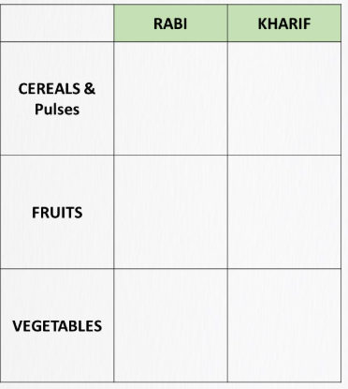
- Number the following images in proper sequence to show the correct order of steps involved in agriculture:

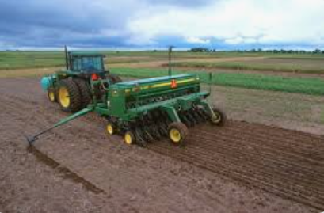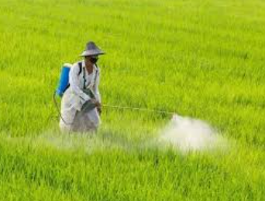

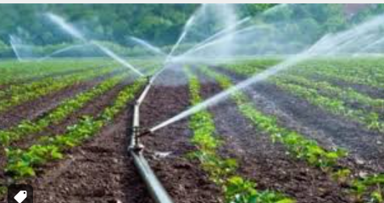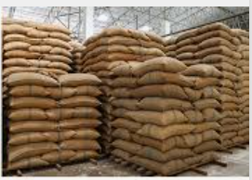

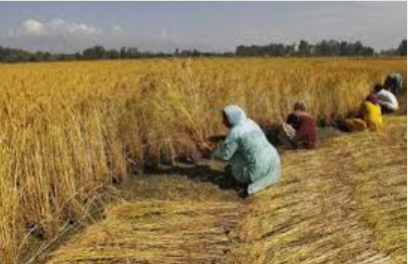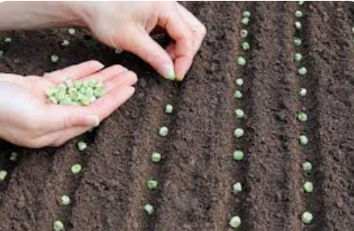

- Collect the picture of any found in different habitats and highlight the adaptations that help them to survive in those regions.

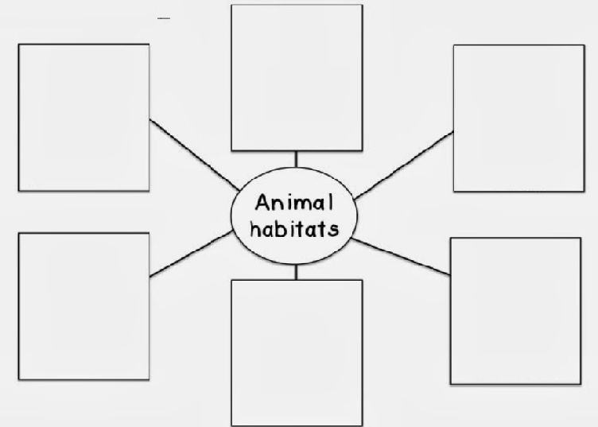

VII. Identify and name the methods of reproduction shown in the following pictures:

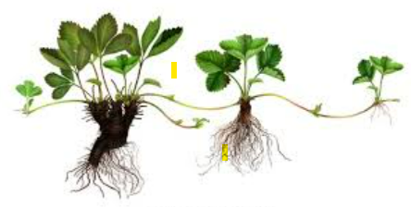
- _____________________ b. __________________________

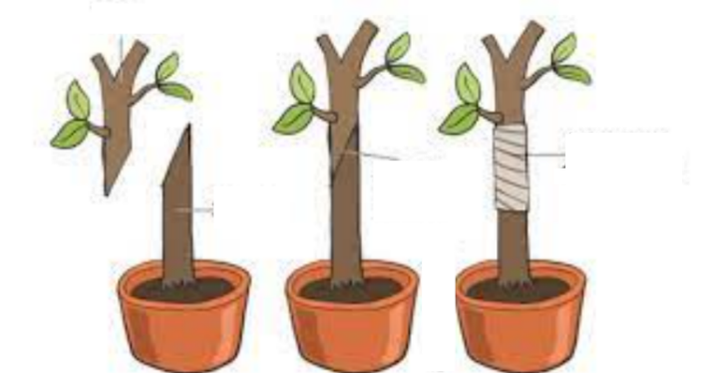
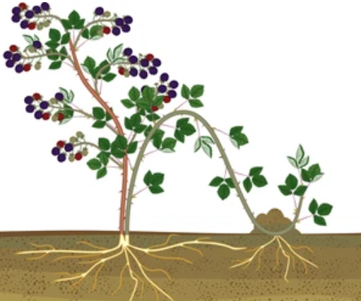

c. _________________________ d. _________________________
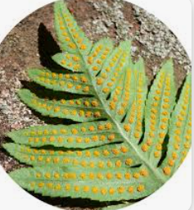
e. ______________________ d. __________________

- Identify the name of the species and their migration:

Pictures | Name of the species | Place of migration
