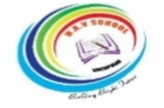
BRINDAVAN ANGLO VEDIC INTERNATIONAL SENIOR SECONDARY SCHOOL
Affiliated to CBSE, New Delhi
Name: PERIODIC ASSESSMENT - III DATE:
STD: V SCIENCE
SECTION - A
I. MCQ: 10 X 1 = 10
- A break or crack in bone is called a _________
- rabies (b) victim (c) fracture (d) bandage.

- We should wear only ____ clothes while lighting crackers.
- nylon (b) polyster (c) cotton (d) synthetic.

- _____ is a person who has been attacked or injured.
- axle (b) force (c) victim (d) fire

- ____ is a disease caused by an animal bites
- cholera (b) common cold (c) fatigue (d) rabies.

- _____ should not be used for electical fire accidents
- water (b) splint (c) sprain (d)wasp.

- The _____ of the earth pulls object towards its center.
- friction (b) gravity (c) magnet (d) heat

- Plants use _______ energy from the sun to prepare food.
- light (b) magnet (c) gravity (d) force

- A wheel attached to a rod is called ___________.
(a) Axle (b) axe (c) crane (d) magnet
- In magnet, unlike poles _____________ each other.
- Repel (b) attract (c) both a & b (d) none of these

- Sound energy is produced by the _____________ of objects.
- Light (b) heat (c) vibration (d) none of these
SECTION B
II. Answer the following (any 4): 4 X 2 = 8
- What is sprain?
- What should be done in case of a gas leakage?
- What is simple machine?
- An object thrown upwards goes up and then falls down to the ground. Give reason.
- What is friction?
- What is a fire extinguisher?
SECTION – C
III. Answer in detail (any 1): 1 X 4 = 4
- Write the various methods of putting out fire.
- What is lever? Explain the types of lever with one example of each?

SECTION - D
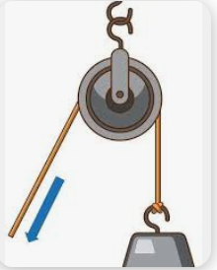
IV. Picture talk: 4 X 1 = 4
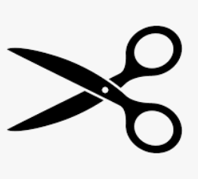

19. _________________ 20. _____________________
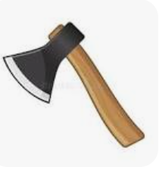
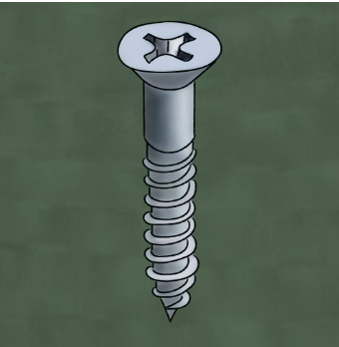

21. _________________ 22. _____________________
SECTION E
V. Case study: 4 X 1 = 4
23. The sun and the eight planets that revolve around it together form the solar system.The sun is at the center of the solar system. Mercury is the smallest planet of the sun. Venus is the hottest and brightest planet. The earth is also called the blue plant.
Questions:
- The ___________ is at the centre of the solar system.
- Which is the smallest planet in the solar system?
- _____________ is the brightest and hottest planet in the solar system.
- Mercury (b) Venus (c) Earth (d) Mars
- Which planet is called as blue planet?

