
BRINDAVAN ANGLO VEDIC INTERNATIONAL SENIOR SECONDARY SCHOOL
Affiliated to CBSE, New Delhi
Name: SCIENCE WORK SHEET DATE:
STD: V

- Observe the pictures given below and write the type of accidents/ injury shown in each.

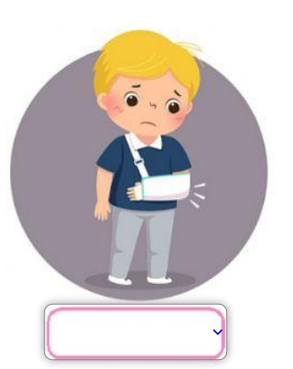
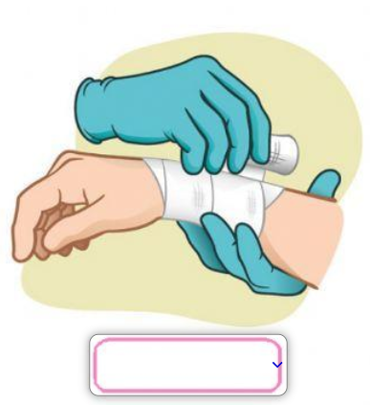
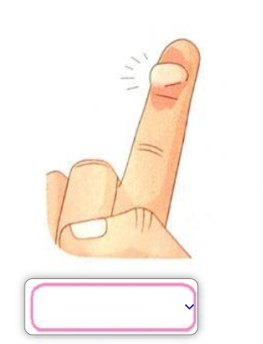

- Choose the correct answer:

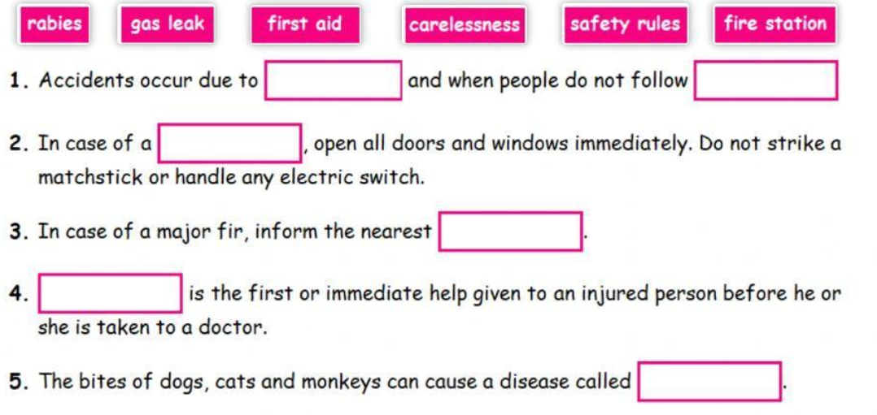

- Find the type of lever and locate the fulcrum, load and effort in the following images:

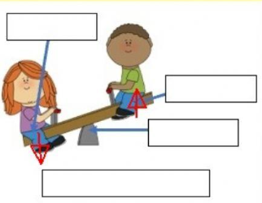
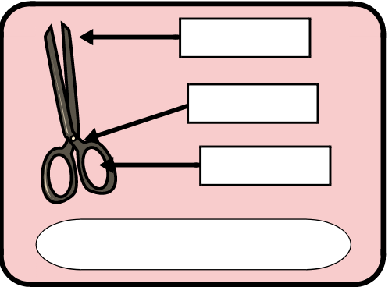

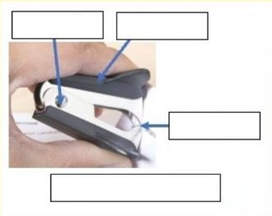
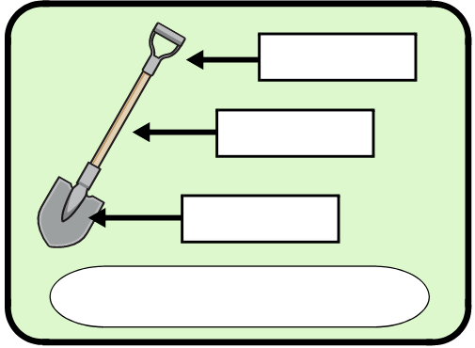

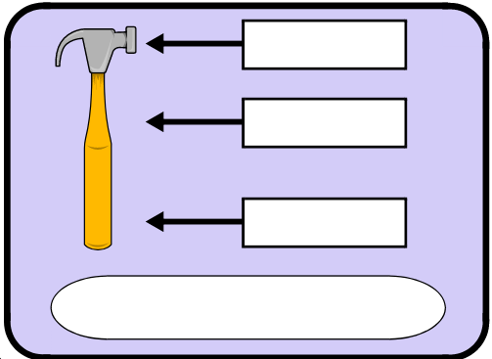
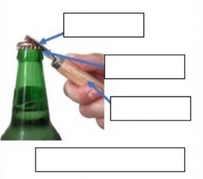

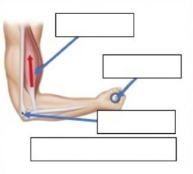
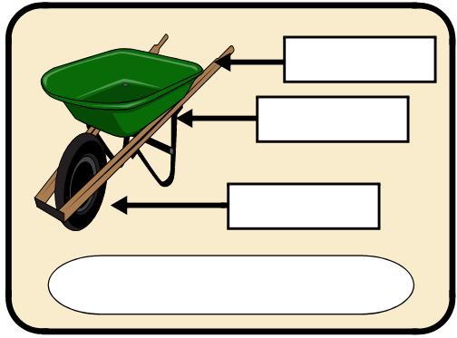

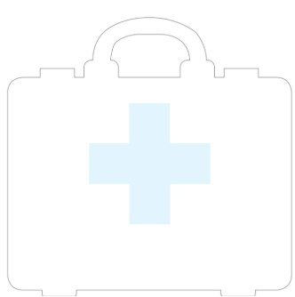
- Draw or stick pictures of what you think should be inside a first aid kit in this empty one:

- Identify what kind of action is performed in the following pictures either pull or push:
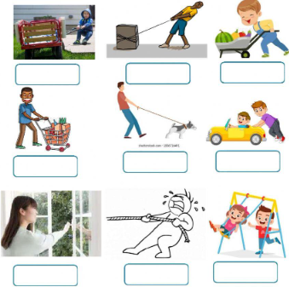

- Resolve the following cross word:
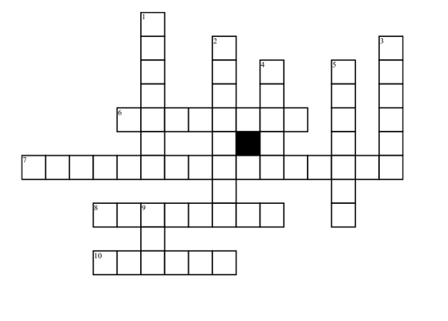

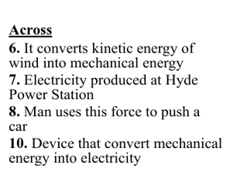
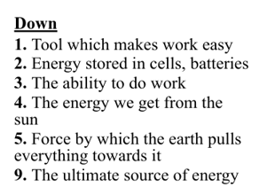

- Identify the transformation of energy based on the activities listed in the table:
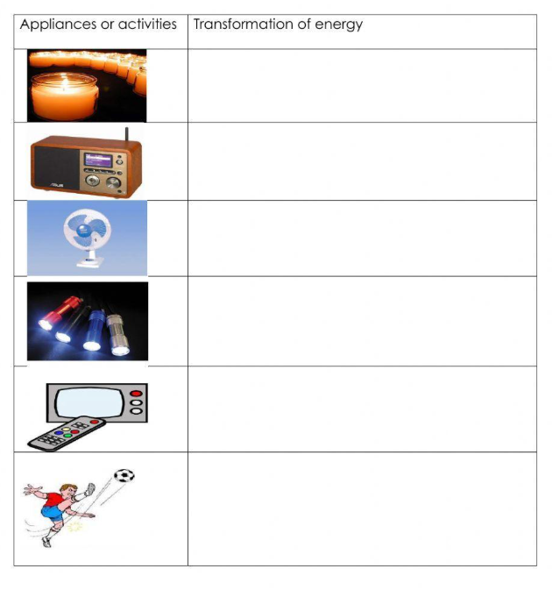

- Find the scramble words related to first aid:
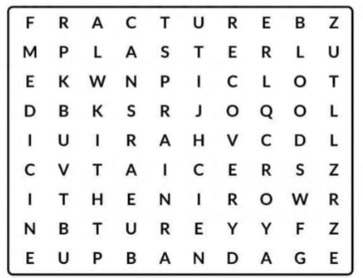

- Identify the simple machines shown in the picture given below. Write the name and the type of each in the space provided:
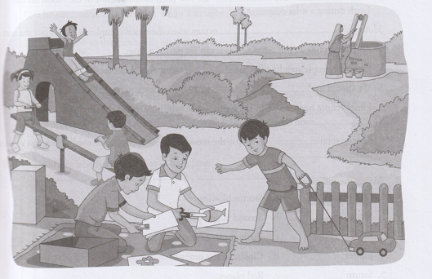

1. _________________________________________________________________________
2. _________________________________________________________________________
3. _________________________________________________________________________
4. _________________________________________________________________________
5. _________________________________________________________________________
6. _________________________________________________________________________

