Today i try to understand TIME SERIES API on our project.

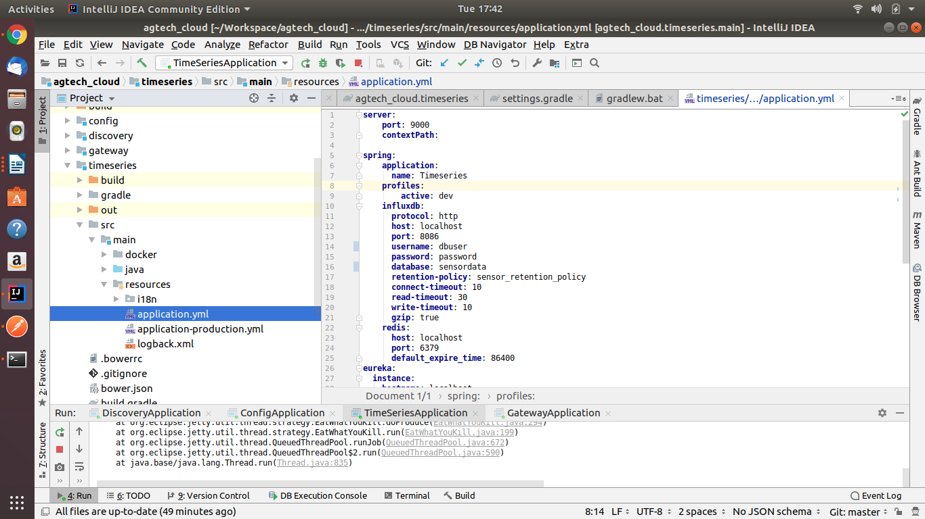
Time series Api run on portno:9000

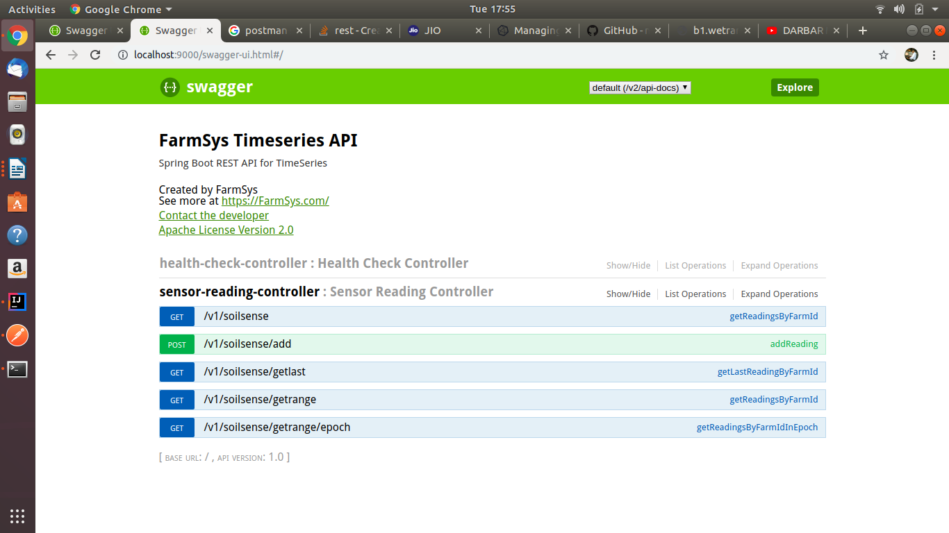

Health Check Controller Run Fine:

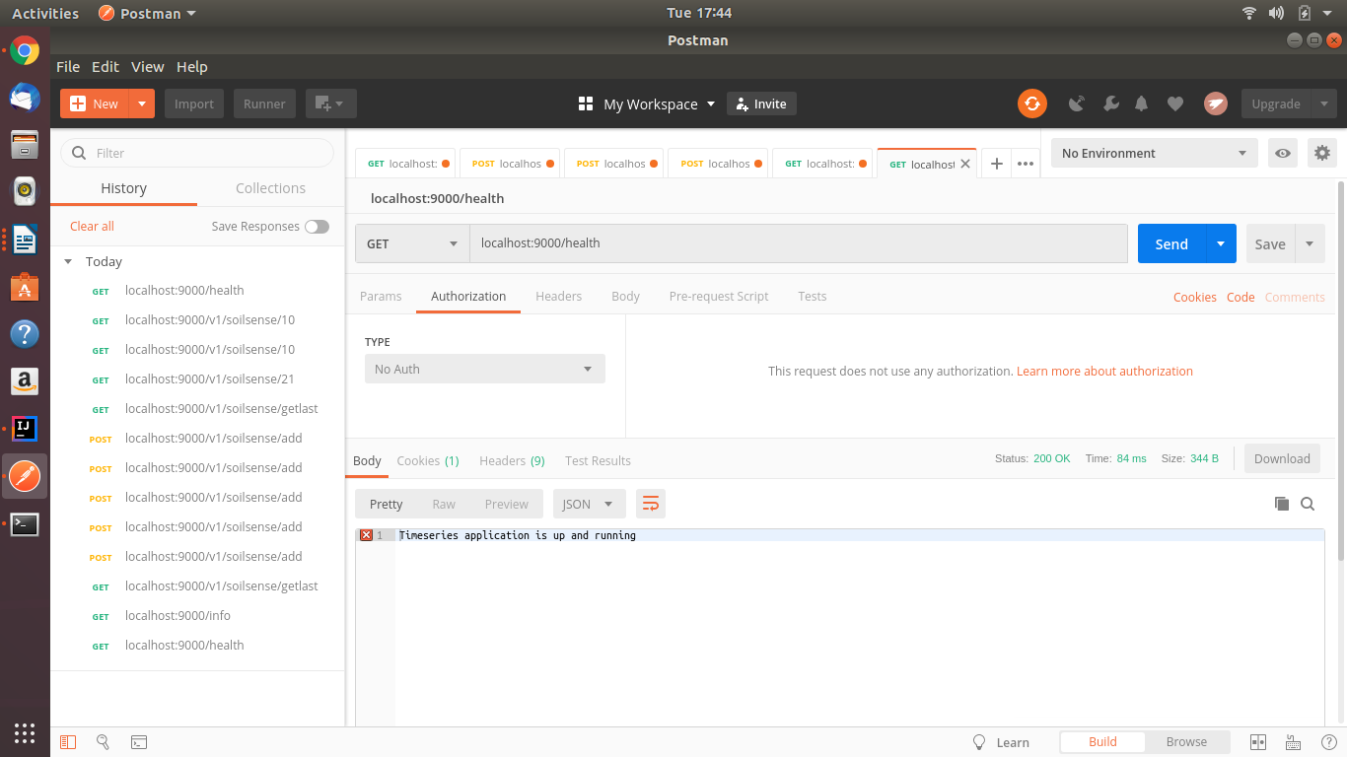
Sensor Reading Controller:
first start influxdb server
create measurement reading in influxdb

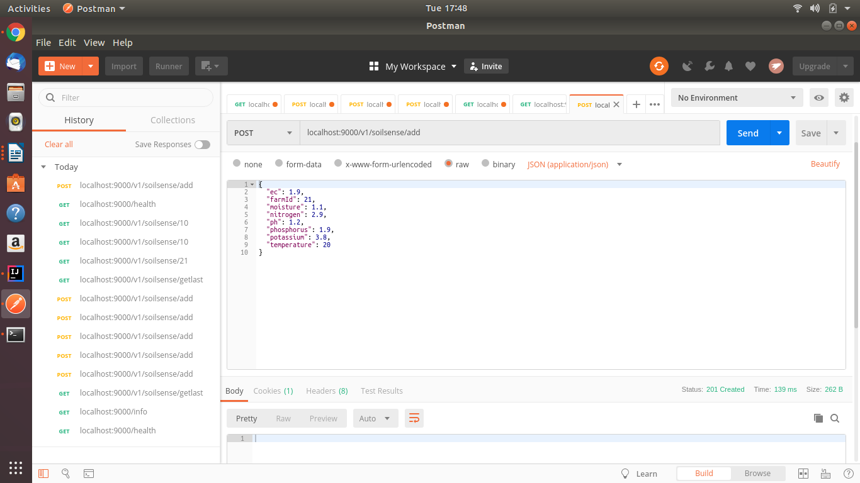
Time series Api Use Influxdb (not mysql)

Post Method work perfect
i check influxdb
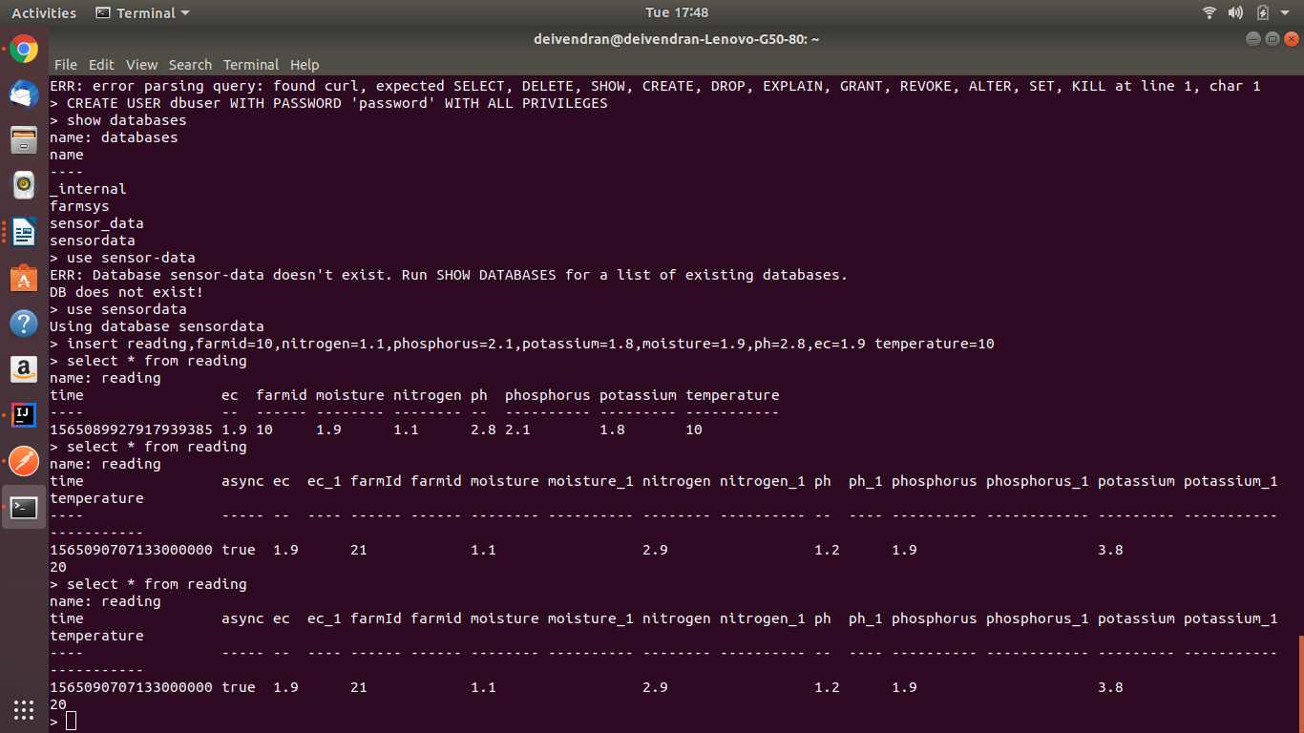

another 3 get Method not working error

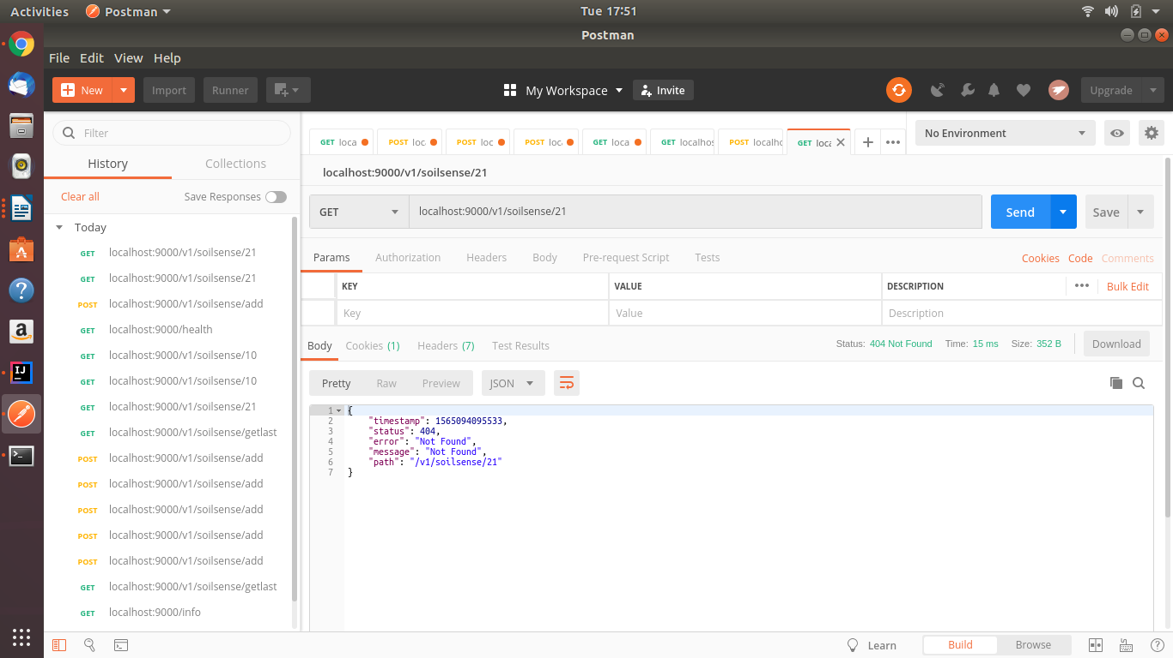

3 get method i got error .i rectify tommorow otherwise i ask to sibasis sir.

