HOME PAGE UPDATE:
- Re-create BCP Specialists Card like below Content :
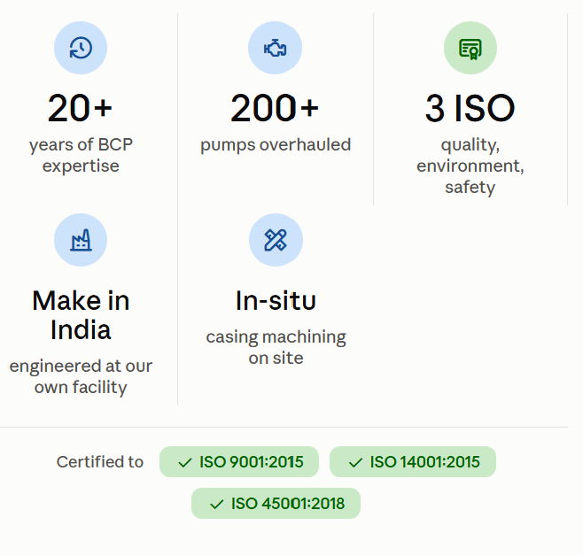

- REMOVE this section: 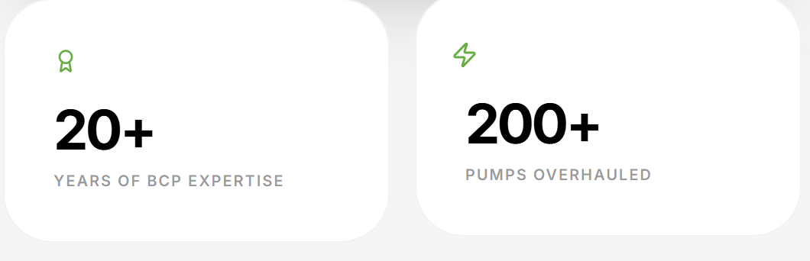
- REMOVE: VALUE PROPOSITIONS SECTION
- REMOVE: COMPANY OVERVIEW SECTION

