# B. 4 IMPLEMENTATION (Maximum 6 pages)

## B.4.1 Quality of infrastructure/facilities and international collaborations of host (outgoing - Berkeley)

Please Berkeley complete

## B.4.2 Quality of infrastructure/facilities and international collaborations of host (return - TUM)

In recent years, the Technische Universität München (TUM) has been consistently ranked the top academic institution in Germany in several independent rankings. It provides an excellent environment (likely the best in Germany) by substantial funding from the Bavarian state government, the German government and many private companies alike. One of the missions of the university is to boost interdisciplinary research across engineering, natural sciences, medicine, and humanities. Today the TUM comprises 13 faculties with more than 23,000 students (about 20 percent of whom come from abroad shows the degree of internationalization), 420 professors, and roughly 6,500 academic and non-academic staff. In electrical engineering the percentage of foreign students reaches up to 40%. The TUM is thus well positioned to create new knowledge and know-how in Europe and the world.

In 2005 the federal and state governments started the so-called Excellence Initiative in Germany. Between 2006 and 2011 they will fund the expansion of top university research with up to 1.9 billion Euros in three funding categories: graduate schools, clusters of excellence and institutional strategies for universities. The TUM was recognized as one of the first three universities that succeeded in all three categories.

The corporate concept “TUM The Entrepreneurial University” supports and advances the existing TUM strategy and promotes top-level research on multiple levels. In this context ‘Entrepreneurial Spirit’ means to activate the diversity of human talent in a concerted, interactive way. In terms of top-level research, it entails combining a maximum of individual freedom with a supportive administration.

The proposed **returning host** is the TUM **Intelligent Autonomous Systems Group** (**IASG**[1]) from Professor Michael Beetz in the Munich city centre, and its extension of the Munich Garching Campus. The Chair consists of two full-time professors, 1 Junior Research Group Leader, 15 Ph.D. students, 2 secretaries.

This very dynamic Chair challenges successfully[2] seven main research topics: Perception for Robots; Knowledge Processing; Plan-based Control; Cognitive Manipulation; CRAM (???); Perception of Human Activities; Facial Expression Recognition.

Its Ph.D. students co-supervise student projects and nurture a solid number of workshops and seminars in German and English, ranging from ROS technologies, Knowledge Representation for Autonomous Robots (IROS 2011 Workshop for example), to 3D Perception in Robotics, Cognition-enabled Mobile Manipulation and up to Probabilistic Methods for Perceiving, Learning and Reasoning about Everyday Activities[3]. The Chair has extended contacts with the Industry, as evidenced by the number of student placements in companies in Munich and elsewhere in Bavaria, and the ongoing research collaborations with major players in the ICT domain. In particular in the robotics field, with companies such as Kuka GmbH, Aldebaran Robotics and others.

The solid and excellent student basis allows this Chair to further develop its scientific path and will give me on my return at TUM the possibility of enriching my skills (in research, technology transfer, teaching and training). In this context, I will benefit from the existing infrastructure to deliver thriving seminar courses to a talented student body. The recently established international CoTeSys Graduate School (2010) will extend its activities with the development of specific additional measures to qualify the next generation of Ph.D. students, which I will contribute to supervise and train.

The returning host IASG has extended research academic collaborations abroad (USA, Japan, South-Korea, Europe), which is a key asset in the context of this IOF proposal, as I will be called upon to contribute to the reinforcement of scientific and student exchanges with the USA and Berkeley University.

The IASG will give me the opportunity to benefit there of an excellent infrastructure with: a) an office of 15m2 fully furnished to perform my activity; b) administrative support; c) budget & financial support.

IT system infrastructure support is strong in Munich with Universities and therefore also this Group, having access to the famous Munich Leibniz-Rechenzentrum (LRZ)[4]. The LRZ is the computer centre for Munich's universities and for the Bavarian Academy of Sciences and Humanities. It takes care of the scientific data network in Munich, it offers a variety of data services, and it provides high-end computing facilities for the scientific community in Germany and beyond.

The TUM IASG is part of the TUM Faculty of Informatics, which is one of the largest Informatics departments of Germany[5]. This faculty has 2200 students, 36 professors, 300 assistants and scientific co-workers, of which almost half are paid with external grants, 115 technicians and administrative staff, ca. 30.000 m2 working surface. This EI TUM Faculty has also extended relations with the Industry, which makes credible the claim that all possible career plans and developments of the fellow are possible.

Prof. Beetz, IASG Director, is additionally a member and the vice-coordinator of the CoTeSys Cluster of Excellence[6] coordinated by TUM. It is a close collaboration between scientists from various disciplines connecting neuro-cognitive and neuro-biological foundations to engineering sciences at leading research institutions in Munich: besides Technische Universität München, scientists from Ludwig-Maximilians-Universität München - LMU, Universität der Bundeswehr, Max-Planck Institute of Neurobiology and German Aerospace Agency DLR are involved (all are shown on the map above). CoTeSys investigates cognition for technical systems such as vehicles, robots, and factories. Cognitive technical systems are equipped with artificial sensors and actuators, integrated and embedded into physical systems, and act in the physical world. They differ from other technical systems since they perform cognitive control and have cognitive capabilities. By cognitive capabilities they mean information processing that take into accounts: perception, attention, memory, action, learning, and planning. The aim of CoTeSys is to produce future innovations.

This will represent another opportunity for me to diversify my activities and find additional partners for R&D projects (whether academic and local, or industrial and spread in Europe).

The host has well-established collaborations with several national and international research groups working on the compression and transmission of multimedia content over wireless and wired networks. Current active collaborators include: Prof. Bernd Girod (Stanford University), Prof. Thomas Wiegand (TU Berlin), Prof. Pascal Frossard (EPFL Lausanne), Prof. Abed El Saddik (University of Ottawa), Prof. Subhasis Chaudhuri (IIT Bombay), Prof. Chang-Wen Chen (New York State University at Buffalo), Prof. Ernst Biersack (Insitute Eurecom, Sophia-Antipolis), Dr. Jacob Chakareski (EPFL Lausanne), Dr. Wolfgang Kellerer (DoCoMo Euro-Labs), Dr. Uwe Horn (Huawei), and Dr. Thomas Stockhammer (Nomor Research).

For Dejan to improve

In addition, on the educational side, the host cooperates with well-known institutions around the world. Some collaborations have led to joint degree programs or extensive student exchange (e.g. double master program with the Georgia Institute of Technology, TEMPUS program with the American University of Beirut, student exchange with the NCKU in Taiwan).

Check if any

## B.4.3 Practical arrangements for the implementation and management of the project at TUM

I will be inserted, as depicted below, in the robust management structure of the IASG. My direct connection with Professor Michael Beetz, enriched by my interaction and supervision of students (currently 15 Ph.D. students and 15 M.Sc. students), will ensure the success of the project.

Prof. Michael Beetz, PhD

Professor

Head of the IAS Group

Computer Science Department

**Grant implementation:**

Eric Bourguignon (CoTeSys Proposal Manager), who has been associated to the non-scientific writing of this proposal, will deliver to the IASG a set of Marie-Curie FP7 tools to manage the project, based on his long-years experience of EU grants management in the FP6 and FP7 programs. The tools to be developed specifically for the projects will include the basic synopsis of all contractual issues related to the project, the yearly reporting ready-to-use templates (science and finance) and regular follow-up meetings with me and the Chair team to ensure a quality delivery of the expected results. The management style will aim at letting as much autonomy in the budget controlling to me as possible. Both administrative staff members, Mrs. Walter and Mrs. Wagner, will take their load to ensure the smooth running of the project.

**Chairs investments on this project:**

It is estimated that Prof. Beetz will spend 1,5 person-month on this project on the 36 months of the project duration. The Chair will lead regular reviewing of the project and make first sure that the new fellows integrate into the existing Chair structure. My re-integration in year 3 will be facilitated by my current knowledge of the University structure, its people, its finance, its other support services.

From their arrival, through the search of national and international funding programs to the development and the promotion of new projects, the recruited TUM scientists receive high quality services from the University, e.g. from **TUM Office for Research and Innovation** (**TUM-Forte**), the Welcome Office, the TUM Corporate Communications Centre and the **TUM Patent and License Office**. I know them, and will re-learn quickly how to interact with them.

* I will be associated to the weekly group meetings and the yearly retreat.
* A strong involvement from me will be expected in the design and monitoring organization of main national and international workshops (e.g. please complete). I will then coordinate teams of students to ensure that these events are successful.
* From the beginning, I will fully dispose of my own travel budget to attend international high-level conferences as well as to develop my own scientific network and scientific partnerships.
* I will supervise Ph.D. students and Master students.

All details have been agreed in common with Prof. X at Berkeley and Prof. Beetz at TUM, during the preparation of this project proposal.

## B.4.4 Feasibility and credibility of the project, including work plan

In Sections B.1.1 and B.1.2 we detailed the three tasks to be carried out in this project, including the research methodology and the expected results. In the figure below we have represented the work plan including the three research tasks, plus an additional extra task for the fellowship's training, and we assigned an approximate time schedule for each of them.

Task 0

Task 1

Task 2

Task 3

Year 1 Year 2

**Task 0.** We have explicitly dedicated part of the first year for training in advances in xyz. As first step, I would like to enhance my knowledge of xyz, with particular attention to the related xyz algorithms and statistical models adopted. In this period, I will attend some courses and I will interact weekly with Prof. xyz at Berkeley about my specific needs for the research training.

**Task 1.** The xyz will be the first task. I have previous experiences in xyz. By combining my background with the new knowledge acquired, we believe it will be feasible to accomplish this task. This task will last for one year (or a little bit less). By the end of the first semester we expect to have the first results in terms of identification and preliminary design of a suitable model we can use. By the end of the first year instead, we believe to complete the xyz by fixing a definitive model and by entirely characterizing its behavior in comparison with the most common state of the art models.

**Task 2.** We will start with the xyz six months later and it will take around six-eight months. This task has several aspects correlated with the xyz developed and there will be clear benefit of developing them in parallel. I am familiar with the most common xyz optimization techniques, and the related tools useful to analyze the xyz behavior. Thanks to this, even if this task is challenging, we expect to have publishable results within the first year.

**Task 3.** After a year working in Tasks 1 and 2 and having completed the fellowship's training, we will start the third and last task, involving the study of practical scenarios where the proposed scheme can be applied. This task will last for the final year of the project. We would like to devote half of the project time to this task since, in principle, there are several applications of great interest that can be considered and the design of an efficient solution would represent alone a significant research result. In the first six months we intend to study and design systems for xyz, while in the last six months we will investigate suitable applications to xyz. We plan to obtain publishable results after the first six months for the first family of applications, and by the end of the second year for the second family. Depending on the obtained results we will decide if it will be more convenient to publish them separately or jointly as a unified solution for both scenarios, that can be differentiated depending on the application.

## B.4.4 Practical and administrative arrangements and support for the hosting of the fellow

B4.4.1 – At Berkeley

Please describe

B4.4.2 – At TUM

The language center of TUM offers an extensive language and cultural training program in German with both regular and intensive (crash) courses. The courses range from beginner to advanced level. Details about the currently offered courses can be found at:

<http://portal.mytum.de/studium/sprachenzentrum/index_html>. I plan to participate to these advanced courses throughout the third year in order to increase my re-integration into the German society.

The dominant scientific language of the laboratory is English, including communication with administrative staff that can make the link to the external services.

The TUM has also a strong life-long learning training offer, which can be delivered in English on demand (from technology transfer, grant writing skills, to communication and entrepreneurship / business acumen).

To cover all practical arrangements I will benefit from the existing structure of the TUM Dual Career Office.

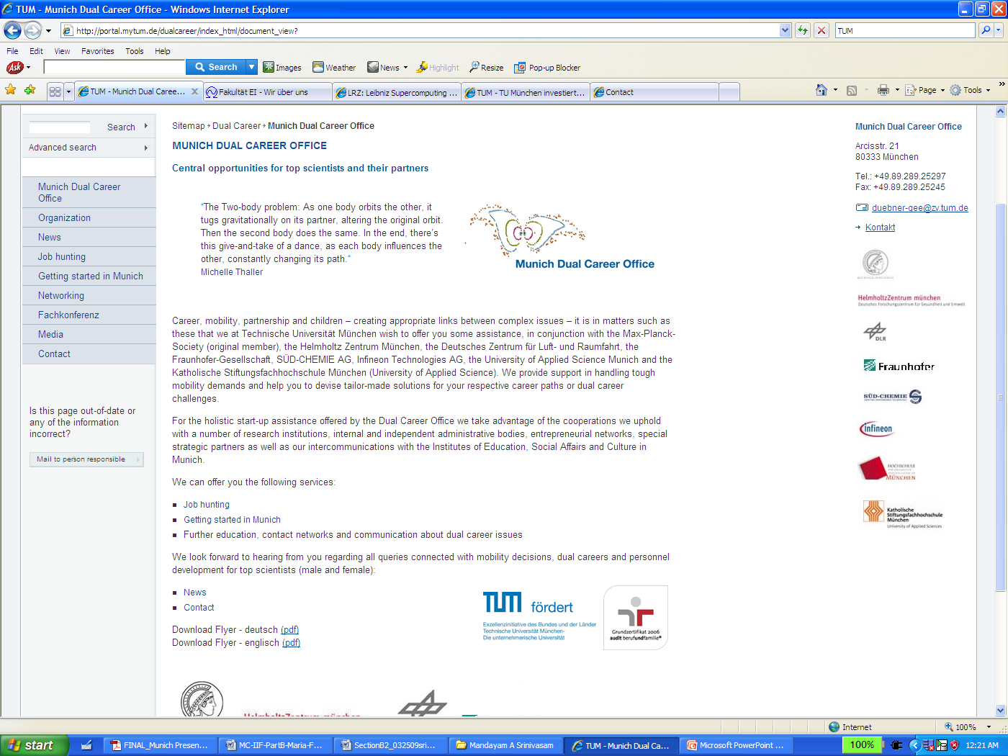

The Munich Dual Career Office[7] assists spouses/partners of top-level scientists, who are faced with various mobility needs. By means of a differentiated network of research institutions and industry along with institutes of education and social affairs, they provide assistance in mobility decisions through the development of individual solutions for dual career challenges. The Munich Dual Career Office is a service of Technische Universität München in collaboration with:

• Max-Planck-Society (founding member), Helmholtz Zentrum München

• German Aerospace Center (DLR) and Fraunhofer-Gesellschaft

• SÜD-CHEMIE AG, Infineon Technologies AG

• University of Applied Sciences – Munich and Katholische Stiftungsfachhochschule München

Through these collaborations the TUM Dual career Office can help for:

* Establishment of connections, development of strategies to look for career opportunities, support in job application procedures.
* Encouraging the integration of top-level scientists in Munich.
* Supporting in relocation issues.
* Answering to day care questions, schools, education, opportunities for recreational, cultural and social engagements, answers to transportation questions, access to further education in Munich.
* Facilitating nurseries (already the best place in Germany).
* Invitations to events relating to dual career concerns, pairing with mentors, communities, etc.

I will benefit from their help in order to find an accommodation and to get started in Munich again. The accommodation prices and the apartment hunting is an issue in Munich, but I already contacted the Dual Career Office, and they assured me that they will propose a low-cost accommodation for Guest Professors from the Munich Student Services for the first months to lower the initial costs and make my re-moving easy. Moreover, they offered me all their willingness to help me in finding a suitable long-term accommodation reasonably near to the University.

1. Description of the Intelligent Autonomous Systems Group is under: http://ias.cs.tum.edu/
2. List of recent publications is under: http://ias.cs.tum.edu/publications
3. http://ias.cs.tum.edu/events
4. http://www.lrz-muenchen.de/english/index.html
5. http://www.ei.tum.de/fakultaet/index_html
6. http://www.cotesys.org/
7. http://portal.mytum.de/dualcareer/index_html/document_view?