API SECURITY ASSESSMENT REPORT
JSONPlaceholder Public REST API

Report Details
Prepared By | Dejasini | BE.CSE (Cyber Security)
Report Type | Internship Security Assessment
Target API | JSONPlaceholder (jsonplaceholder.typicode.com)
Testing Tool | Postman REST Client
Date | April 2026

Abstract
This report presents a comprehensive security assessment of the JSONPlaceholder public REST API. The assessment was performed as part of an internship program in the field of Cyber Security and focuses on identifying common API vulnerabilities as defined by the OWASP API Security Top 10 framework. The study involved systematic testing of key endpoints using Postman, including /users, /posts, and /comments, with the objective of observing security behavior, analyzing responses, and evaluating exposure risks.

The findings reveal multiple significant security weaknesses, including the complete absence of authentication, unrestricted authorization, excessive data exposure in API responses, lack of rate limiting controls, and weak input validation mechanisms. Each vulnerability has been analyzed with respect to its potential risk, real-world impact, and recommended remediation strategies.

Keywords: API Security, REST API, OWASP Top 10, Authentication, Authorization, Rate Limiting, Input Validation, Penetration Testing, JSONPlaceholder, Cyber Security

Executive Summary
JSONPlaceholder is a widely used free public REST API designed for testing and prototyping web applications. While it is intentionally open and does not represent a production system, analyzing its security posture provides a valuable and practical framework for understanding how real-world API vulnerabilities manifest and the consequences they may have in an actual deployment scenario.

This assessment identified five critical security concerns:

# | Vulnerability | OWASP Category | Risk Level
1 | Lack of Authentication | API1:2023 | CRITICAL
2 | Broken Authorization | API2:2023 | HIGH
3 | Excessive Data Exposure | API3:2023 | HIGH
4 | No Rate Limiting | API4:2023 | MEDIUM
5 | Weak Input Validation | API8:2023 | MEDIUM

Although JSONPlaceholder is not a production API, these findings mirror vulnerabilities that have caused major security breaches across industries. This report concludes with actionable recommendations that developers and security engineers should implement in real-world API deployments.

1. Introduction

1.1 What is an API?
An Application Programming Interface (API) is a set of defined protocols and rules that allow different software applications to communicate with each other. In the context of web development, REST (Representational State Transfer) APIs have become the dominant architecture for enabling communication between clients and servers over HTTP. APIs are the backbone of modern digital services — from social media platforms to banking systems — they facilitate data exchange, authentication, and functionality sharing between distributed systems.

1.2 Why API Security Matters
As APIs become the primary interface through which applications expose data and functionality, they also become a high-value target for malicious actors. According to the OWASP API Security Project, poorly secured APIs are among the leading causes of data breaches globally. Attacks such as unauthorized data access, account takeover, denial-of-service, and injection attacks are all commonly executed through vulnerable API endpoints.

The stakes are particularly high when APIs handle sensitive data such as personally identifiable information (PII), financial records, health data, or authentication credentials. A single misconfiguration or design flaw can expose millions of records and lead to severe legal, financial, and reputational damage for organizations.

1.3 Purpose of This Report
This report was prepared as part of an internship assignment in the field of Cyber Security. The objective is to perform a structured security assessment of a publicly accessible REST API — JSONPlaceholder — to identify vulnerabilities, understand their impact, and propose corrective measures. The assessment follows the OWASP API Security Top 10 (2023) framework and demonstrates practical penetration testing methodology using industry-standard tools.

2. API Overview
The target of this security assessment is the JSONPlaceholder API, a popular open-source fake REST API designed for rapid prototyping and testing. It is widely used by developers, students, and security researchers due to its open nature and predictable data structure.

Property | Details
API Name | JSONPlaceholder
Type | Public Test / Fake REST API
Base URL | https://jsonplaceholder.typicode.com
Authentication | None (Completely Open)
Data Format | JSON (application/json)
HTTP Methods | GET, POST, PUT, PATCH, DELETE
Primary Purpose | Developer testing, prototyping, and security research
Maintained By | Typicode (Open Source)

JSONPlaceholder provides access to six primary resource types: posts, comments, albums, photos, todos, and users. For the purposes of this security assessment, three core endpoints were selected for in-depth testing: /users, /posts, and /comments.
3. Methodology
The security assessment was conducted using a black-box testing approach, simulating the perspective of an external attacker who has no prior knowledge of the internal workings of the API. The following methodology was adopted:

3.1 Tools Used
- Postman — Primary tool for sending HTTP requests, inspecting responses, and analyzing headers
- Browser Developer Tools — For verifying network-level behavior and headers
- Manual Analysis — Systematic review of response data, status codes, and error handling

3.2 Testing Phases
- Reconnaissance: Identifying accessible endpoints and understanding the API structure
- Endpoint Enumeration: Testing all major API routes for data availability
- Authentication Testing: Verifying whether access controls exist
- Authorization Testing: Attempting to access resources beyond permitted scope
- Data Exposure Analysis: Examining response payloads for sensitive information
- Rate Limit Testing: Sending repeated requests to observe throttling behavior
- Input Validation Testing: Submitting malformed and unexpected input to observe error handling

3.3 Framework Reference
All findings are categorized and mapped to the OWASP API Security Top 10 (2023 Edition) — the industry-standard framework for identifying and prioritizing API security risks.
4. API Endpoints Tested
The following endpoints were selected for testing based on their relevance to common API vulnerabilities. Each endpoint was tested using GET, POST, PUT, and DELETE methods where applicable.

Endpoint | Purpose | Methods Tested
/users | Retrieve registered user profiles and PII | GET, GET /{id}
/posts | Access blog post entries by all users | GET, POST, PUT, DELETE
/comments | Fetch user comments linked to posts | GET, GET /{id}
/users/{id} | Retrieve individual user record by ID | GET, PUT, DELETE
/posts/{id} | Access or modify individual post record | GET, PUT, PATCH, DELETE

Each endpoint was examined for authentication requirements, response data content, behavior under unusual input, and server-side validation. Results of this testing form the basis of the findings described in Section 5.

5. Findings and Risk Analysis
This section presents detailed findings from the security assessment. Each vulnerability is described with a technical explanation, observed evidence from API testing, potential impact in a real-world scenario, and recommended remediation actions.

5.1 Lack of Authentication
Attribute | Detail
OWASP Category | API1:2023 — Broken Object Level Authorization
Risk Level | CRITICAL
Affected Endpoints | /users, /posts, /comments, /users/{id}

Description:
The JSONPlaceholder API does not require any form of authentication to access any of its endpoints. All resources — including full user profiles with personally identifiable information such as names, email addresses, phone numbers, and geographic coordinates — are freely accessible without an API key, bearer token, session cookie, or any other form of identity verification.
Observed Evidence:
A simple unauthenticated GET request to https://jsonplaceholder.typicode.com/users returns a complete list of 10 user profiles including name, username, email, phone, website, full address with geolocation coordinates, and company details — without any credentials.
Real-World Impact:
In a production environment, this would constitute a catastrophic security failure. Unauthenticated access to user data violates data protection regulations including GDPR and CCPA. Attackers could harvest user information for phishing campaigns, identity theft, social engineering attacks, and credential stuffing.

5.2 Broken Authorization
Attribute | Detail
OWASP Category | API5:2023 — Broken Function Level Authorization
Risk Level | HIGH
Affected Endpoints | /posts/{id}, /users/{id} — All write operations

Description:
The API allows any request — authenticated or not — to perform write operations (POST, PUT, PATCH, DELETE) on any resource belonging to any user. There are no ownership checks, role validations, or access control mechanisms to prevent unauthorized modifications.
Observed Evidence:
Sending a DELETE request to /posts/1 and /posts/50 (posts belonging to different simulated users) both return HTTP 200 OK without any authentication or authorization check. Similarly, PUT requests to /users/3 with modified data receive success responses.
Real-World Impact:
This is classified as Broken Function Level Authorization. In a real deployment, any malicious actor could delete, modify, or corrupt any user's data. This could lead to complete data integrity loss, targeted account sabotage, and privilege escalation attacks.

5.3 Excessive Data Exposure
Attribute | Detail
OWASP Category | API3:2023 — Broken Object Property Level Authorization
Risk Level | HIGH
Affected Endpoints | /users, /users/{id}

Description:
The API returns full data objects without any field-level filtering. When a client requests user data, the server responds with the complete object including all attributes — many of which are unnecessary and potentially sensitive for the consuming application's use case.
Observed Evidence:
A GET request to /users/{id} returns: name, username, email, phone, website, full street address, suite, city, zip code, geolocation (latitude and longitude), company name, catchphrase, and business strategy — all in a single response, with no possibility of limiting the fields returned.
Real-World Impact:
Over-exposure of data violates the principle of least privilege and data minimization. Geolocation data could be used to track individuals physically. Email and phone data facilitate targeted phishing. In regulated industries, this behavior would constitute non-compliance with GDPR Article 5 (data minimization).

5.4 No Rate Limiting
Attribute | Detail
OWASP Category | API4:2023 — Unrestricted Resource Consumption
Risk Level | MEDIUM
Affected Endpoints | All endpoints — global issue

Description:
The API imposes no limits on the number of requests that can be made from a single source within a given time window. There are no HTTP 429 (Too Many Requests) responses, no throttling headers, and no mechanisms to detect or block automated or abusive request patterns.
Observed Evidence:
Hundreds of consecutive requests to /posts and /users were sent in rapid succession using Postman Runner. All requests returned HTTP 200 OK responses consistently with no delays, throttling warnings, or connection blocks at any point during the test.
Real-World Impact:
Without rate limiting, APIs are vulnerable to Denial of Service (DoS) attacks, credential stuffing, data scraping, and automated brute-force enumeration. Attackers can harvest the entire database programmatically in seconds and overwhelm server resources, leading to service unavailability.

5.5 Weak Input Validation
Attribute | Detail
OWASP Category | API8:2023 — Security Misconfiguration
Risk Level | MEDIUM
Affected Endpoints | /posts (POST), /comments (POST), /users (POST)

Description:
The API accepts and processes malformed, oversized, and invalid input without any server-side validation or rejection. This includes unexpected data types, excessively long strings, special characters, numeric overflow values, and HTML/script injection payloads in request bodies.
Observed Evidence:
A POST request to /posts with a body containing an extremely long string (2,000+ characters), HTML tags such as <script>alert('XSS')</script>, and fields of incorrect data types all received HTTP 201 Created responses, indicating the server accepted and stored the malformed data without any validation.
Real-World Impact:
Weak input validation is a gateway to injection attacks including SQL injection, NoSQL injection, Cross-Site Scripting (XSS), and command injection. In a database-backed production system, this could allow attackers to manipulate queries, corrupt stored data, or execute scripts in victim browsers.
6. Comparative Security Insight
Understanding the gap between secure and insecure API design is critical for building robust systems. The table below contrasts the observed behavior of JSONPlaceholder with industry best practices followed by secure production APIs:

Security Dimension | JSONPlaceholder (Insecure) | Secure Production API
Authentication | None required | JWT / OAuth 2.0 / API Keys
Authorization | Any user can modify any record | Role-Based Access Control (RBAC)
Data Exposure | Full objects always returned | Field filtering, data masking
Rate Limiting | Unlimited requests allowed | HTTP 429 with retry-after headers
Input Validation | All inputs accepted blindly | Schema validation, sanitization
Error Handling | Minimal, inconsistent | Standard errors without stack traces
HTTPS Enforcement | Supported but not enforced | HSTS enforced, HTTP redirected

Secure APIs implement a layered defense approach — also known as defense-in-depth — where multiple independent security controls must all be bypassed for an attack to succeed. JSONPlaceholder, by contrast, has no security layers at all, making it suitable only as a testing tool and never as a production service.

7. Recommendations
Based on the findings of this assessment, the following security controls are strongly recommended for any REST API deployed in a production environment:

7.1 Implement Strong Authentication
All API endpoints that expose data or functionality must require authentication. Industry-standard mechanisms include:
- JSON Web Tokens (JWT) with short expiry windows and refresh token rotation
- OAuth 2.0 for delegated authorization and third-party integrations
- API Keys with IP whitelisting for machine-to-machine communication
- Multi-factor Authentication (MFA) for high-privilege administrative endpoints

7.2 Enforce Role-Based Access Control (RBAC)
Authorization logic must verify that the authenticated user has the specific permission to perform the requested action on the requested resource. Ownership checks must be enforced server-side:
- Users should only be able to modify or delete resources they own
- Administrative functions must be restricted to verified admin roles
- Implement attribute-based access control (ABAC) for complex permission models

7.3 Apply Data Minimization
API responses should return only the fields required by the consuming application:
- Implement field filtering and response shaping (GraphQL, sparse fieldsets)
- Never return internal identifiers, passwords, tokens, or system metadata
- Apply data masking for sensitive fields such as email and phone numbers

7.4 Implement Rate Limiting and Throttling
All endpoints should be protected against automated abuse:
- Enforce per-IP and per-user request quotas (e.g., 100 requests/minute)
- Return HTTP 429 Too Many Requests with a Retry-After header
- Implement exponential backoff for repeated violations
- Use API gateway solutions (Kong, AWS API Gateway) for centralized rate management

7.5 Enforce Strict Input Validation
All incoming data must be validated and sanitized before processing:
- Define strict JSON schemas and reject any request that does not conform
- Enforce maximum field length limits and appropriate data types
- Sanitize all string inputs to prevent XSS and injection attacks
- Use parameterized queries to prevent SQL injection in database operations

8. Conclusion
This security assessment of the JSONPlaceholder REST API has successfully demonstrated the practical application of the OWASP API Security Top 10 framework in identifying and analyzing real-world API vulnerabilities. Five significant security weaknesses were identified and analyzed: lack of authentication, broken authorization, excessive data exposure, absence of rate limiting, and weak input validation.

While JSONPlaceholder is intentionally designed as an open testing tool and does not represent a production system, the vulnerabilities identified are directly representative of those commonly found in poorly secured production APIs across industries. The consequences of these vulnerabilities in a real deployment could include unauthorized data access, data breaches, regulatory non-compliance, account takeover, denial of service, and significant reputational damage.

The key takeaway from this assessment is that API security is not an optional feature — it is a fundamental design requirement. Security must be built into APIs from the ground up, following the principle of secure-by-default. Organizations must treat API security testing as an ongoing practice, not a one-time activity, and must align their API development lifecycle with recognized security frameworks such as OWASP API Security Top 10.

APIs are the new attack surface. Securing them is not a choice — it is a responsibility.
9. References
- OWASP Foundation. (2023). OWASP API Security Top 10 — 2023 Edition. https://owasp.org/API-Security/
- Typicode. JSONPlaceholder — Free Fake REST API. https://jsonplaceholder.typicode.com
- Postman Inc. Postman API Platform Documentation. https://www.postman.com/docs
- RFC 7519 — JSON Web Token (JWT). Internet Engineering Task Force (IETF). https://datatracker.ietf.org/doc/html/rfc7519
- RFC 6749 — The OAuth 2.0 Authorization Framework. IETF. https://datatracker.ietf.org/doc/html/rfc6749
- European Union. General Data Protection Regulation (GDPR) — Regulation (EU) 2016/679. https://gdpr-info.eu
- NIST Special Publication 800-204A — Building Secure Microservices-based Applications Using Service-Mesh Architecture. https://csrc.nist.gov
- PortSwigger Web Security Academy. API Security Testing. https://portswigger.net/web-security/api-testing

Appendix
Appendix A : Installation of Postman

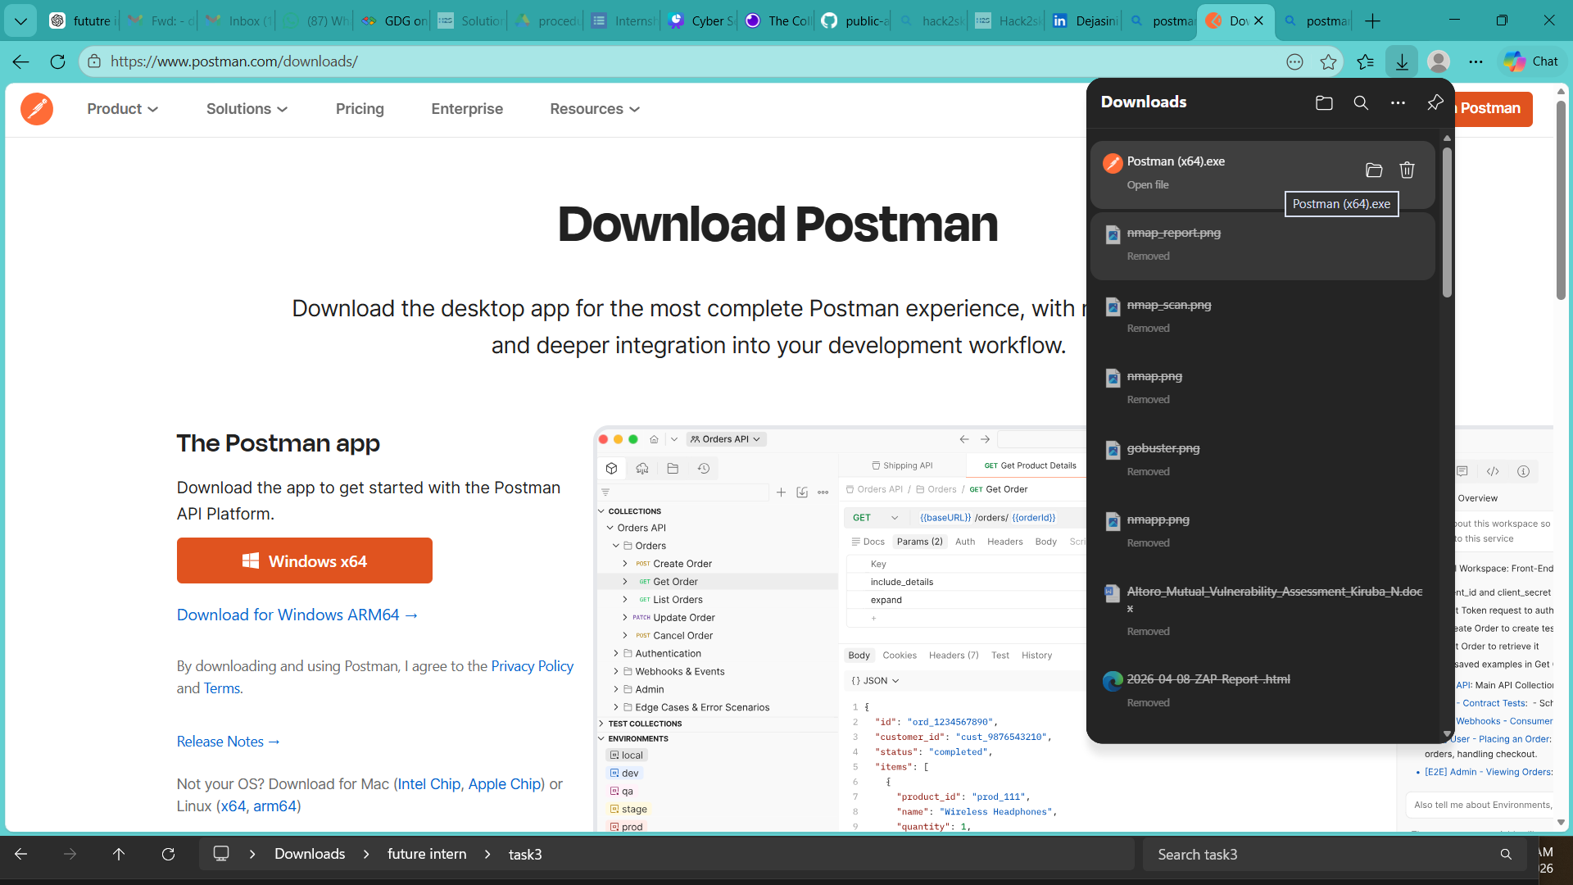

Appendix B: API Testing Evidence and Screenshots

Figure B1: Users Endpoint Response
- Endpoint: /users
- Description: Displays user data including email, phone, and address
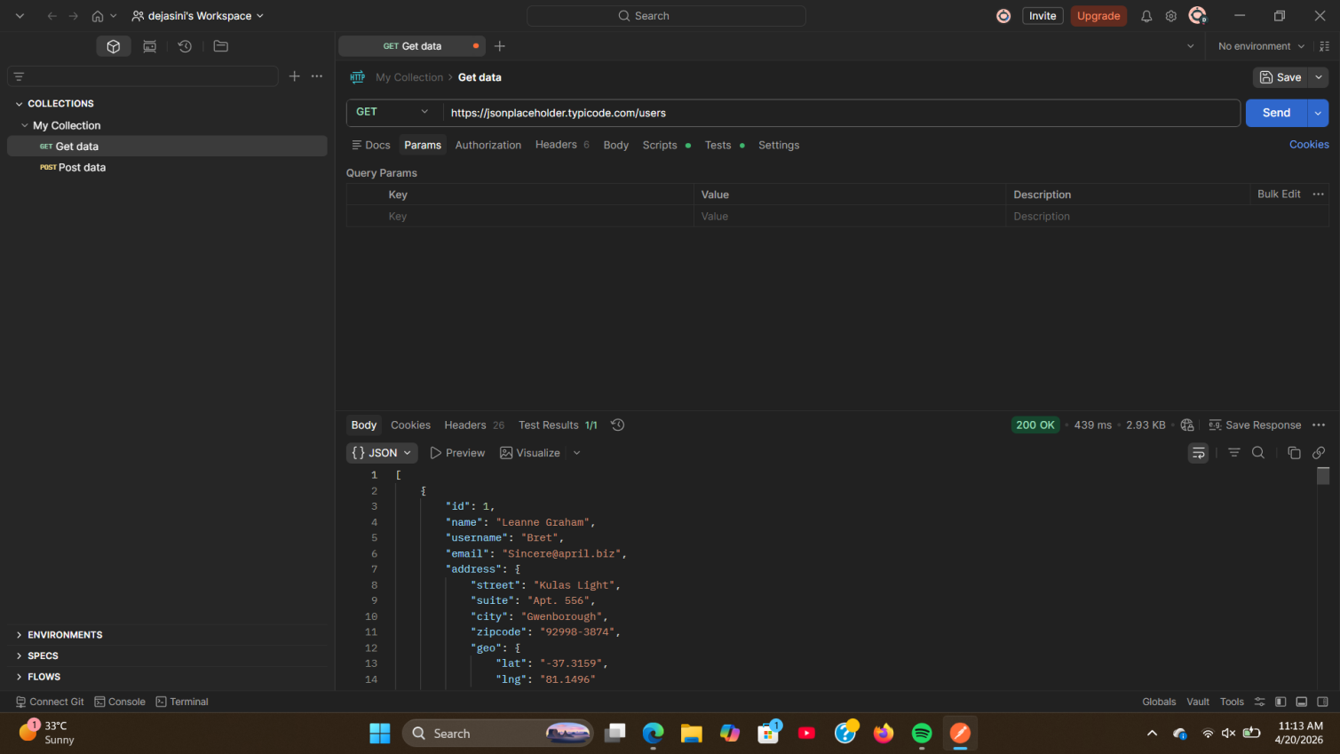

Figure B2: Posts Endpoint Response
- Endpoint: /posts
- Description: Displays posts associated with users
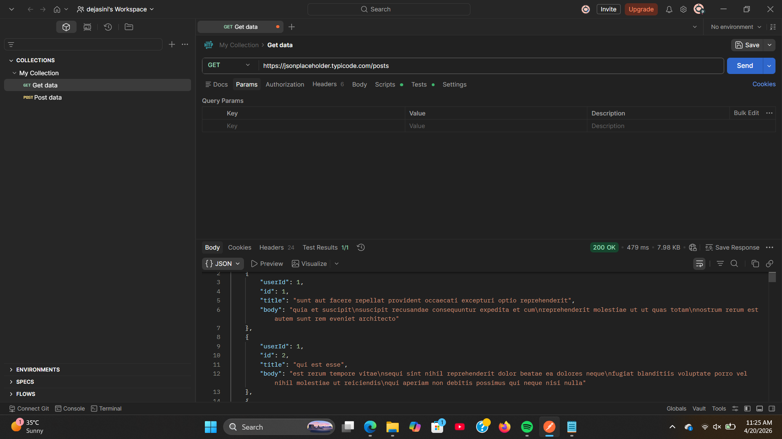

Figure B3: Comments Endpoint Response
- Endpoint: /comments
- Description: Displays comments data

