1. Design the simple calculator GUI

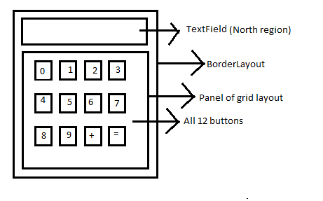

Enter number in the text field , + , = Should work to display addition.

1. Line drawing using MouseListener . From mousePressed location to mouseReleased location.

3. Display label (Name) .. TextField

Display three radio buttons Red , Green , Blue and whichever radio button is selected

change the color of a text field. (void setBackground(Color c))

4.

Name (TextField)

Course Joined (JComboBox).....( Java, .Net)

Paid Fees : (TextField)

OK Button

As the user will select OK button, display name, which course joined ,accordingly display fees. (for Java..fees 4500 , .Net .. fees 6400), paid fees and also display pending fees.