metin içeren bir resim

Açıklama otomatik olarak oluşturuldu

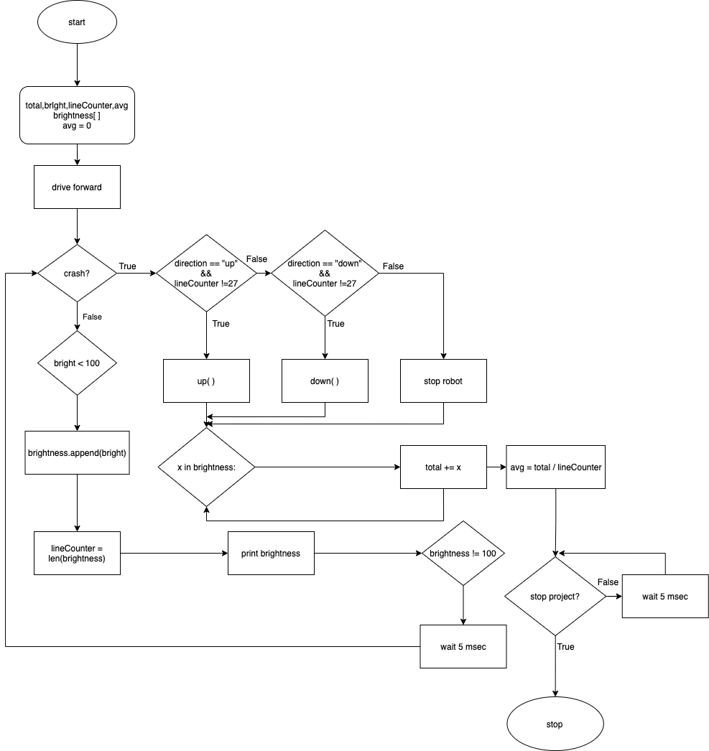

from vexcode import *

def up():

drivetrain.stop()

wait(5, MSEC)

drivetrain.turn_for(RIGHT, 90, DEGREES)

if drivetrain.rotation(DEGREES) != 90:

drivetrain.turn_for(RIGHT, (90 - drivetrain.rotation(DEGREES)), DEGREES)

drivetrain.drive_for(FORWARD, 400, MM)

drivetrain.turn_for(RIGHT, 90, DEGREES)

def down():

drivetrain.stop()

wait(5, MSEC)

drivetrain.turn_for(LEFT, 90, DEGREES)

if drivetrain.rotation(DEGREES) != 90:

drivetrain.turn_for(RIGHT, (90 - drivetrain.rotation(DEGREES)), DEGREES)

drivetrain.drive_for(FORWARD, 400, MM)

drivetrain.turn_for(LEFT, 90, DEGREES)

def getLineBrightness(lineCounter,bright):

brain.print(f"Brightness of {lineCounter}. Line: {bright}")

brain.new_line()

def avgLinesBrightness(total,lineCounter):

avg = total / lineCounter

brain.print("Average of Lines Brightness: ","{:.4f}".format(avg))

while not stop_project():

wait(5,MSEC)

def LinesBrightness(direction):

global total

global bright

global lineCounter

global avg

avg = float(0)

drivetrain.set_drive_velocity(100,PERCENT)

drivetrain.drive(FORWARD)

while not left_bumper.pressed():

wait(5, MSEC)

if down_eye.brightness(PERCENT) < 100:

bright = float(down_eye.brightness(PERCENT))

brightnesses.append(bright)

lineCounter = len(brightnesses)

getLineBrightness(lineCounter,bright)

while not down_eye.brightness(PERCENT) == 100:

wait(5,MSEC)

if direction == "up" and lineCounter != 27:

up()

LinesBrightness("down")

elif direction == "down" and lineCounter != 27:

down()

LinesBrightness("up")

else:

drivetrain.stop()

for x in brightnesses:

total += x

avgLinesBrightness(total,lineCounter)

def main():

global total

global brightnesses

global lineCounter

brightnesses = []

total = 0

LinesBrightness("up")

stop_project()

vr_thread(main())