metin içeren bir resim

Açıklama otomatik olarak oluşturuldu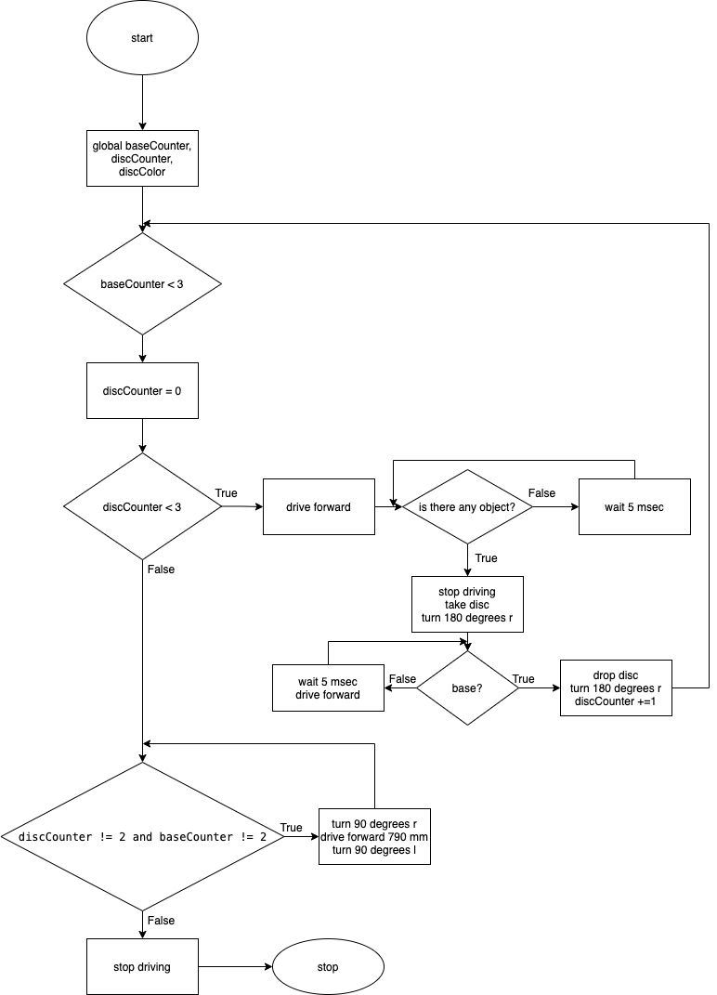

from vexcode import *

def colorDatas(bright):

global color

colorDict = {

58.7:"GREEN",

11.4:"BLUE",

29.9:"RED",

}

return colorDict.get(bright,"NONE")

def baseFinder():

if discCounter != 2 and baseCounter != 2:

wait(5,MSEC)

drivetrain.turn_for(RIGHT, 90, DEGREES)

drivetrain.drive_for(FORWARD, 790, MM)

drivetrain.turn_for(LEFT, 90, DEGREES)

else:

drivetrain.stop()

brain.print("Mission Accomplished")

def discMover():

global baseCounter

global discCounter

global bright

global color

global discColor

color = "a"

bright = 0

baseCounter = 0

while baseCounter <3:

discCounter = 0

while discCounter <3:

drivetrain.drive(FORWARD)

while not down_eye.near_object() == True:

wait(5,MSEC)

bright = down_eye.brightness(PERCENT)

color = colorDatas(bright)

drivetrain.stop()

magnet.energize(BOOST)

discColor = color

brain.print(baseCounter+1,". Line/ Color of",discCounter+1,". disc: ",discColor)

brain.new_line()

wait(5,MSEC)

drivetrain.turn_for(RIGHT, 180, DEGREES)

while not distance.get_distance(MM) < 200:

wait(5,MSEC)

drivetrain.drive(FORWARD)

magnet.energize(DROP)

wait(5,MSEC)

drivetrain.turn_for(RIGHT, 180, DEGREES)

discCounter += 1

wait(5,MSEC)

baseFinder()

baseCounter += 1

def main():

drivetrain.set_drive_velocity(100, PERCENT)

drivetrain.set_turn_velocity(100, PERCENT)

discMover()

stop_project()

vr_thread(main())