

Restaurant system

OOP2 Project Assignment 2016



November 30, 2016

Yeong De jong

T00185309

Table of Contents

1. Requirement Specification 2

2. Class Diagrams 6

3. VOPC Diagram 8

4. GitHub Logs 10

# Requirement Specification

**URL:** https://github.com/dejongyeong/OOP2_Project_2016/tree/master/RestaurantSys

The purpose of this project is to simulate a restaurant system that can be use by the user (owner) to record data. The system is implemented based on Graphical User Interface (GUI) that allows less complexity to the user.

First, when the owner of the restaurant invokes the system, the system prompts for username and password and do some validation before the system displays the main user interface. For this project, the system validates the username and password by checking if either username field or password field is empty. If both username and password is empty, it will display an invalid username/password error message.

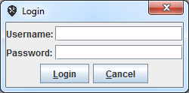 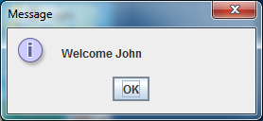

When user has successfully log in to the system, the system displays the main user interface which shows a welcome message, today’s date, today’s time, and some shortcut button on the user interface. The shortcut buttons allow user to have fast access to add staff details, add cuisine details, and add today’s sales value by just clicking on a button.

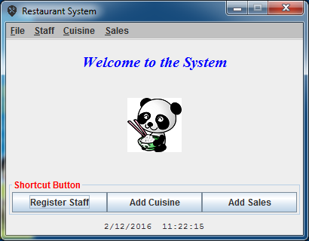

The system allows user to add a staff if staff is recruited. When user enters details for that staff, it validates the data entered. If empty field detected, it displayed an error message to ask if user want to continue to register staff. If user clicks ‘No’, it will return to main user interface, else it will re-prompt user for entering staff’s details.

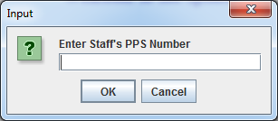 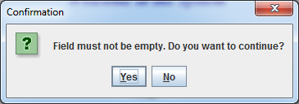

User can also view staff details. When user clicks ‘View Staff’ in main menu, system displays a list of staff’s name that are added into the system in combo box. When user selects the staff to view the staff details, the system will get the following staff details that user had selected and display the selected staff’s details to the user.

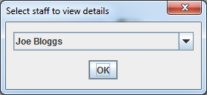 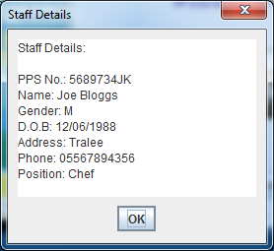

When a staff has been fired/withdrawn from the restaurant, user can remove the staff from the system. When user invokes ‘Remove Staff’ function, the system displays a list of staff’s name and let user to select the staff to be removed.

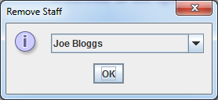

Other than that, the system also allows user to manage cuisines that are available in the restaurant. User can add a new cuisine if a new cuisine/dish is introduced. When user invokes the ‘Add Cuisine’ function, the system first prompt for user to select the cuisine category for that dish by displaying a list of cuisine category. After selecting the cuisine category, it prompts for user input to enter the dish’s name, description, and the price for that dish.

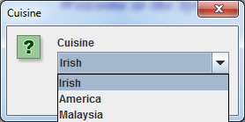 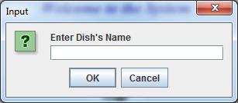

User can also view cuisine details. System will display a list of cuisine’s name that are added to the system to the user. User selects the dish details to be view and the system will search through the cuisine list and display the full details of the selected dish in user interface.

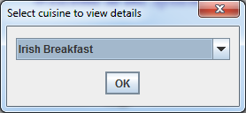 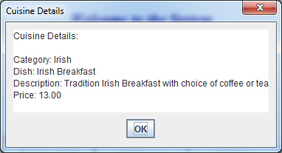

User can also remove seasonal cuisine/dish from the system. When user invokes ‘Delete Cuisine’ function, the system displays an information message to inform user to select a cuisine to be removed from the system. After that system displays a list of cuisine’s name which allow user to remove the cuisine from the system. After the cuisine, has been removed, it displays a confirmation message to inform user that the cuisine selected has been removed.

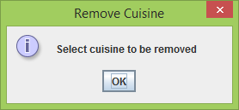 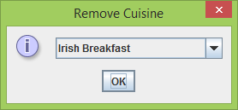

User can also add total sales for today business into the system. The date displayed is auto updated using the Date class from Java Application Programming Interface (API). System will validate the input from user until a valid input has been entered.

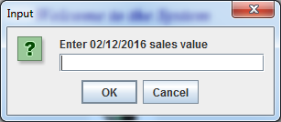

User can also view the sales for each day from the system. Every time when user adds in the total sales, the system will automatically add them together by adding total sales for today business to the previous total sales value.

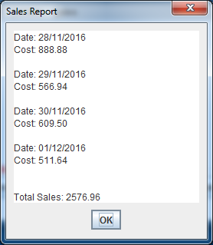

Lastly, user can save the data structure to file by just clicking ‘save’ in the system. When user reinvoke the system, user can load back the saved filed by just clicking ‘open’ in the system.

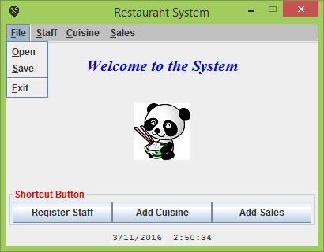

# Class Diagrams

*The following class diagram has been produced to describe the responsibility of the Restaurant System:*



# VOPC Diagram

**Authentication Class:**

Authentication

+Authentication()

JLabel

JDialog

JButton

JPanel

JPasswordField

JTextField

javax.swing

javax.swing

javax.swing

javax.swing

javax.swing

javax.swing

ImageIcon

javax.swing

**RestaurantSys Class:**

RestaurantSys

+RestaurantSys()  
+createFileMenu()  
+createStaffMenu()  
+createDishMenu()  
+createSalesMenu()  
+sysClock()  
+save()  
+open()  
+addStaff()  
+displayStaff()  
+deleteStaff()  
+addCuisine()  
+deleteCuisine()  
+displayCuisine()  
+addSales()  
+viewSales()

JMenu

JLabel

JPanel

JButton

BufferedImage

TitledBorder

JMenuItem

ImageIO

ImageIcon

JComboBox

JTextArea

javax.swing

javax.swing.border

javax.swing

javax.swing

javax.swing

javax.swing

java.awt.image

javax.swing

javax.imageio

javax.swing

javax.swing

# GitHub Logs

**commit 8f811570c3fa0e884c2691b593fb6d10e80f22ab**

Author: De Jong Yeong <t00185309@365s.ittralee.ie>

Date: Tue Dec 6 14:31:21 2016 +0000

Final Commit

3 files changed, 20 insertions(+), 19 deletions(-)

**commit 190023a30af211c1964875a109f6d7383d945eaf**

Author: De Jong Yeong <t00185309@365s.ittralee.ie>

Date: Fri Dec 2 09:03:15 2016 +0000

Found some minor error and fix it

3 files changed, 18 insertions(+), 40 deletions(-)

**commit cbe82822232c2c96fd424a028d950c95daaeeb2e**

Author: De Jong Yeong <t00185309@365s.ittralee.ie>

Date: Thu Dec 1 11:30:36 2016 +0000

Commit workspace.xml

1 file changed, 2 insertions(+), 2 deletions(-)

**commit dea012b69fb421135bbd6ec11b31e5f2cac91b29**

Author: De Jong Yeong <t00185309@365s.ittralee.ie>

Date: Thu Dec 1 11:26:36 2016 +0000

Did last checking, Final Commit

11 files changed, 76 insertions(+), 68 deletions(-)

**commit c6ad4b9652281c26b64a7c95aad30cb14f49387f**

Author: De Jong Yeong <t00185309@365s.ittralee.ie>

Date: Thu Dec 1 11:07:28 2016 +0000

Added some comments, Final Commit

6 files changed, 187 insertions(+), 140 deletions(-)

**commit a5d0744462096a8011a217dbaf45d8900b4a6d8c**

Author: De Jong Yeong <t00185309@365s.ittralee.ie>

Date: Wed Nov 30 15:27:04 2016 +0000

Final Commit

1 file changed, 2 insertions(+), 2 deletions(-)

**commit c2447f519c85321155a30f7d178ad8430aa04278**

Author: De Jong Yeong <t00185309@365s.ittralee.ie>

Date: Wed Nov 30 14:50:32 2016 +0000

Final Commit

6 files changed, 107 insertions(+), 178 deletions(-)

**commit 2f49be2bb6d8d90b0af55e358caca9e556c2b22b**

Author: De Jong Yeong <t00185309@365s.ittralee.ie>

Date: Tue Nov 29 14:09:23 2016 +0000

Did some changes

6 files changed, 214 insertions(+), 142 deletions(-)

**commit 18b1aa9a0db72dc3c8c1d31bb7abba47ffb8d847**

Author: De Jong <De Jong>

Date: Mon Nov 28 19:03:13 2016 +0000

Added RestaurantSys Driver class

17 files changed, 197 insertions(+), 96 deletions(-)

**commit a6735bb0b25ba7778664f0d740310b969c6118f6**

Author: De Jong <De Jong>

Date: Sat Nov 26 15:40:07 2016 +0000

Did some changes

10 files changed, 244 insertions(+), 263 deletions(-)

**commit db178453b2984df5d07b056812897038eadfa07e**

Author: De Jong <De Jong>

Date: Sat Nov 26 00:19:21 2016 +0000

Did some changes

6 files changed, 328 insertions(+), 543 deletions(-)

**commit 10f5fba5245587525602906082bd285c97a99979**

Author: De Jong Yeong <t00185309@365s.ittralee.ie>

Date: Thu Nov 24 11:55:21 2016 +0000

Completed View and Delete method for Cuisine Class

14 files changed, 349 insertions(+), 124 deletions(-)

**commit 22cdf9be8b66895e1bd0f776464726fa7d17c5c7**

Author: De Jong Yeong <t00185309@365s.ittralee.ie>

Date: Wed Nov 23 15:47:46 2016 +0000

Completed Cuisine Class

10 files changed, 187 insertions(+), 42 deletions(-)

**commit 25b98aa29ece56c23bcd2925d68813085b4f6b77**

Author: De Jong Yeong <t00185309@365s.ittralee.ie>

Date: Wed Nov 23 15:29:18 2016 +0000

Added some methods, done Staff Processing

14 files changed, 234 insertions(+), 338 deletions(-)

**commit 3a03cc23403b0932c29bbd3c76e65b15ee09de93**

Author: De Jong Yeong <t00185309@365s.ittralee.ie>

Date: Tue Nov 22 15:51:57 2016 +0000

Added some methods and Deleted StaffFrame class

8 files changed, 632 insertions(+), 76 deletions(-)

**commit c1511f6edc2a2ebaf27db1f3879edb7f9855a8bc**

Author: De Jong <De Jong>

Date: Fri Nov 18 20:09:55 2016 +0000

Did some changes and added Cuisine Class

4 files changed, 70 insertions(+), 40 deletions(-)

**commit 6dc86acc89d89061a1fb73d9c47500bc8c9c04d9**

Author: De Jong <De Jong>

Date: Thu Nov 17 22:32:24 2016 +0000

Did some changes

13 files changed, 216 insertions(+), 443 deletions(-)

**commit 71ef378e66f615b952b705bc35c0b9569aa44798**

Author: De Jong Yeong <t00185309@365s.ittralee.ie>

Date: Thu Nov 17 11:51:24 2016 +0000

Did some changes

12 files changed, 154 insertions(+), 58 deletions(-)

**commit 6a377959eab034b369554a71daa5dd3ce8659976**

Author: De Jong <De Jong>

Date: Wed Nov 16 22:55:42 2016 +0000

Added Staff class and did some changes

4 files changed, 377 insertions(+), 21 deletions(-)

**commit 2e2282e8c4fc67e7e8a9b2358d07943bbba726f7**

Author: De Jong Yeong <t00185309@365s.ittralee.ie>

Date: Wed Nov 16 15:51:54 2016 +0000

Add some JComponents and did some changes

10 files changed, 656 insertions(+), 62 deletions(-)

**commit b3f31821d05f5fe8f0be1ca40ae2f7fb04a41a1e**

Author: De Jong <De Jong>

Date: Tue Nov 15 22:08:11 2016 +0000

Change Project Title to RestaurantSys

34 files changed, 788 insertions(+)

**commit d15259f03a948630661be163d8736ad73d31179b**

Author: De Jong <De Jong>

Date: Mon Nov 14 22:31:46 2016 +0000

Did some changes

11 files changed, 25 insertions(+), 232 deletions(-)

**commit aafffc133f38ed041eee537bb3c0fbffa3486c70**

Author: De Jong <De Jong>

Date: Sun Nov 13 23:19:13 2016 +0000

Did some changes

5 files changed, 64 insertions(+), 75 deletions(-)

**commit cac2f016896018fe47fcf08098eab364038f4ab2**

Author: De Jong <De Jong>

Date: Sat Nov 12 23:08:51 2016 +0000

Added Player and Position Class

12 files changed, 469 insertions(+), 95 deletions(-)

**commit 27f1cf92f09f3a6baa17ce6d7821448c46b4eb08**

Author: De Jong <De Jong>

Date: Fri Nov 11 22:36:46 2016 +0000

Added Dice and Board class

4 files changed, 140 insertions(+)

**commit 93f8c17bcf22f51c654cf1b8f90dcaca3bd26659**

Author: De Jong <De Jong>

Date: Thu Nov 10 22:43:58 2016 +0000

Original source file

2 files changed, 45 insertions(+)

**commit 5263cabcc1ba36f509eb2faee485766237ae66e0**

Author: Yeong De Jong <de.jong.yeong@students.ittralee.ie>

Date: Thu Nov 10 22:40:40 2016 +0000

Initial commit

1 file changed, 1 insertion(+)