Klik2learn Programming Test

## Startup instructions

Download and install the development platform *Meteor* from:

<https://www.meteor.com/install>

Once Meteor is installed create a new project in a directory of your discretion by using the command:

**Meteor create Test**

This will create a blank meteor project.

Once the project has been created replace the three files in the folder *~/Test/client* with the three files from the *Test Files* folder supplied.

Navigate to the directory *Test*

Run the Meteor project with the command:

**Meteor**

Type **Localhost:3000** into your browser and you should see the following page:

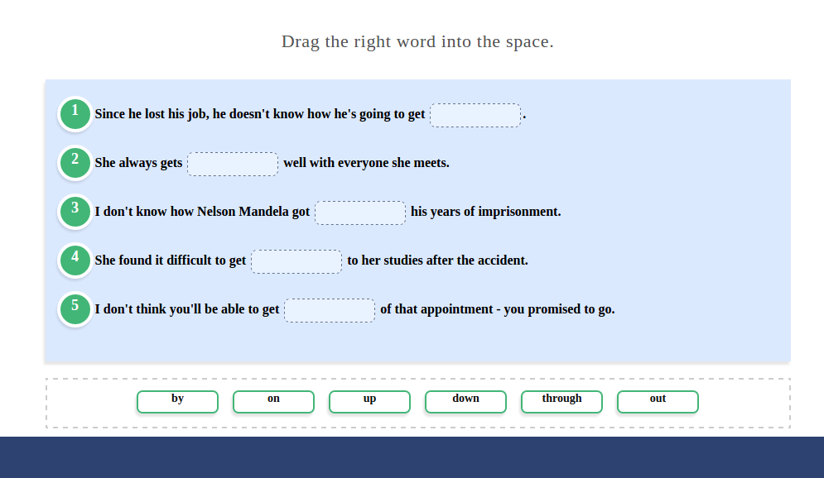

## Task

The provided page is a standard drag and drop exercise we use, developed internally. The task is to add the functionality to this page to make it interactive.

The criteria follows:

1. Each of the *ddsourceseated* must be **draggable** by the user.
2. Each of the *ddsourceseated* targets will have **an individual target**. i.e ‘by’ is the correct answer for sentence 1 so the first *ddseatedtarget* should only accept the *ddsourceseated* containing ‘by’.
3. If a *ddsourceseated* is dropped into the **correct** *ddseatedtarget* then the **current** *ddsourceseated* must be removed from the **source box** and the information must be placed inside the *ddseatedtarget.*
4. The classes *shadow*, *ddsourceseated* should be removed from a **successful** drag element. The class *ddsourceseated2* should be added to the **leftover** HTML element.
5. The classes *ddwidth7, dd1line, ddseatedtarget* should be removed from a **successful** drag target. The class *ddseatedtarget2* should be added to the **current** element.
6. A new div should be inserted within the *ddseatedtarget2* element with this classes *ddwidth7, dd1line,ddsourceseated* and the HTML content from the **original** *ddsourceseated.*
7. A counter should be created to execute code to display the template ‘complete’ **after 5** drag elements have **successfully** been placed in the correct targets.

d&dSources.png

*(ddsourceseated)*

d&dTargets.png

*(ddseatedtarget)*

## Advanced Task

This is not required but an attempt is encouraged.

Once a user has succeeded in dragging all the answers to their correct locations an entry to a collection within the inbuilt Meteor MongoDB is created and populated. Discretion is given on naming the collection and to what is added to the collection.

## Report

While completing the task, using a bullet points list in a text editor of your choice, outline the thought process and steps taken into solving this problem and save it as [yourname]_report.txt

## Submitting

To submit your test all files created must be sent to [daniel@klik2learn.com](mailto:daniel@klik2learn.com). It will be checked to verify it fulfills the desired requirements.

## Time Limit

**Five days** are given to complete this task upon accepting. If more time is required it will be given if a valid reason is given.