

Mobile Games Development 1 Coursework: Blog

**BSc Computer Games (Software Development)**

Dawid Piotr Kubiak

S1717551

GitHub Repository:

<https://github.com/dejwkubikson/Mobile-Games-1-Coursework>

*I confirm that the code contained in this file (other than that provided or authorised) is all my own work and has not been submitted elsewhere in fulfilment of this or any other award*.

*Dawid Kubiak*

Contents

Cookies.js 5

Functions 5

saveCookie(name,value) 5

readCookie(name) 5

Drawing.js 5

Variables 5

shakeMoneyTimer 5

shakeMoney 5

shakeMoneyPositive 5

Functions 5

drawRemoveConfirmation() 5

drawObjectRange() 5

drawMap() 6

drawMainMenu() 6

drawInstructions(pageNo) 6

drawEndScreen() 6

drawSideMenu() 6

shakeMoneyAnimation(type) 6

drawInfoText() 6

drawPlayerStats() 6

drawReloading(obj) 7

drawObstacles() 7

drawPlayerObjects() 7

drawBullets() 7

drawSpecialEffects() 7

drawEnemies() 7

drawProhibited() 7

drawGame() 7

drawPause() 8

Game.js 8

Variables 8

Game variables 8

Gameplay variables 8

Wave variables 8

State variables 8

Functions 8

msToMMSS(milliseconds) 8

getTileDistance(fromX, fromY, toX, toY) 8

getAngleTowardsObject(fromX, fromY, toX, toY) 8

objectBehaviour(obj) 8

createBullet(obj, enemy) 8

moveBullets() 9

dealDamage(bullet) 9

removeDeadEnemies() 9

createTankExplosion(posX, posY) 9

createRocketExplosion(posX, posY) 9

reload(obj) 9

shootAtEnemy(obj, enemy) 9

moveEnemies() 9

endPointReached() 10

restartGame() 10

startGame() 10

showInstructions() 10

endGame() 10

update() 10

getEnemyType() 10

waitForNextWave(timer) 10

createWave(timer) 10

objects.js 10

Variables 10

Object arrays 10

objToRemove 10

selectedMapObject 11

Functions 11

checkIfPossibleToBuild(posX, posY) 11

createObjectOnMap(posX, posY, objNumber) 11

removeObject(objToRemove) 11

createEnemy(typeToUse) 11

player.js 11

Variables 11

playerBestTime 11

playerBestWave 11

playerBestSaved 11

Functions 11

savePlayersBest(time, wave) 11

assignPlayersBest() 12

raycast.js 12

Functions 12

getCoords(elID) 12

getTileCoords(posX, posY) 12

touchRaycast(e) 12

setup.js 12

Variables 12

currentResource 12

resourcesToLoad 12

spawnPoint 12

endPoint 12

movePoints 12

movementTiles 12

Functions 12

createObstacles() 12

loadResources() 13

resourceLoad() 13

sounds.js 13

Variables 13

Functions 13

playBackgroundMusic() 13

pauseBackgroundMusic() 13

Resources 13

Images 13

Music 13

Sound Effects 13

# Initial idea

Three different game types have been chosen to review.

## A shooter game

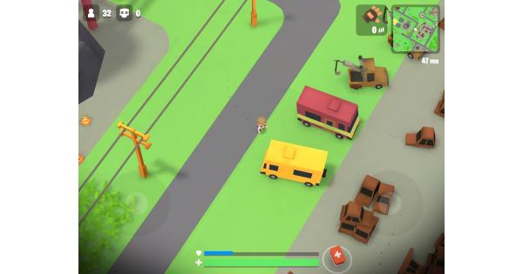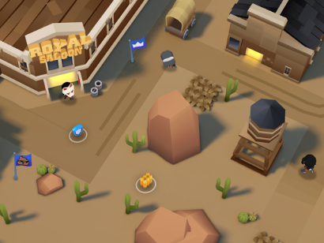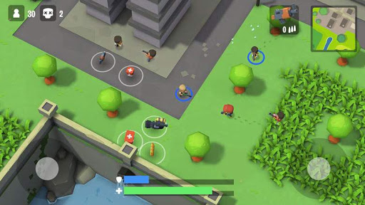

## A tower defence game

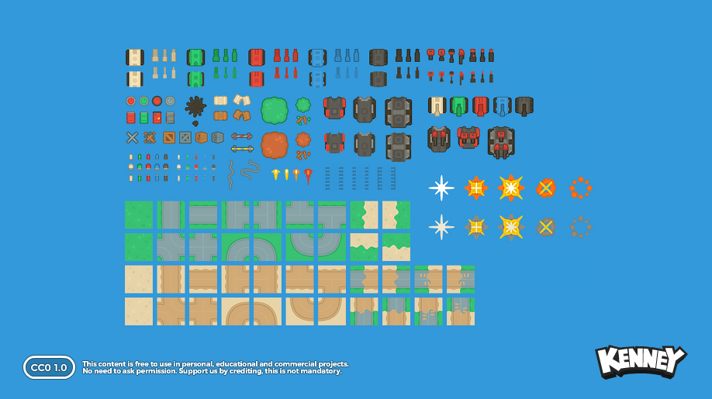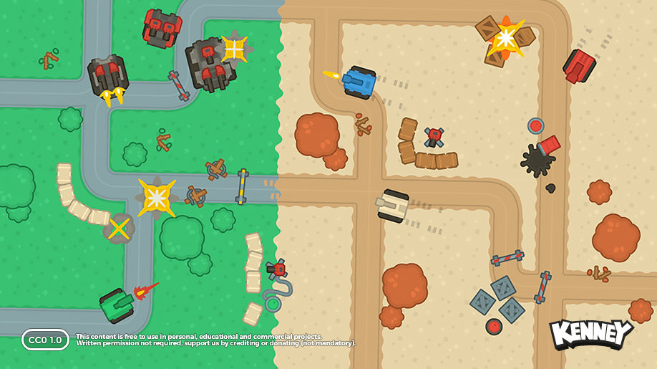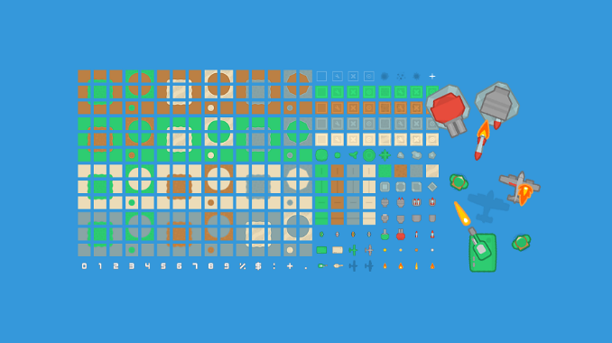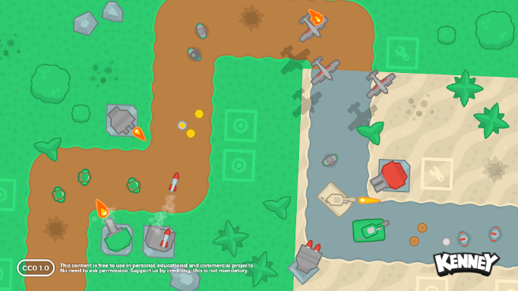

## A racing game

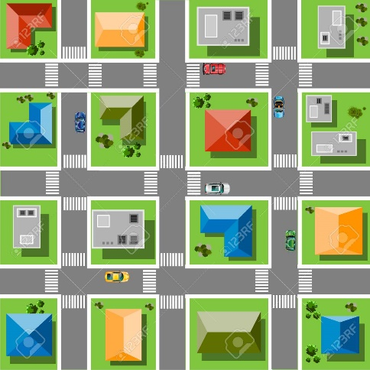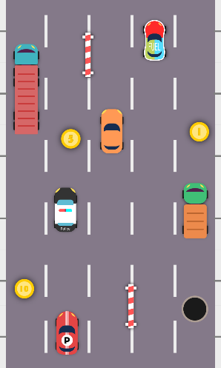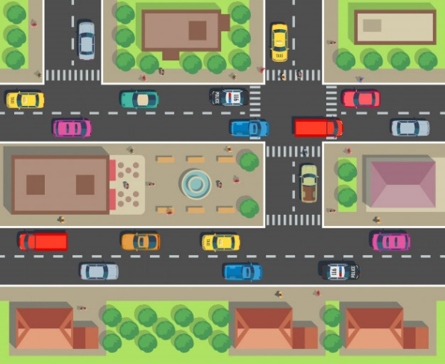

# Chosen path

I decided to go for a tower defence game. It’s definitely a game that works well on mobile phones due to its not as fast paced environment as it could be in a racing or shooter games. Furthermore, I feel that more people might enjoy such game type as I think it targets much wider audience than shooter or racing games.

# Research

## Tower defence games

There’s a lot of tower defence games on the market, each vastly different than another. Some are placed in medieval times, some are placed in a complete fantasy world. I couldn’t find much tower defence games with ‘real’ tanks and soldiers, so this was my choice to go for.

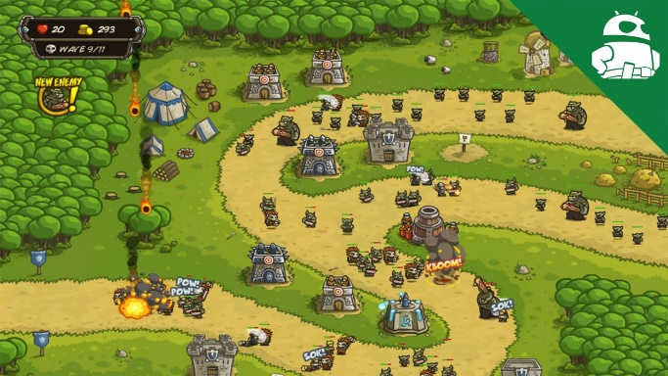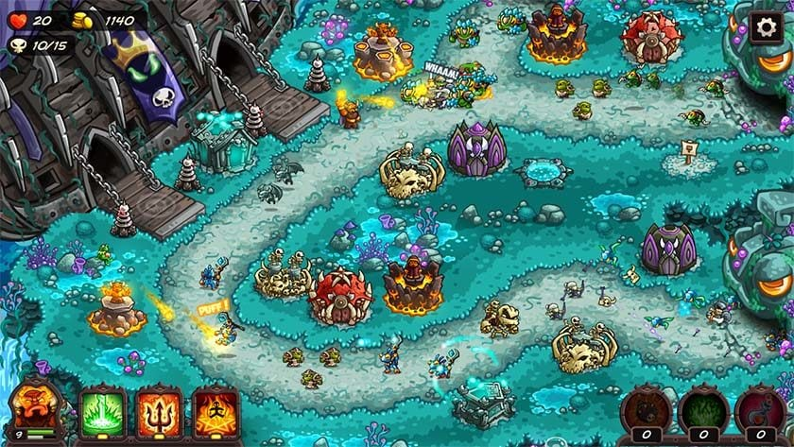

## Tower defence path ideas

The next step is to investigate what path for the enemies would work the best for the game.

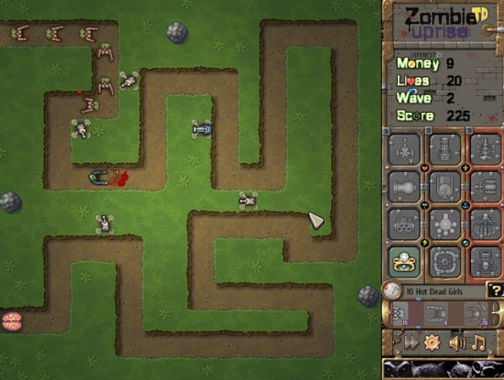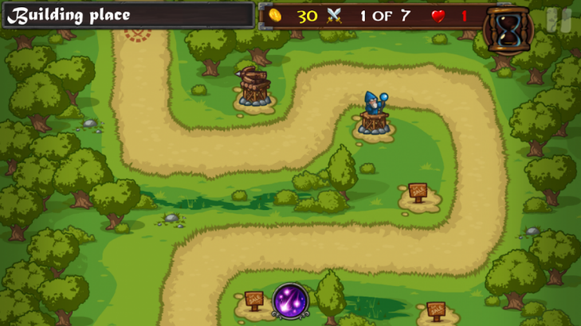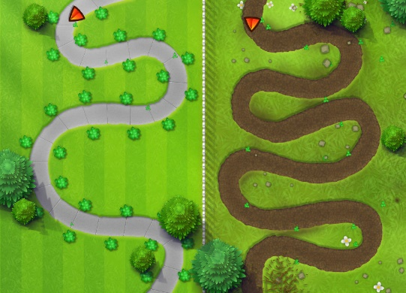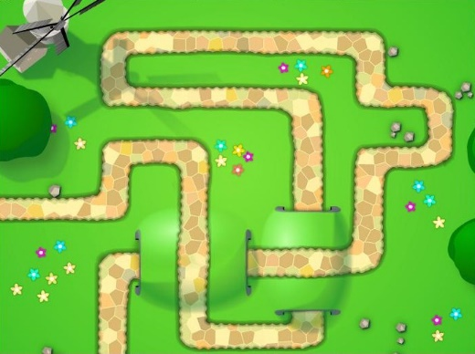

Looking at different examples, I wanted the path to not be too short, but also to keep it simple. Since I didn’t want to have a simple square made up from the path, this is what I came up with.

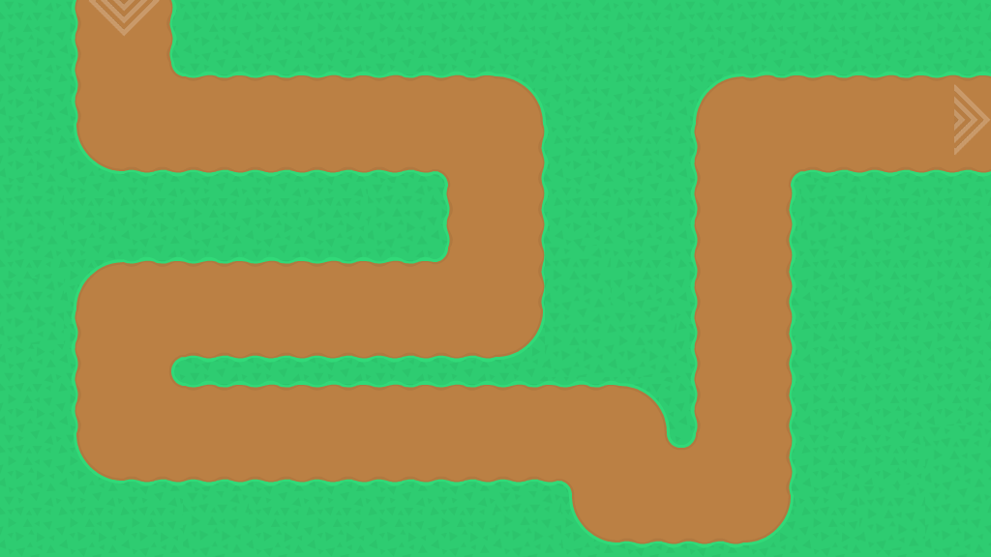

This allows the player to place his objects around the map quite freely, but at the same time, limiting it in certain areas to make it more challenging in that places.

# Obstacles

First objects on the map are obstacles – small and big trees. Again, the idea is to place them in a way that would give the player the possibility to manoeuvre freely, but at the same time blocking the strategic places.

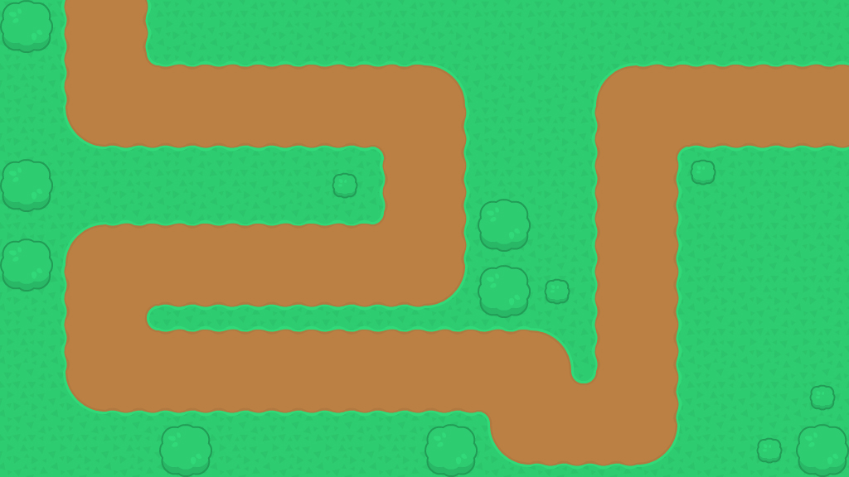

# Player Objects

Player objects are now in the game. They consist of a base – same for every object – and the ‘batter’ itself. It’s done in such a way to allow for object rotation in the future. I’ve managed to make it possible for the player to create one of the objects on a selected tile. The idea of how the objects will operate is displayed on the flow chart.

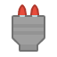

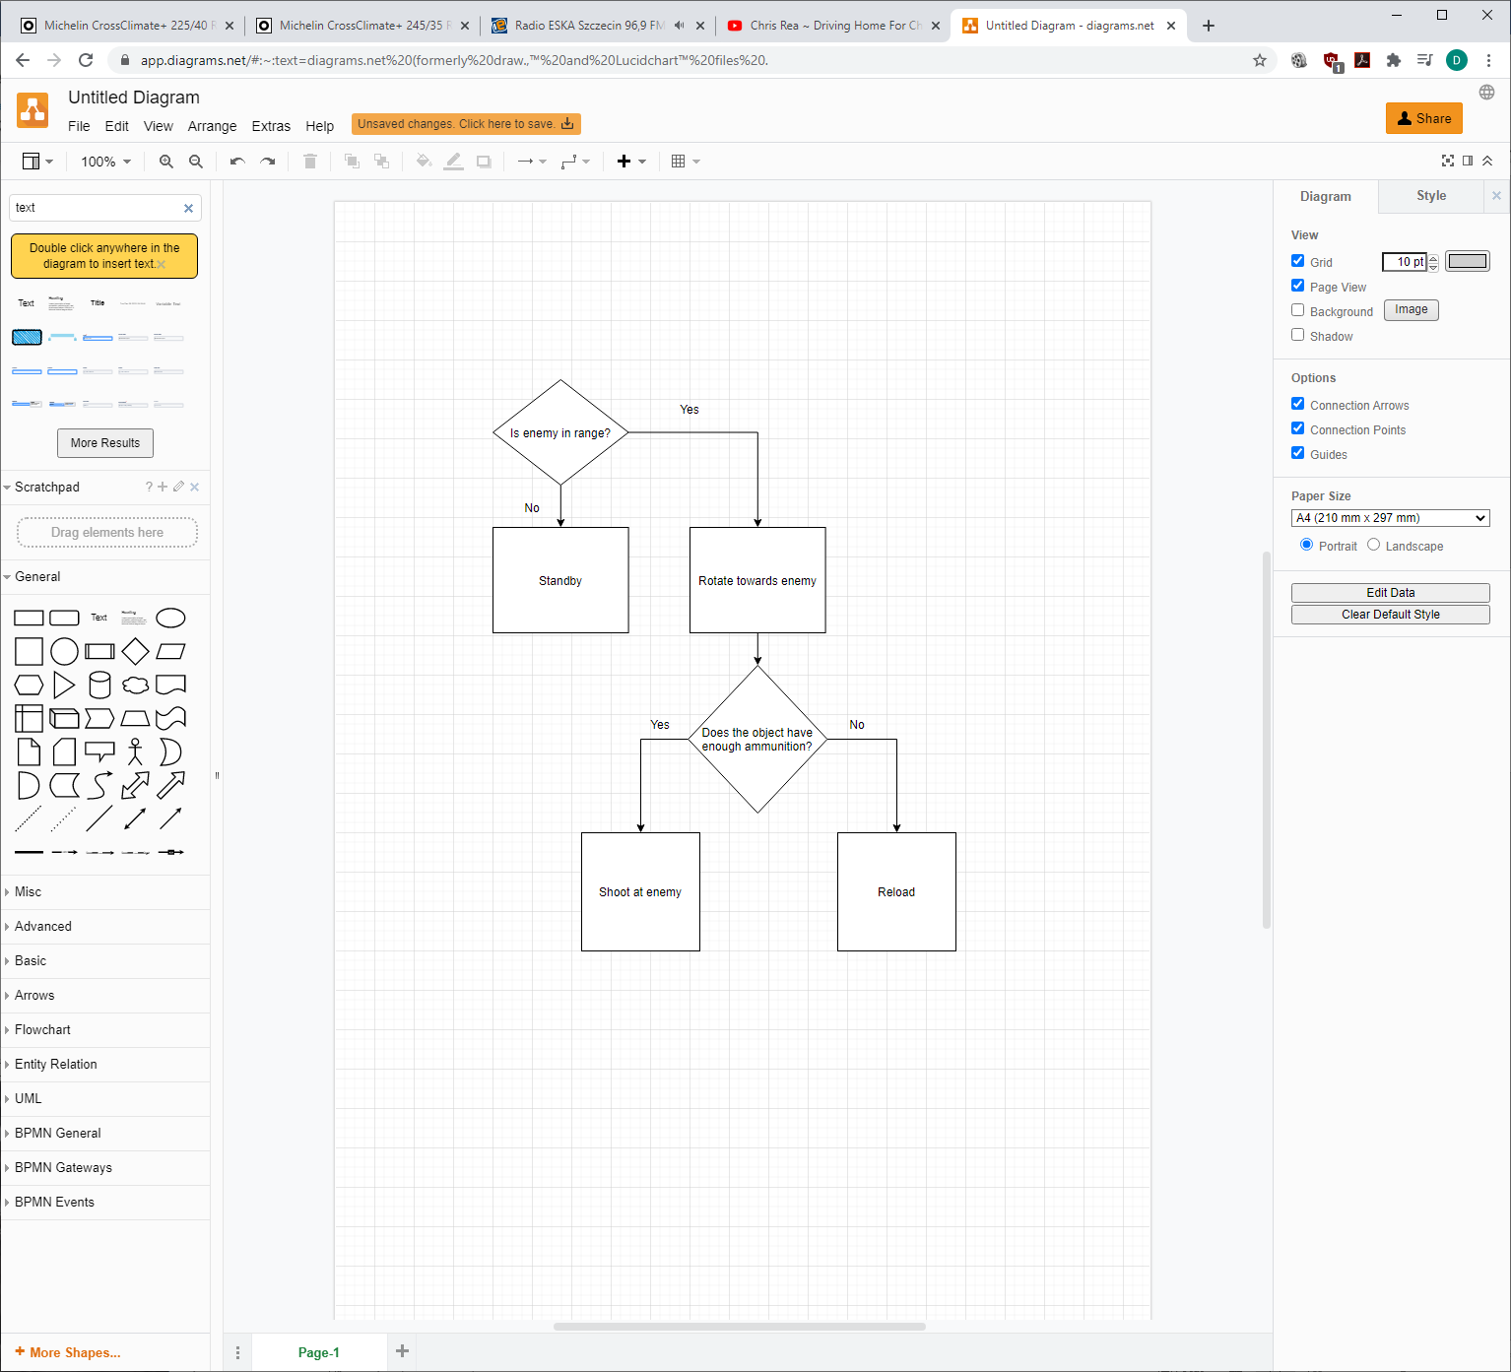

# Enemy Objects

Enemy objects are added to the game. Two tanks, and two soldiers. The green tanks will be the easier ones to defeat. The objects now follow the created path and rotate accordingly to where they are facing. The enemy objects have a simple task, they just need to move to the next point.

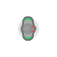

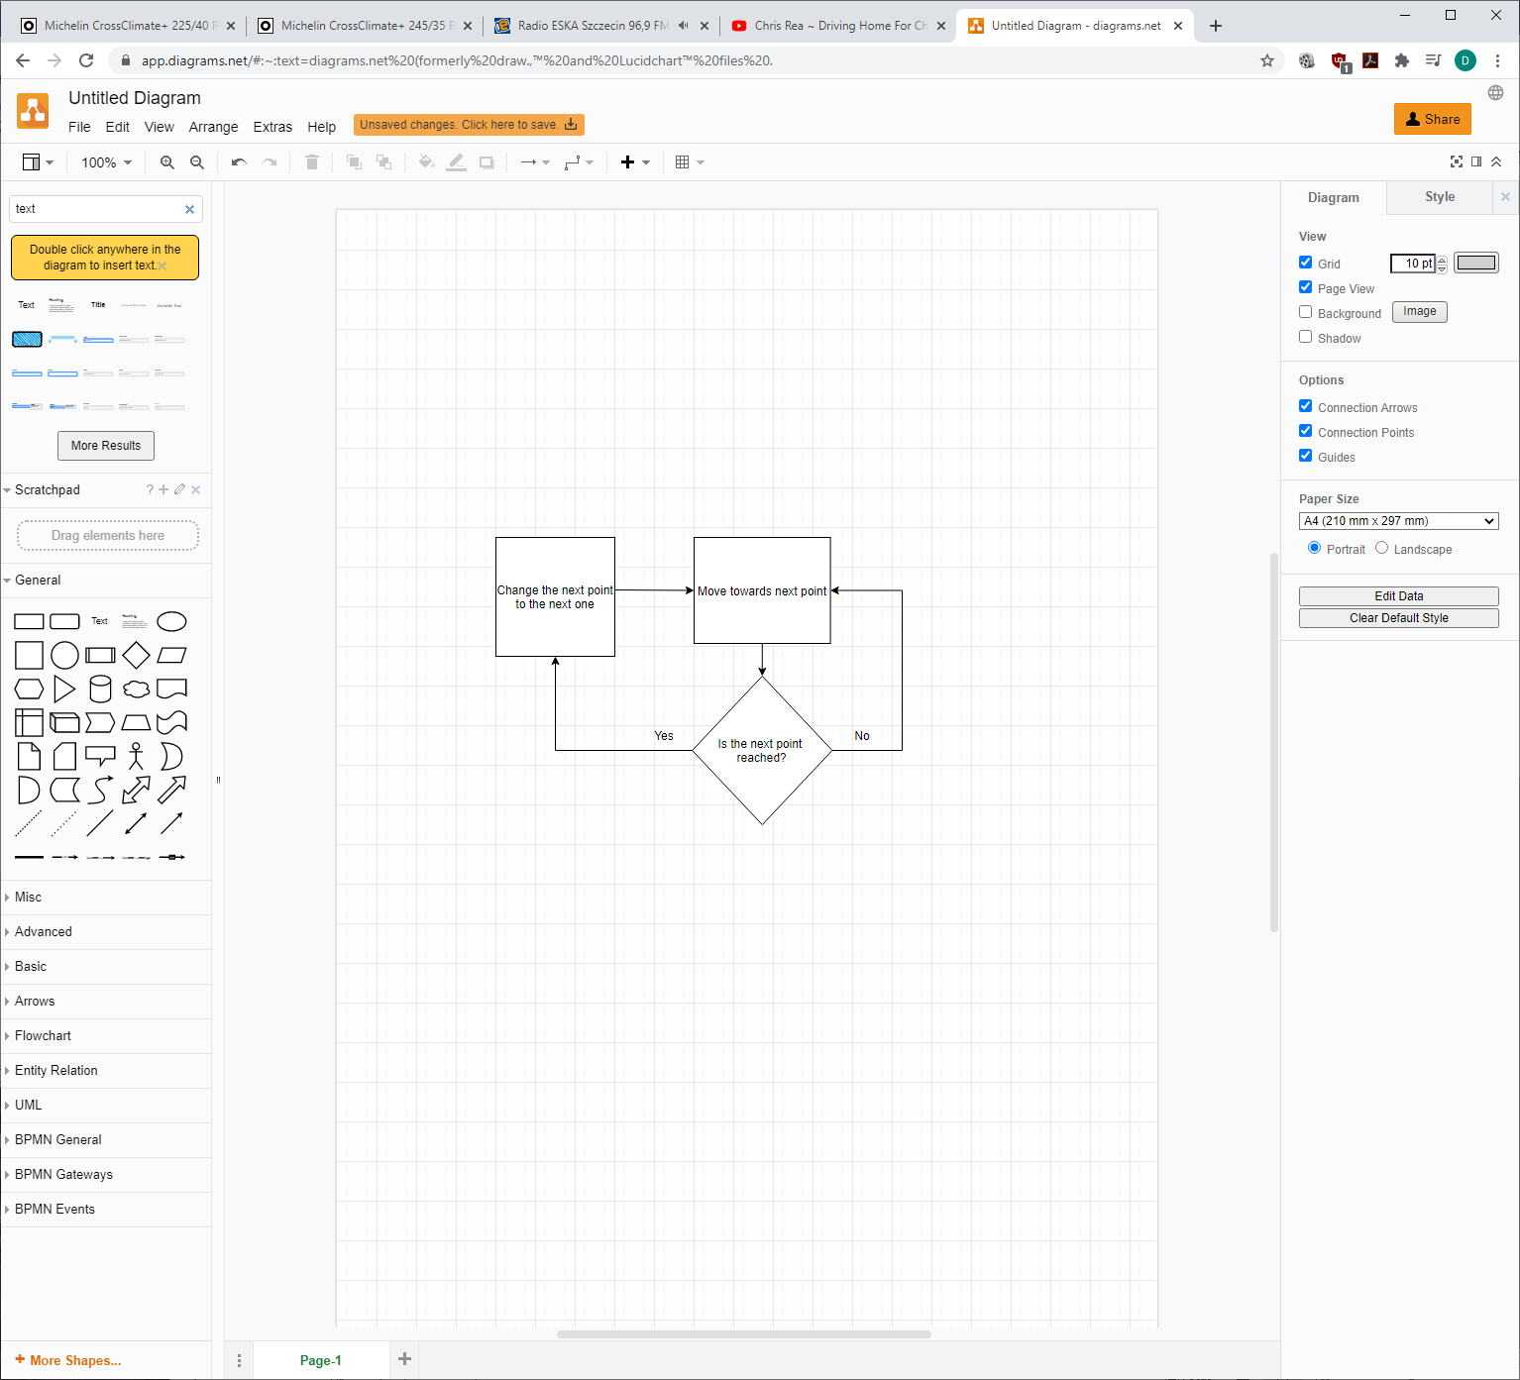

# Bullet objects

Bullets have been created, and since the towers use different type of ammunition, there are four different bullet designs. The bullets now are shot from the tower towards the enemy and deal damage.



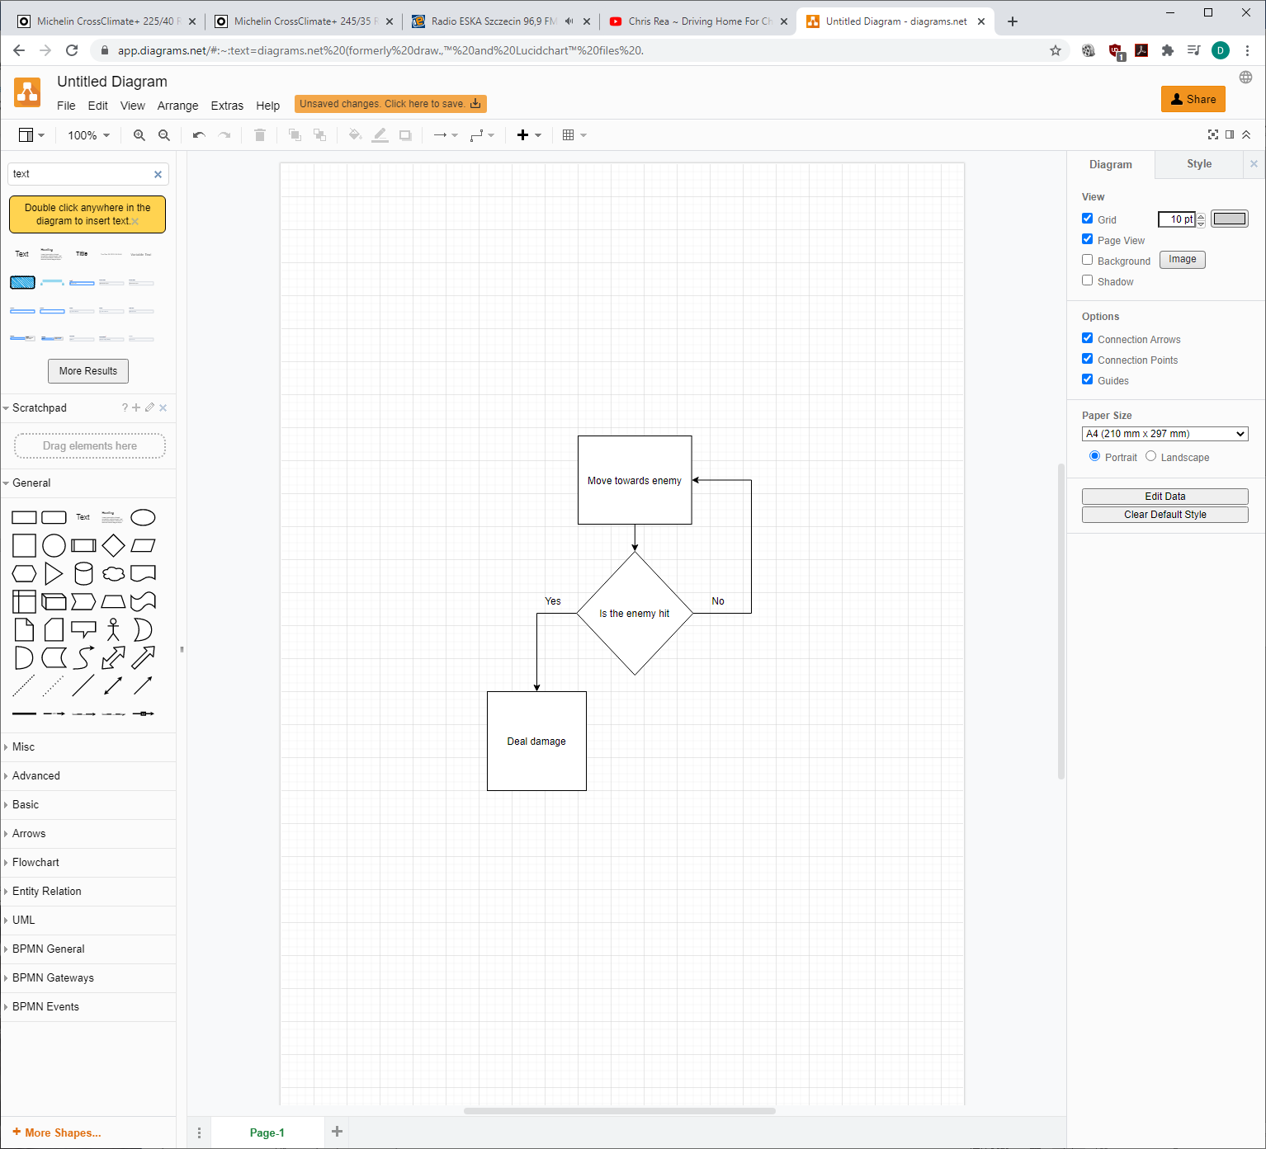

# Player information

Finally, player statistics are added to the screen - game time, wave, money and lives.

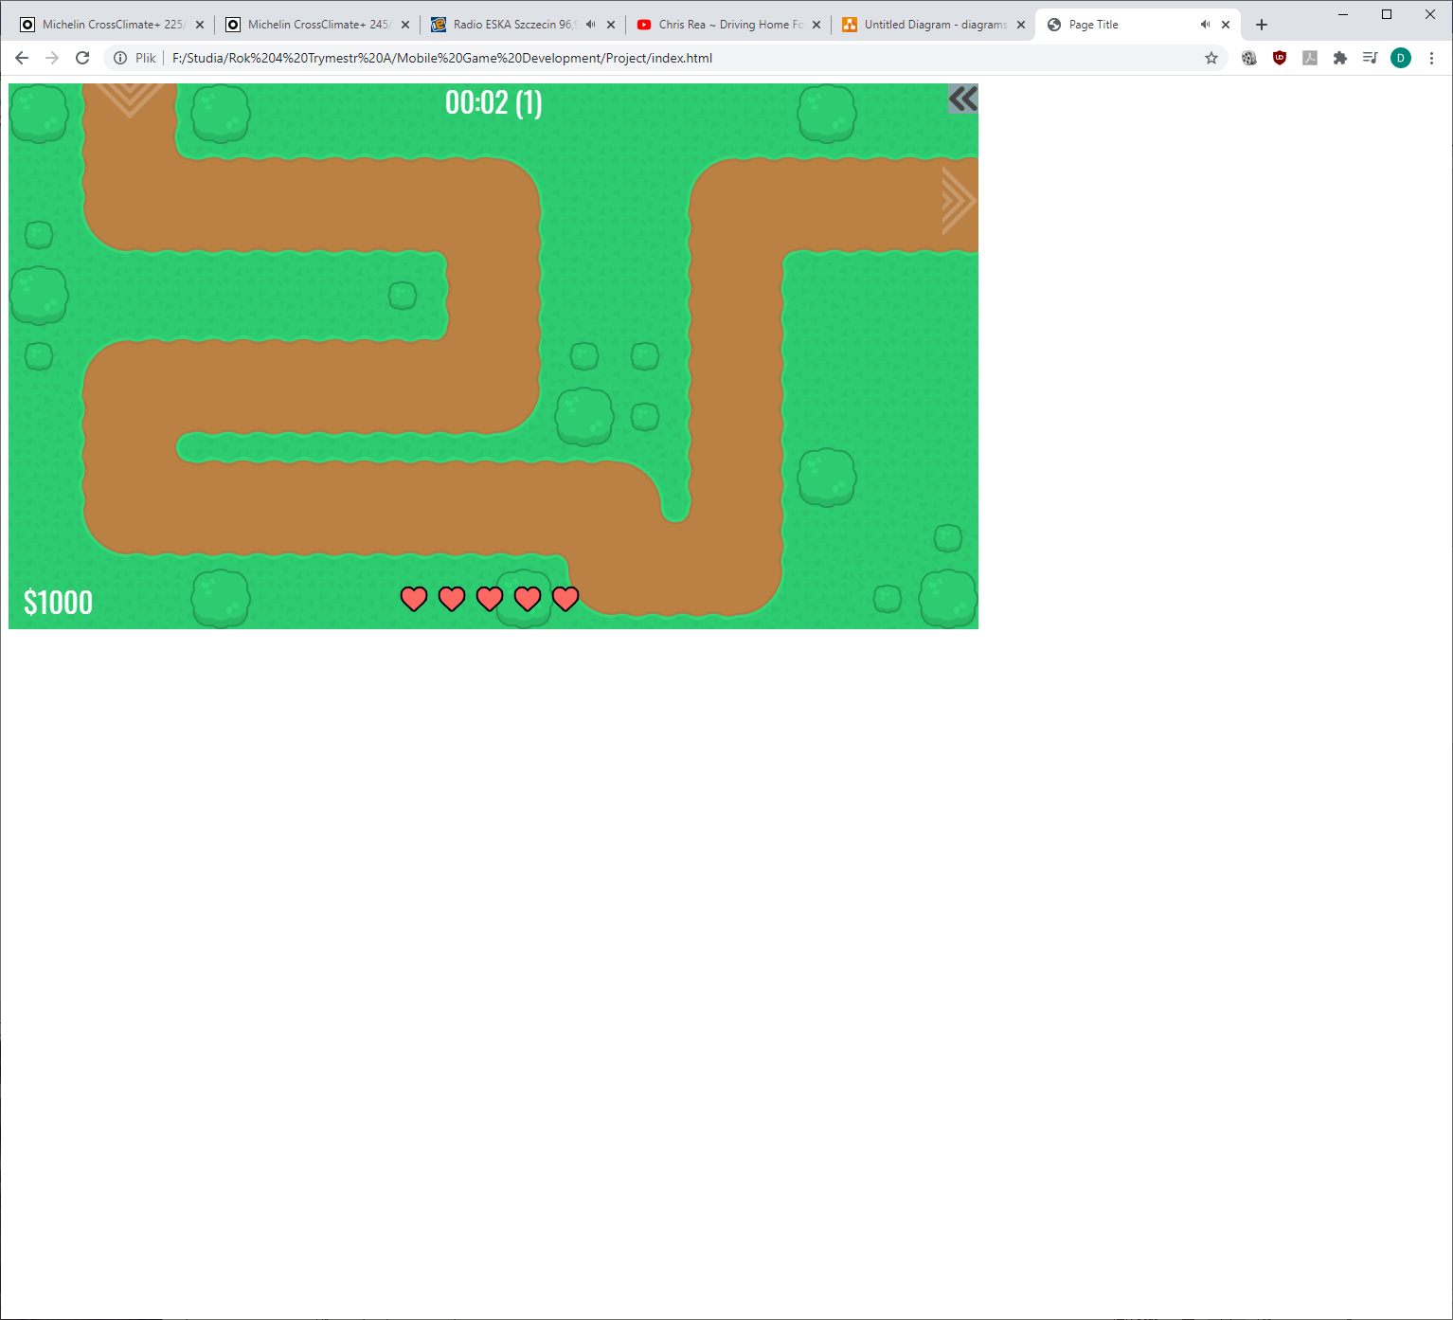

# Main menu

Main menu has been added to the game with start and instructions buttons. The Start button takes the player to the game and instructions will take the player to the instructions screen which is currently under development.

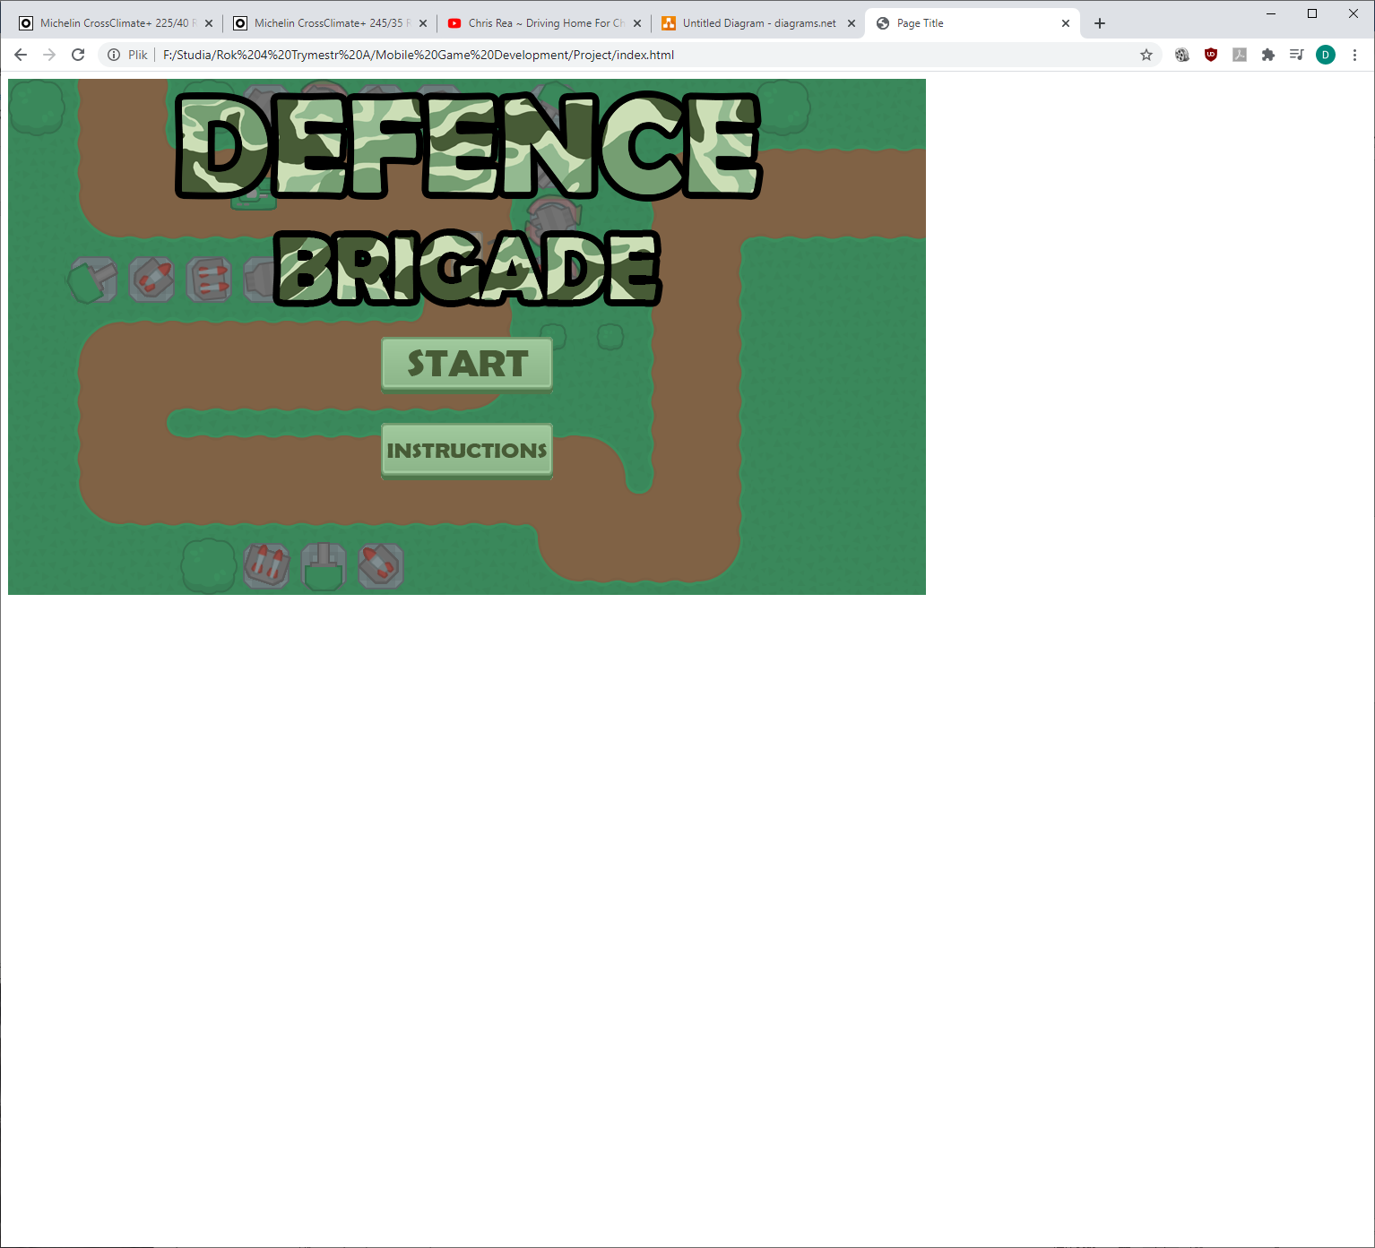

# Instructions

Instruction screens have been added to the game. The instructions are spread across three pages, so next, previous and start buttons are added accordingly to appropriate page.

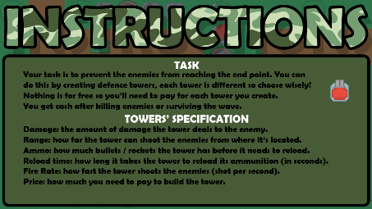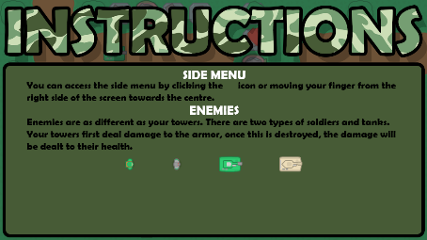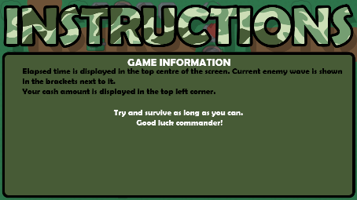

# End screen

Game over screen has been added to the game with the possibility to replay the game again. Furthermore, using cookies, player’s best time and wave are saved and displayed to allow the player to compare if it was his best game.

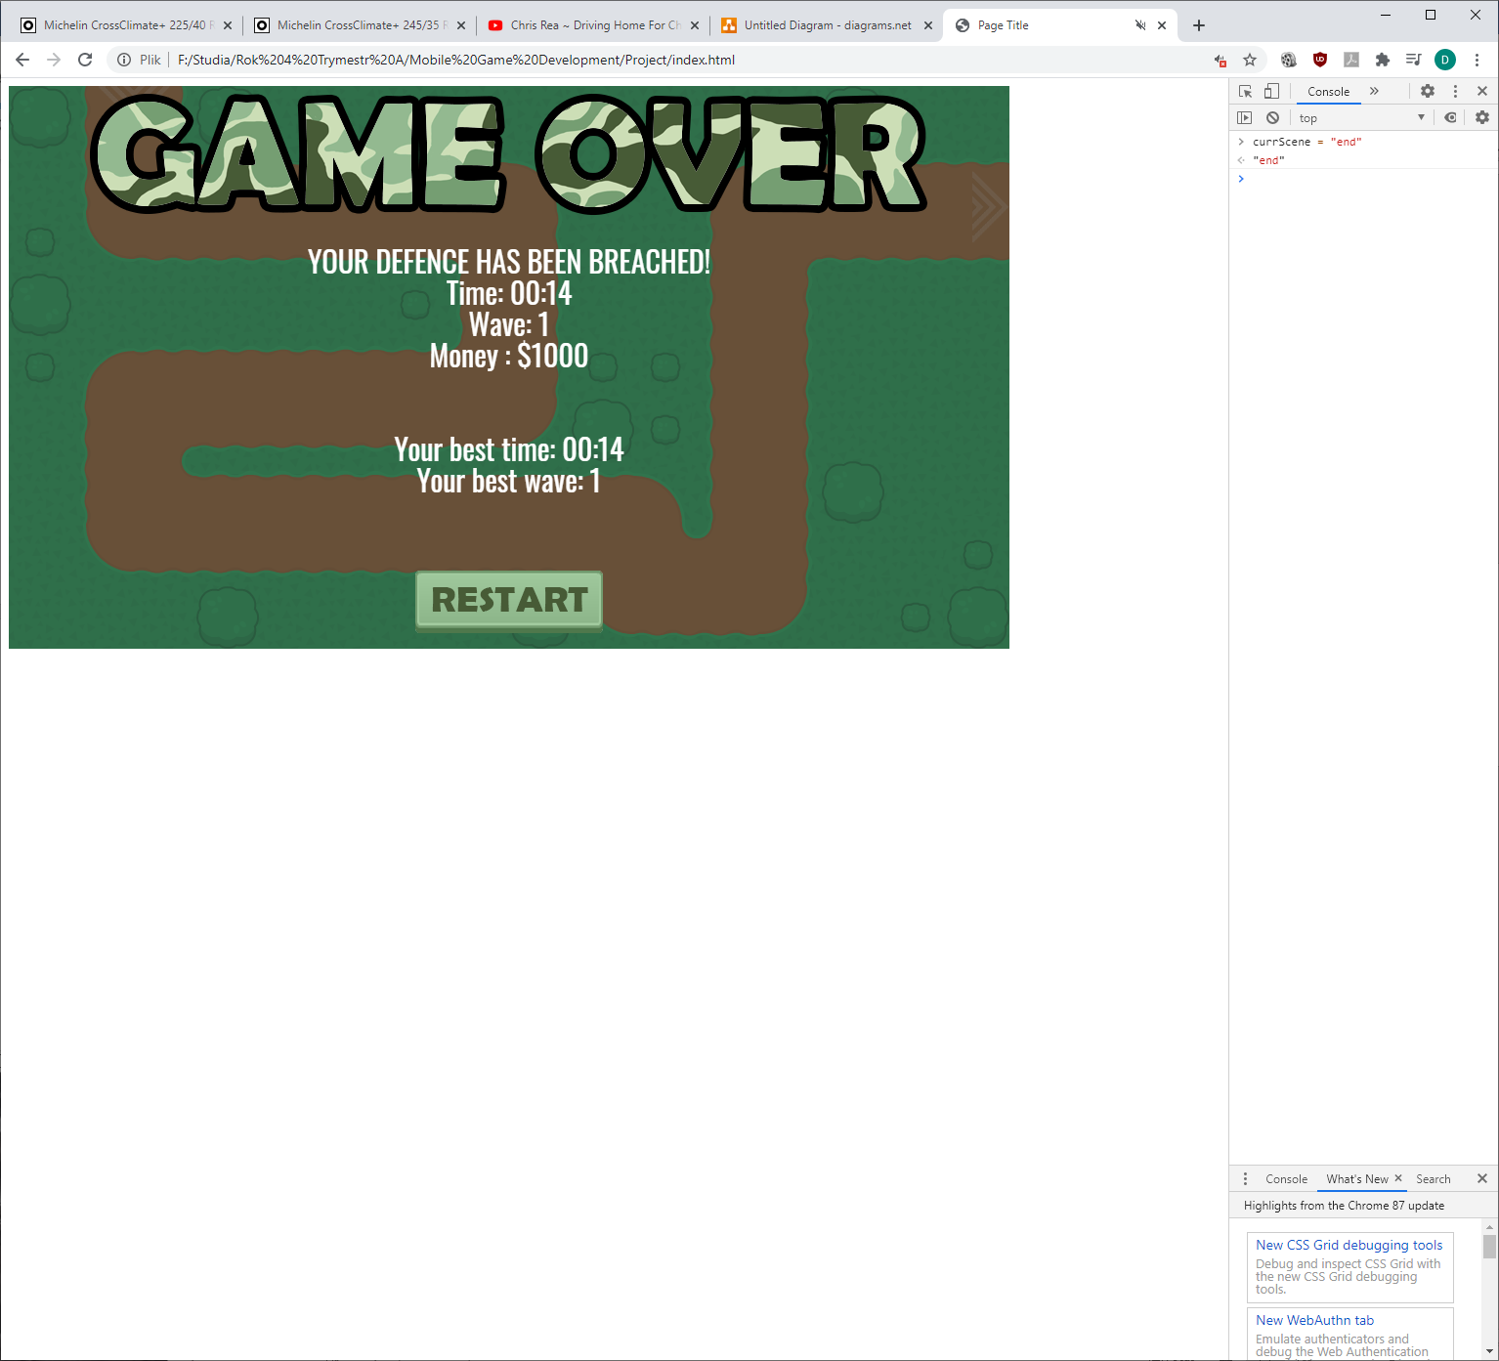

# Pause screen

Paused screen has been added to the game. It allows the player to pause the game, walk away from it, and continue again once back.

# 

# Side Menu

A side menu has been created for the player to choose objects from.

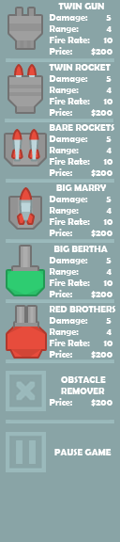

# Testing

Finally, I have entered the testing stage. Some minor tweaks have been made to make the game more enjoyable and playable by changing objects’ damage, range, price and so on. Same has been done for enemies.