Analyzing and Visualizing Usage for Human Reference Atlas User Interfaces Using Amazon CloudFront Logs
Aydian Brown, Kaustav Deka, & Akriti Kumari
Indiana University, Bloomington

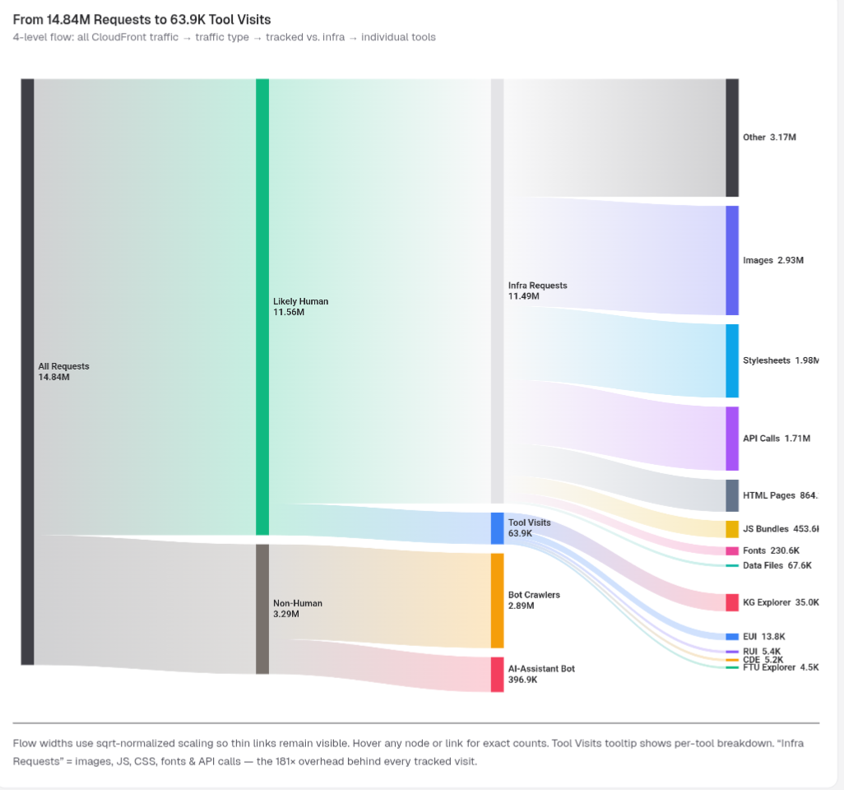
Fig. 1. Flow widths use sqrt-normalized scaling so thin links remain visible. Hover any node or link for exact counts. Tool Visits tooltip shows per-tool breakdown. “Infra Requests” = images, JS, CSS, fonts & API calls — the ~181× overhead behind every tracked visit. This project’s focus is on human tool visits.
1. INTRODUCTION AND PRIOR WORK
The Human Reference Atlas (HRA) provides an evolving digital framework for understanding the structure and function of the human body through integrated biological data and interactive visualization tools. As the HRA platform continues to expand in both scope and global reach, understanding how users interact with its interfaces becomes increasingly important. Usage data collected from web infrastructure such as Amazon CloudFront provides valuable insight into user behavior, system performance, and engagement patterns at scale. Analyzing this data enables the identification of trends in usage, evaluation of the impact of releases and outreach efforts, and the prioritization of improvements to the platform.
This project focuses on analyzing usage logs generated by Amazon CloudFront for HRA user interfaces. By examining request patterns, interaction events, error logs, and geographic distribution of traffic, the project uncovers trends that correspond with external drivers such as training workshops, platform releases, and research activities. These insights provide stakeholders with a clearer understanding of how the platform is used in practice and what factors influence its adoption.
In particular, this analysis investigates whether major HRA releases, which typically occur in June and December, correlate with spikes in website traffic. Additionally, the project explores the extent to which external drivers such as workshops, scientific publications, and community engagement influence user behavior. Early results indicate that organized events play a significant role in driving both short-term spikes and long-term growth in usage.
1.1 Stakeholder Groups
Several stakeholder groups are involved in or benefit from this project. The Human Reference Atlas development team serves as a primary stakeholder, requiring detailed insights into user behavior to improve system performance, usability, and reliability. Researchers and scientific users who rely on HRA tools for biomedical analysis form another key group, as understanding their interaction patterns helps ensure that the platform meets their needs effectively.
Human Reference Atlas Development Team.
Developers and maintainers of the HRA platform are primary stakeholders. They require insights into how users interact with the platform in order to improve system performance, usability, and reliability.
Researchers and Scientific Users.
Scientists and researchers who rely on HRA tools for biological and biomedical research form another key stakeholder group. Understanding their usage patterns helps ensure that the platform supports their needs effectively.
Project Managers and Outreach Teams.
Project managers and outreach teams are also important stakeholders, as they are responsible for coordinating releases, workshops, and publications. These stakeholders benefit from understanding how such activities influence traffic and engagement. Finally, visualization and data analysis teams require effective methods for presenting complex usage data in a clear and interpretable manner, allowing patterns and trends to be easily identified.
Visualization and Data Analysis Teams.
Teams responsible for presenting and interpreting usage data benefit from visualizations that reveal trends, geographic distribution of users, and behavioral patterns.
1.2 Stakeholder Needs
Each stakeholder group has distinct needs that this project aims to address. The HRA development team requires detailed insights into system usage patterns and error distributions in order to identify performance bottlenecks and prioritize fixes. Researchers benefit from a platform that evolves based on real usage data, ensuring that frequently used workflows are optimized and underutilized features are improved or redesigned.
The HRA development team requires detailed insights into system usage patterns and error logs in order to identify performance issues and optimize infrastructure. Researchers and users benefit from a reliable platform whose design evolves based on observed usage behavior.
Project managers and outreach teams require high-level summaries that demonstrate how events such as workshops and releases influence engagement. The ability to correlate spikes in usage with specific outreach efforts provides a data-driven basis for planning future initiatives. Visualization and analytics teams require intuitive visual representations of complex log data, including geographic maps, time-series plots, and network diagrams, to effectively communicate findings to both technical and non-technical audiences.
Finally, visualization and analytics teams require intuitive visual tools that communicate complex log data in an accessible way. Visualizations such as geographic maps, heatmaps, and time-series plots allow stakeholders to quickly identify trends and patterns in usage.
2. DATA ACQUISITION
The primary dataset for this project consists of Amazon CloudFront access logs associated with the Human Reference Atlas user interfaces. These logs capture detailed records of all requests made to the platform, including timestamps, request URIs, response codes, geographic origin, and additional metadata. The logs provide a comprehensive and high-resolution view of how users interact with the system over time.
Data acquisition involves collecting these logs from the project repository and transforming them into structured datasets suitable for analysis. This process includes parsing raw log files, standardizing timestamp formats, extracting relevant attributes, and filtering incomplete or malformed entries. Special attention is given to separating meaningful user interactions from infrastructure-related requests such as API calls, JavaScript files, and image assets.
Proper preprocessing and documentation are essential to ensure reproducibility and transparency. All processed datasets are stored in structured formats and documented clearly to support downstream analysis and visualization.
2.1 Data Sources
The primary data source for this project is CloudFront access log files that record traffic to the HRA platform. These logs include detailed information about each request and response, enabling both behavioral and system-level analysis.
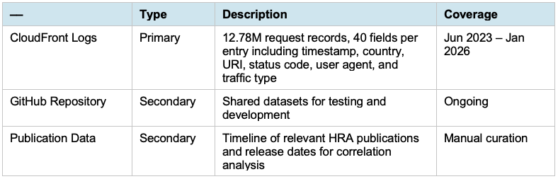
Table. 1. Summary of data sources used in the project.
Additional contextual data may include records of HRA release dates and timelines of relevant scientific publications, which can be compared against traffic trends.
2.2 Data Description, Quality and Coverage
The dataset comprises 15,810,917 individual log records (after deduplication of 1,504 exact duplicates) spanning June 2023 through April 2026, covering approximately 34 months of activity. Each record contains 40 attributes describing request behavior, system response, and geographic origin. Across the full dataset, requests originate from 128 distinct countries, reflecting broad global usage. A complementary dataset of CloudFront logs from cns.iu.edu (16.4M raw records spanning April 2008 through April 2026) was also analyzed in parallel; this report focuses on the HRA platform.
Traffic is classified into three categories: Likely Human (78.0%, 12.34 million requests), Bot (19.3%, 3.06 million requests), and AI-assistant or crawler traffic (2.6%, 417 thousand requests). After filtering for meaningful engagement, the analysis focuses on 78,879 verified human tool visits across five primary interfaces: KG Explorer (49,358 visits), EUI (14,007), RUI (5,548), CDE (5,286), and FTU Explorer (4,680).
A total of 170,685 user interaction events were recorded, including clicks, hovers, errors, page views, keyboard inputs, and model changes. The dataset is largely complete for all critical analytical fields, and the scale of the data provides strong coverage for both behavioral and geographic analysis.

3. DATA ANALYSIS
The analysis phase focuses on extracting meaningful patterns from the filtered dataset to address the project’s research questions. After excluding non-human traffic and isolating tool-level interactions, the analysis examines temporal trends, user behavior, geographic distribution, and system reliability.
Temporal analysis reveals several major traffic inflection points that align with confirmed external events. HRA releases in June and December consistently produce measurable increases in traffic. For example, the v2.0 release in December 2023 produced a 38% increase, the v2.1 release in June 2024 resulted in a 104% increase in visits, while v2.2 in December 2024 and v2.3 in June 2025 produced increases of 11% and 34%, respectively. The most recent v2.4 release in December 2025 coincided with the launch of the HRA Knowledge Graph Explorer (KG Explorer), which has since become the dominant tool, accounting for 63% of all human tool visits as of April 2026. In addition to releases, workshops emerge as significant drivers of engagement. A confirmed HuBMAP Training Workshop and Demo Day in March 2024 drove EUI visits from 171 to 7,140, representing a 4,075% increase within a single month. Additional events, including the HRA Powers of Ten Workshop, HuBMAP Annual Meetings, IEEE VIS panels, and the HuBMAP HRA Hackathon (Aug 2025), correspond with multi-tool traffic surges.
Publication correlation analysis incorporates 54 HRA-related publications retrieved using the PubMed API and deduplicated to remove preprint/journal-version overlaps. Months containing at least one publication average 3,134 tool visits compared to 1,758 visits in months without publications, representing a 78% increase in activity. While this relationship suggests a strong association between research output and platform usage, overlapping factors such as releases and workshops introduce confounding effects that limit causal interpretation.
Geographic analysis shows that usage spans 128 countries, with the United States leading in total visits (29,166), followed by France (12,445), Hong Kong (10,461), China (3,751), and Canada (3,526). Regional differences in tool preference are pronounced: U.S. users heavily favor EUI (80.7% of EUI traffic), while KG Explorer has the inverse pattern — France and Hong Kong combined account for nearly half of KG Explorer traffic, with the U.S. at only 13.4%. These differences highlight the importance of region-specific usage patterns and the international reach of the newer knowledge-graph interface.
Error analysis identifies 38,922 error events, which were clustered into approximately eight categories using TF-IDF vectorization (max 2,500 features, unigram + bigram) followed by K-Means clustering. The number of clusters is determined dynamically by a square-root heuristic clamped to the range [4, 8]. Seventy-two percent of all errors originate from three primary root causes: API CORS failures, missing CDN asset retrieval, and null reference errors in EUI. These findings indicate that system reliability issues are highly concentrated and addressable through targeted fixes rather than broad UX redesign.
4. VISUALIZATIONS
Visualizations play a central role in communicating insights derived from the dataset. The project employs a comprehensive interactive dashboard consisting of seven HRA pages, six parallel CNS pages, and over seventy chart components, implemented using Apache ECharts within a Next.js and TypeScript framework. The dashboard also includes 58 automated data-integrity tests (pytest) and a one-command pipeline runner that auto-detects the latest parquet file.

The visualizations include time-series trend charts with annotated events, geographic choropleth maps, Sankey diagrams, force-directed network graphs, funnel charts, and cohort retention heatmaps. Together, these visualizations provide a multi-dimensional view of system usage and user behavior.
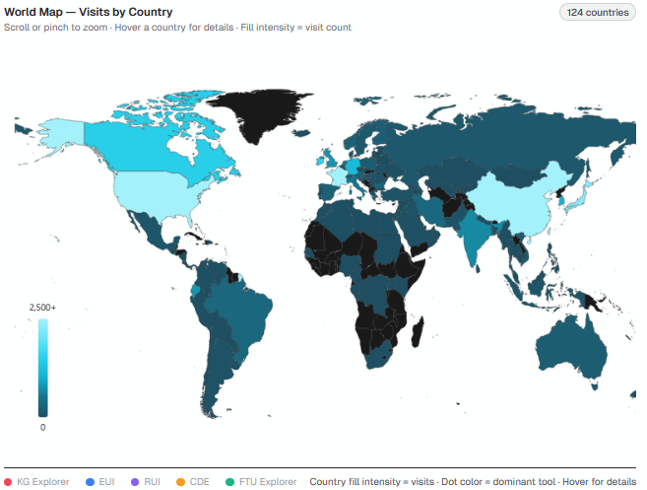
Figure 2. Updated sketch of geographic heatmap visualization showing request distribution by region.
4.1 Geo Maps Visualization
The geographic visualization presents a global heatmap of HRA usage, with color intensity representing visit counts by country. This visualization highlights the widespread adoption of HRA tools and reveals regional patterns in engagement. The inclusion of international data demonstrates that more than half of all usage originates outside the United States, emphasizing the platform’s global impact.
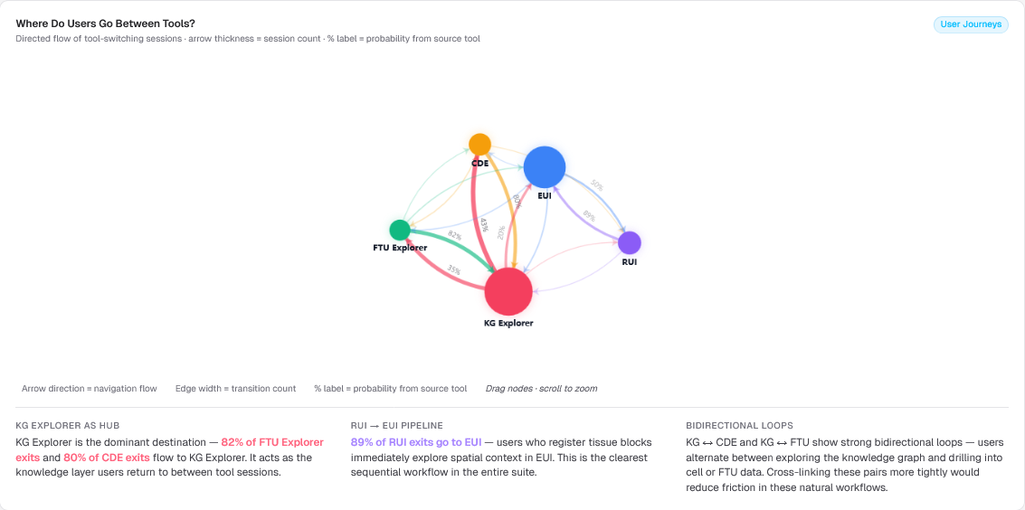
Figure 3. Network depicting directed flow of tool-switching sessions. May be adapted to determine correlation between publication release and social media impact on tool usage.
4.2 Network Graph Visualization
Network-based visualizations are used to represent relationships between tools and user navigation patterns. These graphs show that KG Explorer functions as a central hub, with strong transitions from other tools such as CDE and FTU Explorer. Directed flow diagrams also reveal clear workflows, such as the strong transition from RUI to EUI, indicating a common sequence of user actions.
4.3 Timeline and Publication Correlation Visualization
To better understand the relationship between external academic output and platform engagement, a combined timeline and line chart visualization was developed. This visualization overlays monthly tool visits with markers representing HRA releases and publication activity, enabling direct comparison between user engagement and external events.
The visualization shows that releases consistently correspond with increases in traffic, while publication months exhibit a 78% higher average level of activity. By aligning these datasets on a shared temporal axis, the visualization reveals patterns that are not immediately visible in isolated charts. However, the overlap between releases, workshops, and publication activity indicates that these factors are interdependent rather than independent drivers.
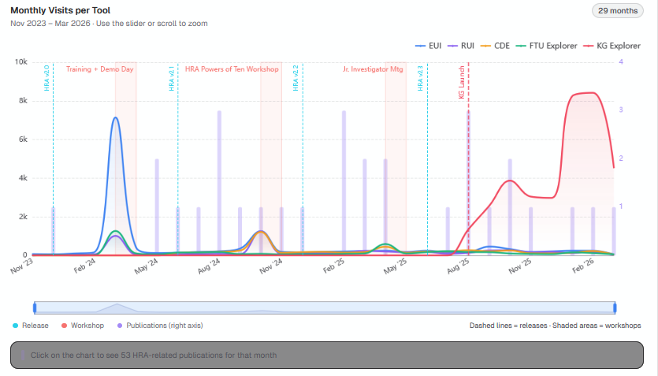
Figure 4. Timeline and line chart overlay of HRA tool visits with releases and publications, showing traffic increases following releases and a ~78% higher average during publication months.
Analysis of release events shows that major HRA updates are consistently associated with increases in platform usage. For example, the v2.0 release in December 2023 resulted in a 38% increase in visits compared to the previous month. Similarly, the v2.1 release in June 2024 produced a substantial 104% increase in traffic, representing one of the most significant growth points in the dataset. Subsequent releases, including v2.2 in December 2024 and v2.3 in June 2025, also demonstrate positive impacts, with increases of 11% and 34%, respectively. The v2.4 release in December 2025 coincided with the launch of the HRA Knowledge Graph Explorer, which has subsequently grown to dominate the platform — KG Explorer alone now accounts for 49,358 of the 78,879 total tool visits (63%). These findings suggest that releases serve as reliable drivers of user engagement, particularly when accompanied by new features, expanded datasets, or new tools.
In addition to release events, the visualization examines the relationship between scientific publications and platform traffic. Across a total of 54 publications over a 30-month period of monthly tool-visit data, months containing publications exhibit an average of 3,134 visits compared to 1,758 visits in months without publications. This represents an approximate 78% increase in traffic during publication months, indicating a strong association between research output and platform usage.
However, the visualization also reveals that this relationship is not purely causal. Many publication months coincide with releases or organized events such as workshops, making it difficult to isolate the independent effect of publications alone. As a result, the observed correlation should be interpreted as suggestive rather than definitive. Nonetheless, the consistent increase in activity during publication periods supports the conclusion that academic dissemination plays a meaningful role in driving engagement with HRA tools.
Overall, this combined timeline visualization provides a more comprehensive view of how external factors influence platform usage. By integrating multiple data sources into a single representation, it allows stakeholders to better understand the interplay between releases, publications, and user behavior. These insights can inform future strategies for coordinating releases, publications, and outreach efforts to maximize impact and engagement.
5. EVALUATION AND REDESIGN
Evaluation of the visualizations was conducted through feedback from peers and collaborators, focusing on clarity, interpretability, and usefulness for stakeholders. Several key issues emerged during this evaluation process.
One major issue was that early visualizations made it difficult to distinguish between total request volume and meaningful user engagement. Many viewers initially misinterpreted infrastructure requests as user activity. This problem was addressed by explicitly separating tool visits from background requests and redesigning visualizations to emphasize human interaction metrics.
Another issue involved the interpretation of temporal trends. Users found it difficult to understand the causes of traffic spikes when viewing time-series charts in isolation. This led to the development of the timeline overlay visualization, which integrates releases, workshops, and publication events directly into the chart. This redesign significantly improved interpretability by providing contextual explanations for observed patterns.
Geographic visualizations also required refinement. Initial versions lacked clear legends and consistent color scaling, making it difficult to compare regions. The redesigned choropleth maps incorporate standardized color scales and improved labeling, allowing users to more easily interpret global engagement patterns.
Network and flow visualizations were also adjusted based on feedback. Early versions were visually dense and difficult to interpret. The introduction of normalized edge scaling and improved hover interactions made these visualizations more accessible while preserving detail.
Overall, the redesign process focused on reducing ambiguity, improving clarity, and aligning visualizations more closely with stakeholder needs. These changes resulted in a more intuitive and informative dashboard that better supports data-driven decision making.
6. CHALLENGES AND OPPORTUNITIES
Several challenges were encountered throughout the project. One major challenge was the complexity of the dataset, particularly the large volume of infrastructure requests relative to meaningful user interactions. Isolating true engagement required careful preprocessing and filtering, which introduced additional computational overhead.
Data quality presented another challenge. While most critical fields were complete, certain attributes were missing or inconsistently reported, requiring assumptions during preprocessing. Additionally, overlapping external events such as releases, workshops, and publications made it difficult to isolate causal relationships in the analysis.
Scalability was also a concern due to the size of the dataset. Efficient querying required the use of high-performance tools such as DuckDB, and visualization performance had to be optimized to handle large datasets in an interactive environment.
Despite these challenges, the project presents several opportunities for future work. One promising direction is the integration of causal inference methods to better separate the effects of releases, publications, and workshops. Another opportunity lies in enhancing personalization and regional targeting based on geographic usage patterns.
Further extensions could include deeper session-level analysis, improved anomaly detection using machine learning models, and integration of user feedback data to complement log-based analysis. Expanding the dashboard to support real-time monitoring could also provide additional value for stakeholders.
7. USAGE AND CRITIQUE OF AI TOOLS
AI tools such as large language models were used occasionally throughout this project to assist with routine tasks like writing boilerplate code, drafting SQL queries, and scaffolding chart components. They served primarily as a productivity aid rather than a core analytical method.
However, reliance on AI tools also presents limitations. Generated code may contain errors or inefficiencies and must be carefully reviewed to ensure correctness. Additionally, AI models may lack transparency in how recommendations are generated, making validation important when applying them to scientific or analytical workflows.
All AI-generated outputs were reviewed and validated against the underlying data before being incorporated. Future work may explore integrating AI-based anomaly detection methods to automatically identify unusual patterns in usage logs, though such integration would require careful evaluation given current limitations.
8. INTERPRETATION OF RESULTS
The results of this analysis provide a comprehensive understanding of how users interact with the Human Reference Atlas platform. The findings demonstrate that external events are primary drivers of engagement, with releases producing consistent increases, workshops generating large short-term spikes, and publications contributing sustained growth.
The rapid rise of KG Explorer as the dominant tool highlights shifting user preferences toward knowledge graph exploration. At the same time, low adoption of certain features indicates opportunities for improving usability and discoverability.
Error analysis shows that system reliability issues are highly concentrated and can be significantly reduced through targeted fixes. Geographic patterns reveal global adoption with strong regional specialization, suggesting opportunities for tailored outreach and support.
Overall, the project demonstrates the value of combining large-scale log analysis with interactive visualization to generate actionable insights. These findings can inform future development, improve user experience, and guide strategic decisions for the continued growth of the HRA platform.
9. Related Work
Analysis of web server logs has long been used to understand user behavior, monitor system performance, and improve website design. Web usage mining techniques extract meaningful patterns from server log data by analyzing attributes such as timestamps, IP addresses, request types, and response codes. These patterns can reveal traffic trends, user navigation behavior, and system performance issues. Previous studies have demonstrated that analyzing server logs can provide valuable insights into user interactions and website effectiveness without requiring intrusive client-side tracking mechanisms [5,6].
Several systems and tools have been developed to support the analysis of web server logs. Early tools such as Webalizer and AWStats automatically parse log files and generate statistical summaries including visitor counts, geographic distribution, and request frequencies. These tools demonstrate the potential of log-based analytics to monitor web traffic and identify patterns in user behavior. However, such systems often focus primarily on static statistical reporting rather than interactive exploration or advanced visualization of usage patterns.
More recent research has explored the integration of visualization techniques with log analytics to support deeper insights into system activity. For example, visualization frameworks for network and web traffic analysis allow analysts to explore large-scale event logs using interactive dashboards and coordinated views [7]. These systems enable analysts to identify anomalies, temporal trends, and relationships between events that may not be easily observable in raw log data.
Interactive dashboards have also been proposed to monitor user interactions with visualization systems themselves. Wang et al. developed a dashboard that analyzes interaction logs to derive key performance indicators and usage patterns, allowing developers to better understand how tools are used in real-world environments [8]. This approach demonstrates the value of combining log analysis with visualization to support iterative system improvement.
Other work has explored methods for transforming web logs into graph structures to reveal relationships between requests and browsing sessions. Network-based approaches can highlight structural properties of user behavior, identify automated traffic such as bots, and reveal patterns in user navigation paths [9]. These techniques show how log data can be analyzed using more advanced data science and graph-based methods.
Building upon this body of research, the current project focuses on analyzing Amazon CloudFront logs associated with the Human Reference Atlas user interfaces. The goal is to combine log analysis with visualization techniques-such as geographic heatmaps and temporal traffic plots-to help stakeholders understand usage trends, geographic engagement, and correlations with events such as platform releases or research publications.
ACKNOWLEDGEMENTS
We would like to thank the Human Reference Atlas team and course instructors for providing guidance, datasets, and support throughout this project.
[1] K. Börner. Atlas of Knowledge: Anyone Can Map. MIT Press, 2015.
[2] K. Börner, A. Bueckle, and M. Ginda. “Data visualization literacy: Definitions, conceptual frameworks, exercises, and assessments.” PNAS, 116(6):1857–1864, 2018.
[3] K. Deka. HRA Visualization Repository. GitHub. https://github.com/deka27/hra-viz/tree/main (see our completed work).
[4] K. Deka. HRA Visualization Web Application. https://hra-viz.vercel.app/ (see our completed work).
[5] J. Srivastava, R. Cooley, M. Deshpande, and P. Tan. “Web Usage Mining: Discovery and Applications of Usage Patterns from Web Data.” ACM SIGKDD Explorations Newsletter, 1(2):12–23, 2000.
[6] B. Mobasher. “Web Usage Mining and Personalization.” In Practical Handbook of Internet Computing, CRC Press, 2004.
[7] D. H. Jeong, C. Ziemkiewicz, and R. Chang. “Understanding and Improving the Visualization of Network Traffic Data.” Information Visualization, 9(2), 2010.
[8] J. Wang, M. AlKadi, and B. Bach. “Show Me My Users: A Dashboard Visualizing User Interaction Logs.” arXiv preprint, 2023.
[9] K. Brown and D. Doran. “Contrasting Web Robot and Human Behaviors with Network Models.” arXiv preprint, 2018.

Here is the link to the shared drive folder:
https://drive.google.com/drive/folders/1if_7lUzXNRaCn9FHMnvKCGxKGFXCKmTI?usp=sharing

