*The Effect of US Troops’ Withdrawal on Civilian Targeting in Afghanistan*

Researchers: Sadi Gülbey, Asrın Berkin Özkaya, Tan Deniz, Tevfik Güzel

**Introduction**

In 2021 US withdrew its troops from Afghanistan. This study investigates the impact of US withdrawal on civil targeting in Afghanistan. The key variables such as civilian targeting; are converted from categorical to numerical to facilitate quantitative analysis. Using spatial regression, we analyze how the frequency and distribution of civilian targeting have changed spatially and temporally before and after the troop withdrawal. Our aim is to understand not just the timeline of events, but also the geographic influence and potential diffusion effects across neighboring regions, providing a holistic view of the consequences of this significant geopolitical event.

**Goals**

The main goal of the project is to find out whether US troops’ withdrawal from Afghanistan has affected civilian targeting or not. Therefore, in this project as a subgoals, these will be inspected:

* Did civilian targeting count increase significantly?
* Did civilian targeting percentage increase significantly?
* Did spatially civilian targeting change?
* Did fatalities of events increase or decrease considering civilian targeting change?

**Methodology**

The methodology used in this study consists of data collection, literature review, data preparation, analysis and visualization. These three preparation steps start from downloading necessary data like ACLED data, shape files, elevation files. Then, with respect to collected data, literature review is done to see if the study’s aim is already accomplished or not, and to gain domain knowledge about the project. In the data analysis and visualization part, with R programming language, grouping, summarizing and plotting basic graphs like bar graph, line graph and correlation matrices are done.

After these methods, the research has implemented spatial data analysis with plotting maps considering counts and fatalities. Also, with Density Analysis and Spatial Autocorrelation analysis, spatial civilian targeting shift has been demonstrated throughout the research.

In the end, the researchers have used regression analysis to see the significance of increase in civilian targeting with respect to year and fatalities.

**Results**

Data is provided from Acled. Data contains 64,996 observations.

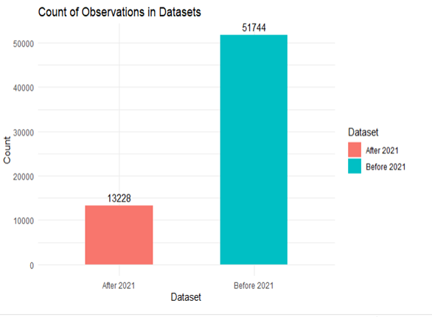

Most of the observations belong to before 2021 because there is a short time between after 2021 and today.

Part1: Relationship Between Total Events, Events Toward Civilians and Fatalities.

*1*.*1) The Relationship Between Total Events and Civilian Targeting Events*

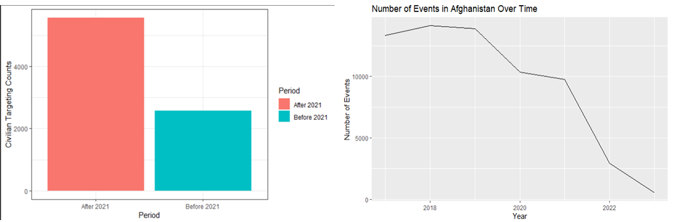

Even though the number of events decreased after 2021, the number of events against the civilians increased after the US withdrew. It means that after 2021, the events were mostly directed towards civilians.

*1.2) More Data About Civilian Targeting Events*

The city-based distribution of civilian targeted events can be observed in the below graph. The red ones are high civilian targeting cities, and the green ones are low civilian targeting cities. After the US withdrew, civilian targeting events increased for several cities.

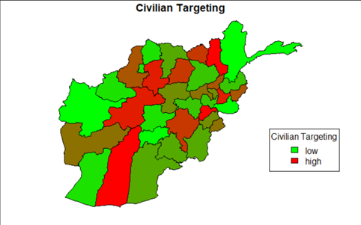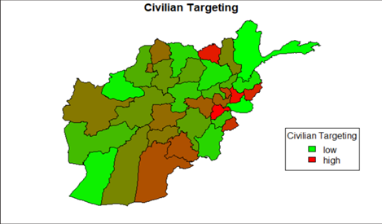

*1.3) Total Fatalities and Fatalities Due to Civilian Targeting Events*

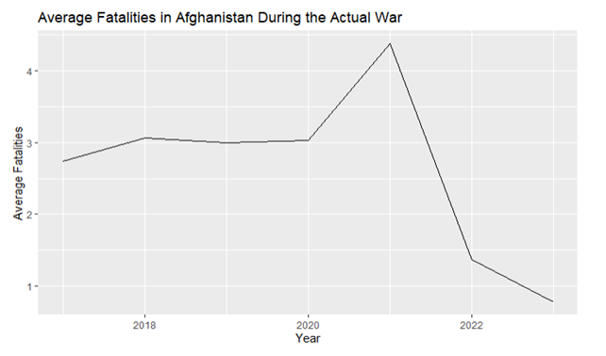

The same pattern in the number of events can be seen in the average fatality. average fatalities have significantly dropped after 2021.

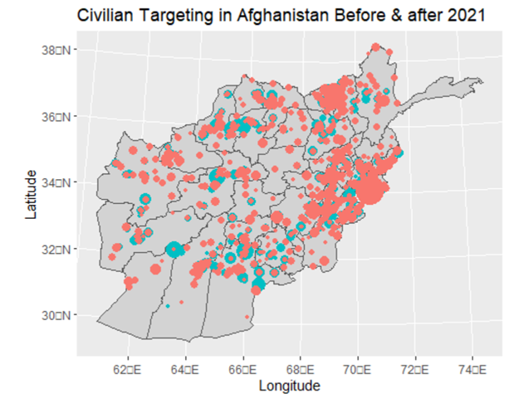

In the above graph, blue represents before 2021 and red represents after 2021. Even though average fatality decreased after the US withdrawal, fatality due to the civilian targeting events increased after the US withdrawal.

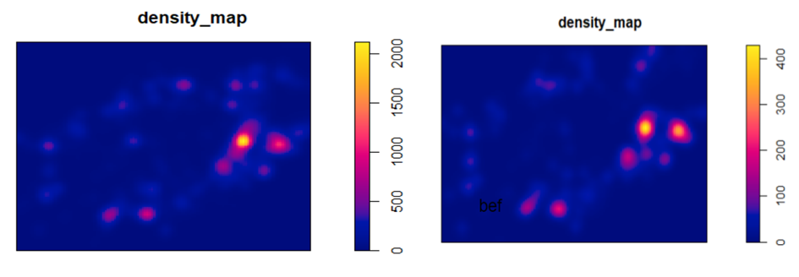

In the graphic above, the city density of fatalities due to civilian targeted events can be observed. The left one represents before 2021, and the right one represents after 2021. When these two graphs are compared, it can be claimed that the density has increased after 2021.

*1.4) More on Civilian Targeting Events*

In this part, components of civilian targeted incidents will be examined. This research divided the civilian targeted events into 10 different sub-events and obtained numerical data on all of them.

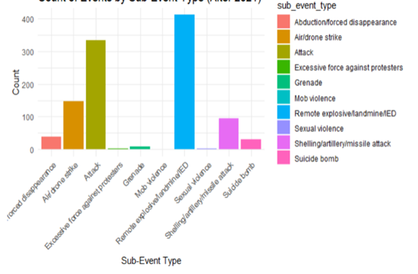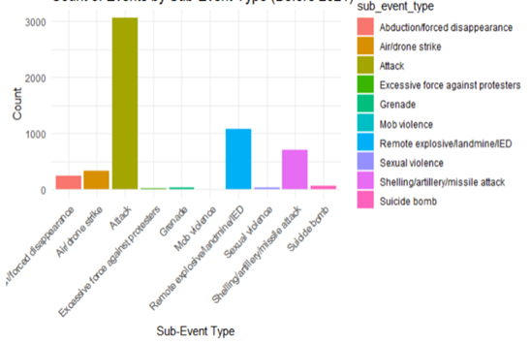

The left graph indicates the before 2021, and the right one represents the after 2021. In the graphs above, it was observed that the number of civilian targeted events and the fatalities due to civilian targeted events increased with the withdrawal of the USA. Moreover, the city distribution of civilian targeting events was changed after the US withdrawal. Now, the change in the distribution of the sub-events of civilian targeting events can be observed. Before the withdrawal the order of the sub-events was remote/explosive, attack, air/drone strike, and shelling/artillery/missile attack respectively. On the other hand, the order of the sub-events are attack, remote/explosive, shelling/artillery/missile, and air/drone strike respectively after the withdrawal.

*1.5) Spatial Autocorrelation Analysis*

During the research, to see the shift of locations that civilian targeting and overall events have happened, spatial autocorrelation analysis has been conducted. There were 3 different analysis about this: overall data, before and after 2021 data respectively.

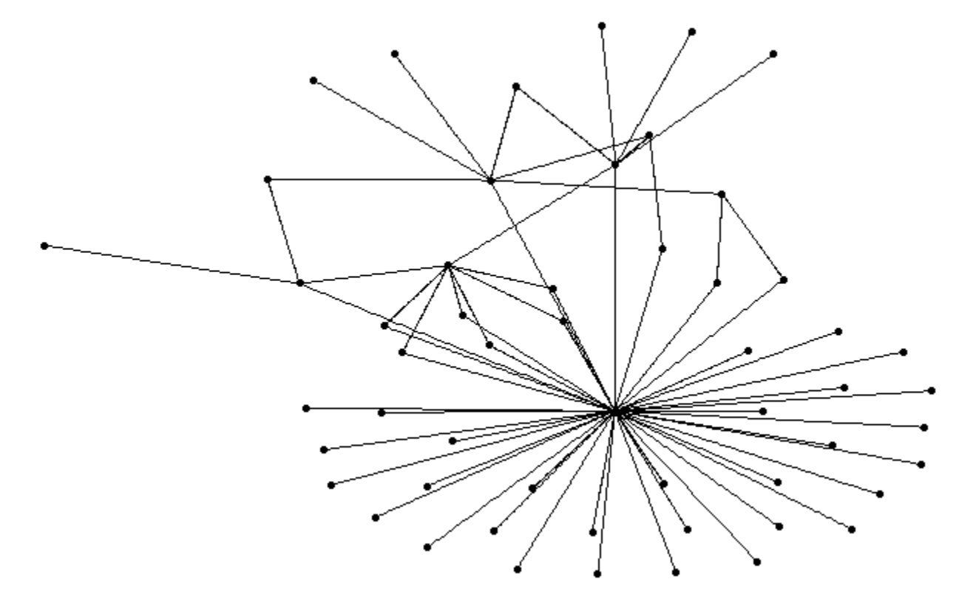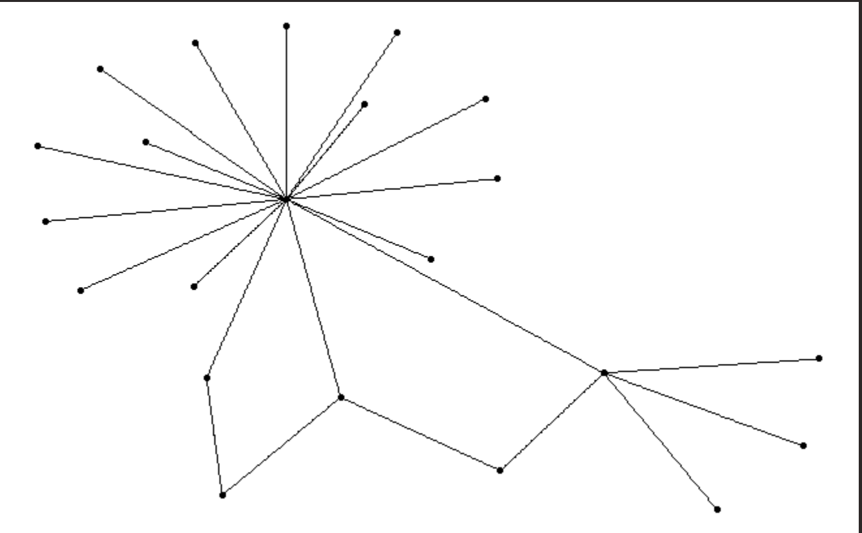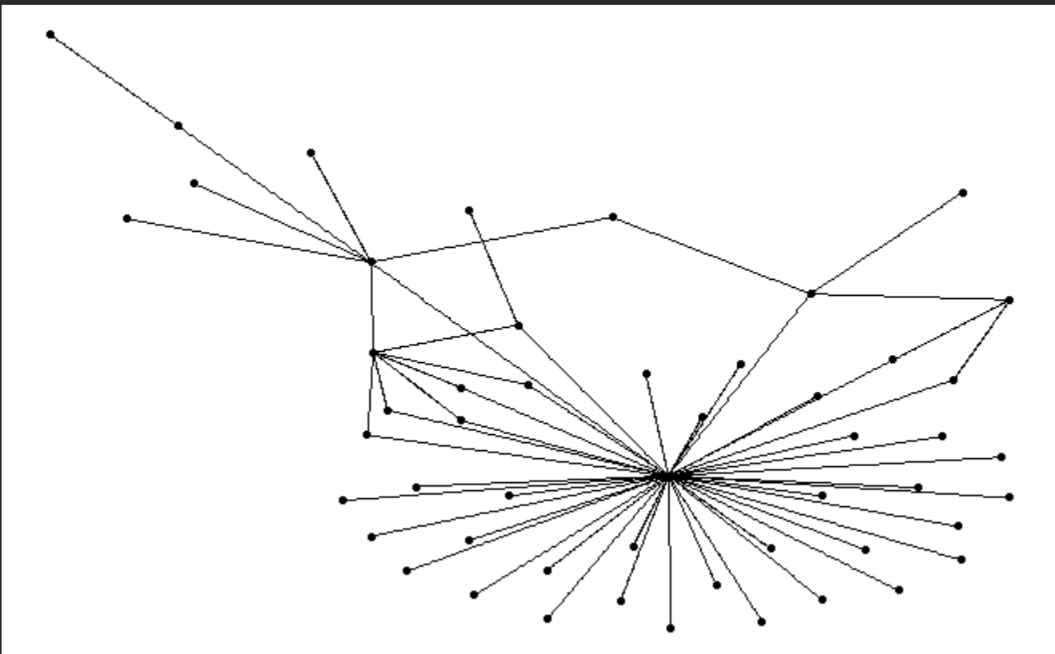

As one can see above, overall analysis (1st network) and after 2021 analysis (3st network) looks similar, since most of the civilian targeting events happened **after** 2021. Compared to before 2021 autocorrelation analysis, a reader can see that civilian targeting events have been shifted through other locations, since civilian targeting became the main aim instead of battles.

Therefore, one can state that civilian targeting and location has a significant relationship considering Afghanistan.

*1.6) Regression analysis*

Lastly, the researchers have performed regression analysis to see if there is a significant impact of year and fatalities to civilian targeting. Even though fatalities could create an endogeneity problem, year’s impact has no counter-argument that can decrease the significance of it when it is proven.

The results of the regression analysis is given below:

|  |  |
| --- | --- |
| (Intercept) | 0.085*** |
|  | (0.001) |
| year | 0.144*** |
|  | (0.003) |
| fatalities | -0.004*** |
|  | (0.000) |
|  |  |
| Num.Obs. | 64972 |
| R2 | 0.042 |

As regression analysis shows, fatalities and binary variable years (before and after 2021) are significant at 99% significance level. By looking at the signs, one can conclude that after 2021 civilian targeting will increase **significantly**. Also, civilian targeting and fatalities have negative relationships, however the coefficient is too small to clearly conclude that.

**Conclusion**

In conclusion, the withdrawal of the United States from Afghanistan has had significant consequences, particularly in terms of civilian targeting. The evidence suggests that since the withdrawal, there has been a notable increase in the targeting of civilians by various armed groups. The Afghanistan war has shifted its focus towards civilians, resulting in a higher likelihood of direct attacks on non-combatants. As a result, the number of civilian casualties has seen a significant rise. These findings substantiate the hypothesis that after the US withdrawal, civilians have become the primary targets of gloating groups operating in Afghanistan. The implications of this shift in targeting are deeply concerning, as it underscores the heightened vulnerability and suffering experienced by innocent civilians in the region. Efforts to mitigate and address this alarming trend are crucial to ensuring the safety and well-being of the Afghan civilian population.