LLVM installation on MAC (Useful link: <http://llvm.org/docs/GettingStarted.html>)

1. Set up GIT if you already have not done so. <https://help.github.com/articles/set-up-git/>
2. Download GitHub for mac

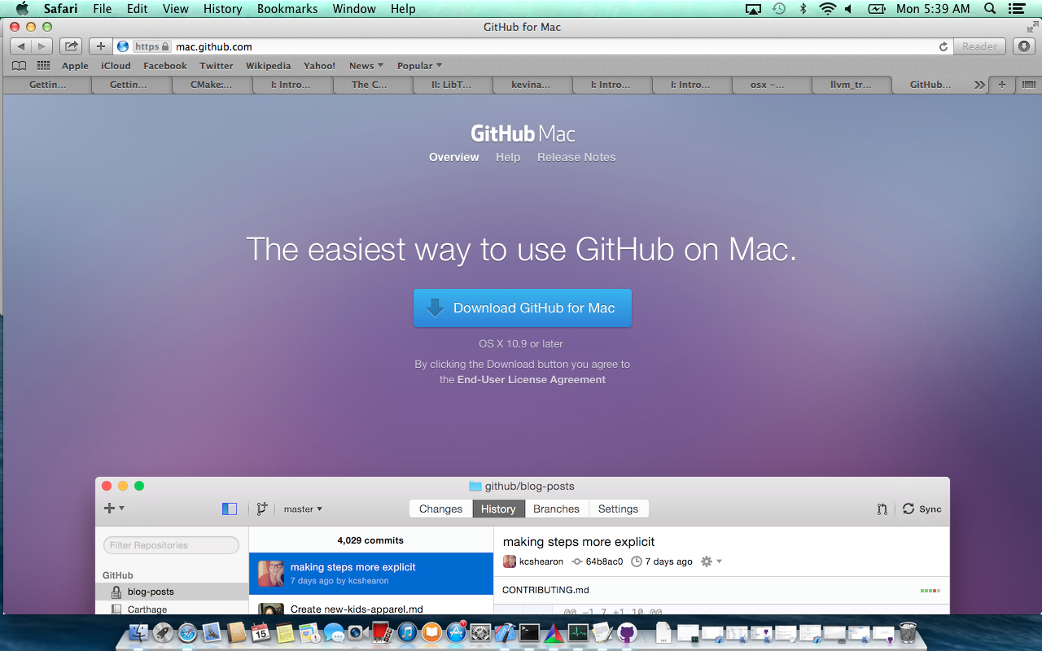

1. Visit our <https://github.com/jayakrish/llvm> or <https://github.com/dekasthiti/llvm> (mirror of official llvm repository at <https://github.com/llvm-mirror/llvm.git>)
2. Fork from this repository into your GIT username by clicking on fork. Your llvm repository is now <https://github.com/YOUR_USERNAME/YOUR_LLVM_FORK>

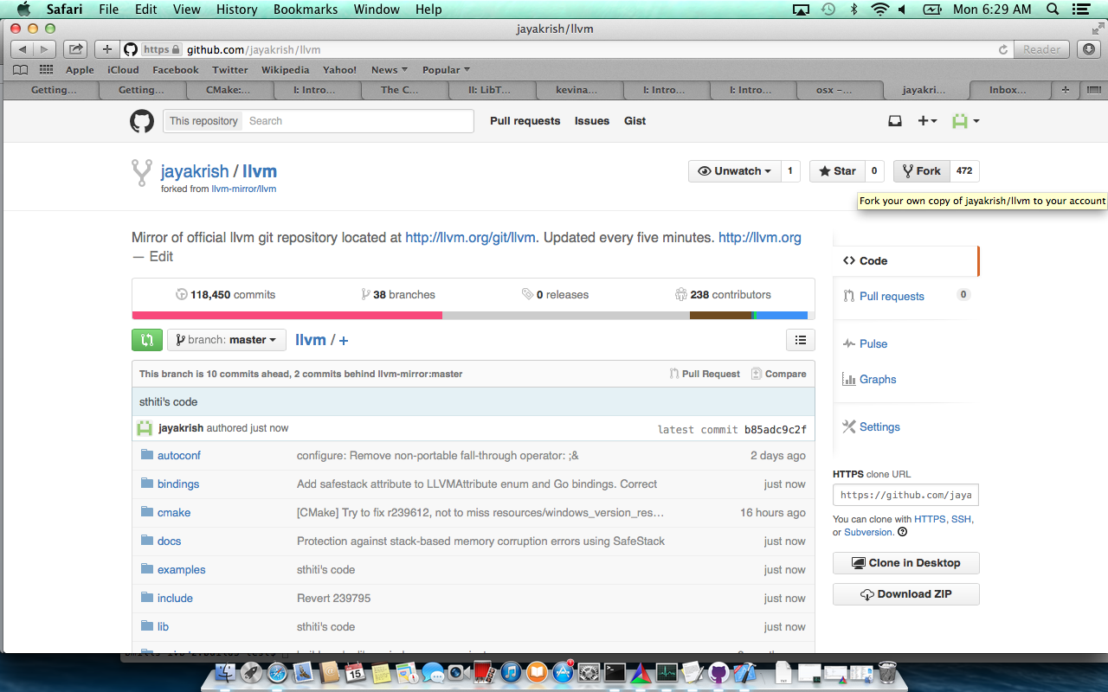

1. Clone llvm code locally to your desktop/workstation. Now you have local copy of the llvm code

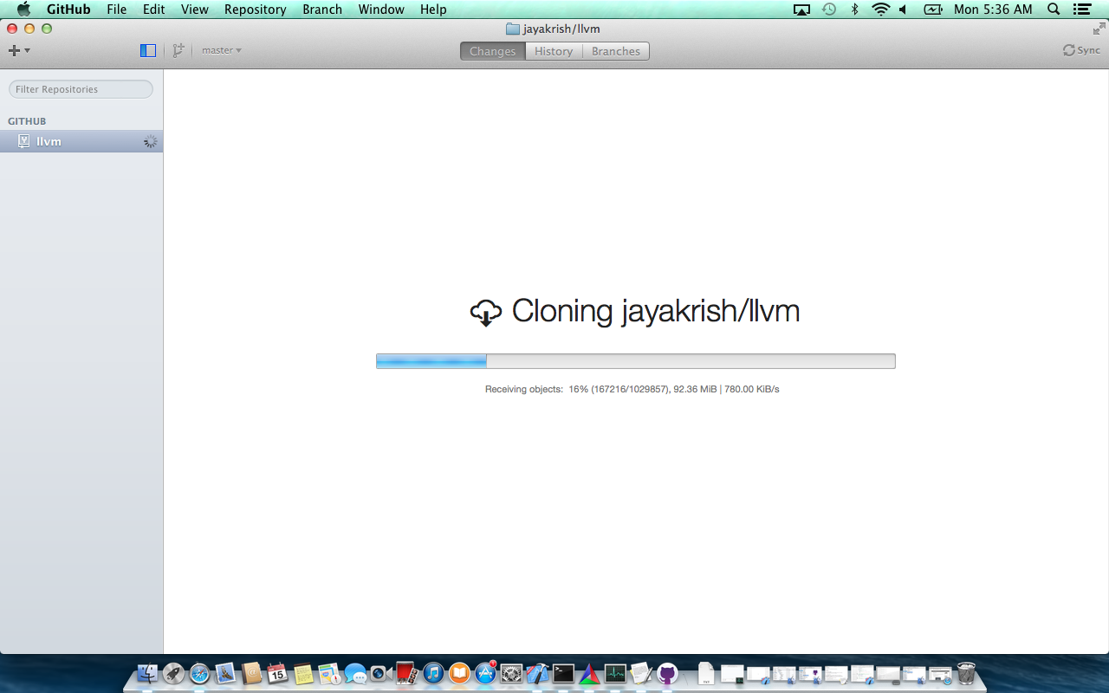

1. Once LLVM code has been cloned, you need to clone clang code to be able to use clang tools.

Now fork from the clang repostiroty <https://github.com/jayakrish/clang> or <https://github.com/dekasthiti/clang> (mirror of the official clang git repository at <http://llvm.org/git/clang>)

1. Clone clang code locally to your desktop/workstation at <dir_where_llvm_is_cloned>\llvm\tools. Now you have local copy of the clang code

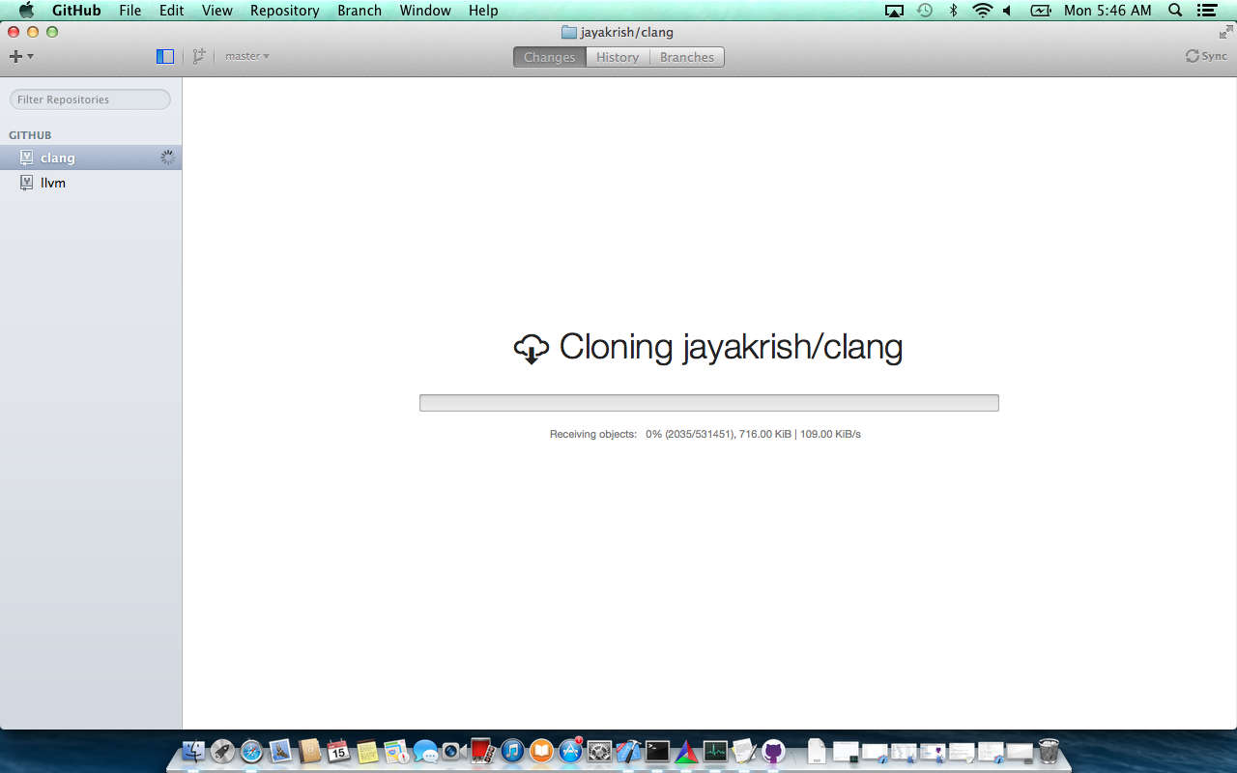

1. Now that you have both llvm and clang, install cmake for mac from <http://www.cmake.org/download/>
2. Open Cmake. Point to the LLVM source directory for the “Where is the source code” and where you want the llvm build to be placed for “Where to build the binaries”. If the path to the build directory does not exist llvm will ask if it should create one for you. Click on “yes”

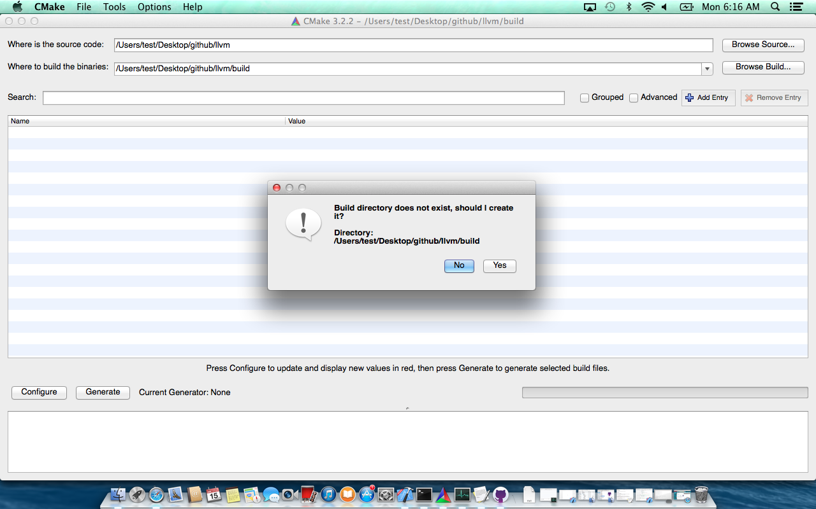

1. Now click on “Configure”. Pick the “Xcode” compiler if you have one installed on you mac. If not pick the “unix makefile system”. Now click on “Finish”

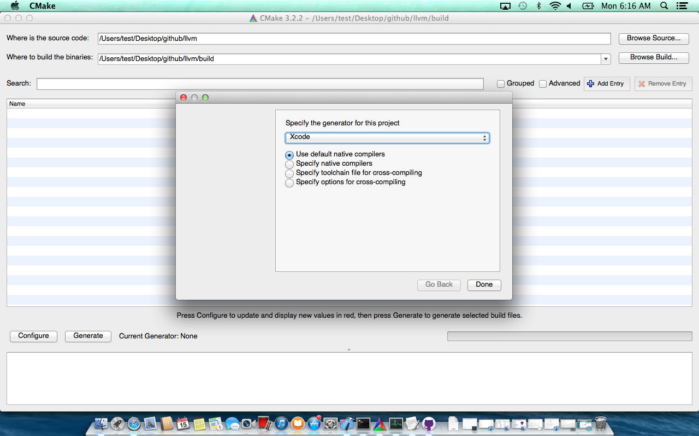

1. Configure begins. Wait till you see the “Configuring done” status message.

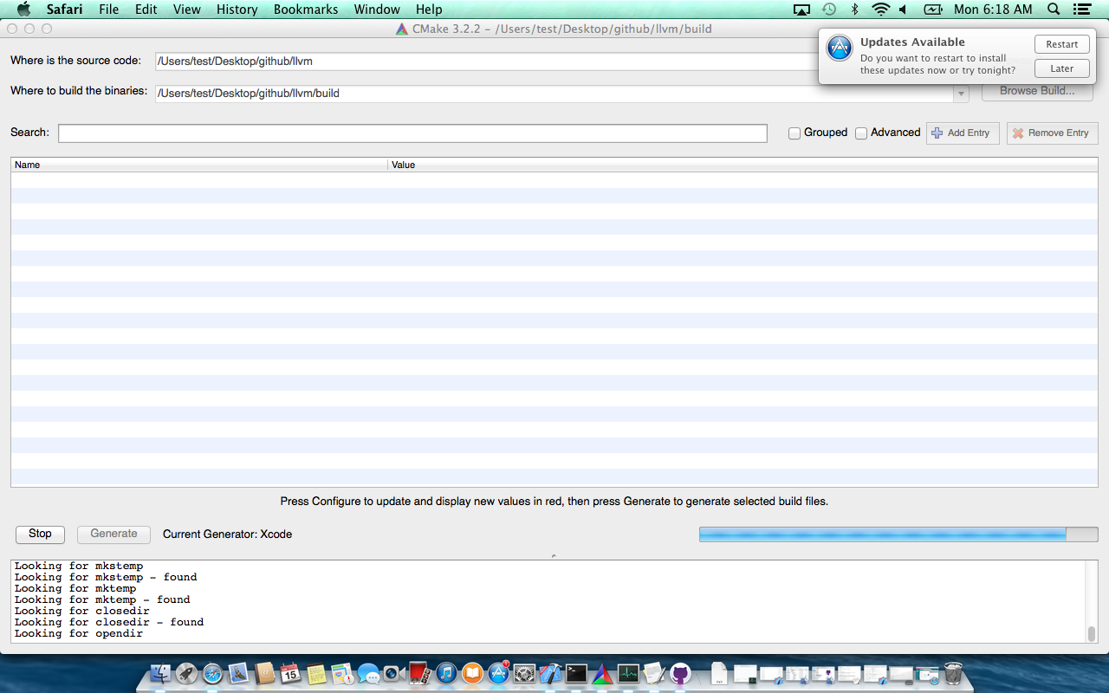

1. Once “Configuring done” is displayed you can see a bunch of LLVM options. Make sure the “LLVM_BUILD_EXAMPLES” option is chekced and then click on “Generate”

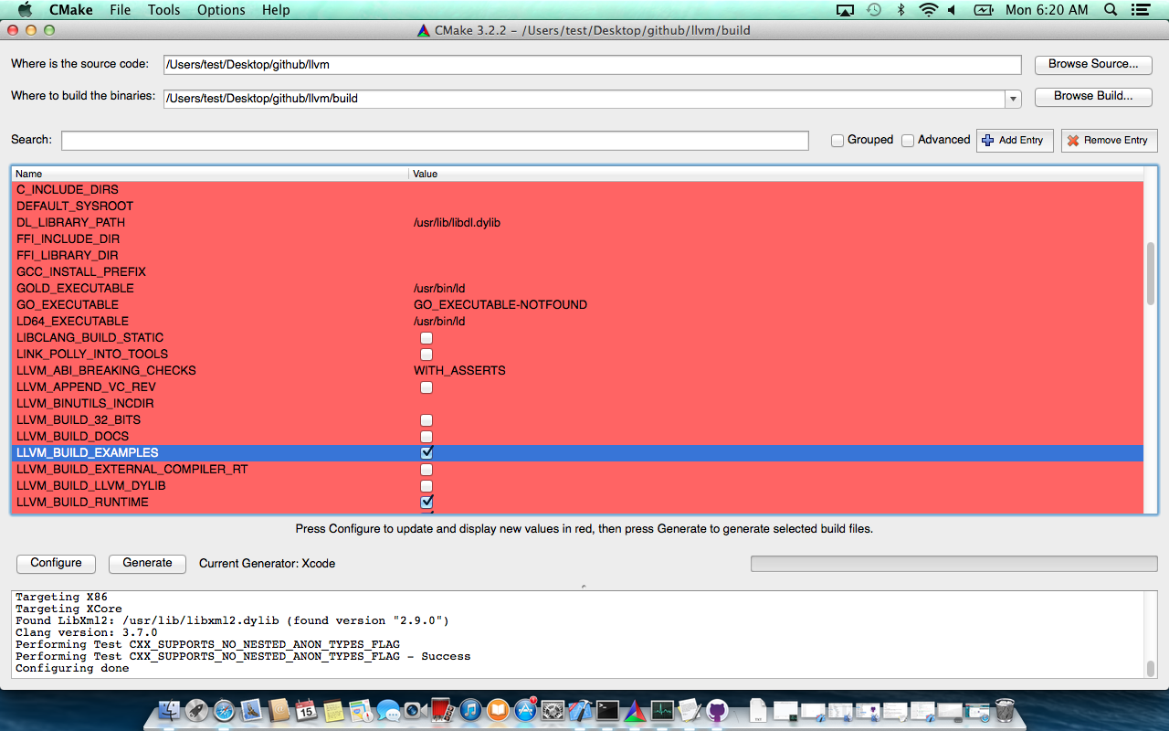

1. Once you see the “Generating Done” message, you should find the LLVM.xcodeproj in the build path if your compiler choice was “xcode”.

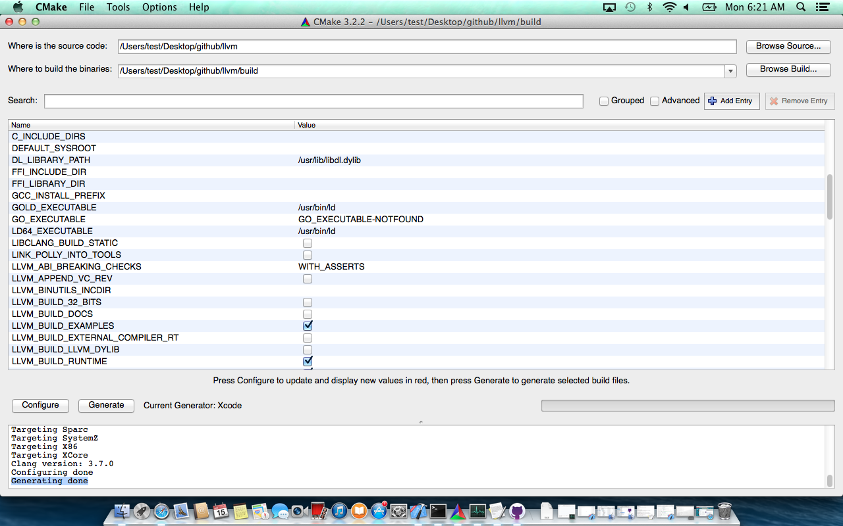

1. Open the Xcode project from the build path. Right click on “ALL_Build” and build the LLVM project
2. Checkout the workshop slides to see how to build and run examples.