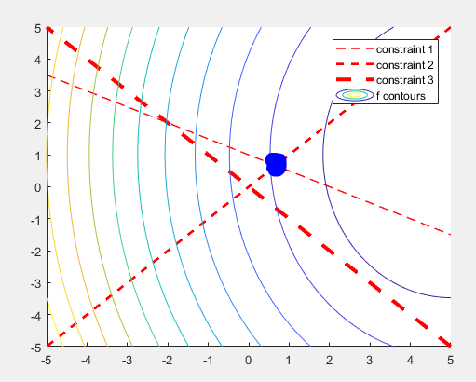

Feasible area and level sets of objective functions.

Optimal point is located at the lowest level set of the feasible area: it is the intersection of constraints 1 and 2.

