**Add/Edit BuffelGrass**

In this page you can add and edit buffelgrass points.

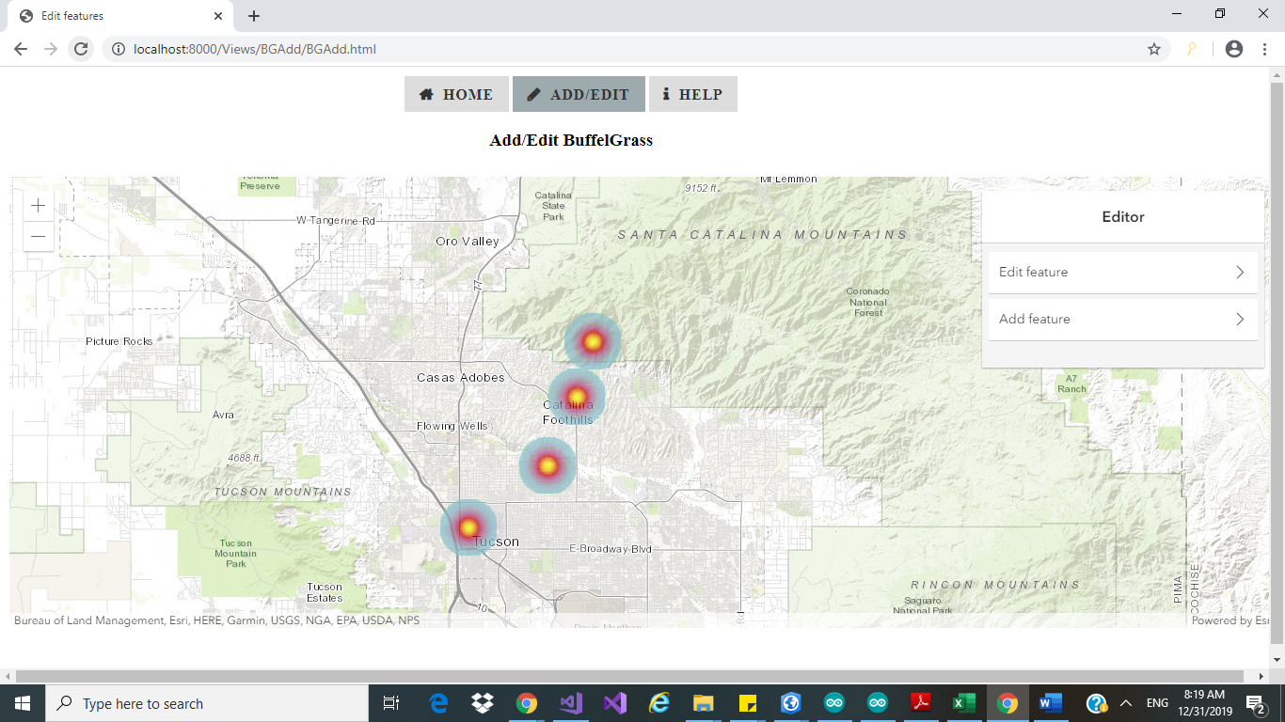

Figure first look to add/edit BG

If you want to add new buffelgrass point click on “Add Feature”. And click on location on map and add feature.

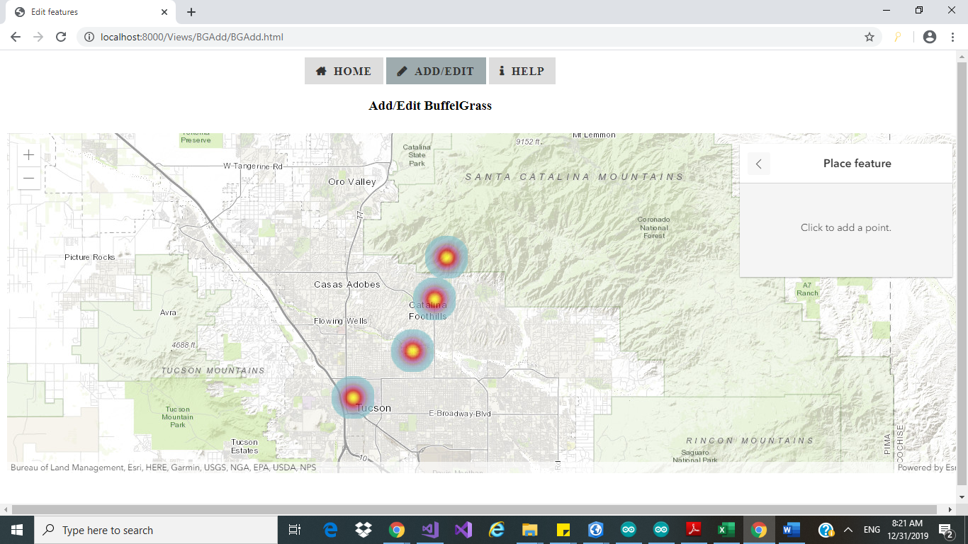

Figure Image after Clicking Add Feature

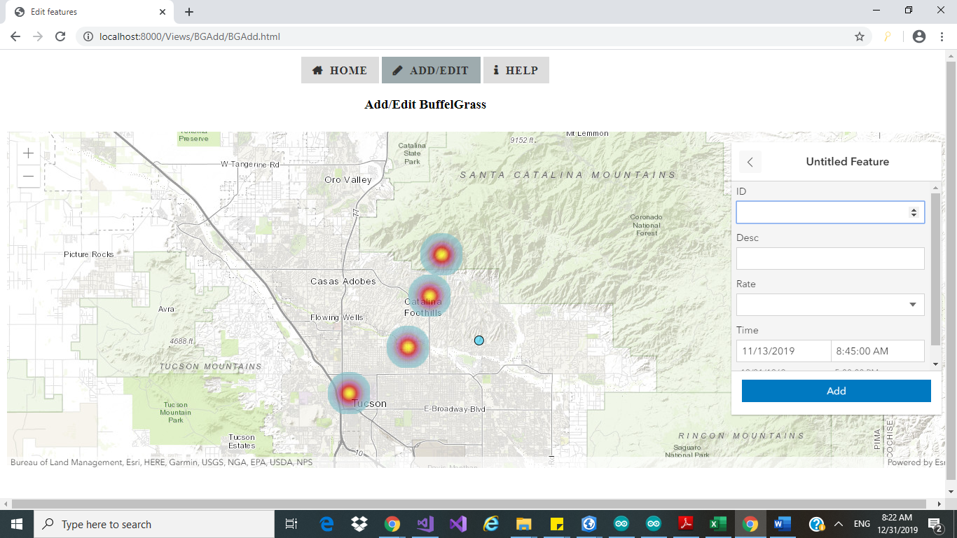

Figure Image after you click on map.

Similarly, you can do edit click on edit feature and select point on map you can edit.