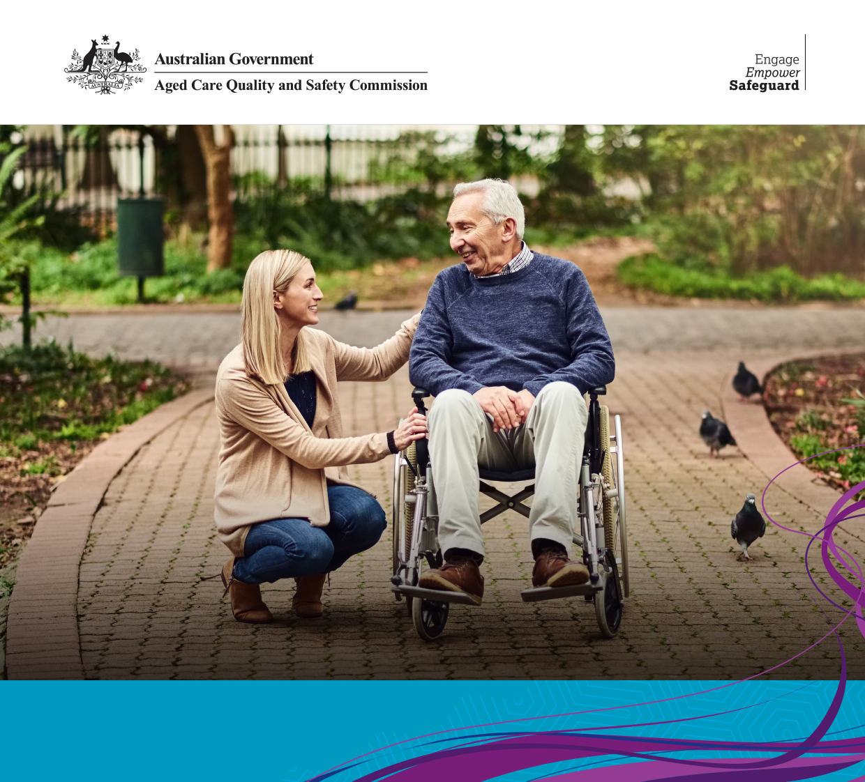**Performance**

**Report**

**1800 951 822**

Agedcarequality.gov.au

|  |  |
| --- | --- |
| Name of service: | RFBI Care at Home - ACT |
| Service address: | 138 Hardwick Crescent HOLT ACT 2615 |
| Commission ID: | 200955 |
| Home Service Provider: | Royal Freemasons' Benevolent Institution |
| Activity type: | Assessment Contact - Desk |
| Activity date: | 20 December 2022 |
| Performance report date: | 23 January 2023 |

This performance report **is published** on the Aged Care Quality and Safety Commission’s (the **Commission**) website under the Aged Care Quality and Safety Commission Rules 2018.

**This performance report**

This performance report for RFBI Care at Home - ACT (**the service**) has been prepared by M Murray, delegate of the Aged Care Quality and Safety Commissioner (Commissioner)[1].

This performance report details the Commissioner’s assessment of the provider’s performance, in relation to the service, against the Aged Care Quality Standards (Quality Standards). The Quality Standards and requirements are assessed as either compliant or non-compliant at the Standard and requirement level where applicable.

The report also specifies any areas in which improvements must be made to ensure the Quality Standards are complied with.

# Services included in this assessment

**Home Care:**

* RFBI Community Services ACT - EACHD, 17263, 138 Hardwick Crescent, HOLT ACT 2615

# Material relied on

The following information has been considered in preparing the performance report:

* the assessment team’s report for the Assessment Contact - Desk; the Assessment Contact - Desk report was informed by review of documents and interviews with staff, consumers/representatives and others.

# Assessment summary for Home Care Packages (HCP)

|  |  |
| --- | --- |
| Standard 2 Ongoing assessment and planning with consumers | Not applicable as not all requirements have been assessed |
| **Standard 3** Personal care and clinical care | Not applicable as not all requirements have been assessed |
| **Standard 4** Services and supports for daily living | Not applicable as not all requirements have been assessed |
| **Standard 8** Organisational governance | Not applicable as not all requirements have been assessed |

Where the Quality Standard is Not Met, one or more requirements of that Quality Standard has been assessed as Not Met.

Where the Quality Standard is Met, a finding of non-compliance has not been made and all requirements of that Quality Standard have been assessed.

A detailed assessment is provided later in this report for each assessed Requirement.

# Areas for improvement

There are no specific areas identified in which improvements must be made to ensure compliance with the Quality Standards. The provider is required to actively pursue continuous improvement in order to remain compliant with the Quality Standards.

# Standard 2

|  |  |  |
| --- | --- | --- |
| Ongoing assessment and planning with consumers | | HCP |
| Requirement 2(3)(a) | Assessment and planning, including consideration of risks to the consumer’s health and well-being, informs the delivery of safe and effective care and services. | Compliant |
| Requirement 2(3)(b) | Assessment and planning identifies and addresses the consumer’s current needs, goals and preferences, including advance care planning and end of life planning if the consumer wishes. | Compliant |
| Requirement 2(3)(d) | The outcomes of assessment and planning are effectively communicated to the consumer and documented in a care and services plan that is readily available to the consumer, and where care and services are provided. | Compliant |
| Requirement 2(3)(e) | Care and services are reviewed regularly for effectiveness, and when circumstances change or when incidents impact on the needs, goals or preferences of the consumer. | Compliant |

Findings

I have relied on the evidence provided in the Assessment Team’s report in making my findings of compliance as noted in the table above. This evidence is summarised below.

Consumers interviewed reported they are satisfied with the services and supports they receive and said in various ways, the services increase their independence, enabling them to stay in their own homes and enhancing their well-being.

Care documentation for consumers included relevant risk assessments and risk mitigation strategies.

Management described improving quality systems at the service over the past ten months and said that regular care plan audits are occurring.

Consumers interviewed said the services and supports they receive meet their current needs and their goals and that care preferences are addressed.

There is evidence that end-of-life discussions have been offered for consumers with high care needs. The Assessment team sighted the training register which demonstrated staff and management have completed training in Advanced Care Planning.

Consumers described changes to their needs triggering reviews and new services being implemented to their satisfaction.

Care documentation consistently included sufficient information to guide care and service delivery. Staff said they have sufficient information to support consumers safely.

I am satisfied, based on the evidence presented, that the approved provider has returned to compliance in the Requirements outlined in the table above.

# Standard 3

|  |  |  |
| --- | --- | --- |
| Personal care and clinical care | | HCP |
| Requirement 3(3)(a) | Each consumer gets safe and effective personal care, clinical care, or both personal care and clinical care, that:   1. is best practice; and 2. is tailored to their needs; and 3. optimises their health and well-being. | Compliant |
| Requirement 3(3)(b) | Effective management of high impact or high prevalence risks associated with the care of each consumer. | Compliant |
| Requirement 3(3)(d) | Deterioration or change of a consumer’s mental health, cognitive or physical function, capacity or condition is recognised and responded to in a timely manner. | Compliant |
| Requirement 3(3)(e) | Information about the consumer’s condition, needs and preferences is documented and communicated within the organisation, and with others where responsibility for care is shared. | Compliant |
| Requirement 3(3)(f) | Timely and appropriate referrals to individuals, other organisations and providers of other care and services. | Compliant |

Findings

I have relied on the evidence provided in the Assessment Team’s report in making my findings of compliance as noted in the table above. This evidence is summarised below.

Consumers described coordinated care being received involving general practitioners and other health providers. Clinical care, including wound management, was found by the Assessment Team to be in line with good clinical management and evidenced a best practice monitoring approach.

The service demonstrated an understanding of high impact and/or high prevalence risks associated with the care of consumers, including falls. Falls management strategies included physiotherapy, massage therapy, provision of aids and equipment and home risk assessments. Staff spoke with confidence in minimising the risk of a fall occurring for consumers.

Three consumers described a period of deteriorating clinical health and said staff had been responsive in supporting their return to their previous level of wellbeing, including addressing weight loss, skin integrity and mobility issues.

The Assessment Team found appropriate and timely referrals are made and followed up as required.

I am satisfied, based on the evidence presented, that the approved provider has returned to compliance in the Requirements outlined in the table above.

# Standard 4

|  |  |  |
| --- | --- | --- |
| Services and supports for daily living | | HCP |
| Requirement 4(3)(d) | Information about the consumer’s condition, needs and preferences is communicated within the organisation, and with others where responsibility for care is shared. | Compliant |

Findings

I have relied on the evidence provided in the Assessment Team’s report in making my findings of compliance as noted in the table above. This evidence is summarised below.

Consumers are satisfied that information about their care and services is shared within the service and with others involved in their care. The service has a policy on information sharing which outlines the need for consumer consent prior to information being shared and this is documented in the consumer’s file. The Assessment Team found information is appropriately and effectively shared and informs coordinated care.

I am satisfied, based on the evidence presented, that the approved provider has returned to compliance in the Requirements outlined in the table above.

# Standard 8

|  |  |  |
| --- | --- | --- |
| Organisational governance | | HCP |
| Requirement 8(3)(b) | The organisation’s governing body promotes a culture of safe, inclusive and quality care and services and is accountable for their delivery. | Compliant |
| Requirement 8(3)(d) | Effective risk management systems and practices, including but not limited to the following:   1. managing high impact or high prevalence risks associated with the care of consumers; 2. identifying and responding to abuse and neglect of consumers; 3. supporting consumers to live the best life they can 4. managing and preventing incidents, including the use of an incident management system. | Compliant |
| Requirement 8(3)(e) | Where clinical care is provided—a clinical governance framework, including but not limited to the following:   1. antimicrobial stewardship; 2. minimising the use of restraint; 3. open disclosure. | Compliant |

Findings

I have relied on the evidence provided in the Assessment Team’s report in making my findings of compliance as noted in the table above. This evidence is summarised below.

All sampled consumers provided positive feedback about feeling safe and/or confident in relation to the quality of service they receive from the organisation.

The Assessment Team’s report outlines the service has appointed a ‘Head of Care at Home’ to provide guidance to the care coordination team. This role supports client safety and seeks to optimise the quality of care and services provided to all consumers.

Governance systems support members of the governing body to manage risk, identify potential abuse and neglect of consumers and effectively support consumers.

An incident management system is in place and used effectively to improve the quality of care delivery and manage risk.

A clinical governance framework covering the elements 8(3)(e), (i), (ii) and (iii) above is in place. A member of the governing body has a clinical background and is responsible for the oversight of clinical governance. A clinical care subcommittee and registered nurses on staff provide relevant data, information and insights to help inform the governing body’s decisions.

I am satisfied, based on the evidence presented, that the approved provider has returned to compliance in the Requirements outlined in the table above.

1. The preparation of the performance report is in accordance with section 68A of the Aged Care Quality and Safety Commission Rules 2018.