UNIVERSITY EXAMINATION BOARD
CALCULUS & DIFFERENTIAL EQUATIONS
Year: 2026 | Maximum Marks: 100 | Total Questions: 15 | Time: 3 Hours

GENERAL INSTRUCTIONS: Answer all questions. Show all working, derivations and calculations. Draw and label diagrams wherever required. Use of scientific calculator is permitted.
Q.No | 1 | 2 | 3 | 4 | 5 | 6 | 7 | 8 | 9 | 10 | 11 | 12 | 13 | 14 | 15 | Total
Marks | 6 | 7 | 8 | 7 | 8 | 6 | 7 | 8 | 7 | 7 | 6 | 7 | 8 | 7 | 8 | 100

Question 1 | [6 Marks]
Find the general solution to the first-order linear differential equation: (dy / dx) + 2xy = x e^-x^2.
_________________________________________________________________________________________________________
_________________________________________________________________________________________________________
_________________________________________________________________________________________________________

Question 2 | [7 Marks]
Compute the Jacobian matrix for the vector-valued function f(x,y,z) = (x^2 y, sin(yz), e^x+z).
_________________________________________________________________________________________________________
_________________________________________________________________________________________________________
_________________________________________________________________________________________________________

Question 3 | [8 Marks]
Evaluate the line integral ∫_C (x^2 + y^2) ds where C is the semicircle x^2 + y^2 = 4 from (2,0) to (-2,0).
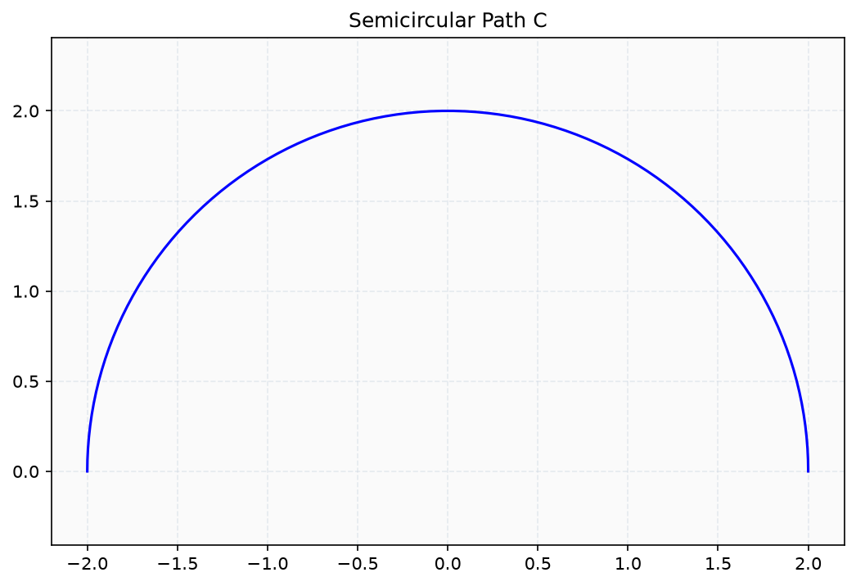
Figure 1
_________________________________________________________________________________________________________
_________________________________________________________________________________________________________
_________________________________________________________________________________________________________

Question 4 | [7 Marks]
Solve the exact differential equation: (2xy + y^3)dx + (x^2 + 3xy^2)dy = 0.
_________________________________________________________________________________________________________
_________________________________________________________________________________________________________
_________________________________________________________________________________________________________

Question 5 | [8 Marks]
Find the critical points of f(x,y) = x^3 + y^3 - 3xy and classify them as local maxima, minima or saddle points.
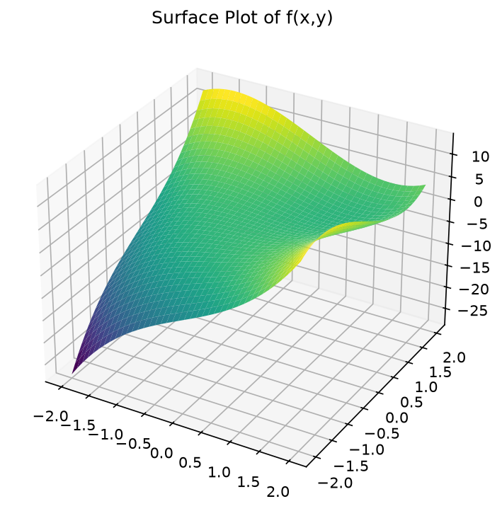
Figure 2
_________________________________________________________________________________________________________
_________________________________________________________________________________________________________
_________________________________________________________________________________________________________

Question 6 | [6 Marks]
Determine the radius of convergence for the power series: ∑[n=1 to ∞] ((2x-3)^n / n 5^n).
_________________________________________________________________________________________________________
_________________________________________________________________________________________________________
_________________________________________________________________________________________________________

Question 7 | [7 Marks]
Solve the Bernoulli equation: (dy / dx) + (y / x) = x^2 y^3.
_________________________________________________________________________________________________________
_________________________________________________________________________________________________________
_________________________________________________________________________________________________________

Question 8 | [8 Marks]
Compute the flux of F = (x^2, y^2, z^2) across the surface of the unit cube [0,1]^3.
_________________________________________________________________________________________________________
_________________________________________________________________________________________________________
_________________________________________________________________________________________________________

Question 9 | [7 Marks]
Find the general solution to the second-order ODE: y'' - 4y' + 4y = e^2x cos x.
_________________________________________________________________________________________________________
_________________________________________________________________________________________________________
_________________________________________________________________________________________________________

Question 10 | [7 Marks]
Evaluate the triple integral _E z dV where E is bounded by the planes x=0, y=0, z=0 and x+y+z=1.
_________________________________________________________________________________________________________
_________________________________________________________________________________________________________
_________________________________________________________________________________________________________

Question 11 | [6 Marks]
Solve the initial value problem: y' = (x^2 / y(1+x^3)) with y(0) = 2.
_________________________________________________________________________________________________________
_________________________________________________________________________________________________________
_________________________________________________________________________________________________________

Question 12 | [7 Marks]
Find the Fourier series representation of f(x) = x^2 on the interval [-π, π].
_________________________________________________________________________________________________________
_________________________________________________________________________________________________________
_________________________________________________________________________________________________________

Question 13 | [8 Marks]
Use Green's Theorem to evaluate ∮_C (y^2 dx + x^2 dy) where C is the boundary of the region between y = x^2 and y = x.
_________________________________________________________________________________________________________
_________________________________________________________________________________________________________
_________________________________________________________________________________________________________

Question 14 | [7 Marks]
Solve the system of differential equations: (dx / dt) = 2x - y, (dy / dt) = x + 2y with initial conditions x(0) = 1, y(0) = 0.
_________________________________________________________________________________________________________
_________________________________________________________________________________________________________
_________________________________________________________________________________________________________

Question 15 | [8 Marks]
Find the Laplace transform of f(t) = t^2 sin(3t) and use it to solve y'' + 4y = t^2 sin(3t) with y(0) = y'(0) = 0.
_________________________________________________________________________________________________________
_________________________________________________________________________________________________________
_________________________________________________________________________________________________________

