UNIVERSITY EXAMINATION BOARD
ADVANCED CALCULUS & DIFFERENTIAL EQUATIONS
Year: 2026 | Maximum Marks: 100 | Total Questions: 20 | Time: 3 Hours

GENERAL INSTRUCTIONS: Answer all questions. Show all working, derivations and calculations. Draw and label diagrams wherever required. Use of scientific calculator is permitted.
Q.No | 1 | 2 | 3 | 4 | 5 | 6 | 7 | 8 | 9 | 10 | 11 | 12 | 13 | 14 | 15 | 16 | 17 | 18 | 19 | 20 | Total
Marks | 5 | 5 | 5 | 5 | 5 | 5 | 5 | 5 | 5 | 5 | 5 | 5 | 5 | 5 | 5 | 5 | 5 | 5 | 5 | 5 | 100

Question 1 | [5 Marks]
Find the general solution to the first-order linear differential equation: (dy / dx) + 2xy = x e^-x^2.
_________________________________________________________________________________________________________
_________________________________________________________________________________________________________
_________________________________________________________________________________________________________

Question 2 | [5 Marks]
Compute the directional derivative of f(x,y,z) = x^2 y + y^2 z at point (1,2,3) in the direction of v = (1,1,1).
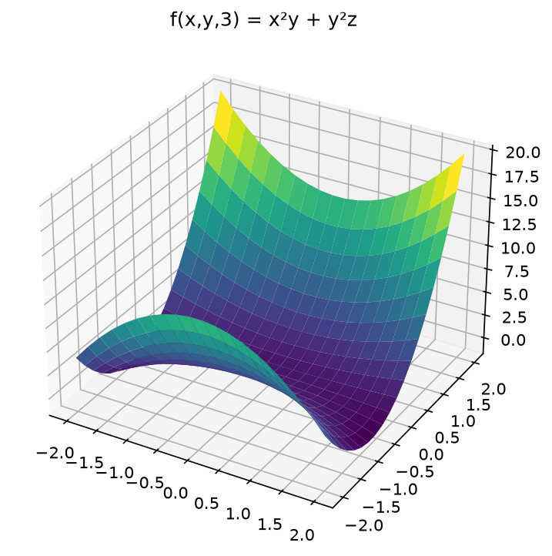
Figure 1
_________________________________________________________________________________________________________
_________________________________________________________________________________________________________
_________________________________________________________________________________________________________

Question 3 | [5 Marks]
Solve the exact differential equation: (2xy + y^3)dx + (x^2 + 3xy^2)dy = 0.
_________________________________________________________________________________________________________
_________________________________________________________________________________________________________
_________________________________________________________________________________________________________

Question 4 | [5 Marks]
Find the critical points of f(x,y) = x^3 + y^3 - 3xy and classify them as maxima, minima or saddle points.
_________________________________________________________________________________________________________
_________________________________________________________________________________________________________
_________________________________________________________________________________________________________

Question 5 | [5 Marks]
Compute the line integral ∫_C (x^2 + y^2)ds where C is the right half of the unit circle x^2 + y^2 = 1 traversed counterclockwise.
_________________________________________________________________________________________________________
_________________________________________________________________________________________________________
_________________________________________________________________________________________________________

Question 6 | [5 Marks]
Solve the Bernoulli equation: (dy / dx) + (y / x) = x^2 y^3.
_________________________________________________________________________________________________________
_________________________________________________________________________________________________________
_________________________________________________________________________________________________________

Question 7 | [5 Marks]
Find the Fourier series representation of f(x) = x on the interval -π < x < π.
_________________________________________________________________________________________________________
_________________________________________________________________________________________________________
_________________________________________________________________________________________________________

Question 8 | [5 Marks]
Compute the surface integral _S (x^2 + y^2)dS where S is the surface z = √(x^2 + y^2) for 0 ≤ z ≤ 1.
_________________________________________________________________________________________________________
_________________________________________________________________________________________________________
_________________________________________________________________________________________________________

Question 9 | [5 Marks]
Solve the initial value problem: y'' + 4y' + 4y = e^-2x, y(0) = 1, y'(0) = 0.
_________________________________________________________________________________________________________
_________________________________________________________________________________________________________
_________________________________________________________________________________________________________

Question 10 | [5 Marks]
Find the general solution to the system of differential equations: (dx / dt) = 2x + y, (dy / dt) = -x + 4y.
_________________________________________________________________________________________________________
_________________________________________________________________________________________________________
_________________________________________________________________________________________________________

Question 11 | [5 Marks]
Compute the divergence and curl of the vector field F = (x^2 y, y^2 z, z^2 x).
_________________________________________________________________________________________________________
_________________________________________________________________________________________________________
_________________________________________________________________________________________________________

Question 12 | [5 Marks]
Solve the partial differential equation: (∂ u / ∂ t) = k (∂^2 u / ∂ x^2) with boundary conditions u(0,t) = u(L,t) = 0 and initial condition u(x,0) = f(x).
_________________________________________________________________________________________________________
_________________________________________________________________________________________________________
_________________________________________________________________________________________________________

Question 13 | [5 Marks]
Find the Laplace transform of f(t) = t^2 sin(3t).
_________________________________________________________________________________________________________
_________________________________________________________________________________________________________
_________________________________________________________________________________________________________

Question 14 | [5 Marks]
Compute the volume integral _V (x^2 + y^2 + z^2) dV where V is the unit sphere x^2 + y^2 + z^2 ≤ 1.
_________________________________________________________________________________________________________
_________________________________________________________________________________________________________
_________________________________________________________________________________________________________

Question 15 | [5 Marks]
Solve the Cauchy-Euler equation: x^2 y'' - 3xy' + 4y = 0.
_________________________________________________________________________________________________________
_________________________________________________________________________________________________________
_________________________________________________________________________________________________________

Question 16 | [5 Marks]
Find the Green's function for the differential operator L[y] = y'' + y with boundary conditions y(0) = y(π) = 0.
_________________________________________________________________________________________________________
_________________________________________________________________________________________________________
_________________________________________________________________________________________________________

Question 17 | [5 Marks]
Compute the flux of F = (x, y, z) through the surface z = 1 - x^2 - y^2 for z ≥ 0.
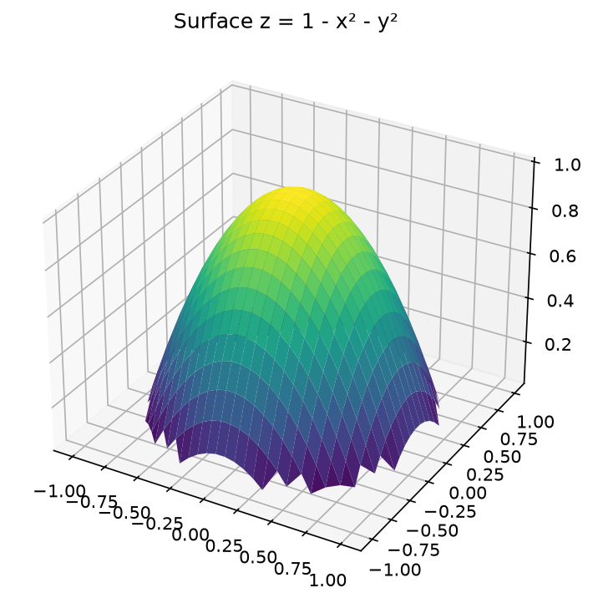
Figure 2
_________________________________________________________________________________________________________
_________________________________________________________________________________________________________
_________________________________________________________________________________________________________

Question 18 | [5 Marks]
Solve the wave equation (∂^2 u / ∂ t^2) = c^2 (∂^2 u / ∂ x^2) with initial conditions u(x,0) = sin(π x/L) and (∂ u / ∂ t)(x,0) = 0.
_________________________________________________________________________________________________________
_________________________________________________________________________________________________________
_________________________________________________________________________________________________________

Question 19 | [5 Marks]
Find the general solution to the nonhomogeneous differential equation: y'' + y = tan x using variation of parameters.
_________________________________________________________________________________________________________
_________________________________________________________________________________________________________
_________________________________________________________________________________________________________

Question 20 | [5 Marks]
Compute the complex line integral ∮_C (e^z / z^2 + 1) dz where C is the circle |z| = 2 traversed counterclockwise.
_________________________________________________________________________________________________________
_________________________________________________________________________________________________________
_________________________________________________________________________________________________________

