UNIVERSITY EXAMINATION BOARD
COMPREHENSIVE AUTOMATED TEST EXAM 2026
Year: 2026 | Maximum Marks: 100 | Total Questions: 2 | Time: 3 Hours

GENERAL INSTRUCTIONS: Answer all questions. Show all working, derivations and calculations. Draw and label diagrams wherever required. Use of scientific calculator is permitted.
Q.No | 1 | 2 | Total
Marks | 50 | 50 | 100

Question 1 | [50 Marks]
Calculate the magnetic flux \Φ = \∫ \· d through loop with =0.5m in field =2.0T.
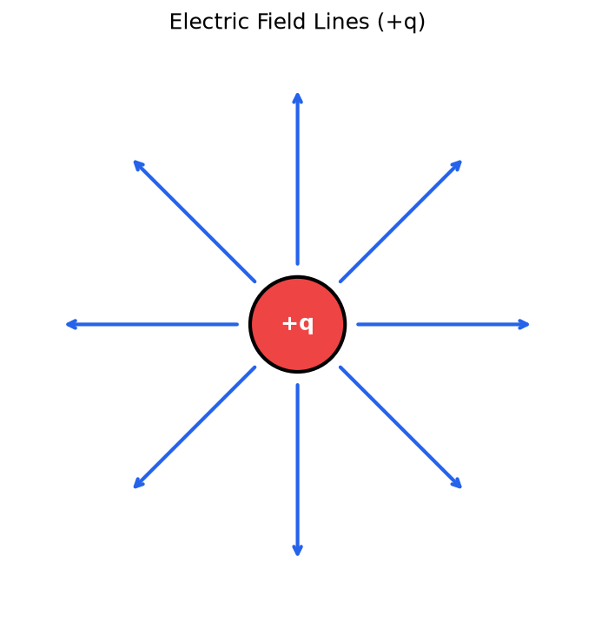
Figure 1
_________________________________________________________________________________________________________
_________________________________________________________________________________________________________
_________________________________________________________________________________________________________
_________________________________________________________________________________________________________
_________________________________________________________________________________________________________
_________________________________________________________________________________________________________
_________________________________________________________________________________________________________
_________________________________________________________________________________________________________
_________________________________________________________________________________________________________
_________________________________________________________________________________________________________

Question 2 | [50 Marks]
Explain prokaryotic DNA replication mechanism.
_________________________________________________________________________________________________________
_________________________________________________________________________________________________________
_________________________________________________________________________________________________________
_________________________________________________________________________________________________________
_________________________________________________________________________________________________________
_________________________________________________________________________________________________________
_________________________________________________________________________________________________________
_________________________________________________________________________________________________________
_________________________________________________________________________________________________________
_________________________________________________________________________________________________________

