EXAMGEN UNIVERSITY
ANNUAL UNIVERSITY EXAMINATION 2026
Course: SCI-301 | Year: 2026 | Maximum Marks: 100 | Total Questions: 5 | Time: 3 Hours

GENERAL INSTRUCTIONS: Answer all questions. Show all working, derivations and calculations. Draw and label diagrams wherever required. Use of scientific calculator is permitted.
Q.No | 1 | 2 | 3 | 4 | 5 | Total
Marks | 20 | 15 | 25 | 20 | 20 | 100

Question 1 | [20 Marks]
Find the derivative of f(x) = sin(x) · e^-0.2x and determine all critical points in the interval [0, 2π]. Sketch the function and clearly label the critical points.
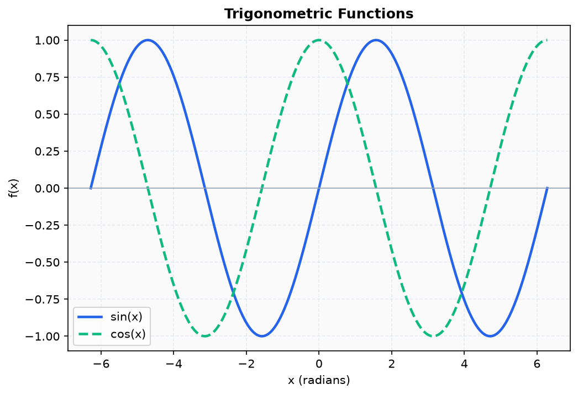
Figure 1
_________________________________________________________________________________________________________
_________________________________________________________________________________________________________
_________________________________________________________________________________________________________
_________________________________________________________________________________________________________
_________________________________________________________________________________________________________
_________________________________________________________________________________________________________

Question 2 | [15 Marks]
With reference to the diagram, label the organelles of an animal cell and describe the function of the mitochondria and nucleus. Explain how the cell membrane regulates the entry and exit of substances.
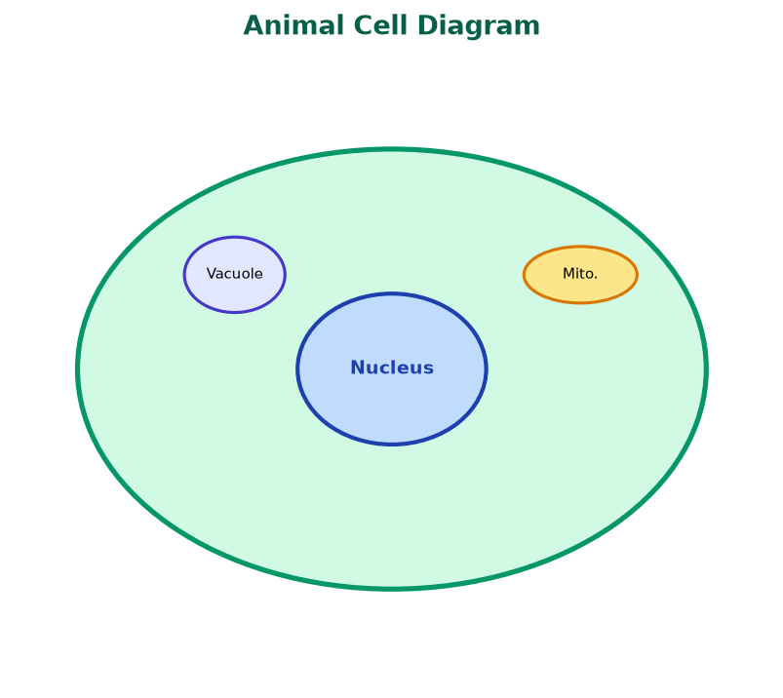
Figure 2
_________________________________________________________________________________________________________
_________________________________________________________________________________________________________
_________________________________________________________________________________________________________
_________________________________________________________________________________________________________
_________________________________________________________________________________________________________

Question 3 | [25 Marks]
A block of mass M = 5\,kg is placed on a frictionless horizontal surface. A force F = 20\,N is applied at an angle θ = 30° to the horizontal. Using Newton's second law F = ma, find the acceleration of the block and the normal reaction force N.
_________________________________________________________________________________________________________
_________________________________________________________________________________________________________
_________________________________________________________________________________________________________
_________________________________________________________________________________________________________
_________________________________________________________________________________________________________
_________________________________________________________________________________________________________
_________________________________________________________________________________________________________
_________________________________________________________________________________________________________

Question 4 | [20 Marks]
Evaluate the definite integral ∫[0 to 1] (x^2 / 1+x^3)\,dx using an appropriate substitution. Show all intermediate steps.
_________________________________________________________________________________________________________
_________________________________________________________________________________________________________
_________________________________________________________________________________________________________
_________________________________________________________________________________________________________
_________________________________________________________________________________________________________
_________________________________________________________________________________________________________

Question 5 | [20 Marks]
Describe the process of meiosis and distinguish it from mitosis. Include a diagram showing the stages of meiosis I and meiosis II.
_________________________________________________________________________________________________________
_________________________________________________________________________________________________________
_________________________________________________________________________________________________________
_________________________________________________________________________________________________________
_________________________________________________________________________________________________________
_________________________________________________________________________________________________________

