**Problem 1**

We analyze approximations to

$\frac{dx}{dt}=t-2x,t_{0}=0,x_{0}=1,t∈[0,2]$,

which has exact solution

$x(t)=\frac{5}{4}e^{-2t}+\frac{1}{4}(2t-1)$,

using Euler's Method, the Modified Euler Method, and the fourth order Runge-Kutta method (RK4). First we show that *x*(*t*) is the exact solution to the initial value problem.

1) Domain of *x* contains a neighborhood of $t_{0}$

The domain of *x*(*t*) is $R$, and therefore, contains a neighborhood of $t_{0}$.

2) $x\left(t_{0}\right)= x_{0}$

$$x\left(t_{0}\right)= \frac{5}{4}e^{0}-\frac{1}{4}$$

$$= \frac{5}{4}-\frac{1}{4}=1= x_{0}$$

3) $\frac{dx}{dt}=t-2x$

$$\frac{dx}{dt}=-\frac{5}{2}e^{-2t}+\frac{1}{2}=? t-2x$$

$=?t-\left[ \frac{5}{2}e^{-2t}+\frac{1}{2}\left(2t-1\right)\right]$

$=?t-\frac{5}{2}e^{-2t}-t+\frac{1}{2}$

$=-\frac{5}{2}e^{-2t}+\frac{1}{2}$

*x*(*t*) satisfies all conditions necessary for it to be the unique solution to the IVP.

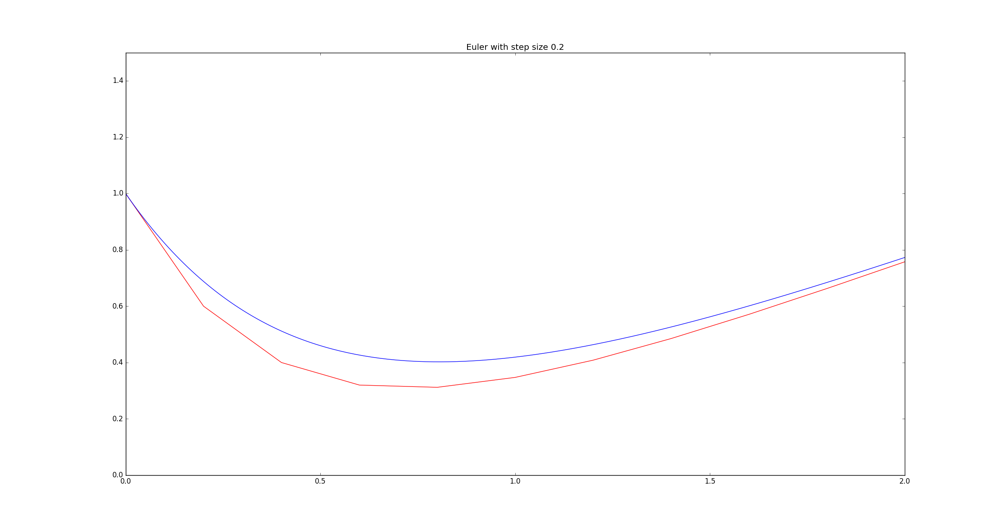Figure 1. The exact solution (blue) and its approximation (red) using the Euler Method with a step size of 0.2.

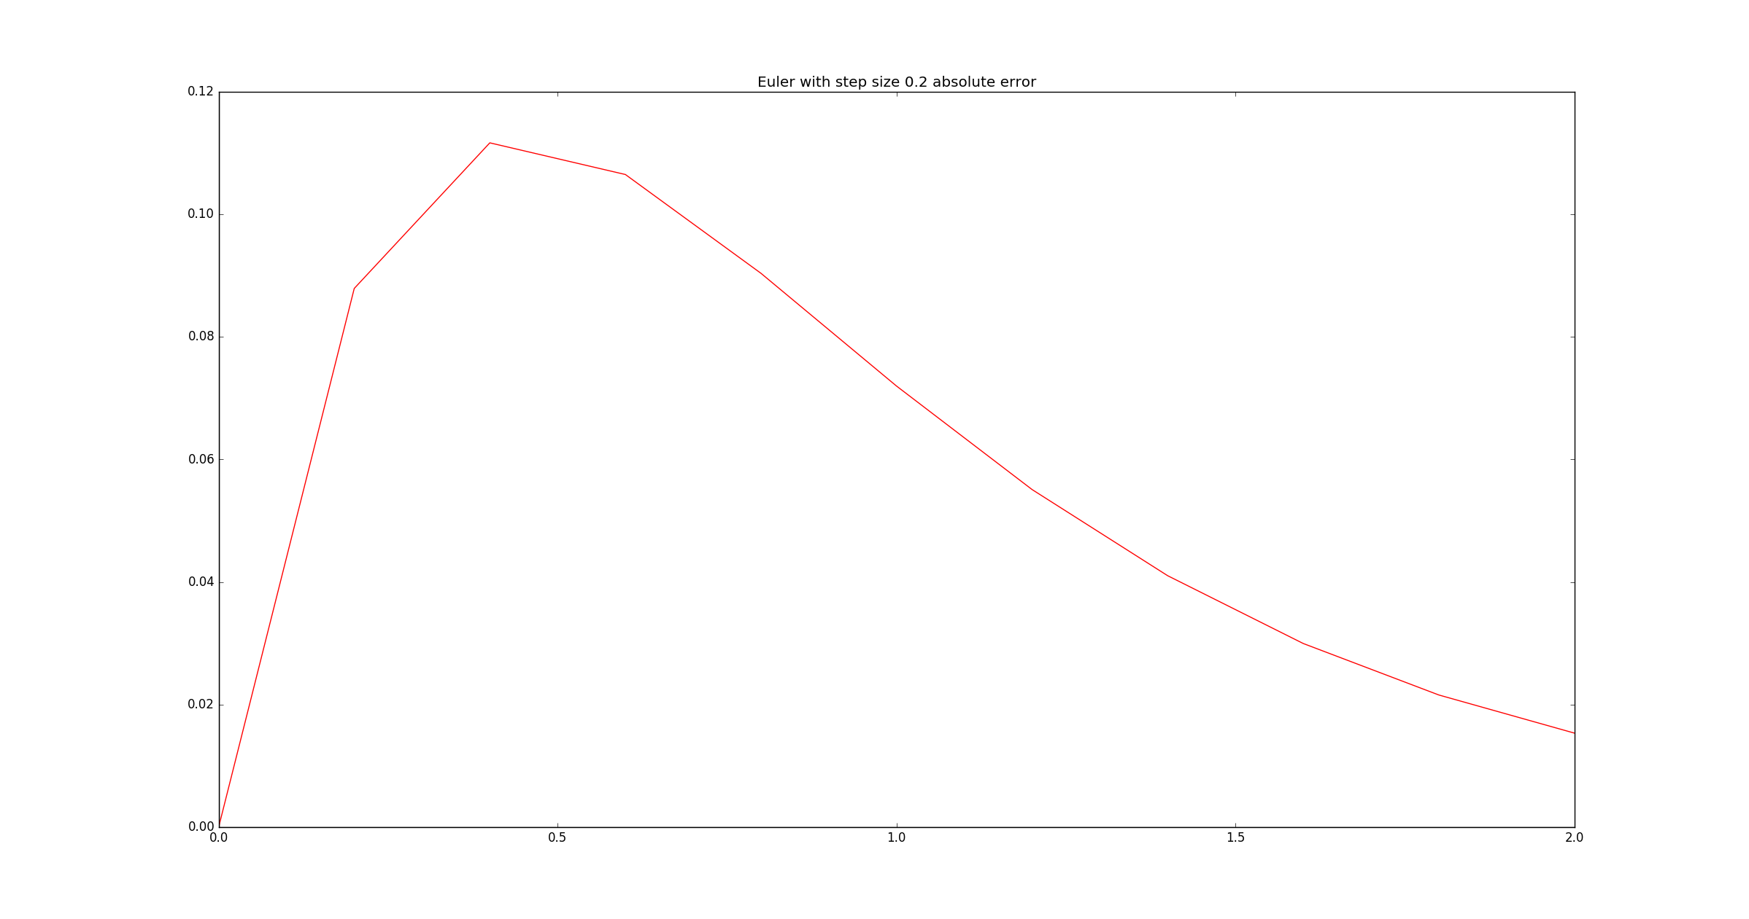Figure 2. The absolute error between the curves in figure 1.

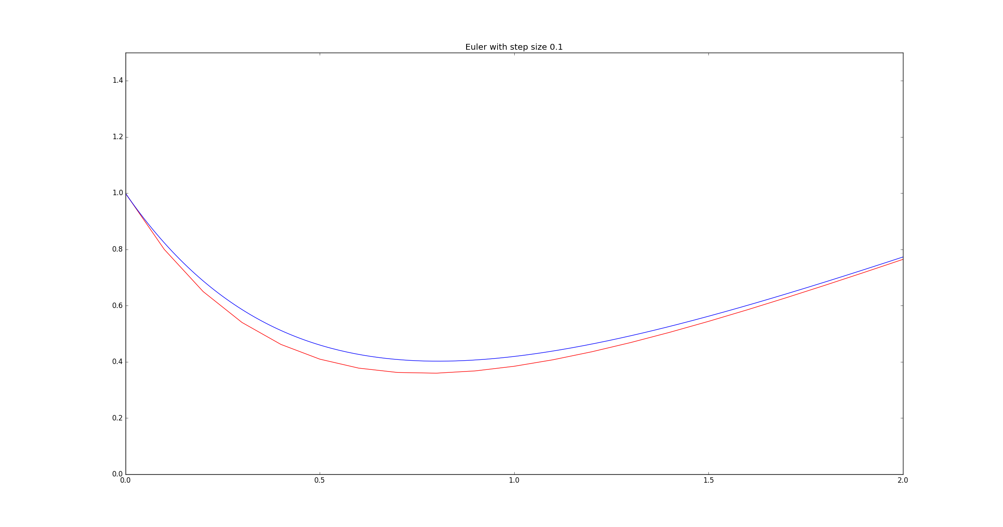Figure 3. The exact solution (blue) and its approximation (red) using the Euler Method with a step size of 0.1.

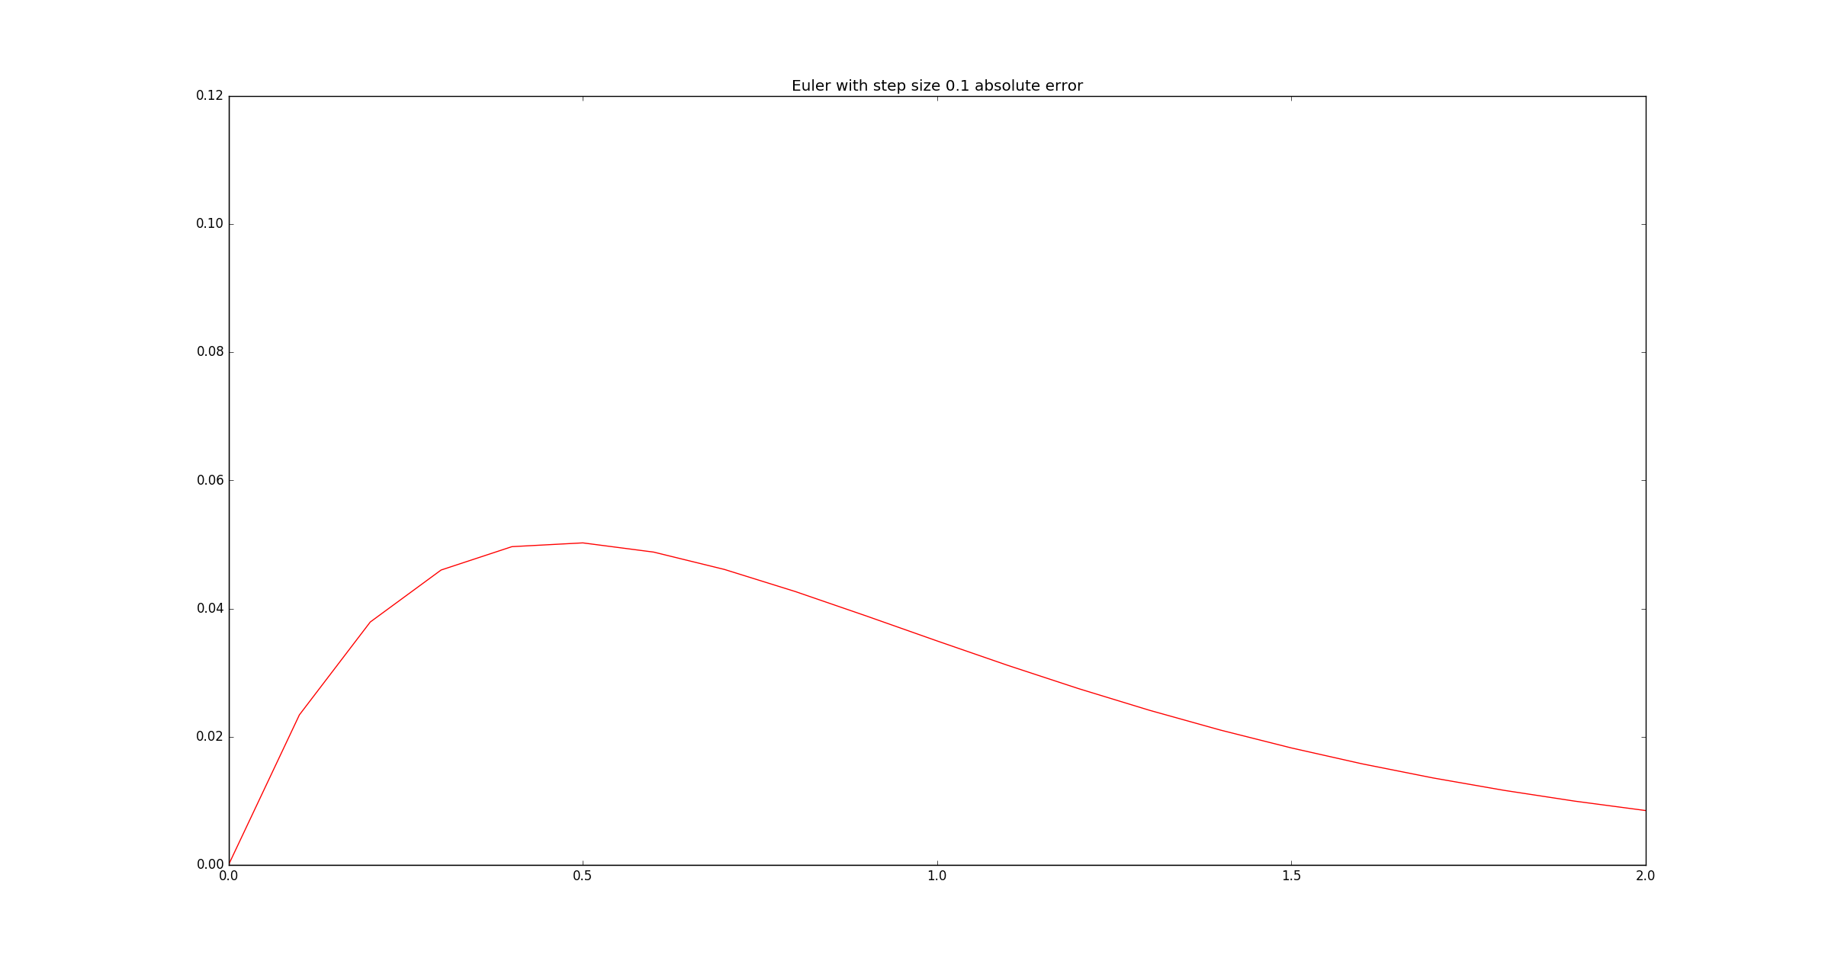Figure 4. The absolute error between the curves in figure 3.

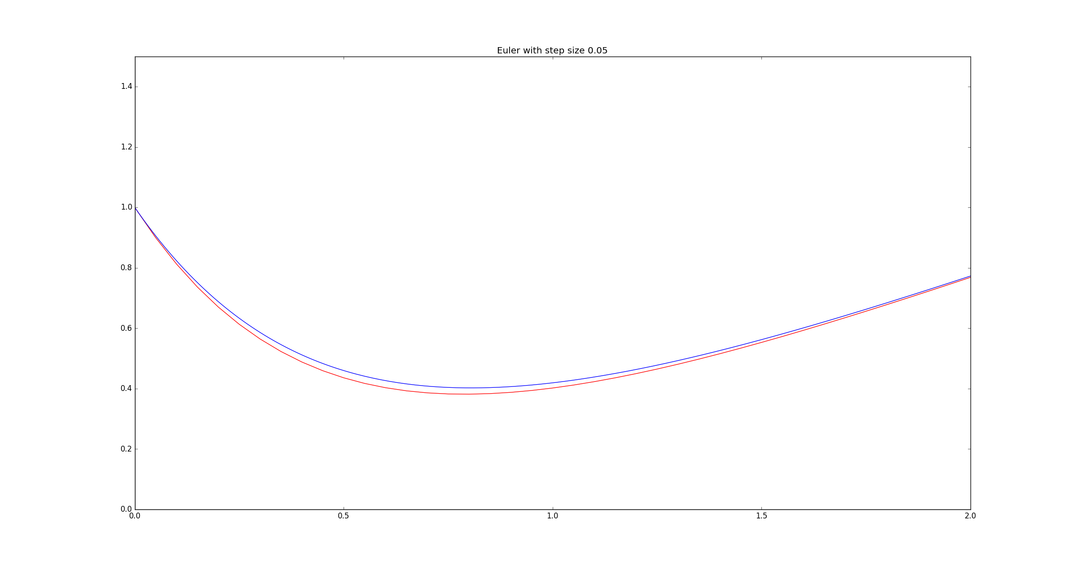Figure 5. The exact solution (blue) and its approximation (red) using the Euler Method with a step size of 0.05.

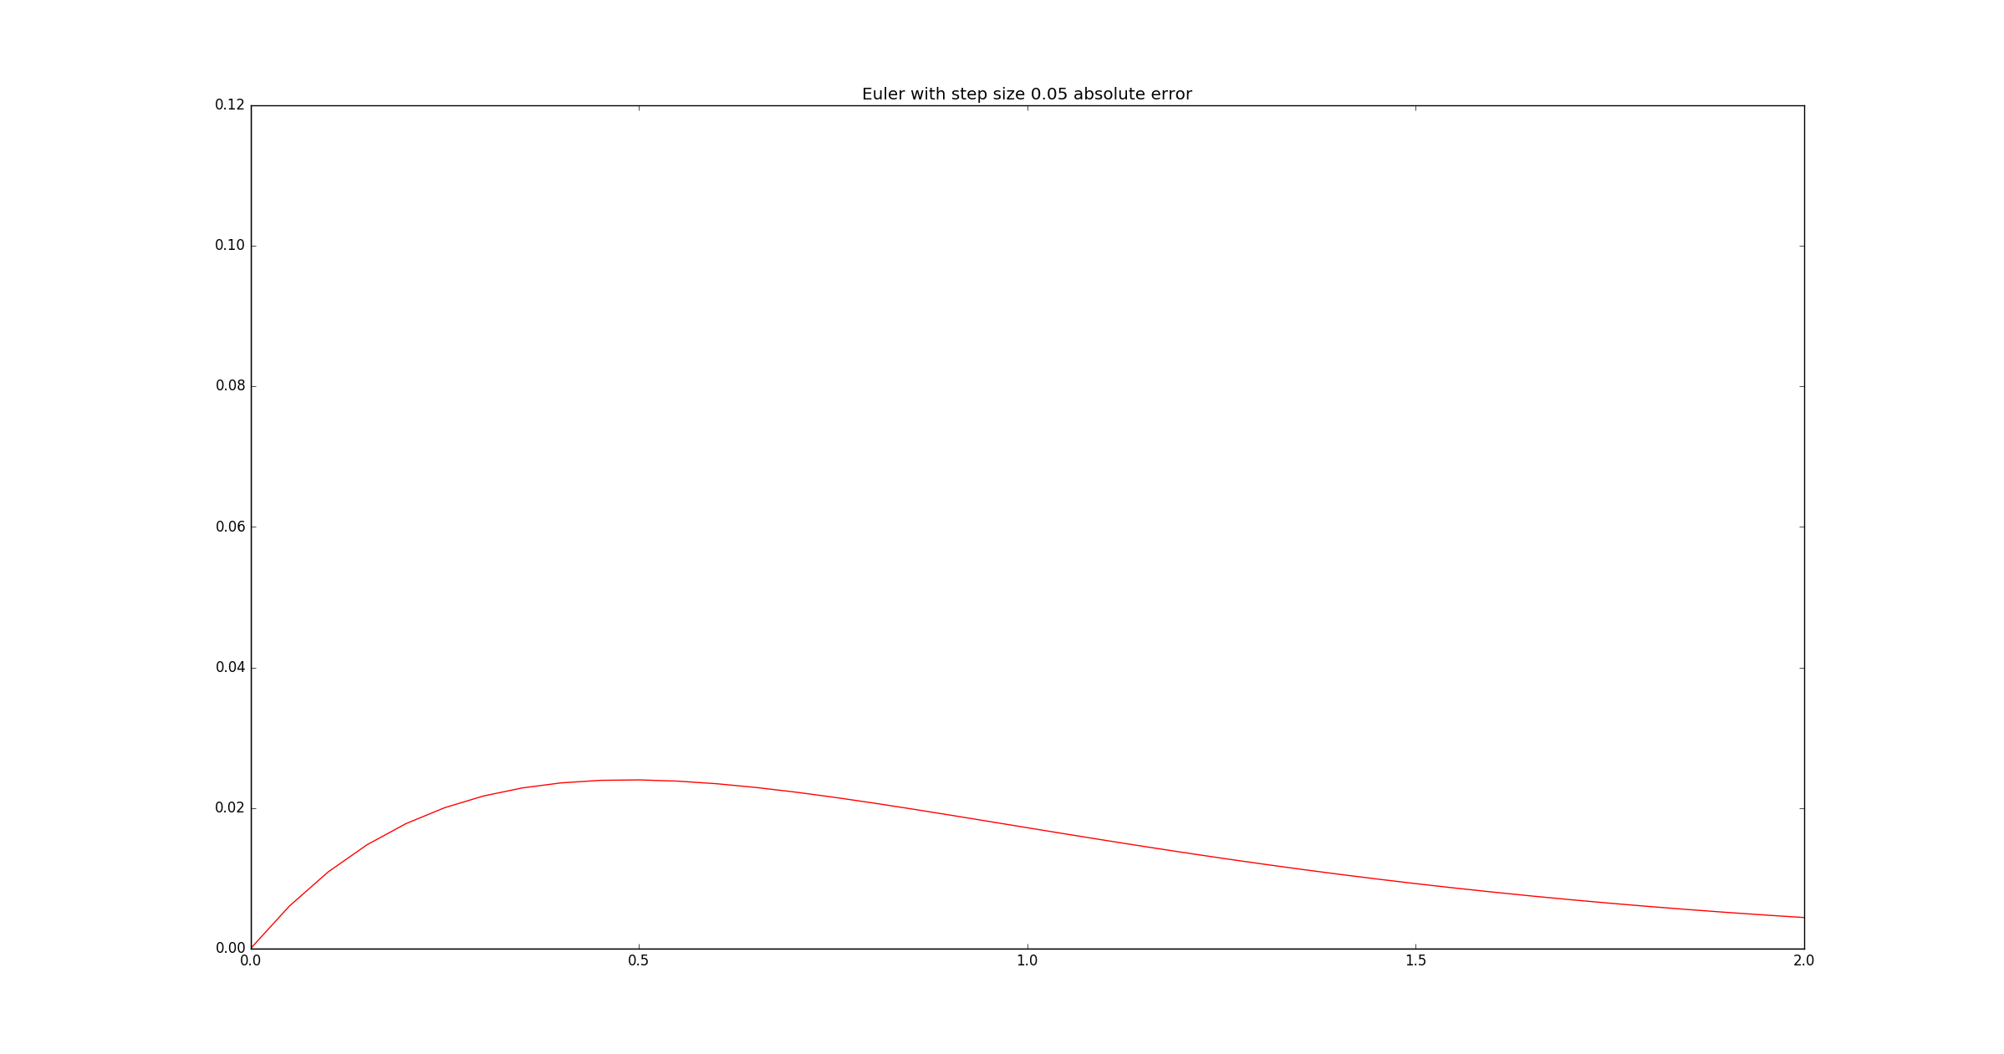Figure 6. The absolute error between the curves in figure 5.

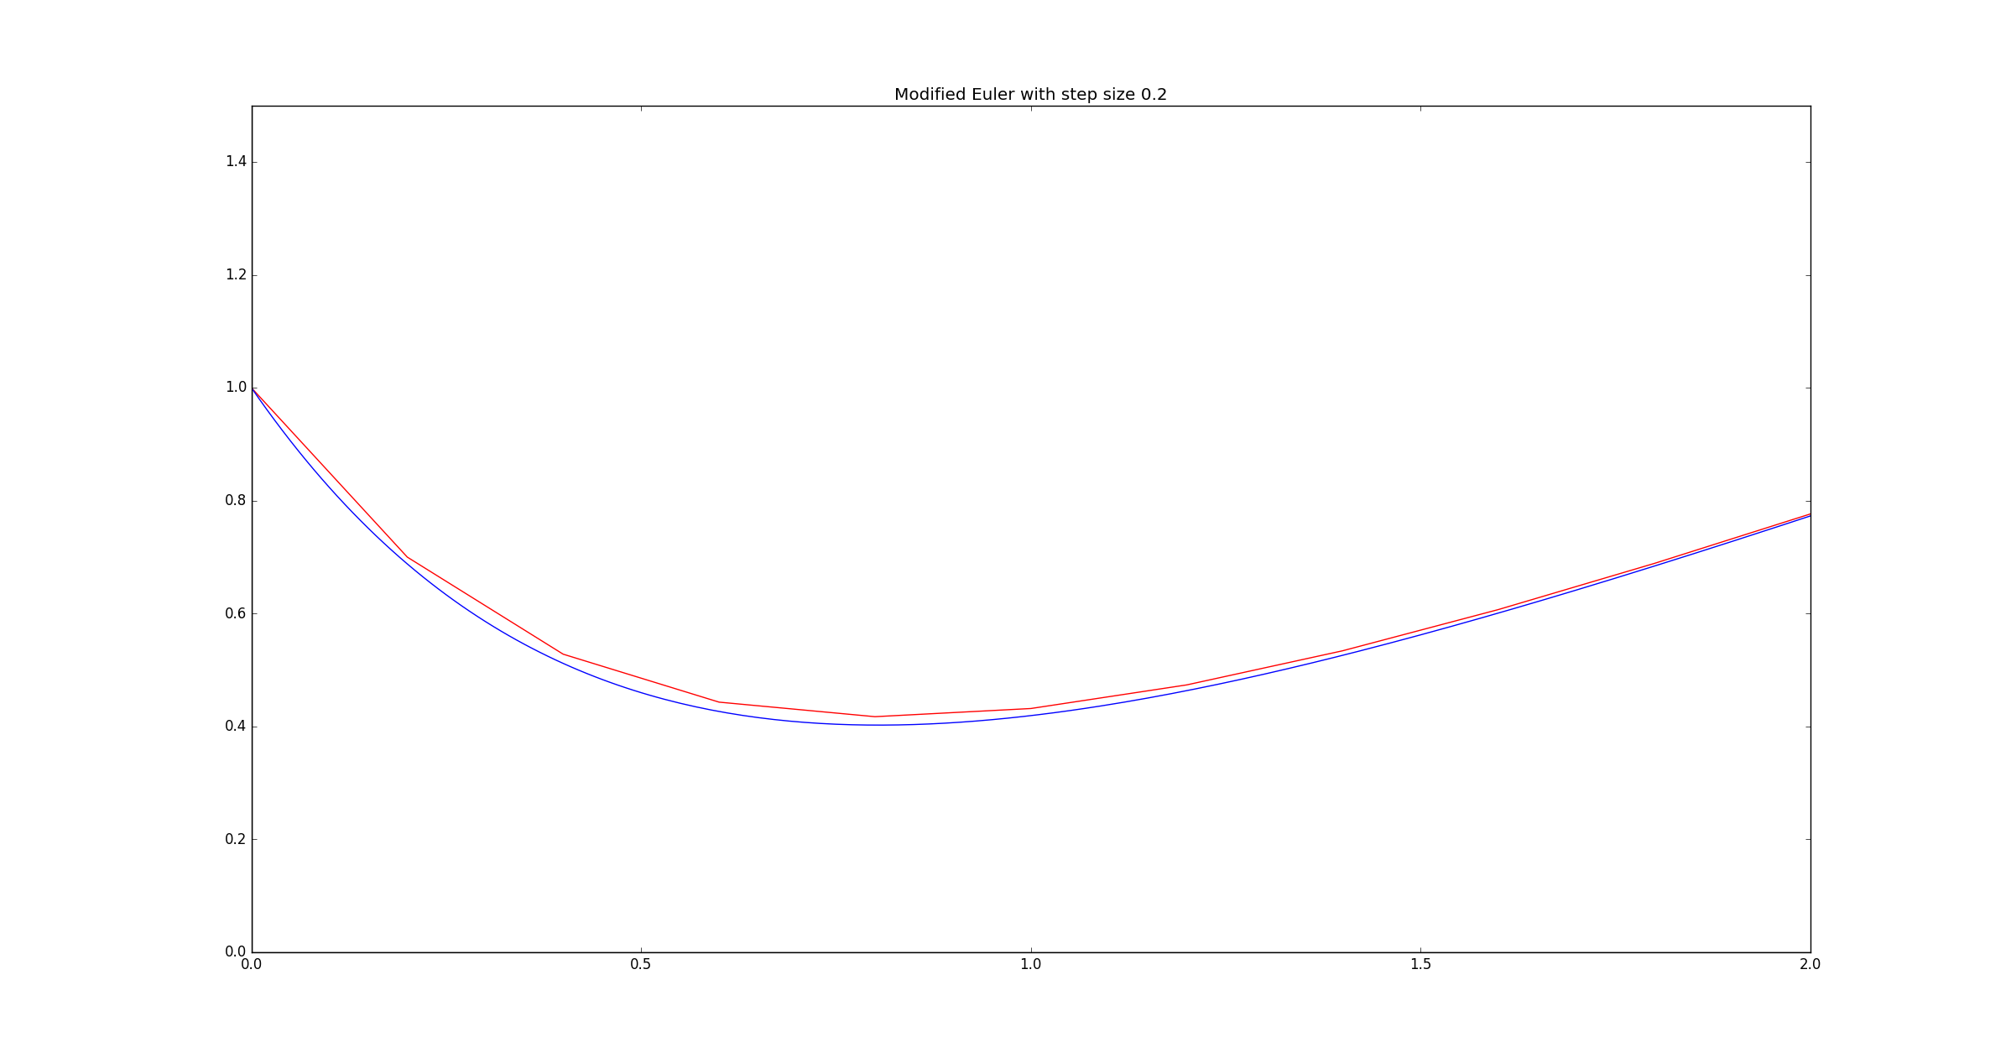Figure 7. The exact solution (blue) and its approximation (red) using the Modified Euler Method with a step size of 0.2.

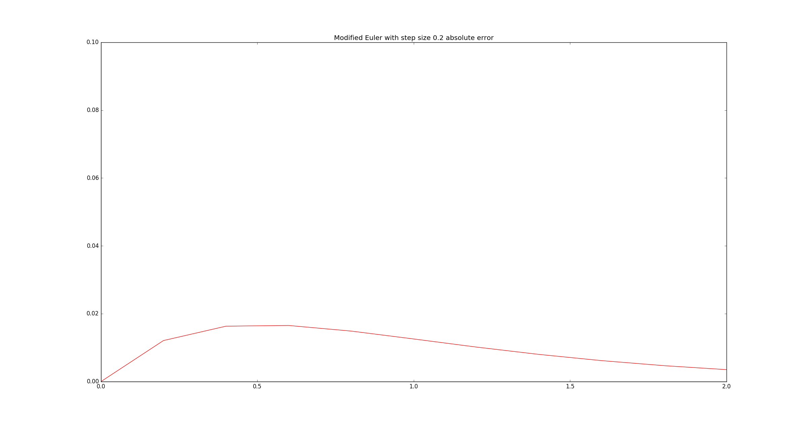Figure 8. The absolute error between the curves in figure 7.

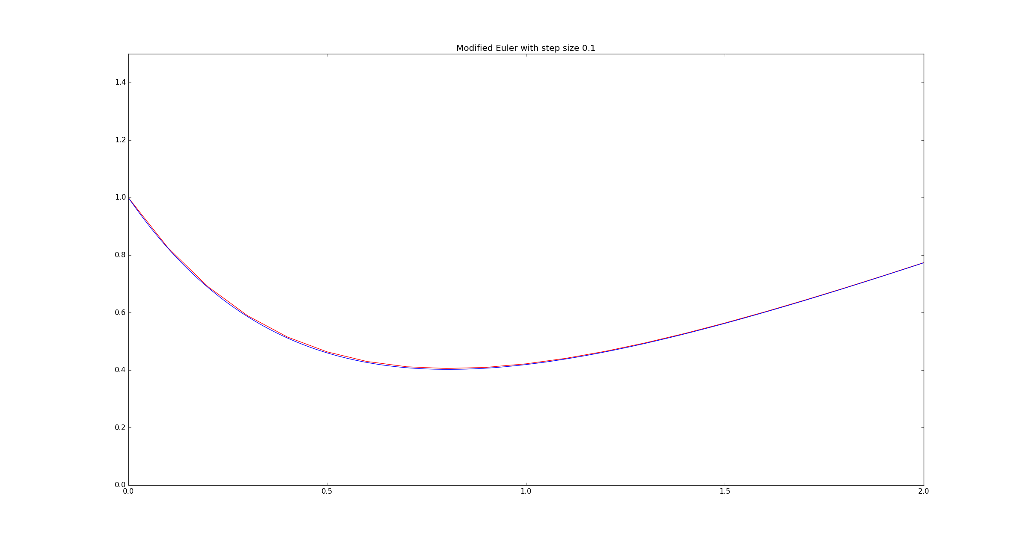Figure 9. The exact solution (blue) and its approximation (red) using the Modified Euler Method with a step size of 0.1.

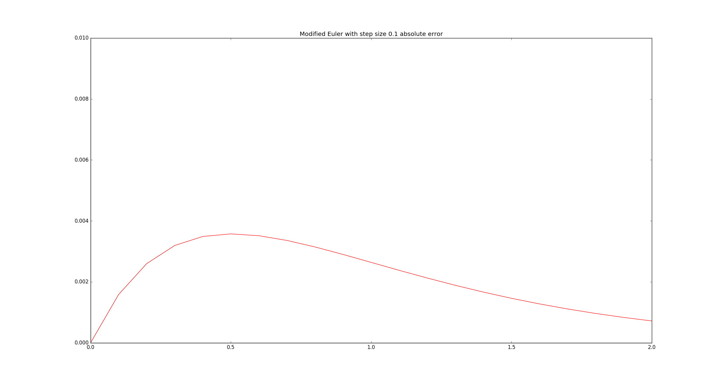Figure 10. The absolute error between the curves in figure 9.

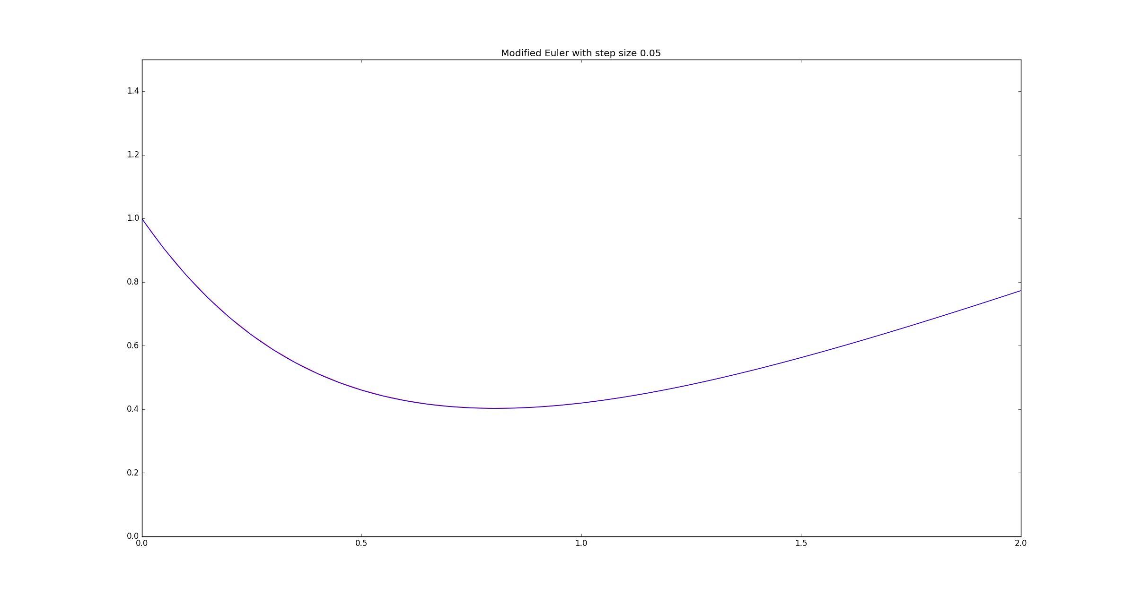Figure 11. The exact solution (blue) and its approximation (red) using the Modified Euler Method with a step size of 0.05.

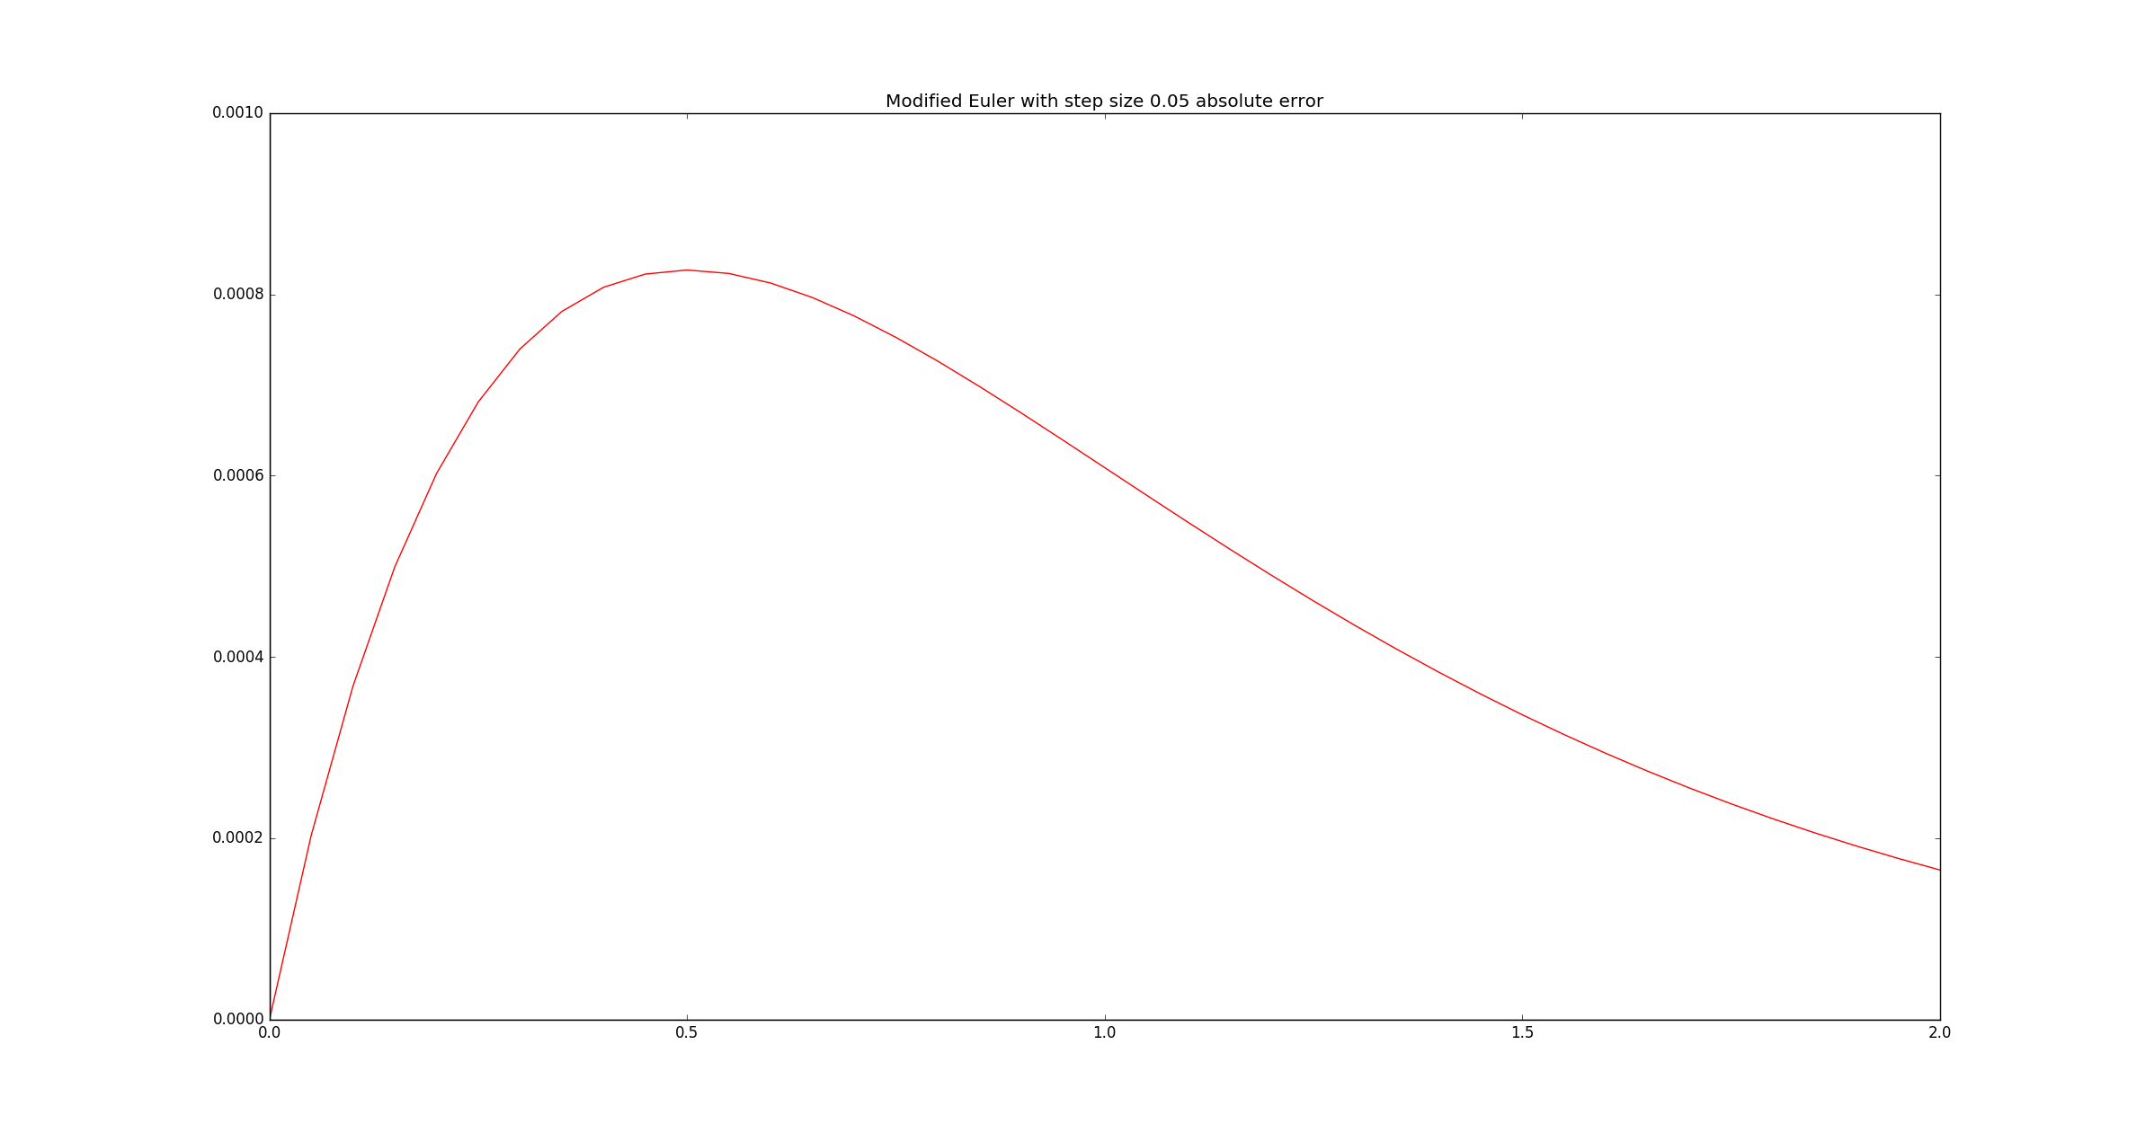Figure 12. The absolute error between the curves in figure 11.

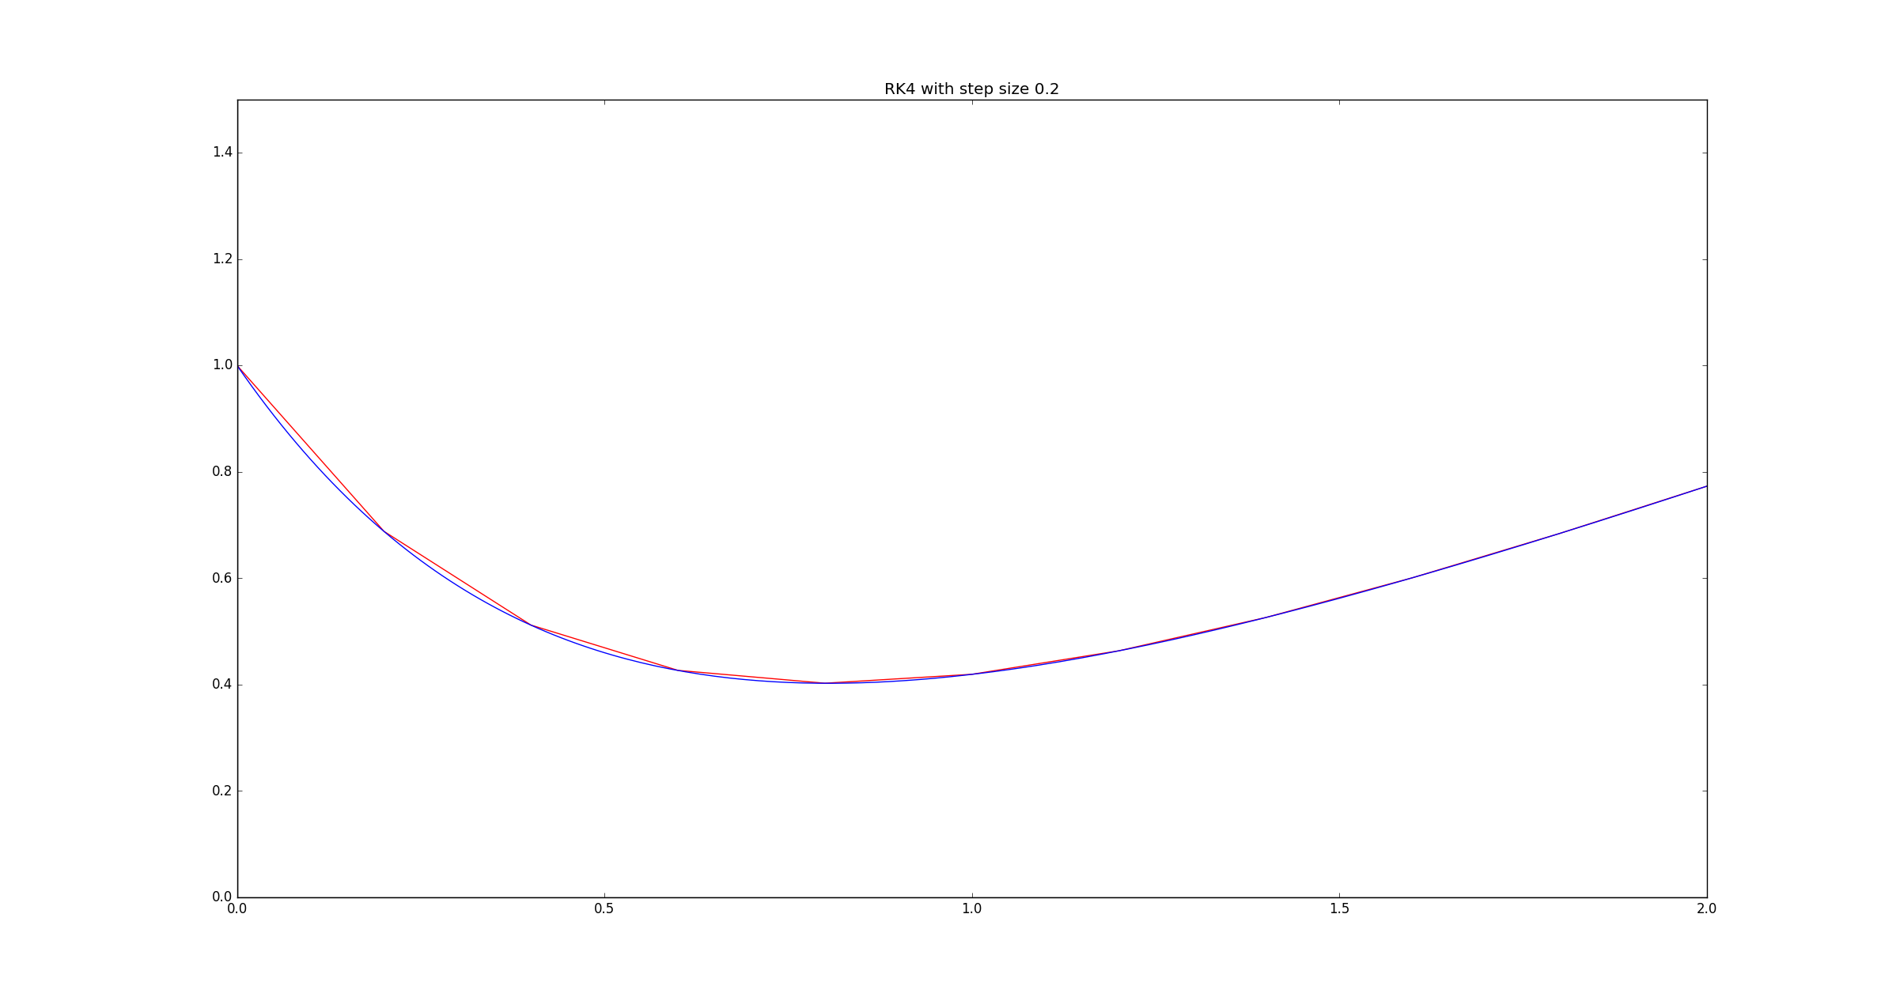Figure 13. The exact solution (blue) and its approximation (red) using the RK4 method with a step size of 0.2.

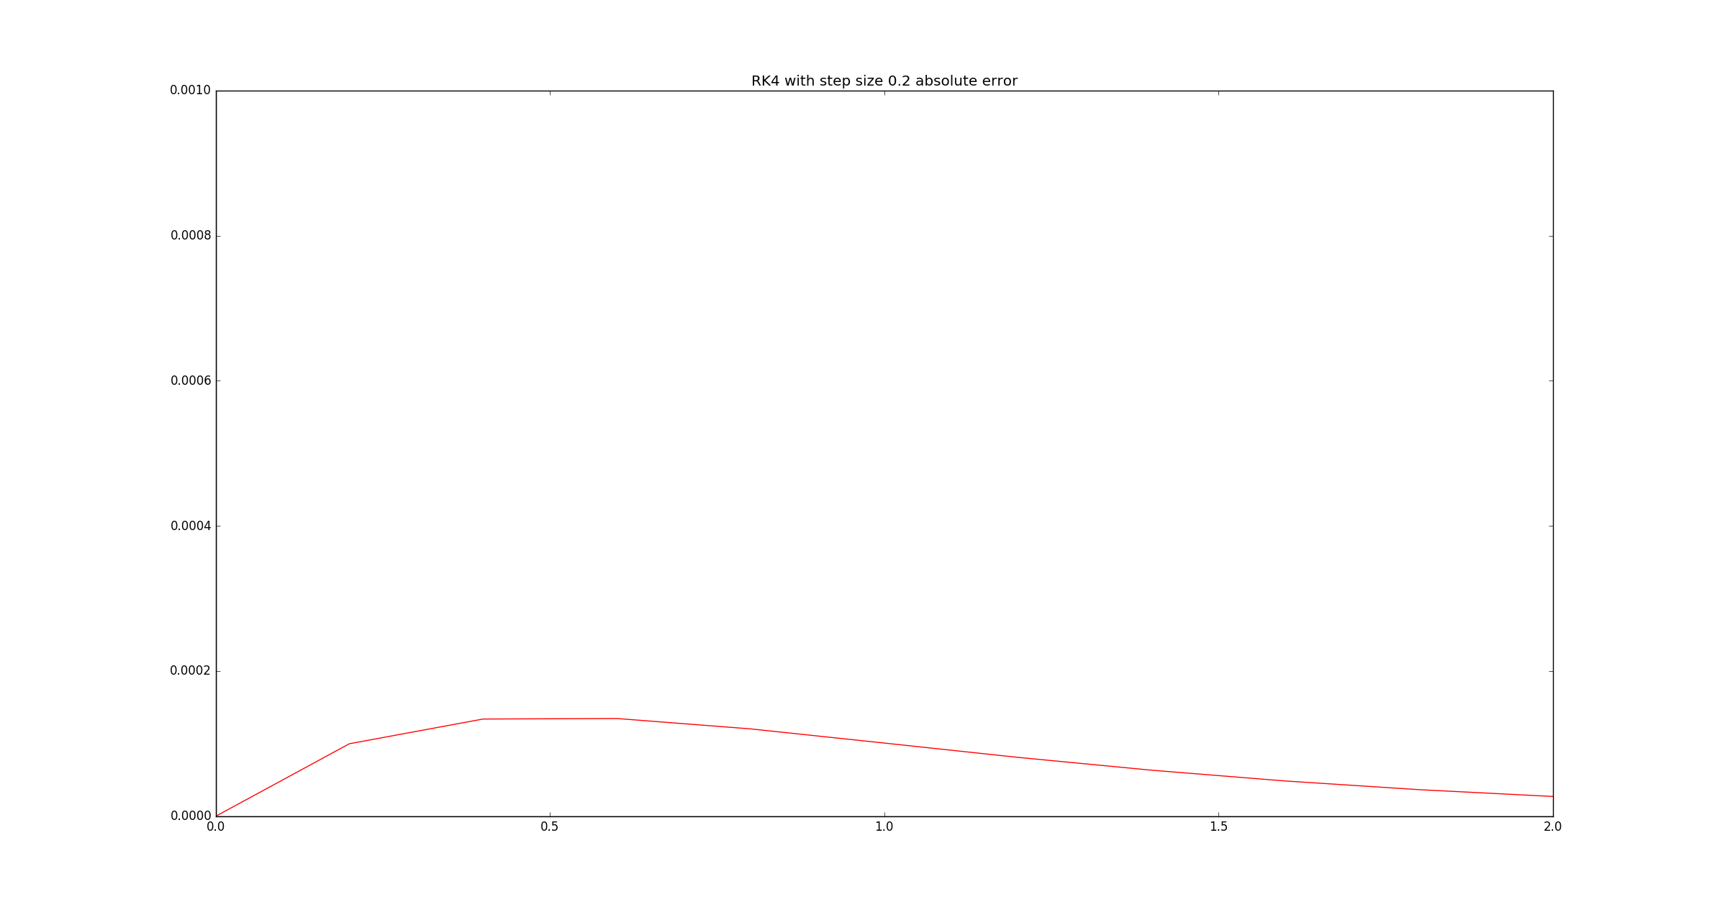Figure 14. The absolute error between the curves in figure 13.

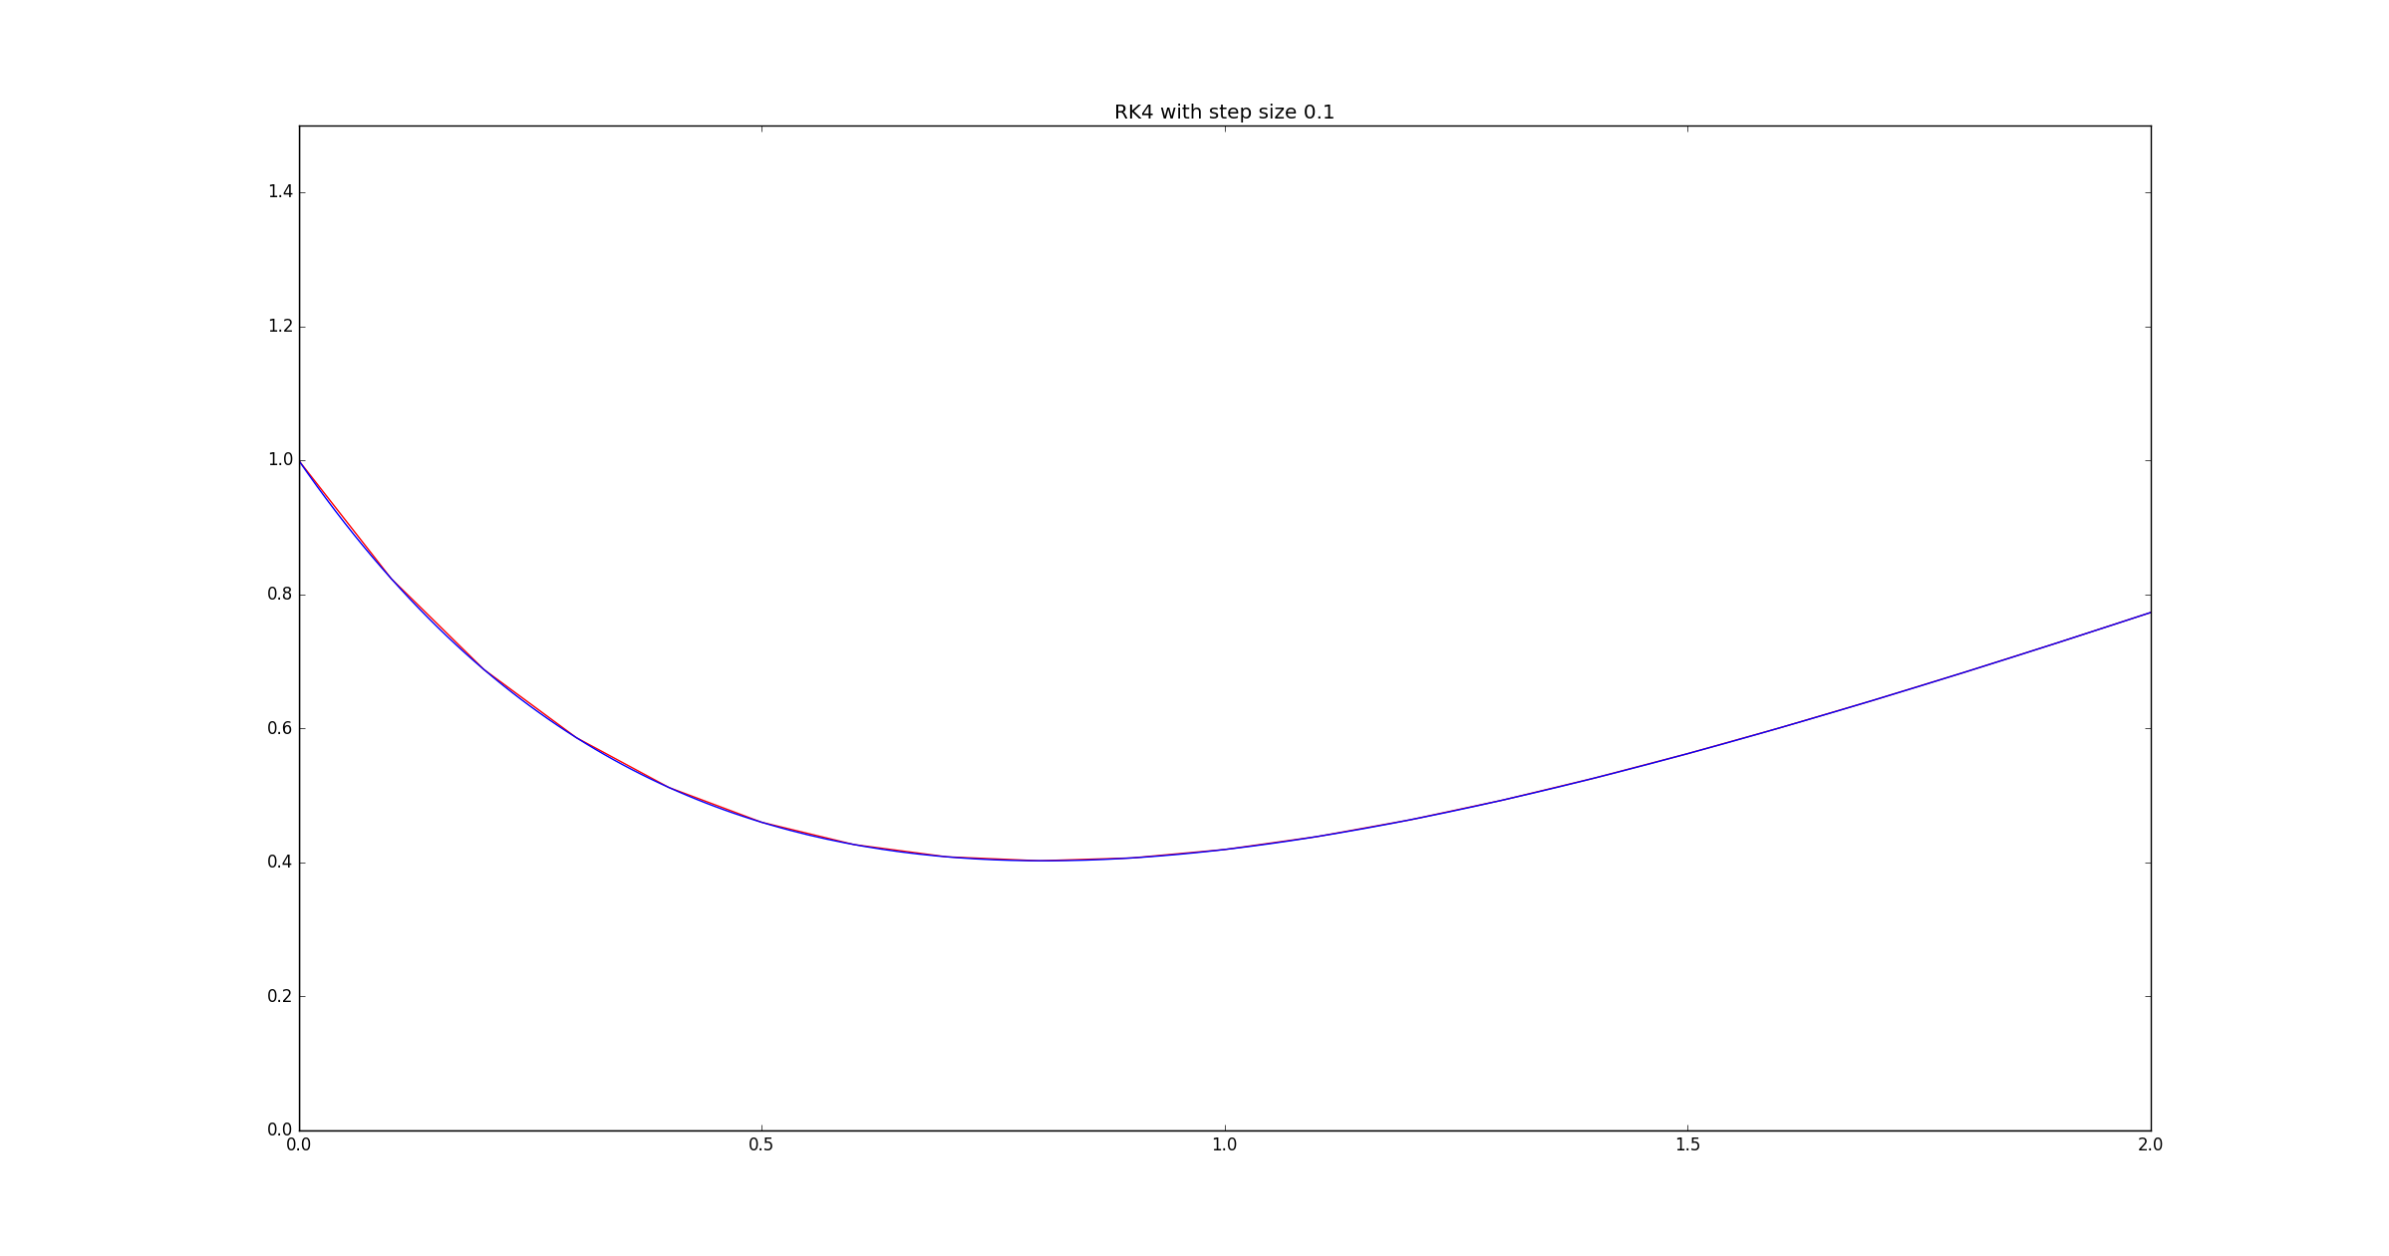Figure 15. The exact solution (blue) and its approximation (red) using the RK4 method with a step size of 0.1.

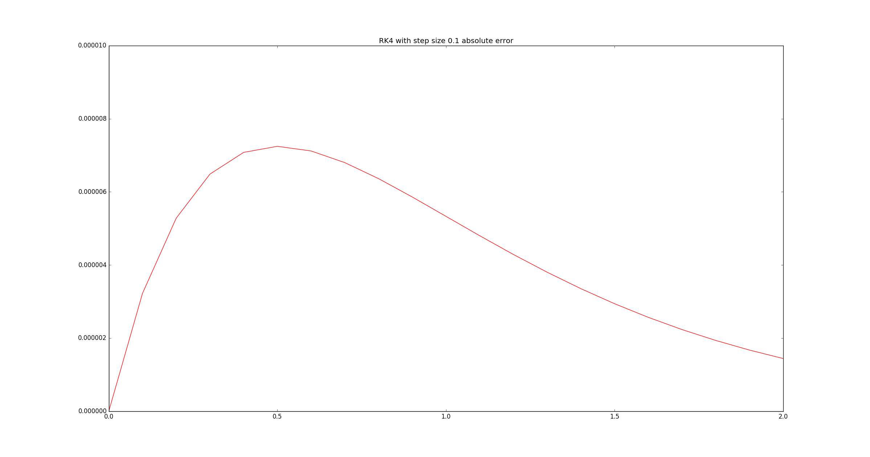Figure 16. The absolute error between the curves in figure 15.

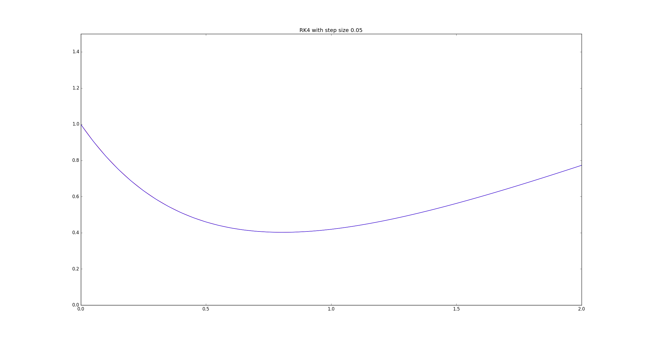Figure 17. The exact solution (blue) and its approximation (red) using the RK4 method with a step size of 0.05.

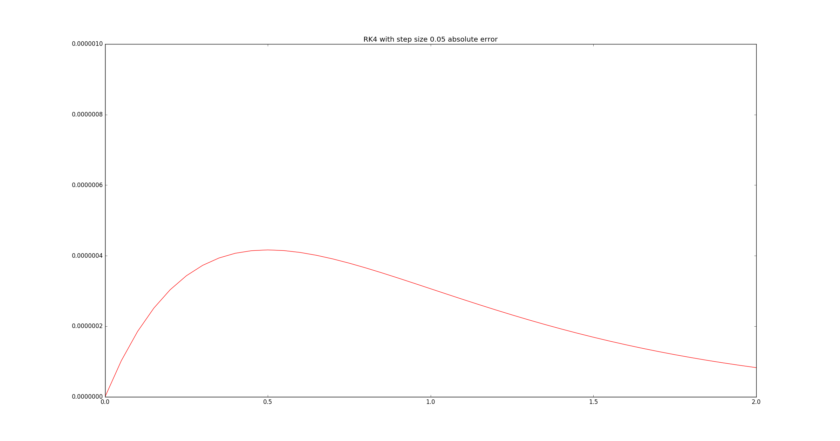Figure 18. The absolute error between the curves in figure 17.

Euler's Method is better as the step size decreases. Despite this, the improvements are not terribly noteworthy. Reducing the step sizes by one half reduces the error by about the same amount, as can be seen pictorially in figures 2, 4, and 6 and tabularly in table 1.

| Step Size | Maximum Absolute Error |
| --- | --- |
| 0.2 | 0.111661205147 |
| 0.1 | 0.0502493014643 |
| 0.05 | 0.0240012513393 |

Table 1. The maximum absolute errors when approximating the solution of *f(t, x)* using Euler's Method with decreasing step sizes. Reducing the step size by half reduces the error by approximately half as well.

This might suggest that the reduction in the step size is linearly related to the accuracy of the approximations: if we reduce the step size by *x*, then we reduce the error by a constant factor of *x*. This means the to get a good approximation, the step size would need to be tremendously small (so much so, perhaps, to be problematic for modern day computers).

Fortunately, the Modified Euler Method yields much better approximations for little extra computational expense.

| Step Size | Maximum Absolute Error |
| --- | --- |
| 0.2 | 0.0165472351097 |
| 0.1 | 0.0035755025357 |
| 0.05 | 0.000826929577637 |

Table 2. The maximum absolute errors when approximating the solution of *f(t, x)* using the Modified Euler Method with decreasing step sizes. Reducing the step size by half reduces the error by approximately a factor of 10.

Table 2 shows that, when using the Modified Euler Method, making the step size half as small reduces the errors by approximately a factor of 10. For a given step size, the Modified Euler Method is vastly better than Euler's Method. Comparing tables 1 and 2, the Modified Euler Method has a smaller error at the largest step size than Euler's Method has at the smallest step size.

Better yet is the fourth order Runge-Kutta method (RK4).

| Step Size | Maximum Absolute Error |
| --- | --- |
| 0.2 | 0.000134737189747 |
| 0.1 | 7.24619232451e-06 |
| 0.05 | 4.16551320159e-07 |

Table 3. The maximum absolute errors when approximating the solution of *f(t, x)* using the RK4 method with decreasing step sizes. Reducing the step size by half reduces the error by at least a factor of 10.

Even at the largest step size, RK4 produces relatively accurate approximations. In fact, RK4 applied with the worst step size is more accurate than the Modified Euler Method applied with the best step size (Table 3). What is more, reducing the step size by half reduces the error by at least a factor of 10. Table 3 shows a decrease in error of about 100 when reducing the step size from 0.2 to 0.1. Whereas the Modified Euler Method is about 100 times more accurate than Euler's Method, RK4 is about 100 to 1000 times more accurate than the Modified Euler Method.

From the graphs of the absolute errors, we notice that the curves all have the same shape. They start at 0, quickly deviate from it, and then slowly approach it. Starting at 0 is clear since the algorithms start at the initial values. The deviation from 0 might be due to the steep slope. Each method is, after all, using a line to approximate the next value. Lines can only do so well when approximating curves that have large variations in slope. The absolute error curves approach zero in the regions where the exact solution is approximately linear.