**Problem 2**

We analyze approximations to

,

which has exact solution

,

using Euler's Method and the fourth order Runge-Kutta method (RK4). First we show that *x(t*) is the exact solution to the initial value problem.

1) Domain of *x* contains a neighborhood of

The domain of *x*(*t*) is , and therefore, contains a neighborhood of .

2)

3)

*x*(*t*) satisfies all conditions necessary for it to be the unique solution to the IVP.

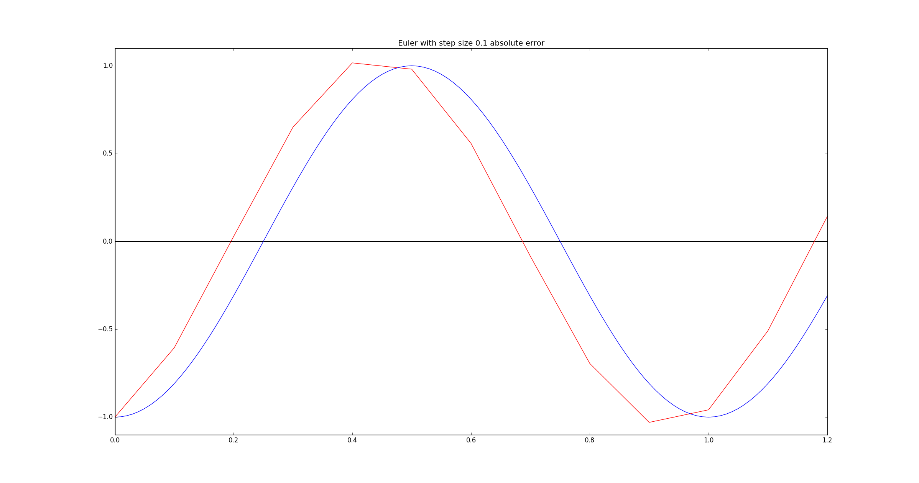Figure 1. Graph of the exact solution (blue) and an approximation of it (red) using Euler's Method with a step size of 0.1.

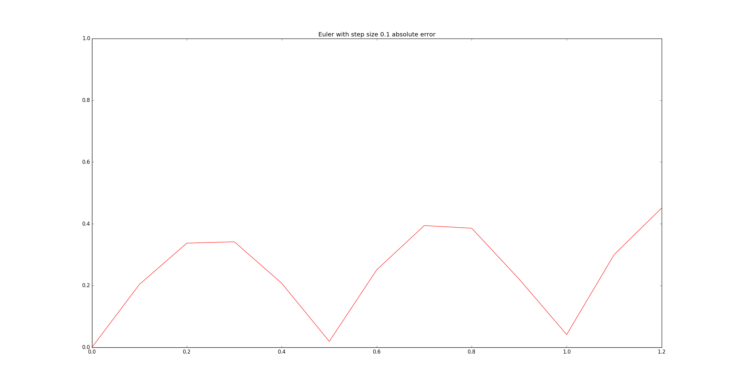Figure 2. Absolute errors between the curves in figure 1.

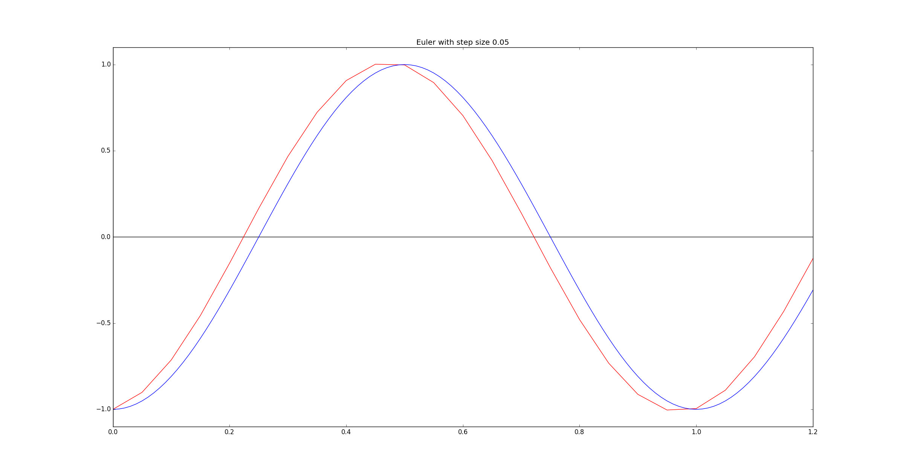Figure 3. Graph of the exact solution (blue) and an approximation of it (red) using Euler's Method with a step size of 0.05.

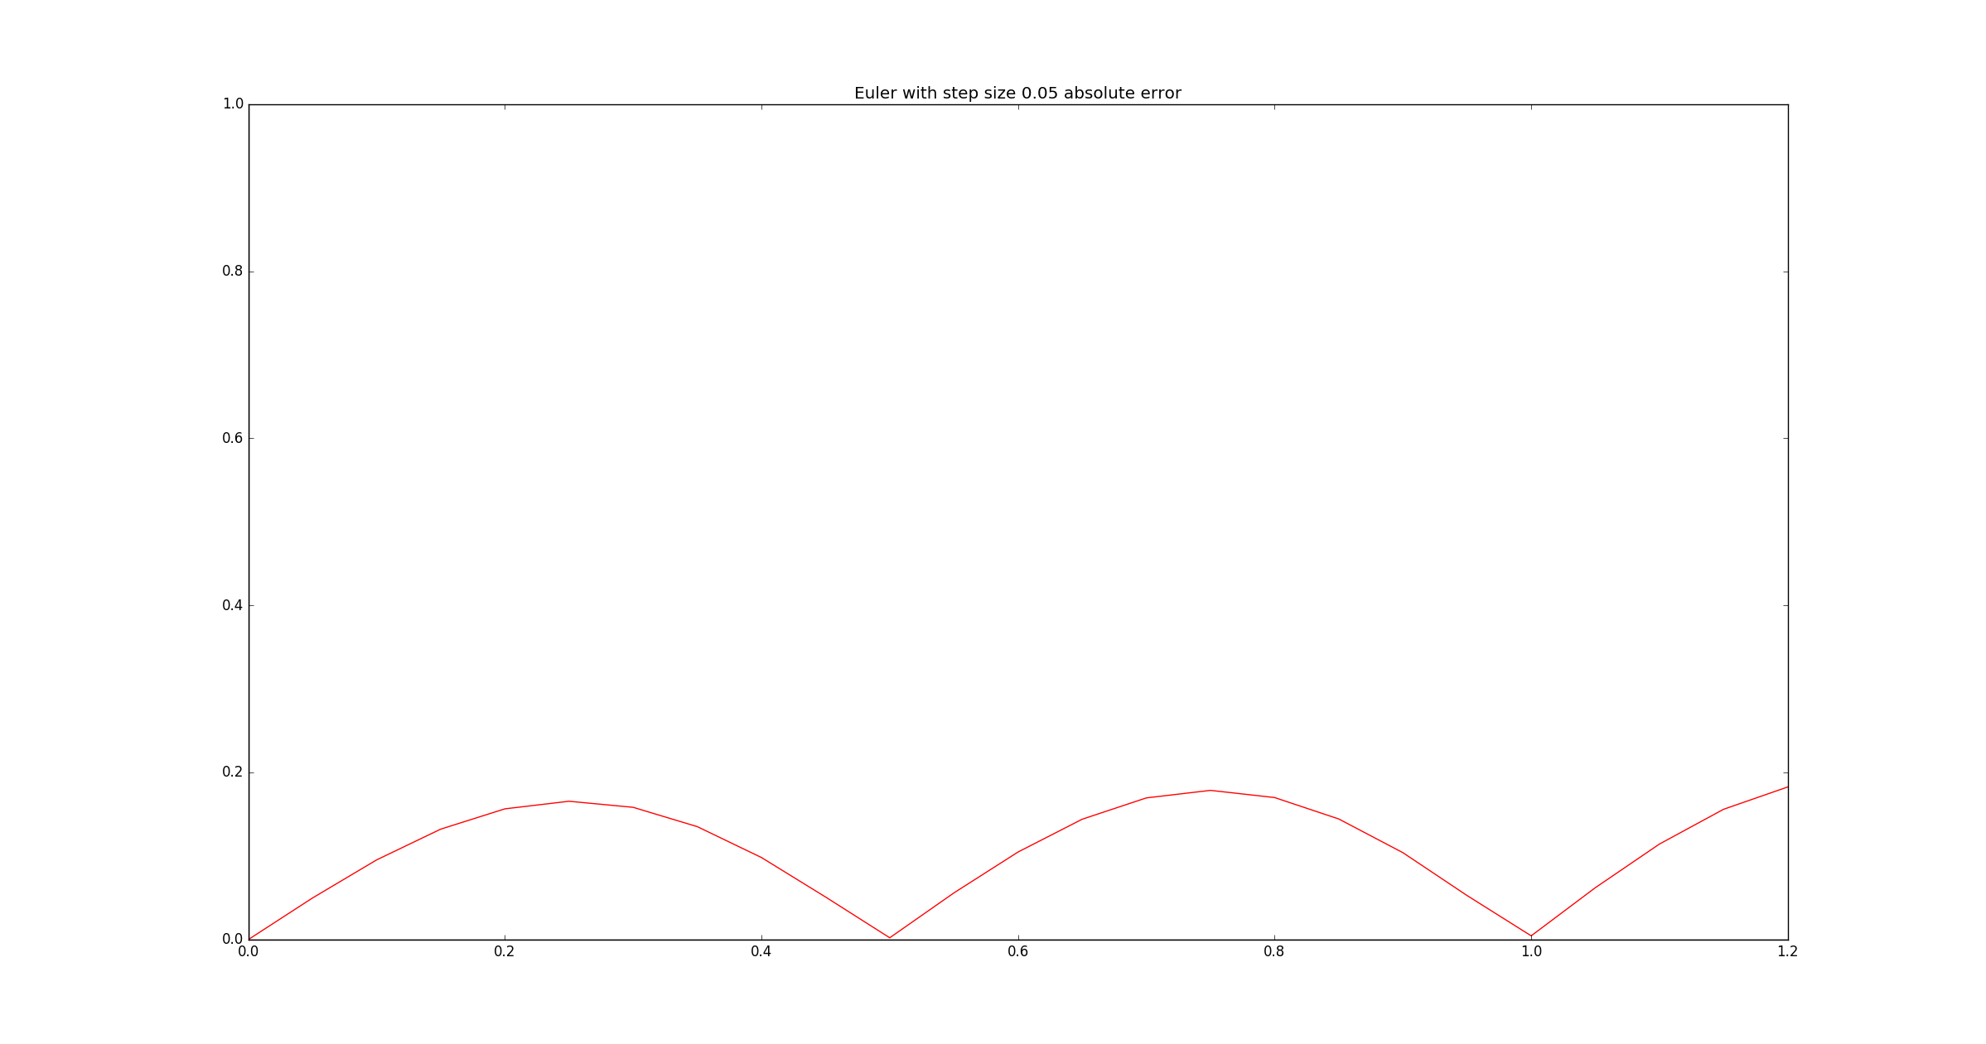Figure 4. Absolute errors between the curves in figure 3.

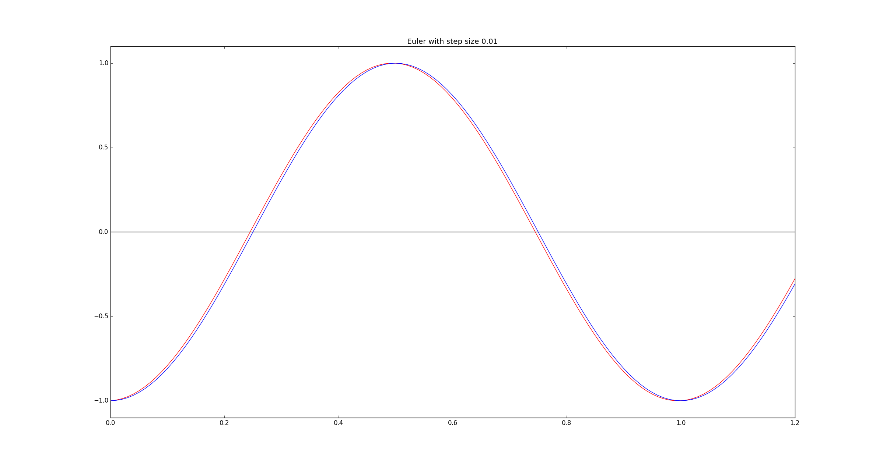Figure 5. Graph of the exact solution (blue) and an approximation of it (red) using Euler's Method with a step size of 0.01.

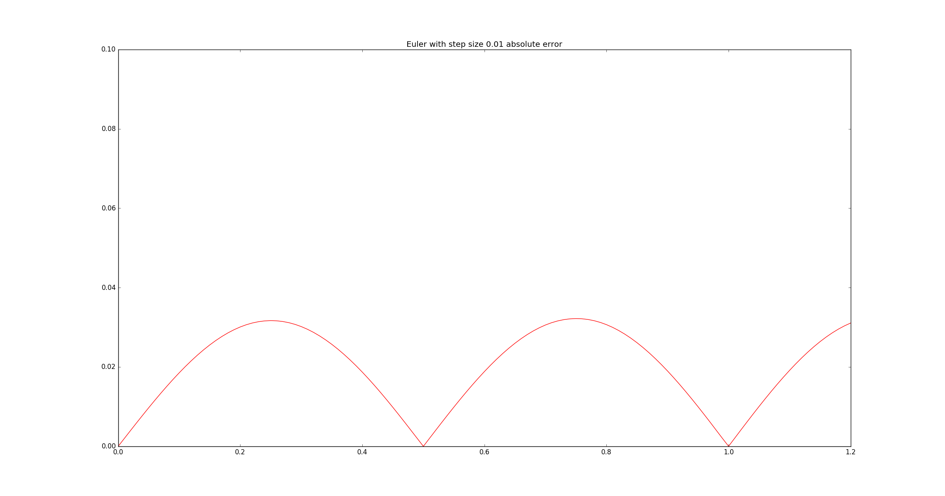Figure 6. Absolute errors between the curves in figure 5.

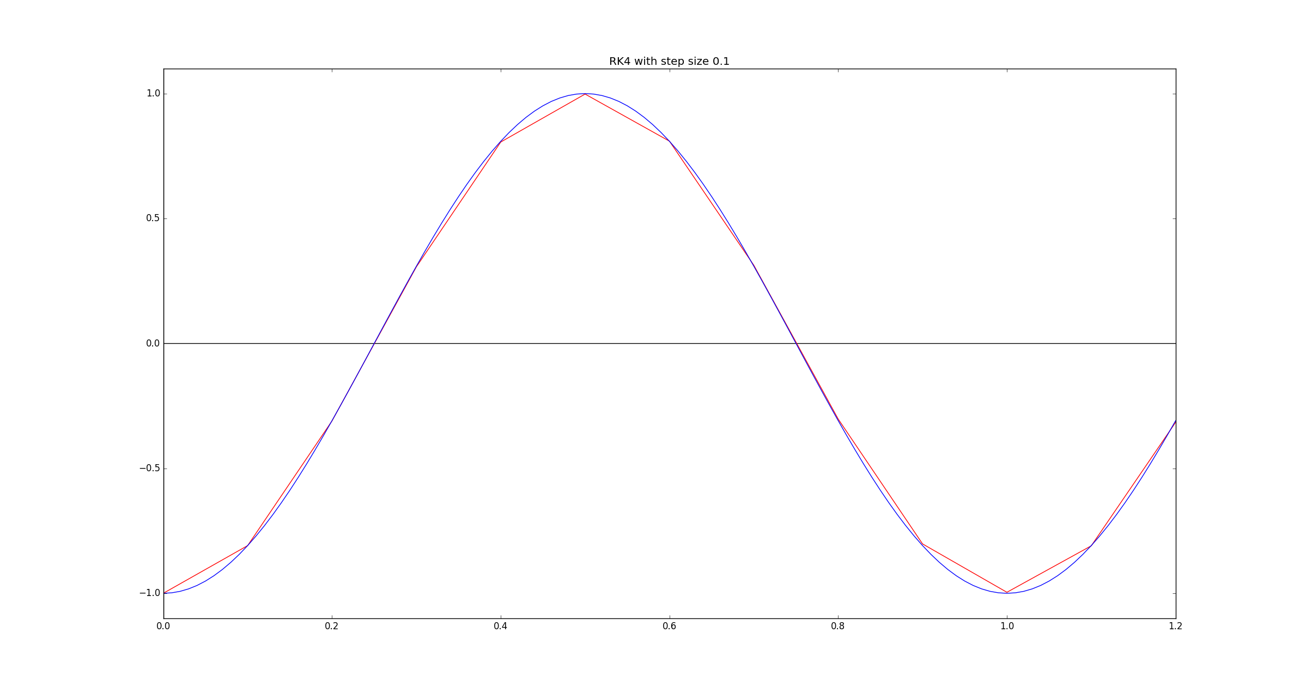Figure 7. Graph of the exact solution (blue) and an approximation of it (red) using the RK4 method with a step size of 0.1.

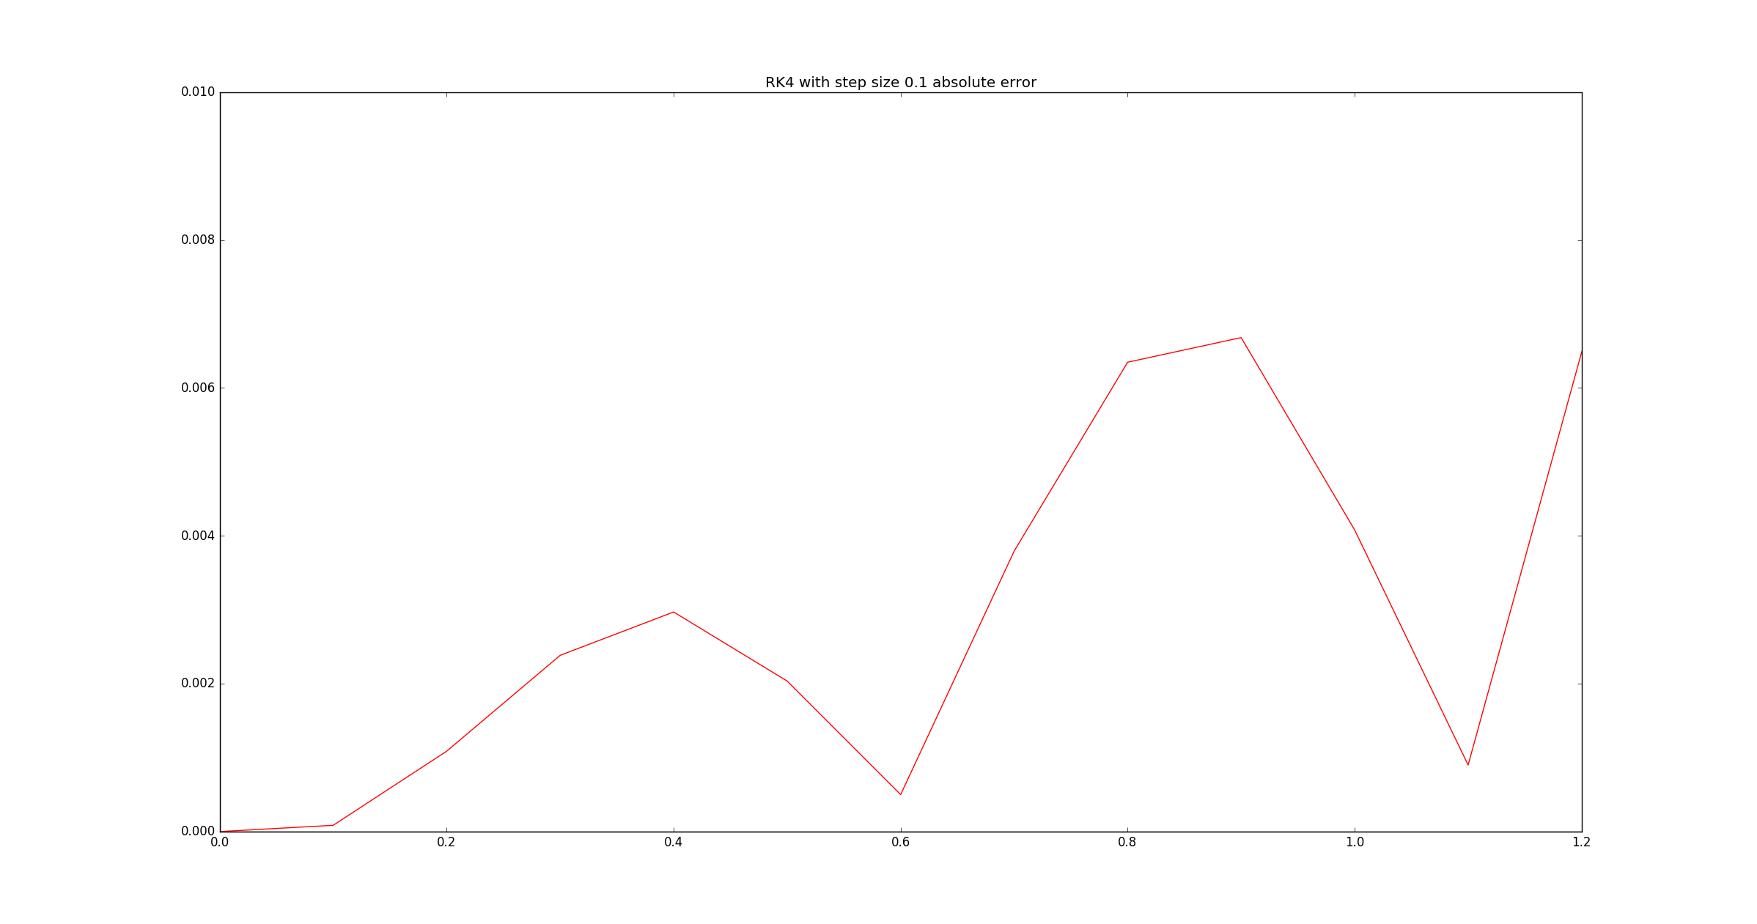Figure 8. Absolute errors between the curves in figure 7.

|  |  |  |  |
| --- | --- | --- | --- |
| **t** | **Exact** | **Approximate** | **Absolute Error** |
| 0.1 | -0.809016994375 | -1.0 | 0.190983005625 |
| 0.2 | -0.309016994375 | -0.605215823956 | 0.296198829581 |
| 0.4 | 0.809016994375 | 0.650961236378 | 0.158055757997 |
| 0.5 | 1.0 | 1.01643529494 | 0.0164352949403 |
| 0.8 | -0.309016994375 | -0.0854105075599 | 0.223606486815 |
| 0.9 | -0.809016994375 | -0.694800685093 | 0.114216309282 |
| 1.0 | -1.0 | -1.02989454665 | 0.0298945466474 |
| 1.1 | -0.809016994375 | -0.958402338192 | 0.149385343817 |

Table 1. The approximate solution using Euler's Method with step size 0.1

|  |  |  |  |
| --- | --- | --- | --- |
| **t** | **Exact** | **Approximate** | **Absolute Error** |
| 0.1 | -0.809016994375 | -0.901303955989 | 0.0922869616142 |
| 0.2 | -0.309016994375 | -0.455566892258 | 0.146549897883 |
| 0.4 | 0.809016994375 | 0.722976492587 | 0.0860405017884 |
| 0.5 | 1.0 | 1.00199261857 | 0.00199261856887 |
| 0.8 | -0.309016994375 | -0.178619651431 | 0.130397342944 |
| 0.9 | -0.809016994375 | -0.732176804373 | 0.0768401900017 |
| 1.0 | -1.0 | -1.00381420858 | 0.00381420858143 |
| 1.1 | -0.809016994375 | -0.888939710516 | 0.0799227161415 |

Table 2. The approximate solution using Euler's Method with step size 0.05

|  |  |  |  |
| --- | --- | --- | --- |
| **t** | **Exact** | **Approximate** | **Absolute Error** |
| 0.1 | -0.809016994375 | -0.827433779738 | 0.018416785363 |
| 0.2 | -0.309016994375 | -0.338715393841 | 0.029698399466 |
| 0.4 | 0.809016994375 | 0.790795614871 | 0.0182213795043 |
| 0.5 | 1.0 | 1.00001611644 | 1.61164385375e-05 |
| 0.8 | -0.309016994375 | -0.279918571702 | 0.0290984226734 |
| 0.9 | -0.809016994375 | -0.791112372215 | 0.0179046221595 |
| 1.0 | -1.0 | -1.00003196558 | 3.19655828138e-05 |
| 1.1 | -0.809016994375 | -0.82685177119 | 0.0178347768154 |

Table 3. The approximate solution using Euler's Method with step size 0.01

|  |  |  |  |
| --- | --- | --- | --- |
| **t** | **Exact** | **Approximate** | **Absolute Error** |
| 0.1 | -0.809016994375 | -0.80910185138 | 8.48570055323e-05 |
| 0.2 | -0.309016994375 | -0.310104008738 | 0.0010870143628 |
| 0.4 | 0.809016994375 | 0.806046873672 | 0.00297012070284 |
| 0.5 | 1.0 | 0.997964059004 | 0.00203594099616 |
| 0.8 | -0.309016994375 | -0.302668755017 | 0.00634823935767 |
| 0.9 | -0.809016994375 | -0.802335813378 | 0.00668118099676 |
| 1.0 | -1.0 | -0.995919916214 | 0.00408008378567 |
| 1.1 | -0.809016994375 | -0.809917297839 | 0.000900303464367 |

Table 4. The approximate solution using the RK4 method with step size 0.1

The graphs show increasing errors as values between the extrema are approximated, and decreasing errors as values near the extrema are approximated. This is counter-intuitive, and against our findings from problem 1, in which a changing slope caused worse approximations. In this case, constant slopes cause worse approximations.

In all graphs, the approximate solution stays a certain distance away from the exact solution in the regions where the curves are nearly linear. Upon reaching an extremum, the approximate solution approaches, contacts, and then distances itself from the curve. Approaching the intersection point from the left or right, then, places the approximate solution at its closest distance from the exact solution.