Problem 2  
  
Since we are given a discrete set of data points and are tasked with finding the least squares exponential, we use the nonlinear system (letting *a* be positive to simplify some calculations) $f_{1}\left(x\right)=\frac{∂E}{∂a}=2\sum_{k=0}^{5}{(y_{k}–be^{ax_{k}})(-bx_{k}e^{ax_{k}})}=0$ $f_{2}\left(x\right)=\frac{∂E}{∂b} =2\sum_{k=0}^{5}{(y_{k}–be^{ax_{k}})(-e^{ax_{k}})}=0$

,where $E(a,b)=\sum_{k=0}^{5}{(y_{k}–be^{ax_{k}})}$, to find the coefficients a and b. Both equations are set to zero to find their minimum. To solve this, we use Newton’s Method, which requires the following equations: $\frac{∂f_{1}}{∂a}=2\sum_{0}^{5}{(b^{2}x_{k}^{2}e^{2{ax}_{k}}–(y_{k}–be^{ax_{k}})bx_{k}^{2}e^{{ax}_{k}})}$ $$\frac{∂f_{1}}{∂b}=2\sum_{0}^{5}{(bx_{k}e^{2ax_{k}}–(y_{k}–be^{ax_{k}})x_{k}e^{ax_{k}})} \\ \frac{∂f_{2}}{∂a}=\frac{∂f_{1}}{∂b},by Clairaut’s Theorem \\ \frac{∂f_{2}}{∂b}=2\sum_{0}^{5}{e^{2ax_{k}}}$$
  
 Then we apply Newton’s method to solve: $\left[\begin{matrix}\begin{matrix}\frac{∂f_{1}(a,b)}{∂a} & \frac{∂f_{1}(a,b)}{∂b} & -f_{1}(a,b) \\ \frac{∂f_{2}(a,b)}{∂a} & \frac{∂f_{2}(a,b)}{∂b} & -f_{2}(a,b)\end{matrix}\end{matrix}\right]$ 
  
   
  
until necessary. We choose the initial guess to be *a = 0.72005416*, *b = 2.1450464*. We got these values by solving the system $\begin{aligned}1.0442=be^{-a0.9998} \\ 0.4660=be^{-a2.1203}\end{aligned}$  
  
   
  
by first substituting for *b*. Table 1 shows the values of *a* and *b* when applying Newton’s Method.

| ***a*** | ***b*** | ***f1(a, b)*** | ***f2(a, b)*** |
| --- | --- | --- | --- |
| -0.698308785055 | 1.9524134382 | 0.00426806347043 | -0.00491427954298 |
| -0.699939809444 | 1.95535180212 | 1.55988397904e-05 | 2.83425536939e-06 |
| -0.699942841078 | 1.95535266987 | 1.44420163328e-10 | 3.36833824721e-11 |
| -0.699942841105 | 1.95535266987 | -3.05311331772e-16 | -5.13478148889e-16 |
| -0.699942841105 | 1.95535266987 | 6.24500451352e-17 | 7.329206686e-17 |

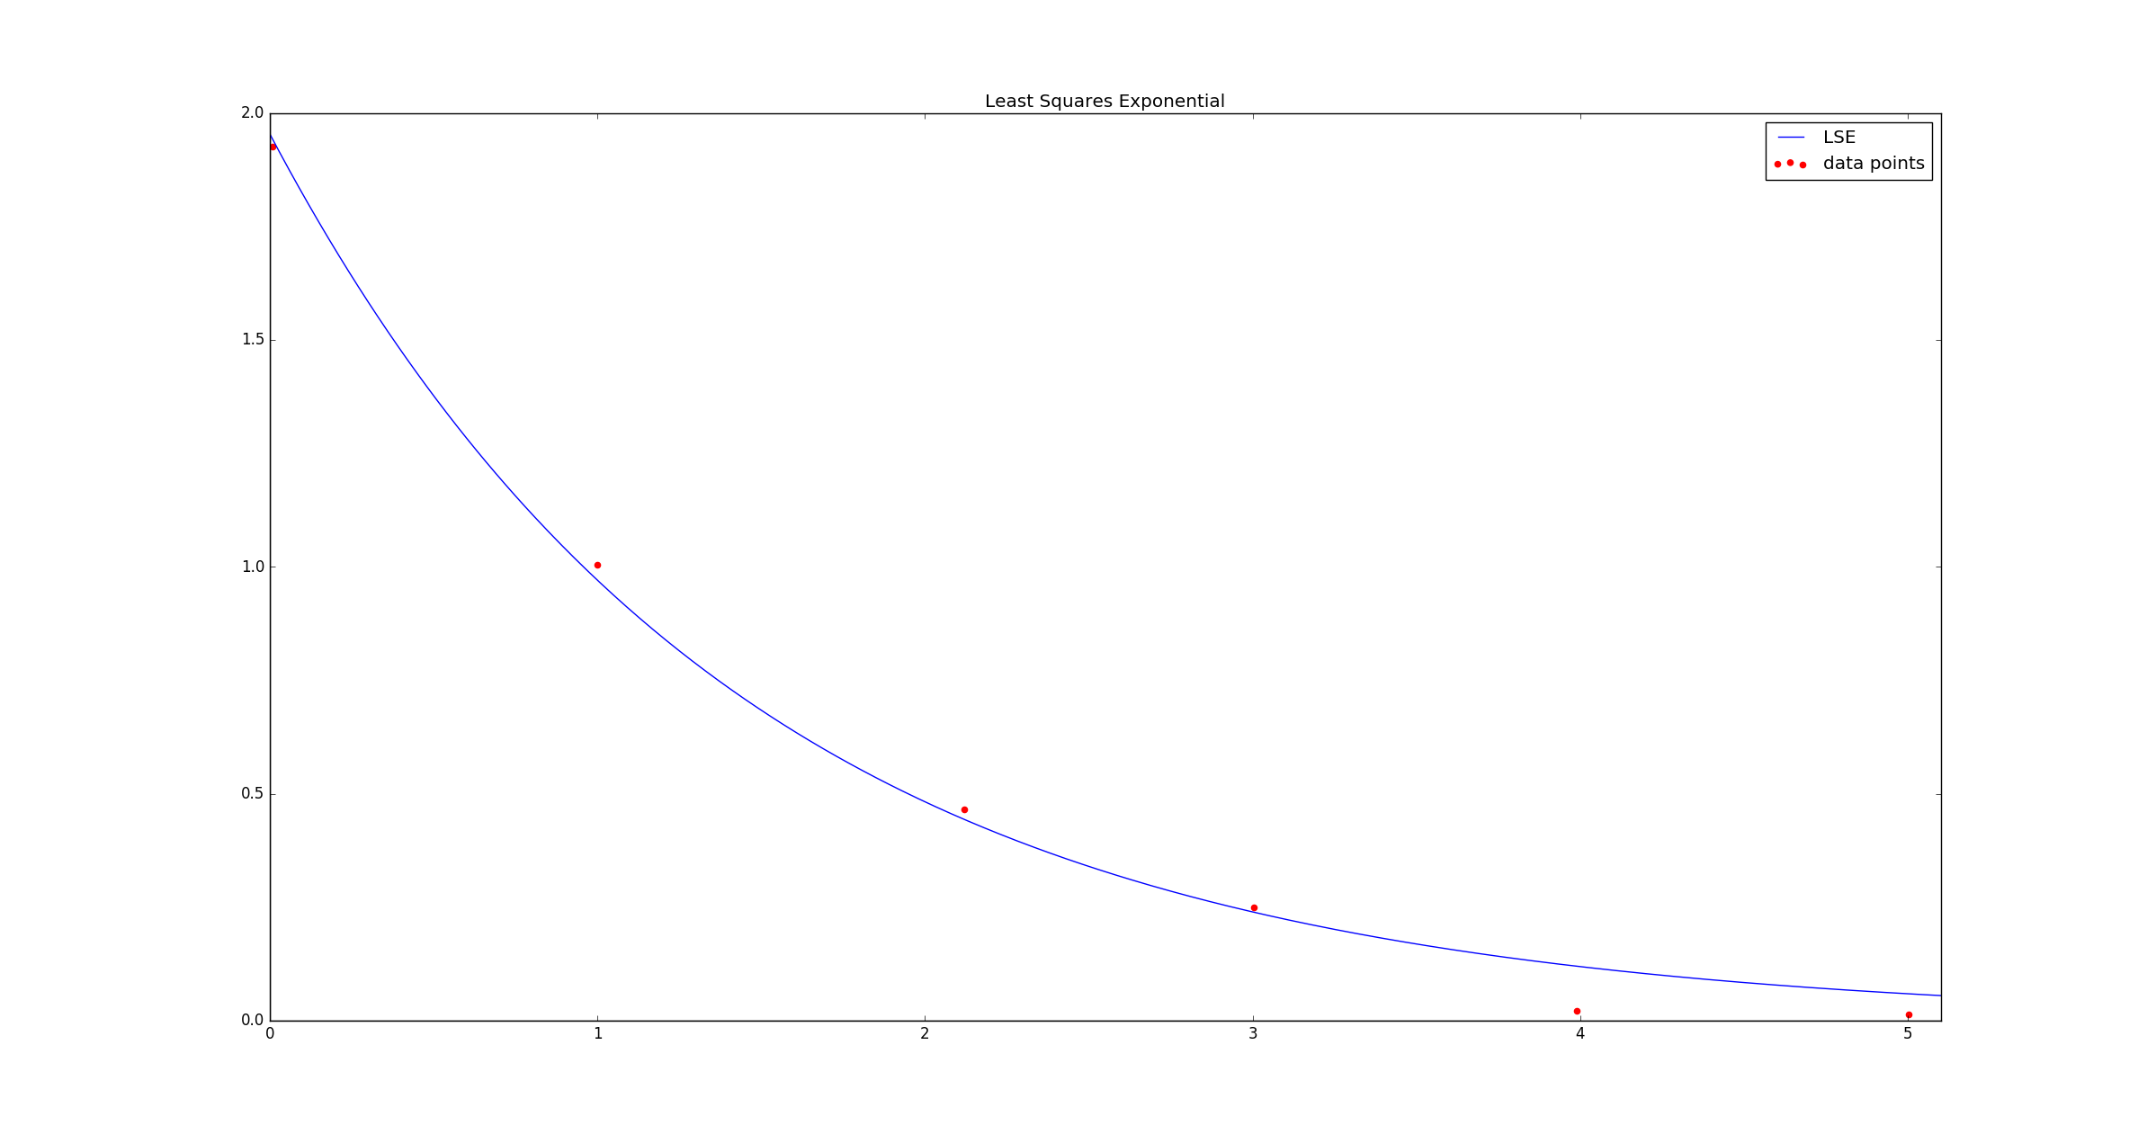 Table 1. Successive iterations of Newton’s Method.  
  
  
After five iterations, we get *a = -0.69994284110*, *b = 1.95535266987*. accurate to the decimal places shown. Thus, the least squares exponential is: $1.95535266987e^{-0.69994284110x}$ 
  
 .  
  
The sum of the squared errors is 0.01376077449.