Problem 3  
  
Since we are given a continuous function and are tasked with finding the least squares polynomial, we can use the linear system $\left[\begin{matrix}\int_{i=0}^{m}{ϕ_{0}ϕ_{0}dx} & \int_{i=0}^{m}{ϕ_{0}ϕ_{1}dx} & ⋯ & \int_{i=0}^{m}{ϕ_{0}ϕ_{n}dx} \\ ⋮ & & & ⋮ \\ ⋮ & ⋮ & \int_{i=0}^{m}{ϕ_{j}ϕ_{k}dx} & ⋮ \\ ⋮ & & & ⋮ \\ \int_{i=0}^{m}{ϕ_{n}ϕ_{0}dx} & \int_{i=0}^{m}{ϕ_{n}ϕ_{1}dx} & ⋯ & \int_{i=0}^{m}{ϕ_{n}ϕ_{n}dx}\end{matrix}\right]\left[\begin{matrix}a_{0} \\ ⋮ \\ a_{j} \\ ⋮ \\ a_{n}\end{matrix}\right]=\left[\begin{matrix}\begin{aligned}\int_{i=0}^{m}{f(x)ϕ_{0}dx} \\ ⋮ \\ \int_{i=0}^{m}{f(x)ϕ_{j}dx} \\ ⋮ \\ \int_{i=0}^{m}{f(x)ϕ_{n}}dx\end{aligned}\end{matrix}\right]$

to find the coefficients, where $ϕ_{j}$ is the *jth* Legendre polynomial.. Since we are using the Legendre polynomials as the set to form the least squares polynomial, the polynomials will be of the form $a_{0}ϕ_{0}(x)+a_{1}ϕ_{1}(x)+…+a_{n}ϕ_{n}(x)$ 
  
   
  
Moreover, since the interval is [-1, 1], the set of Legendre polynomials becomes orthogonal, and we can find the coefficients simply by solving $a_{k}=\frac{⟨f(x),ϕ_{k}(x)⟩}{⟨ϕ_{k}(x),ϕ_{k}(x)⟩}$ 
  
   
  
the results of which are shown in table 1.

|  |  |
| --- | --- |
| **k** | **k’th Degree Coefficient** |
| 0 | 0.25 |
| 1 | 0.0 |
| 2 | -0.46875000000 |
| 3 | 0.0 |
| 4 | 0.26367187500 |

Table 1. The coefficients of the *nth* degree least squares polynomial for the given data.

As expected from the nature of polynomials, the approximating functions are only reliable on [-1, 1] (Figure 2). Outside of this interval, the polynomials venture off into infinity. This makes polynomial approximation functions a bad choice for approximating periodic functions.

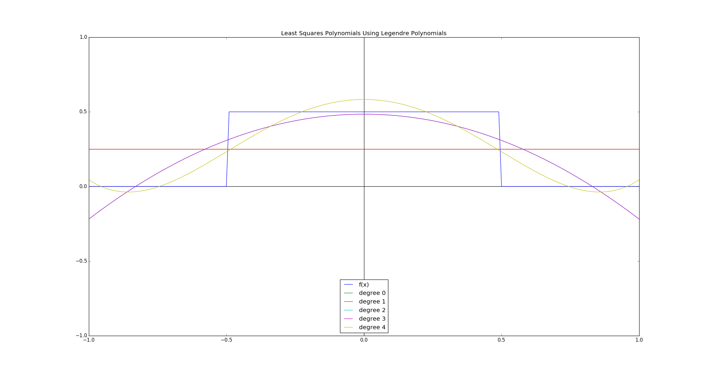Figure 1. Least squares polynomials in [-1, 1]. The polynomials of degree 0 and 1 are the same, as are the polynomials of degree 2 and 3 (since *a1* and *a3* are zero).

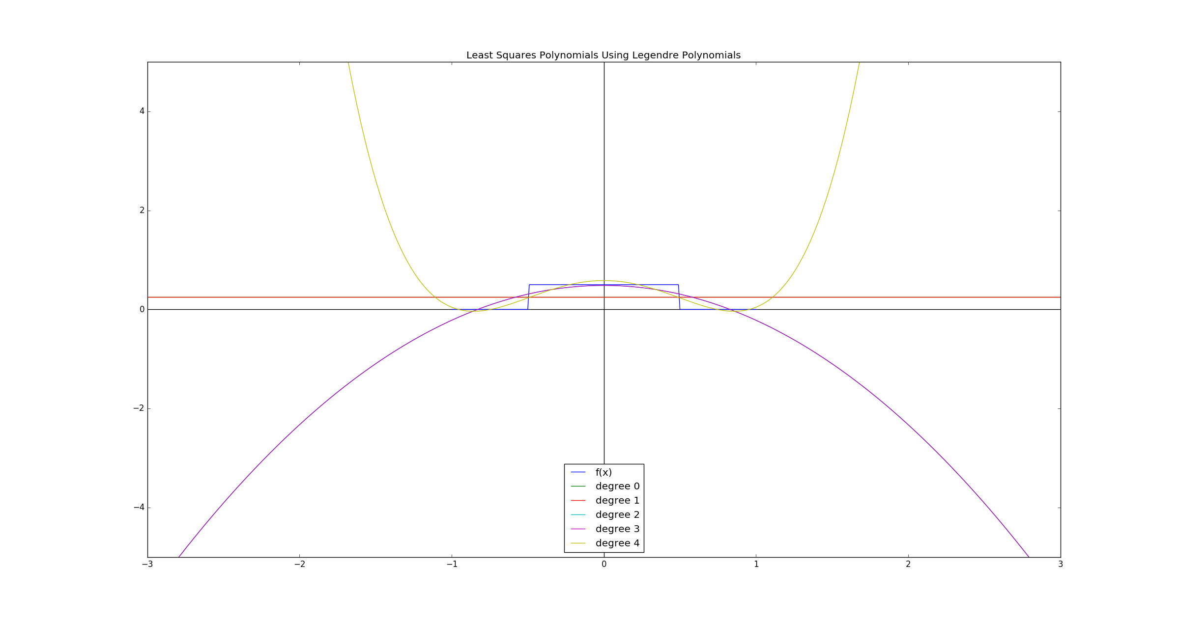Figure 2. Least squares polynomials outside of [-1, 1].