Problem 4  
  
Since we are given a continuous function and are tasked with finding the least squares trigonometric function, we can use the same linear system as in problem 3 to find the coefficients, where $\begin{aligned}ϕ_{0}(x)=\frac{1}{2} \\ ϕ_{j}(x)=cos(jπx),j>0\end{aligned}$  
  
   
  
Next, we show that these functions form a set that is orthogonal on *[-1, 1]*.

at the associated curve is defined by

Since is an orthogonal set on *[-1, 1]*, we can find the coefficients simply by solving $a_{k}=\frac{⟨f(x),ϕ_{k}(x)⟩}{⟨ϕ_{k}(x),ϕ_{k}(x)⟩}$ 
  
   
  
the results of which are shown in table 1.

|  |  |
| --- | --- |
| **k** | **k’th Degree Coefficient** |
| 0 | 0.5 |
| 1 | 0.31828282031 |
| 2 | 0.00000000353 |
| 3 | -0.07551094820 |
| 4 | 0.00003409977 |
| 5 | 0.04268419894 |

Table 1. The coefficients of the k’th degree least squares approximation for the given data.

As can be seen by the graphs, the approximating functions are periodic with a period of 2. If *f*(*x*)is itself periodic, then these approximating functions would be a good choice to approximate it.

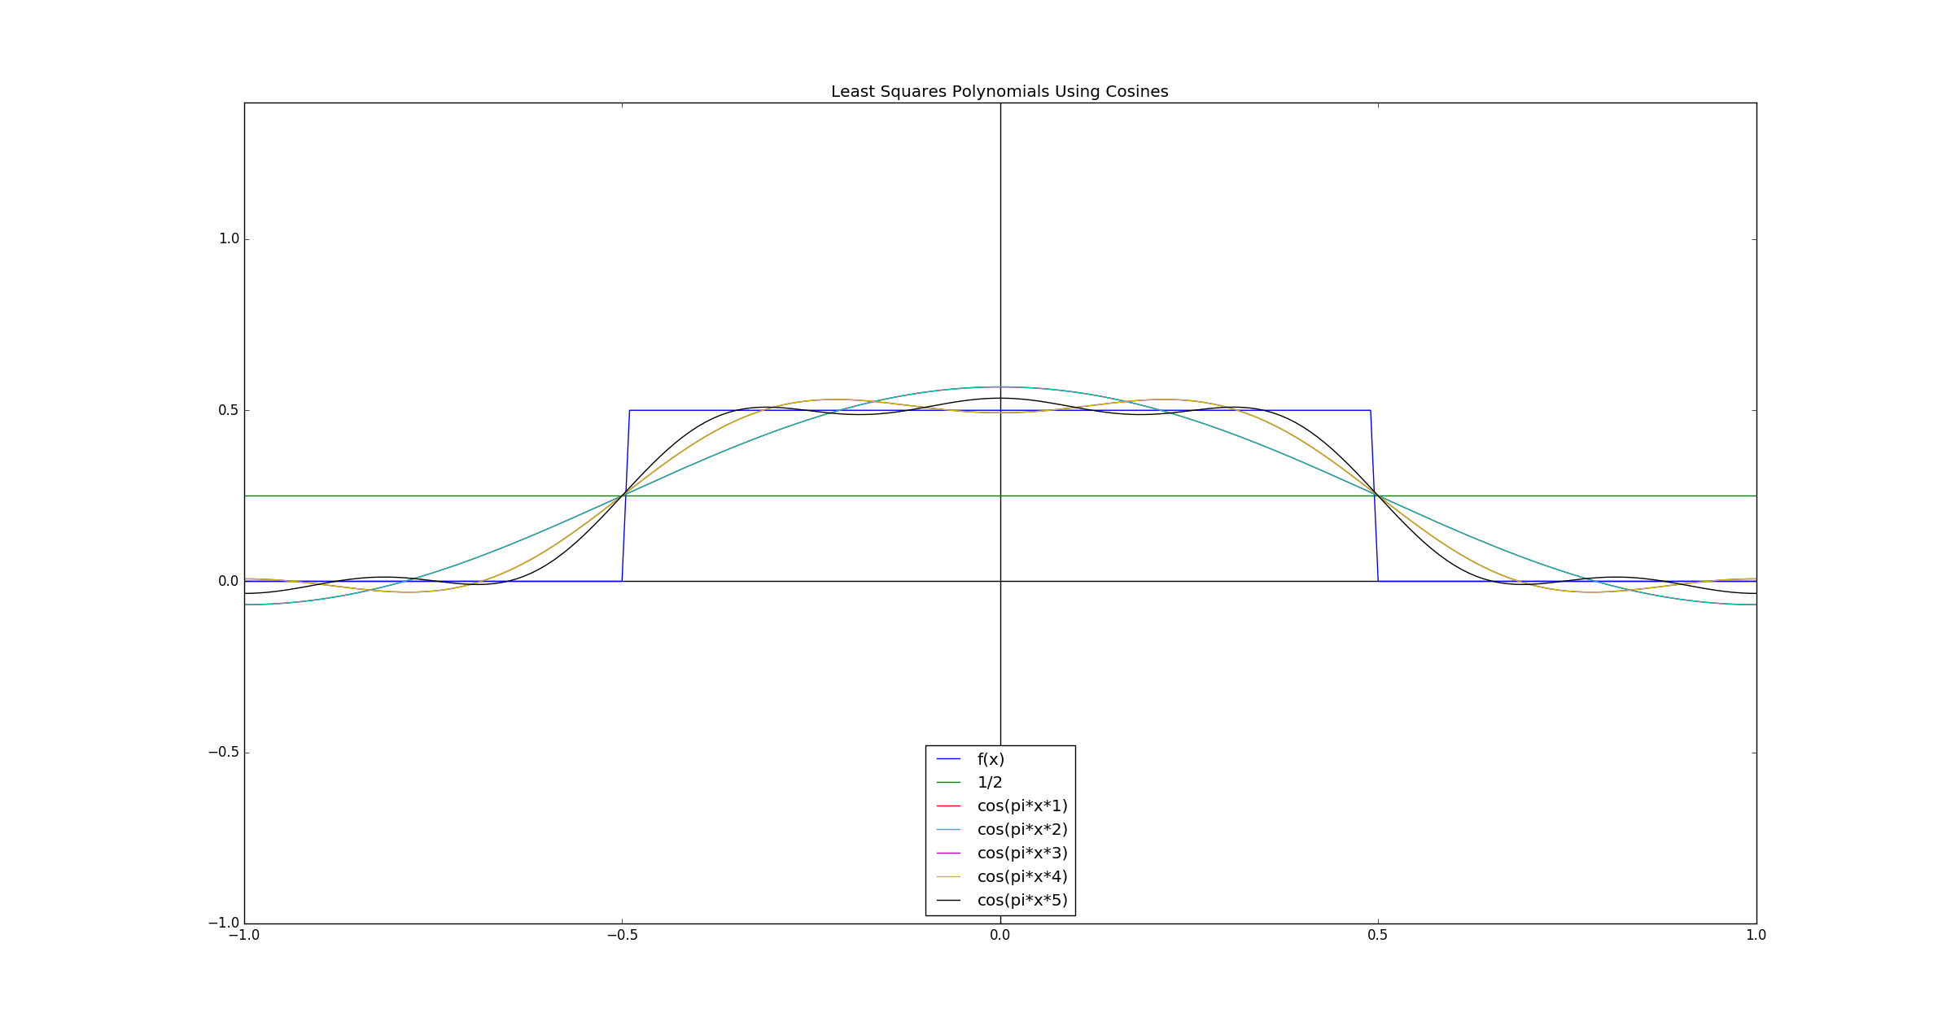

Figure 1. Least squares trigonometric approximations to *f*(*x*)on [-1, 1]. Where the legend reads $cos⁡(kπx)$, it means that the associated curve is defined by ${\frac{1}{2}a}_{0}+a_{1}\cos\left(1πx\right)+ a_{2}\cos\left(2πx\right)+…+ a_{k}\cos\left(kπx\right)$.

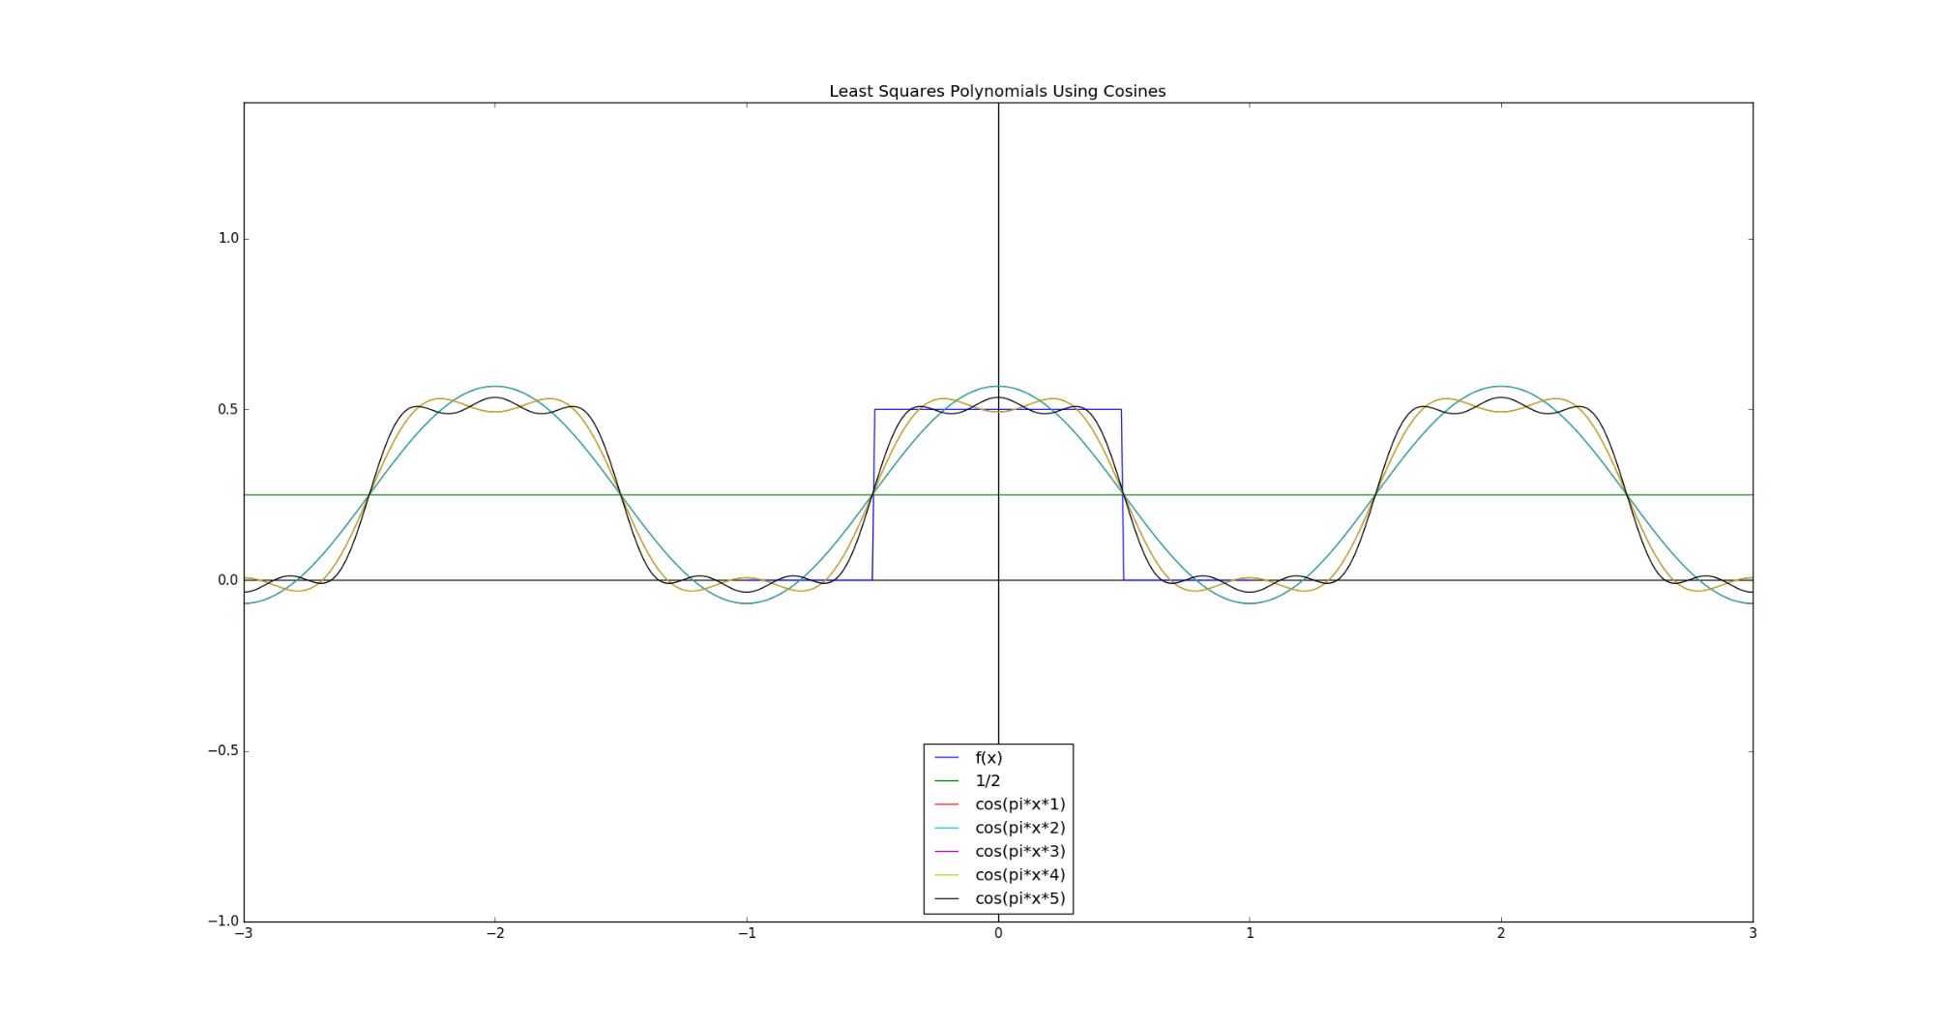

Figure 2. Least squares trigonometric approximations to *f*(*x*)outside of [-1, 1].