Problem 3

To find the two smallest positive values of the equation

,

we let

and use Newton's Method to find the two smallest positive roots.

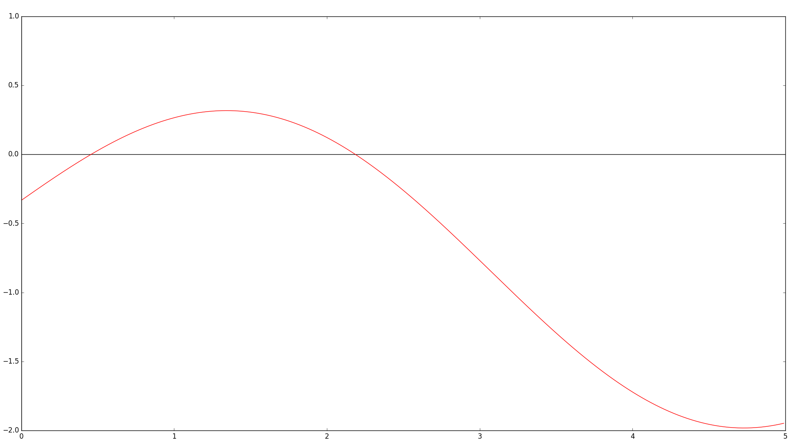
Figure 1. A view of the two smallest positive roots of.

From the graph of the the function, the two smallest positive roots are around 0.5 and 2. Using Newton's method with f(x) and f'(x), with an initial value of 0.5 gives 0.456966319 as the smallest positive root. Next, using the same functions and an initial value of 2, we get 2.186206100 as the second smallest positive root. Both values are correct for all digits shown (nine decimal places).

Therefore, the two smallest positive values for which

,

is true are x = 0.456966319, and x = 2.186206100, both correct to nine decimal places.

