Assignment 2: Distributed Communication

WEIGHT: 20%
DUE DATE: 23 October 2009
GROUP OR INDIVIDUAL: Group of Two

REFERENCES

- Weeks 3 & 4 Lecture Notes
- Week 10 Practical
- C Network Programming Tutorial on the Blackboard

TASKS

Task 1:

You need only attempt this task if you are aiming to achieve a mark up to 74% for this assignment.

This task is to develop a client/server system for cricket funs to query the statistics about the bating figures for a cricket test between Australia and West Indies. The statistics about the test are stored in a text file, batting.txt, which should be stored in the server. The information stored in the text file includes Players’ Name, Country, Innings, Total Runs, Times Not Out, Highest Score, and Highest Score Was Not Out. Below are the contents of the file:

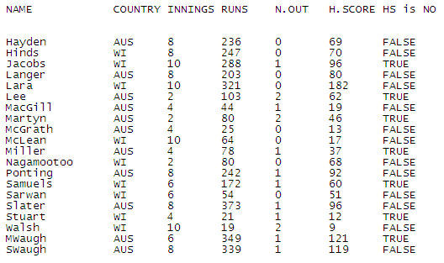
A user can use the client program to query about the information about a player. When a user enters a player’s name, the client program sends a request to the server and the server retrieves the information about the player and sends it back to the client program. The information about the player is then displayed on the client’s console. Below is an example:

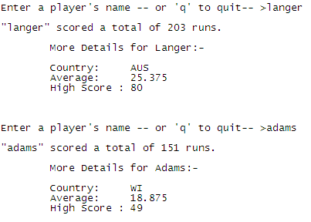

If the player’s name that the user enters is not in batting.txt, the system should display the error information as below:

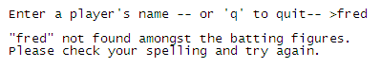

If the user wants to terminate the client program, the user enters ‘q’.

The client/server system should allow up to 30 clients to use the system at the same time. In addition, the client/server system will be console based. No bonuses will be given for fancy or complex user interfaces.

Finally, the client/server system must be developed in sockets and multithread techniques using C in VMWare or Ubuntu 2008/2009.

Task 2:

You need attempt this task in addition to Task 1, if you are aiming to achieve a mark up to 84% for this assignment.

This task is to extend the server program so that it records and displays the total number of the queries about a player on the server side every time a query about the player is received by the server.

Task 3:

You need attempt this task in addition to Task 1 and Task 2, if you are aiming to achieve a mark up to 100% for this assignment.

This task is to add authentication to the client/server system. When the server receives a request from a client, the server needs to check if the client has been granted the access to the cricket test information by verifying the user’s username and password. If the user name entered by the user is found in an authentication file, authentication.txt, and the password entered by the user matches the corresponding password in the authorisation file, the server grants the access to the client and the user can query about the information about the players; otherwise, the server sends a message to the client indicating the user does not have the access to the system and then terminates the connection between the server and the client.

To keep the task simple, you may assume that the authentication file has been created and it is managed manually, and that all the users that have been granted access to the system have been saved in the authentication file. Below is an instance of the authentication file:

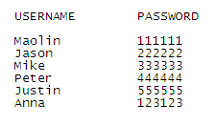

Submissions

You are required to submit the following items in hardcopy:
- A statement of completeness outlining the tasks you attempted in your assignment, deviations from the assignment specifications, and any known or potential logic errors that might exist
- A statement outlining the contributions of the team members
- A diagram showing the high level design of your client/server system
- Output listings showing your client/server system works
- Test plan and test results

You are also required to submit the following items in a CD or USB:
- All the source files, including *.h files and *.c files
- A batch file that compiles the C files, and runs your server and client programs

Each group needs to submit only one copy of your assignment to Assignment Minder ( http://www.am.qut.edu.au/) before or on the deadline.

MARKING CRITERIA (Total Marks: 100)

For those who completed Task 1 only:

- Functionality of the System
  - Task 1: 40

- Quality of the Programs
  - Readability (internal comments, use of indentation and whitespace etc.) 5
  - Robustness (exception handling etc.)
5

- Test Plans and Test Results 8
- Output Listings 5
- High Level Design 5
- Statement of Completeness 2
- Statement of Contributions 2
- Presentation 2

For those who completed Task 1 and Task 2:

- Functionality of the System
  - Task 1: 40
  - Task 2: 10

- Quality of the Programs
  - Readability (internal comments, use of indentation and whitespace etc.) 5
  - Robustness (exception handling etc.)
5

- Test Plans and Test Results 8
- Output Listings 5
- High Level Design 5
- Statement of Completeness 2
- Statement of Contributions 2
- Presentation 2

For those who completed Task 1, Task 2 and Task 3:

- Functionality of the System
  - Task 1: 40
  - Task 2: 10
  - Task 3: 16

- Quality of the Programs
  - Readability (internal comments, use of indentation and whitespace etc.) 5
  - Robustness (exception handling etc.)
5

- Test Plans and Test Results 8
- Output Listings 5
- High Level Design 5
- Statement of Completeness 2
- Statement of Contributions 2
- Presentation 2

