KWAME NKRUMAH UNIVERSITY OF
SCIENCE AND TECHNOLOGY



BSC.BIOCHEMISTRY
BCHEM 365

AGYENIM BOATENG PHILIP
3163522

ELUCIDATING MOLECULAR GENETICS OF GENE THERAPY AND HOW IT TECHNOLOGY HAS HELP WITH THE TREATMENT OF SICKLE CELL DISEASE
INTRODUCTION

Gene therapy, which uses genes to treat, prevent, or even cure a variety of diseases or medical conditions, usually involves replacing a missing or defective gene in a patient's cells with a healthy one or introducing new copies of a faulty gene.

When researchers found that they could change human DNA to help treat genetic diseases in the 1960s, the concept of gene therapy was born. In 1990, a four-year-old girl with severe combined immunodeficiency (SCID) received a healthy ADA gene through her bloodstream, delivered by a modified virus.

Since the completion of the Human Genome Project in 2003, gene therapy has advanced considerably, benefiting from the comprehensive mapping of human DNA. This progress has significantly enhanced the field, making gene therapy a viable solution for numerous diseases, particularly those resulting from mutations in a single gene.
Gene therapy has been group into two types; Ex-vivo and In-vivo Ex-vivo gene therapy deals in removing cells from patients introducing new genetic material and then returning the cells to the patient. In-vivo gene therapy does direct infusion of the vector into the bloodstream of the target organ.
The biopharmaceutical business continues to show interest in gene therapy, which has brought about tremendous development. It is now the accepted treatment for hereditary illnesses, particularly sickle cell disease, which is the main topic of this article.
Red blood cells (RBCs) with irregular shapes are a hallmark of sickle cell disease, a hereditary illness. Because hemoglobin, the protein that carries oxygen, is mutated, the cells become stiff, sticky, and sickle-shaped. RBS obstructs blood flow as a result, resulting in problems and tissue injury.
Genetic mutation, inheritance patterns, and sickling triggers are the causes of this.
Mutations in the HBA gene, which codes for beta globin, result in genetic mutations. The HB protein mutation that results in the aberrant structure of RBS substitutes valine for glutamic acid.
Inheritance pattern; causes when an individual inherit two defectives gene from parebt
Sickle cell diseases can be treated by disease modifying therapy and curative treament
Curative treament include;
- BONE MARROW CELL TRANSPLANT
- GENE THERAPY: Using exagamglogene autotemcel, CRISPR-based treatment which corrects the HBB gene
We will now look at how the technology of gene therapy and has help with the treatment of sickle cell disease.

TREATMENT OF SICKLE DISEASE WITH GENE THERPY
Over the years, gene therapy has demonstrated its capacity to treat sickle disease, a hereditary condition that impairs hemoglobin (RBS). As previously mentioned, sickle makes the RBS stiff and sickle-shaped, which results in blood flow obstructions, excruciating pain, and organ damage.
Previous developments in gene therapy technology have produced therapies that may be able to cure sickle cell disease.
This involves modifying the patient's hematopoietic stem cells using the genome editing technique CRISPR/CAS9. Following transplantation, the patient receives healthy red blood cells from the altered cells.
In 2023, the US Food and Drug Administration (FDA) approved the gene treatments Lyfgenia and Casgevy to cure sickle disease in patients aged 12 and up.
For those who have struggled with the crippling effects of sickle cell disease, gene therapy has provided a curable option. To guarantee long-term success, it is crucial to keep enhancing these treatments' efficiency, durability, and safety.

HOW CRISPR/CAS9 ARE USED IN TREATING SICKLE CELL
Clustered Regularly Interspaced Short Palindromic Repeats is what the acronym CRISPR stands for.
It is an effective technique for gene editing that aids in genetic therapy and research.
The bacterial genome contains a brief repetitive DNA sequence called CRISPR. They serve as a memory system that aids in bacterial recognition and virus defense.
The CAS9 protein is an enzyme that cuts DNA at a specific spot by acting as molecular scissors.

CRISPR/CS9 is revolutionary gene editing technology that treat sickle cell disease by targeting the root cause of the disease by the following ways;
- IDENTIFICATION OF TARGET GENE: Scientist finds out the specific mutation in HB gene responsible for the sickle cell disease

- DESDIGNING GUIDE RNA (gRNA): A guide RNA is made to complement the sequence of the mutant HB gene. This gRNA then shows the cas9 enzyme the precise location in the DNA.

- COLLECTING STEM CELLS:Blood stem cells are collected from the affected individual. Stem cells are responsible for producing all types bloods which also include red blood cell.

- GENE EDITING : The stem cell are treated with CRISPR/CAS9 complex. The guide RNA directs the cas9 enzyme to the faulty HB gene where cas9 makes the cut in the DNA. It does so in two ways;

- BASE EDITING: This convert AT to GC without DSBs which is the correct way for nucleotide correction
- PRIME EDITORS: Use CAS9 reverse transcriptase fusion to find and replace DNA sequence reducing high target risks.

- CORRECTION OF GENE:The template with the correct DNA sequence above with the cell natural repair mechanism repair the cut. This process corrects the mutation in the HB gene.

- TRANSPLANTATION: The edited stem cells and the corrected HB gene are infused back into the patient. The cell engrafts in the bone marrow and start producing the healthy red blood cells.

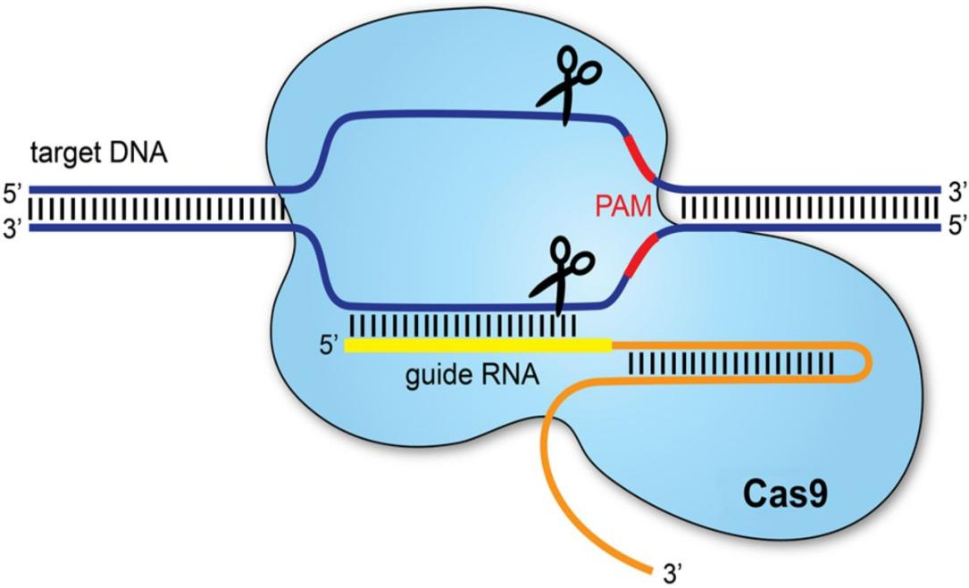

CASGEVY AND LYFGENIA
Casgevy and lyfgenia are another gene therapy approved by FDA for treatment of sickle cell disease in patients 12 years and above.

CASGEVY, was developed by Vertex Pharmaceutical which utilise CRISPR/CAS9 technology
STEAM CELL COLLECTION: patient stem cells are extracted from a blood sample.
GENE EDITING: The BCL11A gene in stem cells is edited using CRISPR/CAS9.This lowers the gene's activity, which increases the creation of dead HbF and stops the red blood cells from sickling.
TRANSPLANTATION: Following the removal of the patient's existing bone, cells are subsequently reintroduced. These cells begin producing new healthy bone marrow and create new bone marrow.

LYFGEENIA is a product of Bluebird Bio. Lyfgenia employs the same strategy as Casgevy, but in their GENE MODIFICATION procedure, functional copies of the beta-globin gene are added to the patient's stem cells using a lentiviral vector. As a result, anti-sickling hemoglobin is produced, preventing vaso-occlusive events (VOCs).

3. Key Differences Between Casgevy and Lyfgenia*
Feature | Casgevy (CRISPR) | Lyfgenia (Lentiviral)
Mechanism | Gene editing (BCL11A  disruption) | Gene addition (HbAT87Q
Hb Type Produced | Fetal hemoglobin (HbF) | Modified adult hemoglobin(HbAT87Q)
Editing Tool | CRISPR-Cas9 | Lentiviral vector
Target | Endogenous gene regulation | Exogenous gene delivery
Therapeutic Durability | Lifelong (if HSCs engraft | Lifelong (if HSCs engraft)
Primary Risk | Off-target edits | Insertional mutagenesis

APPLICATION OF GENETHERAPY TO SICKLE CELL DISEASE

CLINICAL TRIALS AND OUTCOMES
LentiGLOBIN trial (BluebirdBIO)
Method; Autologus HSCs transduced with a lentivirus carrying HBG
Results: Median HbF levels of 40%, with 85% of patients free from vaso-occlusive crises at 24 months.

CRISPR-Cas9 Trial (Vertex/CRISPR Therapeutics):
Method: BCL11A enhancer editing in HSCs.
Results: HbF constituted >30% of total hemoglobin; 94% of participants remained crisis-free for ≥12 months.

COMPARATIVE ANALYSIS OF THERAPY
PARAMETRS | GENE ADDITION | GENE EDITING
Durability | Stable integration | Permanent correction
Safety | Insertional mutagenesis risks | Lower risks with base/prime editing
Cost | 2.1million | 1.8milion
Regulatory Status | FDA approved | Phase |||

IMPACT ON TREATMENT PARADIGMS

- CURATIVE POTENTIAL: It offers a one time intenvention with durable benfits.
Studies shown in 2024 that 90% of this disease who received treatment maintained a normsl Hb level for 5 years

- ECONOMIC AND SOCIAL IMPLICATIONS:Studies has shown most people with sickle disease live in the sub -Saharan Africa where they lack the infrastructure for gene therapy.
It highly costive

- QUALITY OF LIFE IMPROVEMENT :Provides 70% hospitalization rate
Has improve the physical and mental health of people who were suffering from sickle cell disease

- GERMLINE EDITING DEBATE: Concensus restrict CRISPR to somatic cell to avoid unintended generation effect

CHALLLENGES AND ASSOVIATED TREATMENT OF SICKLE CELL DISEASE WITH GENE THERAPY

- CAS9 enzymes can be be directed to the wrong region of the DNA and edit non HBB regions

- Requires a long term monotoring when using Lentiviral integration which can cause riskds when not properly checked

- Can cause cancer

FUTURE OF TREATING SICKLE DISEASE WITH GENE THERAPY

1. Improved Gene Editing Techniques
CRISPR/Cas9: This technology has already shown success in clinical trials, and ongoing research aims to refine its precision and efficiency. Future advancements may lead to even safer and more effective treatments.

2. New Gene Therapy Approaches
Base Editing: This is a newer form of gene editing that allows for precise changes to individual DNA bases without making double-strand breaks. It has the potential to correct the specific mutation causing SCD.

3. Enhanced Delivery Methods
Safer Vectors: Researchers are developing new viral and non-viral vectors to deliver gene therapy more safely and effectively. These vectors aim to reduce the risk of immune reactions and improve the targeting of specific cells.

4. Combination Therapies
Multi-Target Approaches: Combining gene therapy with other treatments, such as hydroxyurea or new pharmacological agents, may enhance the overall effectiveness and provide a more comprehensive approach to managing SCD.

5. Accessibility and Affordability
Global Reach: Efforts are being made to make gene therapy more accessible and affordable, especially in regions where SCD is most prevalent. This includes developing cost-effective manufacturing processes and ensuring equitable distribution.

6. Long-Term Monitoring and Safety
Ongoing Research: Long-term studies are crucial to monitor the safety and durability of gene therapy treatments. Researchers are focused on understanding the potential long-term effects and ensuring that the benefits outweigh any risks.

7. Personalized Medicine
Tailored Treatments: Advances in genomics and personalized medicine will allow for more tailored gene therapy treatments based on an individual's specific genetic makeup and disease characteristics.

Conclusion
By addressing the genetic underlying cause of SCD, gene therapy has completely changed the way the disease is treated. By enabling long-lasting remissions, technologies such as CRISPR and lentiviral vectors have changed sickle cell disease (SCD) from a fatal illness to one that may be treatable. To guarantee fair worldwide access, however, issues with affordability, usability, and security must be addressed. To fully realize the potential of genetic medicine, more innovation and policy changes are required.

Possible references
• Gene Therapy: Prospective Technology Assessment in Medicine – Jon S. B. T. Woldringh, Springer (Discusses the history and application of gene therapy)
• The Human Genome Project and Gene Therapy – Francis S. Collins & Eric D. Green, Science, 2003 (Explains how gene therapy progressed after the Human Genome Project)
• CRISPR-Cas9: Mechanism and Applications – Jennifer Doudna & Emmanuelle Charpentier, Nature, 2014 (Covers how CRISPR is used in gene therapy)
• Gene Therapy for Sickle Cell Disease – Alexis A. Thompson et al., New England Journal of Medicine, 2018 (Research on gene therapy treatment for sickle cell disease)
• CRISPR-Based Therapy for Sickle Cell Disease – Frangoul et al., New England Journal of Medicine, 2021 (Discusses CRISPR treatment for SCD)
• U.S. Food and Drug Administration (FDA) – www.fda.gov (Provides updates on gene therapy approvals like Lyfgenia & Casgevy)
• National Human Genome Research Institute (NHGRI) – www.genome.gov (Covers genome editing and gene therapy research)
• World Health Organization (WHO) – Sickle Cell Disease – www.who.int
• American Society of Hematology (ASH) – www.hematology.org (Updates on sickle cell disease treatment)

